**IoT Project Description**

In this project, you’re going to create an automated coins collection system as shown in Fig.1.

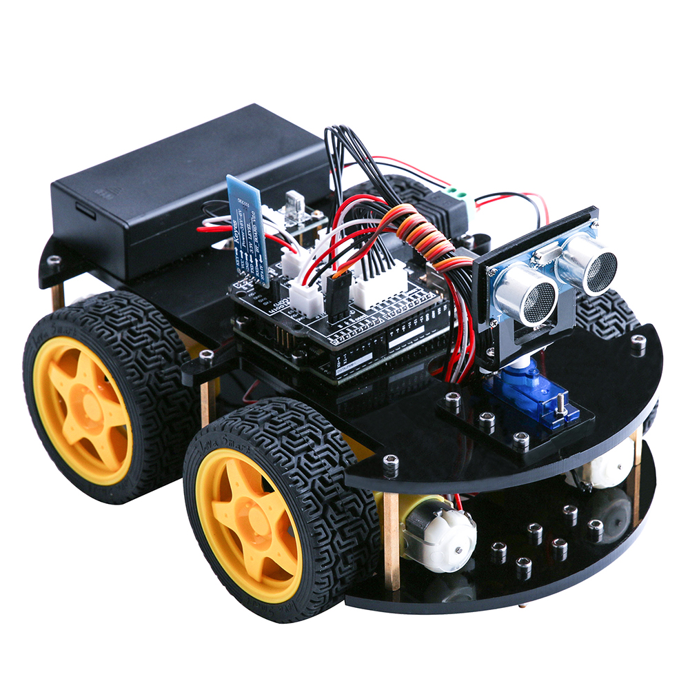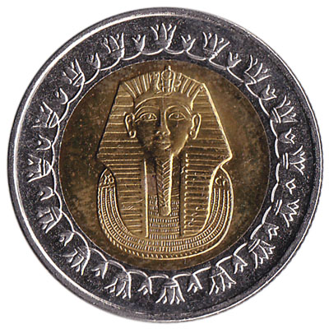

Coin Collection Station

Fig. 1 An illustration example of the ball collection car with a 4x4 grid.

**Detailed description**

Your task is to design 2 robotic cars that will walk on a **4x4 grid** and will collect the coins in the most efficient way and put it inside the collection station at the edge of the grid. The cars should communicate with **a server** that gives them the direction in which they should head next based on the present scenario. For example, if you want to collect coin 1, the server should calculate first which car is the nearest to the coin in order to collect it, in this case, it’s car 1, then it gives the nearest car the order to move and collect coin 1. So you should design your algorithm based on the **shortest path** from each car to each coin.

**N.B.:** The coins will only be placed in the intersection points of the grid



Car 1

Coin 1

Car 2

Coin 2

Coin 3

Coin 4

Coin Collection Station

Car 3

**Project milestones**

Your project is divided into 3 milestones:

**Milestone 1 (Due Date: 28/Feb.)**

* **Hardware part**: you should design and implement your automated car and it should be able to walk and follow a path. A lot of material is available online, type “Line follower”. You can watch this video to get more intuition <https://www.youtube.com/watch?v=Cf-V-giXiRw>

The communication can be done through WiFi or Bluetooth using an **ESP32** or you can use **ESP8266** for WiFi only.

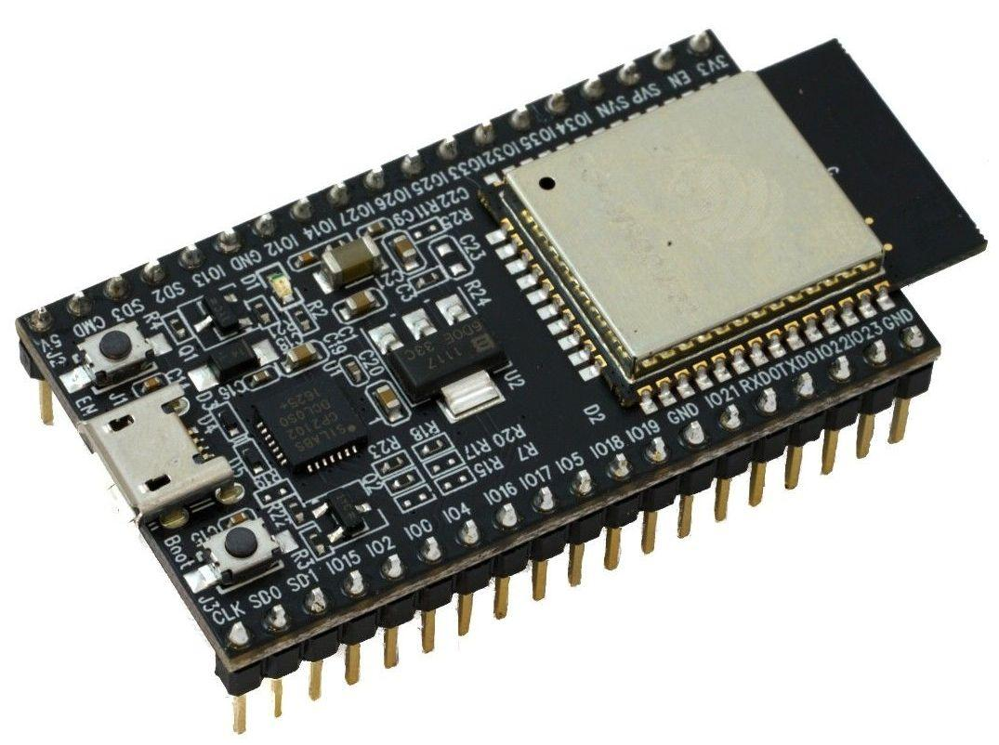

ESP32 module

You can buy it from:

1. RAM electronics
2. El Nekhely
3. Maamoon Electronics
4. Future Electronics

* **Software part:** The robot should be able to forward its location everytime it stops to your mobile using **Bluetooth** or **WiFi** connection. You can use “**Firebase**” for the server implementation and get the next move order.

**You should submit a copy of the used code and a documentation about what components you used.**

**Milestone 2**

* **Hardware part**: your car should now include a **magnet** that can pull the coin whenever needed and it should update the cloud about it. It should also take commands from the cloud on which direction should it take next and finalize Product PCBs
* **Software part**: The cloud should be able to forward its commands to the car through firebase. So, you should design a **full-duplex** communication between the cloud and the car as illustrated below. In addition, a **mobile application** should be developed and should include the option of **pre-defining the coins positions** on the grid

Mobile

Cloud

WiFi

Firebase

Car

Communication Scheme

**You should submit a copy of the used code and a documentation about what components you used.**

**Milestone 3**

This milestone is the **integration** part you have to implement the 2 cars and the three of them should be able to:

* Communicate with the mobile and server simultaneously.
* Move along the map, reach the coin, grab it and put it in the collection station.

GOOD LUCK!