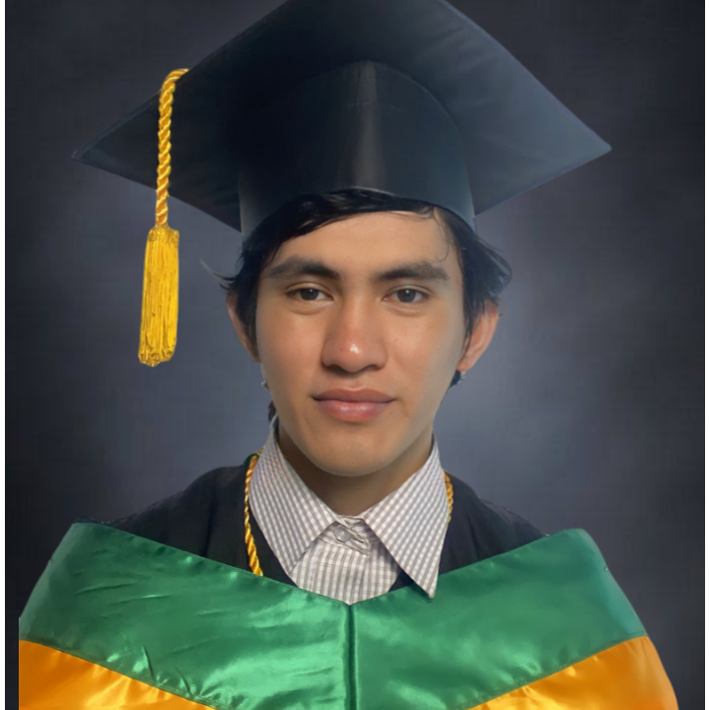**JOHN ERROL L. CARAMBIAS**

Present Address: Sihayon Sta.cruz Tagoloan Misamis Oriental  
Contact number: 09678775985  
Email Address: johnerrolcarambias04@gmail.com

**JOB OBJECTIVES:**

I am seeking a job with a company where I can grow professionally and personally.

**EDUCATIONAL BACKGROUND:**  
  
Year Degree School

2021-2022 BSIT University of Science and Technology

of Southern Philippines

Lapasan, Cagayan de Oro

2017-2018 SECONDARY Phinma- Cagayan de Oro

Puerto Cagayan de Oro

2011-2012 ELEMENTARY Tagoloan Central School

Tagoloan Misamis Oriental

**QUALIFICATIONS**:

* Tagoloan National High School - Computer Hardware Servicing - TVL (2016)
* Phinma - Cagayan de Oro College - General Academic Strand - IT (2018)
* Introduction to Networking - Cisco Certified (2020)
* Introduction to IoT Course - Cisco Certified (2021)

**ACHIEVEMENTS:**

* Dean’s Lister for Third Year First Semester USTP (2020-2020)
* Dean’s Lister for Third Year Second Semester USTP (2021-2021)
* Dean’s Lister for Fourth Year First Semester USTP (2021-2022)
* Dean’s Lister for Fourth Year Second Semester USTP (2022-2022)
* Top 15 Finalist for USTP Solutions Week (2021)

**PERSONAL PROJECTS:**

* JEHAE Currency Converter using Java (2017)
* 7/11 Cashiering and Inventory System using Java (2018)
* Inventory System using Tkinter in Python (2019)
* Subject Recommendation System for TCM Students using Java (2019)
* Personal Portfolio as a Website using HTML, CSS and Javascript (2020)
* Merkago: Mobile Market Application using Flutter (2020)
* Hatag Application using Flutter (2021)
* USTP Mobile Ordering System (2022)

**PERSONAL DATA:**

**Birthday**: October 4, 1999  
**Sex**: Male  
**Height**: 162.9 cm  
**Weight**: 65.5 kg.   
**Citizenship:** Filipino  
**Religion**: Roman Catholic

**SEMINARS ATTENDED:**

* Innovation Nation: Cagayan de Oro Online Roadshow by QBO Innovation Hub (November 2020)
* Deep Mentoring for Solution Challenge (February 2021)
* DevFest Geek Weeks (November 2021)
* GDSC’s Web Dev and Design (December 2021)