## Project Title

Due Date:

Name:

Course:

Instructor:

**Abstract**

This report involves simulating a four loop Pressurized Water Reactor (PWR) using a numerical loop momentum balancing approach. The first section details the theoretical basis for the pressurized water reactor and how the momentum balancing equations provide an accurate approximation for the reactor physics. Next, the report dives into the specific methods used in order to discretize the momentum balance equations for the specific four loop PWR before determining the appropriate Reactor Coolant Pump (RCP) and Steam Generator design parameters needed to meet required mass flux and core inlet temperature rises. This reactor is then analyzed for performance in three pump transients. The first transient evaluates performance in a loss of all AC casualty where all RCPs trip off simultaneously. The second evaluates a locked rotor casualty impacting a single loop, where the loop effectively loses all flow. The third transient analyzes a single RCP shear inducing reverse flow through the associated loop. Finally, reactor performance is analyzed with 10% steam generator tubes clogged in a single loop.

## Table of Contents

Introduction and Theory 1

Methods 1

Problem Formulation 1

Results and Discussion 1

Conclusions 1

References 1

# Introduction and Theory

This report analyses many reactor safety considerations which are involved in designing a pressurized water reactor (PWR). PWRs are common in the nuclear power industry, so analyzing this design provides insight into limiting casualties, reactor safety concerns, and the importance of proper reactor plant design. The specific geometry analyzed in this report involves a four loop PWR, where each loop has a Reactor Coolant Pump (RCP), a steam generator, and no check valves to prevent backwards flow. Loop one is used to determine the transient behavior, and the other three loops are grouped into a set of symmetric loops collectively referred to as loop two. A visual depiction of the PWR is seen in the figure below:

Figure 1: Visualization of PWR Nodes

Where the node categorization is given by the following table:

The approach taken to model the PWR was to use a set of discretized momentum equations in each of the nodes shown in Figure 1. As momentum is conserved within the reactor, any momentum going into a node must either exit the node or be stored within it. This report models the momentum in each node using the below equation:

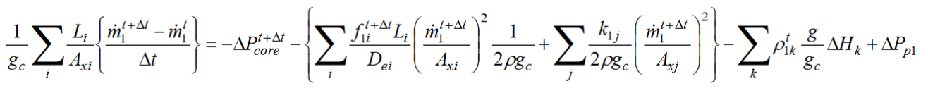

Here, the left hand term represents the equivalent amount of momentum stored within the node over the course of the time step dt.

However, in order to properly model the cha

To model the PWR, the momentum balancing set of Python scripts were created in order to solve the discrete loop momentum equations.

Also includes project objectives.

Typically, the project report can be between 10 to 30 pages long. Grading will be focused on content, logic, and not the size of the report.

Use 12pt font with 1 inch margins and 1.5 spacing.

# Methods

Review the methods and the code used for the project

# Problem Formulation

For example, include schematic of the domain, what is being done and how the results are obtained.

# Results and Discussion

Problem a

Problem b

Problem c

Problem d

Problem e

Problem f

863 clogged tubes

Includes the performed parametric studies and the analysis of the results. This section should include all the tests performed, results and its interpretation.

Specifically, this project requires several specific tasks (see description). Clearly separate the results and discussion for each task

# Conclusions

Discuss problems / issues / good results as well as potential future work. Future work should evaluate reactor safety in longer time domains in order to appropriately factor decay heat removal as a criteria for PWR casualty response.

# References