**CPE301 – SPRING 2019**

Design Assignment 2A

Student Name: John Galanza

Student #: 5002981771

Student Email: galanj1@unlv.nevada.edu

Primary Github address: <https://github.com/JohnGalanza>

Directory:<https://github.com/JohnGalanza/supersmashjoe>

Submit the following for all Labs:

1. In the document, for each task submit the modified or included code (only) with highlights and justifications of the modifications. Also, include the comments.
2. Use the previously create a Github repository with a random name (no CPE/301, Lastname, Firstname). Place all labs under the root folder ESD301/DA, sub-folder named LABXX, with one document and one video link file for each lab, place modified asm/c files named as LabXX-TYY.asm/c.
3. If multiple asm/c files or other libraries are used, create a folder LabXX-TYY and place these files inside the folder.
4. The folder should have a) Word document (see template), b) source code file(s) and other include files, c) text file with youtube video links (see template).

1. **COMPONENTS LIST AND CONNECTION BLOCK DIAGRAM w/ PINS**

* Atmega328p
* Multifunctional Shield
* usb cable

Block diagram with pins used in the Atmega328P

1. **INITIAL/MODIFIED/DEVELOPED CODE OF TASK 1**

**TASK1 IN ASSEMBLY**

LDI R20,0xFF ; R20 = 11111111 in binary

LDI R21,00 ;R21 = 00000000 in binary

SBI DDRB,2

OUT PORTB,R21 ;PORTB = R20(on)

CALL Delay1 ;Delays for .435s

OUT PORTB,R20 ;PORTB = R21(off)

CALL Delay2 ;Delays for .290s

JMP HERE

Delay1:

LDI R17,36

LDI R18,79

LDI R19,221

L1: DEC R19

BRNE L1

DEC R18

BRNE L1

DEC R17

BRNE L1

RET

Delay2:

LDI R17,24

LDI R18,138

LDI R19,232

L2: DEC R19

BRNE L2

DEC R18

BRNE L2

DEC R17

BRNE L2

RET

HERE:JMP HERE

**TASK 1 IN C**

#define F_CPU 16000000UL

#include <avr/io.h>

#include <util/delay.h>

int main(void)

{

DDRB|= (1<<2); //sets portb2 as an output

while(1)

{

PORTB |= (1<<2); //set bit number 2 of portb

_delay_ms(435); //sets delay of .435s

PORTB &= ~(1<<2); //clears the bit in portb

_delay_ms(29); //sets delay of .435s

}

return 0;

}

**TASK 2 IN ASSEMBLY**

; DA2T2.asm

;

CBI DDRC,2 ;makes PC2 an input

LDI R19, 0x04

OUT DDRB, R19 ;makes PB2 an output port

L1: SBIC PINC,2 ;Skip if bit PB2 is LOW

RJMP L1 ;checks if bit is 0

SBI PORTB,2 ;turns on port b

CALL Delay ;delays for 1.250s

CBI PORTB,2 ;clears port b

RJMP HERE

Delay:

LDI R16,102

LDI R17,118

LDI R18,194

L2: DEC R18

BRNE L2

DEC R17

BRNE L2

DEC R16

BRNE L2

HERE:RJMP HERE

**TASK 2 IN C**

#include <avr/io.h>

#define F_CPU 16000000UL

#include <util/delay.h>

int main(void)

{

DDRB = 0x04; //PORTB bit 2 is an output

DDRC = ~(0x04); //PORTC bit 2 is an input

PORTC |= (1<<2); //Enable pull-up

while (1)

{

if(!(PINC & 0x04)) //checks if button is pressed

{

PORTB = (1<<2); //turns on pb2

_delay_ms(1000); //delay last for 1.25s

_delay_ms(250);

PORTB = (0<<2); //turn off pb2

}

else

PORTB = (0<<2); //keeps pb2 off

}

}

1. **DEVELOPED MODIFIED CODE OF TASK 1 and TASK 2**

**TASK 1**

LDI R20,0x04 ; R20 = 00000100 in binary

LDI R21,00 ;R21 = 00000000 in binary

SBI DDRB,2

OUT PORTB,R21 ;PORTB = R20(on)

CALL Delay1 ;Delays for .435s

OUT PORTB,R20 ;PORTB = R21(off)

CALL Delay2 ;Delays for .290s

JMP HERE

Delay1:

LDI R17,36

LDI R18,79

LDI R19,221

L1: DEC R19

BRNE L1

DEC R18

BRNE L1

DEC R17

BRNE L1

RET

Delay2:

LDI R17,24

LDI R18,138

LDI R19,232

L2: DEC R19

BRNE L2

DEC R18

BRNE L2

DEC R17

BRNE L2

RET

HERE:JMP HERE

**TASK 2**

; DA2T2.asm

;

CBI DDRC,2 ;makes PC2 an input

LDI R19, 0x04

OUT DDRB, R19 ;makes PB2 an output port

L1: SBIC PINC,2 ;Skip if bit PB2 is LOW

RJMP L1 ;checks if bit is 0

SBI PORTB,2 ;turns on port b

CALL Delay ;delays for 1.250s

CBI PORTB,2 ;clears port b

RJMP HERE

Delay:

LDI R16,102

LDI R17,118

LDI R18,194

L2: DEC R18

BRNE L2

DEC R17

BRNE L2

DEC R16

BRNE L2

HERE:RJMP HERE

1. **SCHEMATICS**

Use fritzing.org

1. **SCREENSHOTS OF EACH TASK OUTPUT (ATMEL STUDIO OUTPUT)**

Screenshot of T1 showing the proper delay time

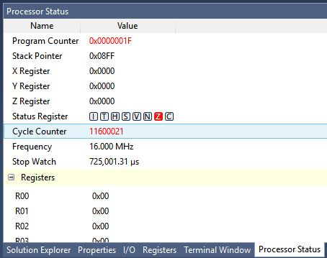

Screenshot of T2 with the proper delay time of 1.25s

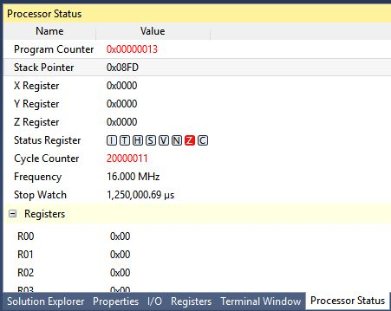

Screenshot of the output bits being active during simulation

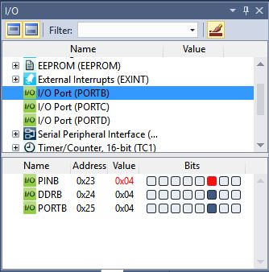

1. **SCREENSHOT OF EACH DEMO (BOARD SETUP)**

1. **VIDEO LINKS OF EACH DEMO**

Video for T1

https://youtu.be/UHYFp5gUGTk

Video for T2

https://youtu.be/YpGuMAGRqwY

1. **GITHUB LINK OF THIS DA**

https://github.com/JohnGalanza/supersmashjoe/tree/master/DA2A

**Student Academic Misconduct Policy**

<http://studentconduct.unlv.edu/misconduct/policy.html>

“*This assignment submission is my own, original work*”.

NAME OF THE STUDENT