**CPE301 – SPRING 2019**

Design Assignment 2C

Student Name: John Galanza

Student #: 5002981771

Student Email: galanj1@unlv.nevada.edu

Primary Github address: <https://github.com/JohnGalanza>

Directory: <https://github.com/JohnGalanza/supersmashjoe>

Submit the following for all Labs:

1. In the document, for each task submit the modified or included code (only) with highlights and justifications of the modifications. Also, include the comments.
2. Use the previously create a Github repository with a random name (no CPE/301, Lastname, Firstname). Place all labs under the root folder ESD301/DA, sub-folder named LABXX, with one document and one video link file for each lab, place modified asm/c files named as LabXX-TYY.asm/c.
3. If multiple asm/c files or other libraries are used, create a folder LabXX-TYY and place these files inside the folder.
4. The folder should have a) Word document (see template), b) source code file(s) and other include files, c) text file with youtube video links (see template).

1. **COMPONENTS LIST AND CONNECTION BLOCK DIAGRAM w/ PINS**

* Atmega328p
* Multifunctional Shield
* USB cable

1. **INITIAL/MODIFIED/DEVELOPED CODE OF TASK 1/A**

#define F_CPU 16000000UL

#include <avr/io.h>

#include <util/delay.h>

int main(void)

{

DDRB|= (1<<2); //sets portb2 as an output

while(1)

{

PORTB |= (1<<2); //set bit number 2 of portb

_delay_ms(435); //sets delay of .435s

PORTB &= ~(1<<2); //clears the bit in portb

_delay_ms(29); //sets delay of .435s

}

return 0;

}

1. **DEVELOPED MODIFIED CODE OF TASK 2/A from TASK 1/A**

**TASK 1**

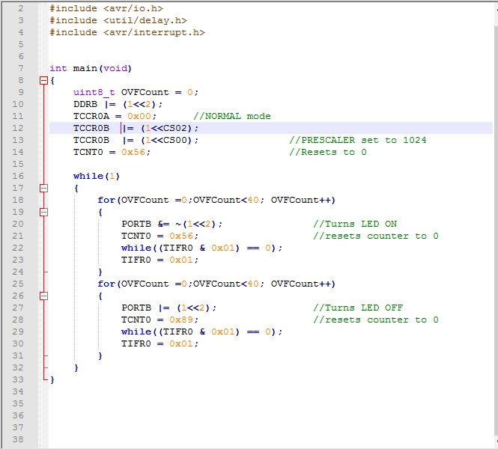

**TASK 2**

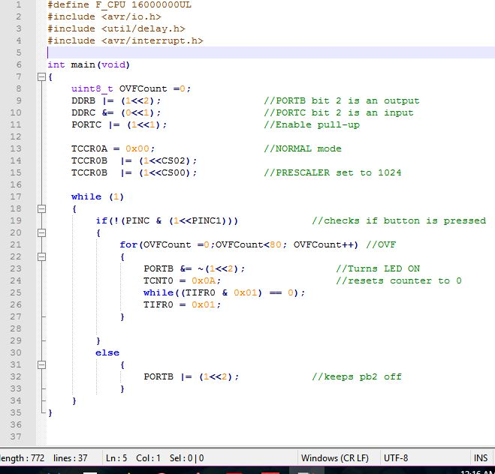

**TASK 3**

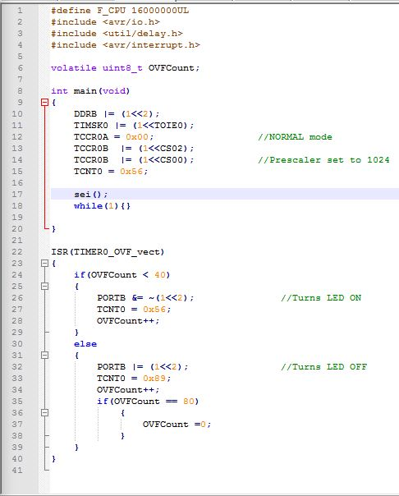

**TASK 4**

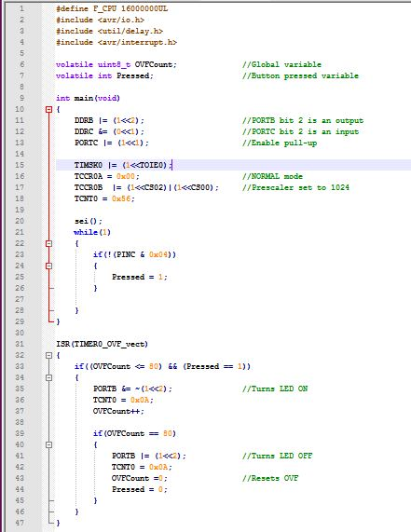

**TASK 5**

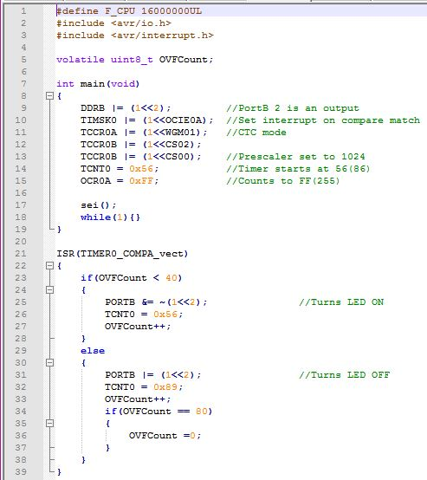

**TASK 6**

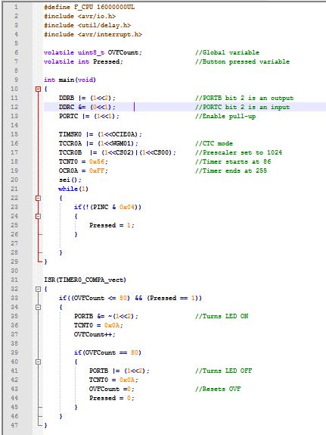

1. **SCHEMATICS**

Use fritzing.org

1. **SCREENSHOTS OF EACH TASK OUTPUT (ATMEL STUDIO OUTPUT)**
2. **SCREENSHOT OF EACH DEMO (BOARD SETUP)**

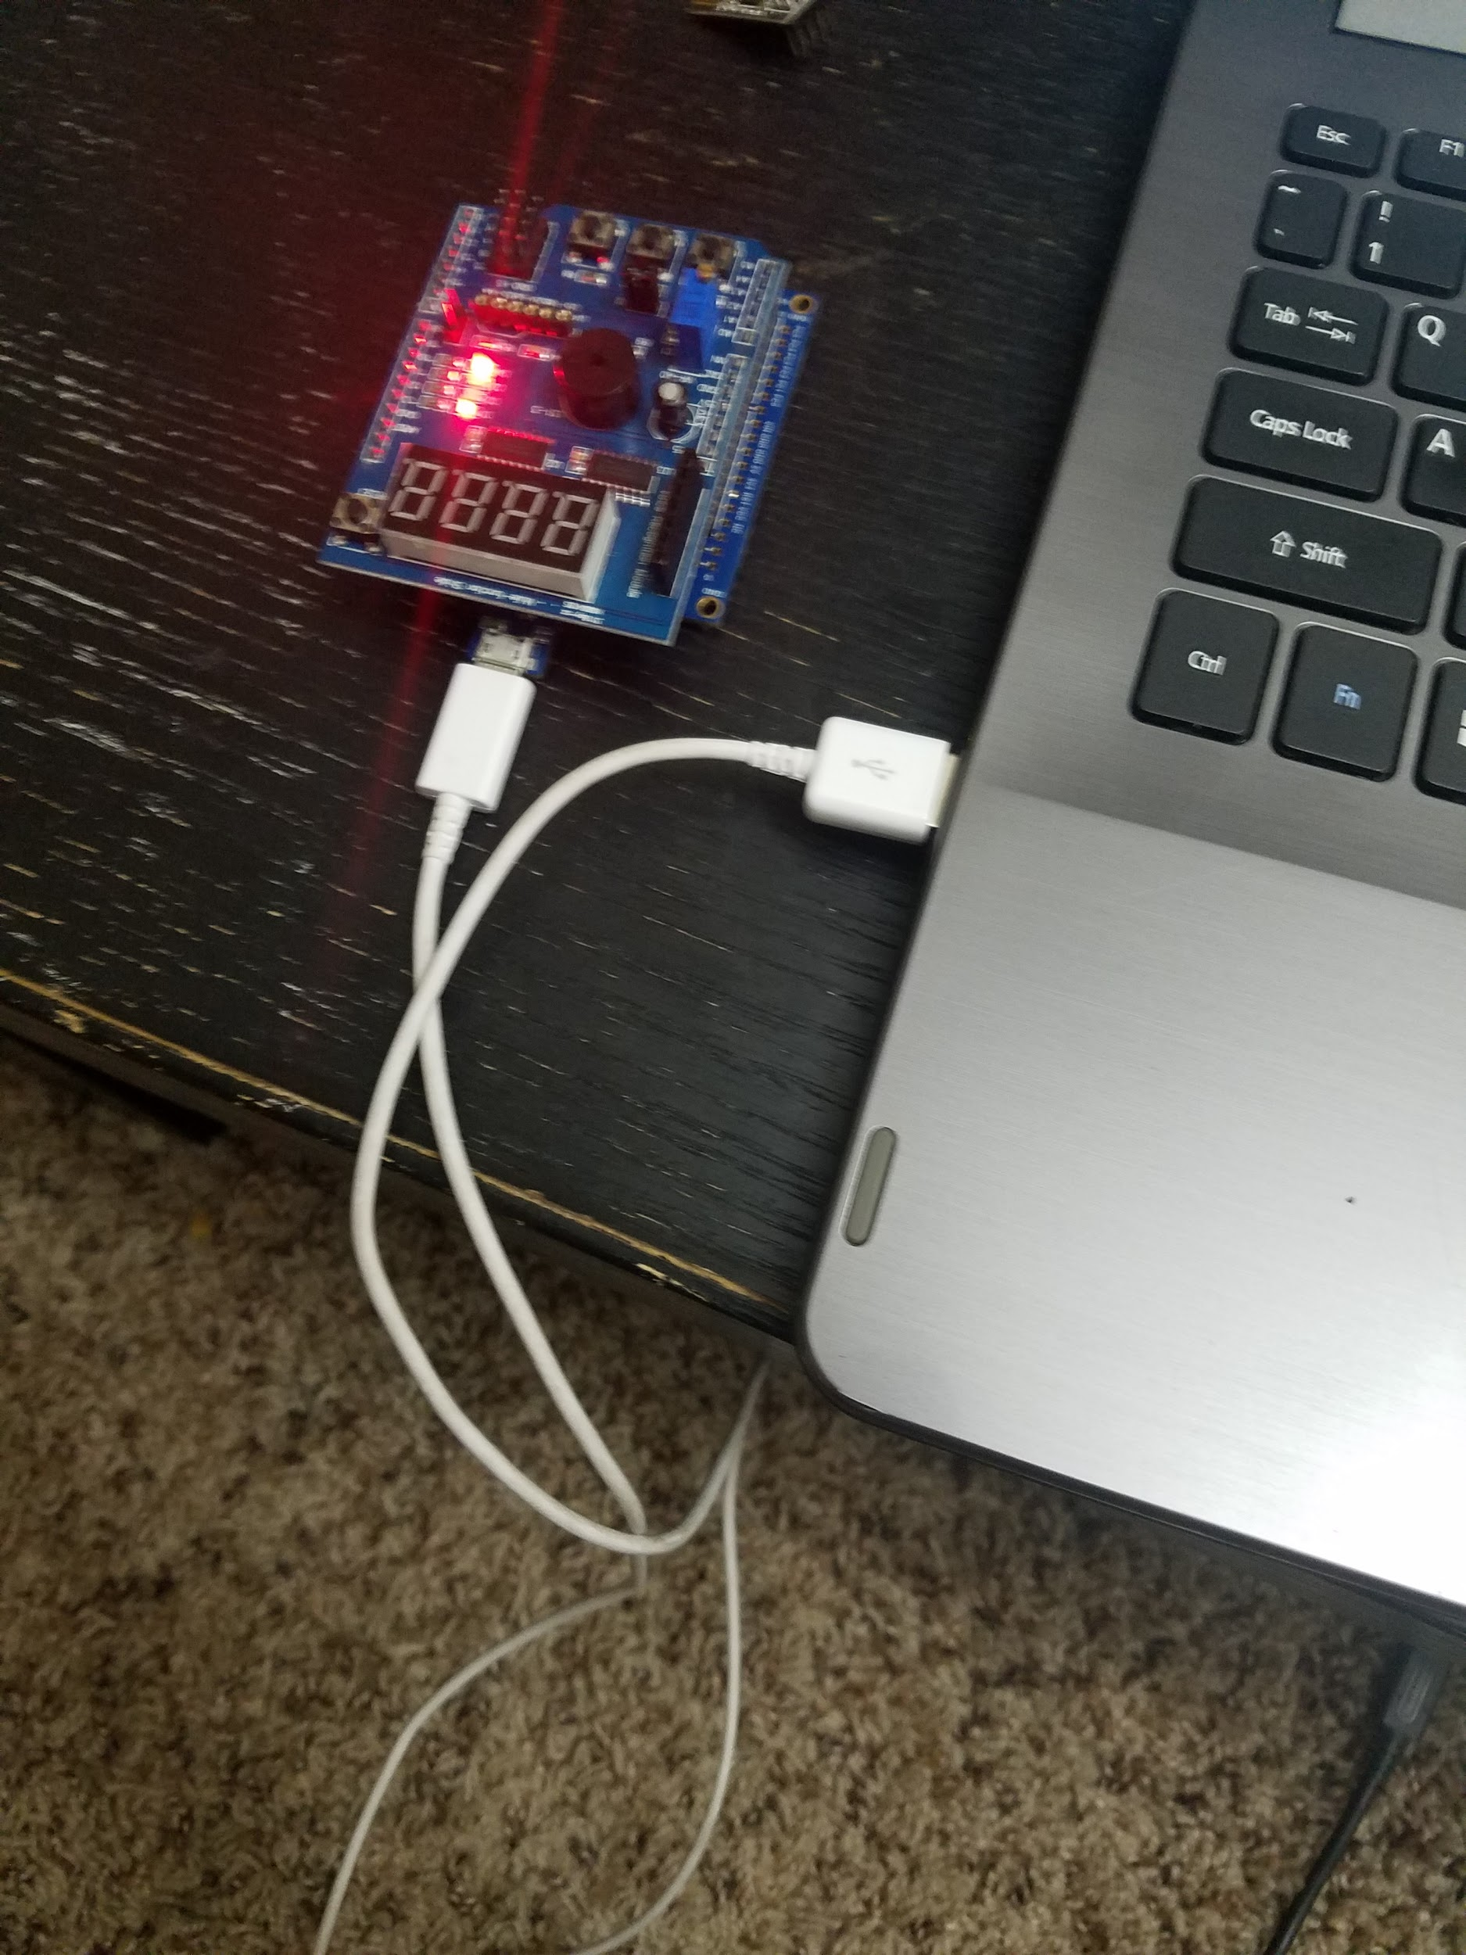

1. **VIDEO LINKS OF EACH DEMO**

TASK 1

<https://youtu.be/pjaYof3yIKA>

TASK 2

<https://youtu.be/sBT-Z97Nobs>

TASK 3

https://youtu.be/TgMnz5WlJqA

TASK 4

<https://youtu.be/ctmlEGbkMs8>

TASK 5

<https://youtu.be/Ck85-ZZhKSs>

TASK 6

<https://youtu.be/pAMC5I5O7OE>

1. **GITHUB LINK OF THIS DA**

https://github.com/JohnGalanza/supersmashjoe/tree/master/DA2C

**Student Academic Misconduct Policy**

<http://studentconduct.unlv.edu/misconduct/policy.html>

“*This assignment submission is my own, original work*”.

John Galanza