**CPE301 – SPRING 2019**

Design Assignment 3b

Student Name: John Galanza

Student #: 5002981771

Student Email: galanj1@unlv.nevada.edu

Primary Github address:<https://github.com/JohnGalanza>

Directory:<https://github.com/JohnGalanza/supersmashjoe>

Submit the following for all Labs:

1. In the document, for each task submit the modified or included code (only) with highlights and justifications of the modifications. Also, include the comments.
2. Use the previously create a Github repository with a random name (no CPE/301, Lastname, Firstname). Place all labs under the root folder ESD301/DA, sub-folder named LABXX, with one document and one video link file for each lab, place modified asm/c files named as LabXX-TYY.asm/c.
3. If multiple asm/c files or other libraries are used, create a folder LabXX-TYY and place these files inside the folder.
4. The folder should have a) Word document (see template), b) source code file(s) and other include files, c) text file with youtube video links (see template).

1. **COMPONENTS LIST AND CONNECTION BLOCK DIAGRAM w/ PINS**

* Atmega328p
* LM 35 temperature sensor
* 2x wires

1. **INITIAL/MODIFIED/DEVELOPED CODE OF TASK 1/A**

Insert initial code here

#define F_CPU 16000000UL

#define BAUD_RATE 9600

//#define UBRR_9600 103

#include <avr/io.h>

#include <util/delay.h>

#include <avr/interrupt.h>

//#include <util/setbaud.h>

#include <stdio.h>

#include <stdlib.h> //all the headerss

void read_adc(void); //Function declarations

void adc_init(void);

void USART_init();

void USART_tx_string(char * data);

void USART_send(unsigned char ch);

void USART_print(char* str);

volatile uint8_t OVFCount;

volatile unsigned int adc_temp;

char outs[20];

int main(void)

{

adc_init(); //Initializes ADC

USART_init(); //Initialize USART

//USART_tx_string("Connected!\r\n"); //system is working here

/*TIMSK0 |= (1<<TOIE0);

TCCR0A = 0x00; //NORMAL mode

TCCR0B |= (1<<CS02)|(1<<CS00); //Prescaler set to 1024

TCNT0 = 0x1F;

*/

// sei();

while (1)

{

ADCSRA|=(1<<ADSC);

while((ADCSRA & (1<<ADIF))==0);

ADCSRA |= (1<<ADIF);

int a = ADCL;

a = a | (ADCH<<8);

a = (a/1024.0)* 5000/10;

USART_send((a/100)+'0');

a = a % 100;

USART_send((a/10)+'0');

a = a % 10;

USART_send((a)+'0'); //converts the number

USART_send('\r');

_delay_ms(1000);

}

return 0;

}

void adc_init(void)

{

//set up and enable ADC

ADMUX = (0<<REFS1)| //Reference selection bits

(1<<REFS0)| //AVcc - external cap at AREF

(0<<ADLAR)| //ADC Left adjust result

(1<<MUX2)| //analog channel selection bit

(0<<MUX1)| //chooses pc5 pin28

(1<<MUX0);

ADCSRA =(1<<ADEN)|

(0<<ADSC)|

(0<<ADATE)|

(0<<ADIF)|

(0<<ADIE)|

(1<<ADPS2)| //prescaler

(0<<ADPS1)|

(1<<ADPS0);

}

void read_adc(void)

{

unsigned char i = 4;

adc_temp = 0;

while(i--)

{

ADCSRA|=(1<<ADSC);

while(ADCSRA & (1<<ADSC));

adc_temp += ADC;

_delay_ms(50);

}

adc_temp = adc_temp/4; //averages a few samples

}

void USART_init(void)

{

UBRR0L = F_CPU/16/BAUD_RATE-1;

UCSR0C = (1<<UCSZ01)|(1<<UCSZ00); //asynchronous 8 N 1

UCSR0B = (1<<TXEN0); //enable receiver, transmitter & RX interrupt

}

void USART_send(unsigned char ch)

{

while(!(UCSR0A & (1<<UDRE0)));

UDR0 = ch;

}

void USART_print(char* str)

{

int i = 0;

while (str[i] != 0)

USART_send(str[i]);

}

//Sends data to serial port

void USART_tx_string(char *data)

{

while((*data!= '\0'))

{

while(!(UCSR0A & (1<<UDRE0)));

UDR0 = *data;

data++;

}

}

//Interrupt where temperature will be displayed and 1s delay will happen

/*ISR(TIMER0_OVF_vect)

{

if(OVFCount<70)

{

TCNT0 = 0x1F;

OVFCount++;

if(OVFCount ==70)

{

TCNT0 = 0x1F;

OVFCount = 0;

read_adc();

snprintf(outs,sizeof(outs),"%3d\r\n",adc_temp);

USART_tx_string(outs);

}

}

}

*/

1. **DEVELOPED MODIFIED CODE OF TASK 2/A from TASK 1/A**

Insert only the modified sections here

1. **SCHEMATICS**

Use fritzing.org

1. **SCREENSHOTS OF EACH TASK OUTPUT (ATMEL STUDIO OUTPUT)**

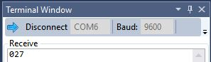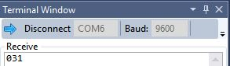

The pictures above show the outputs of room temp(left) then a different temperature when my finger is on the sensor(right).

1. **SCREENSHOT OF EACH DEMO (BOARD SETUP)**

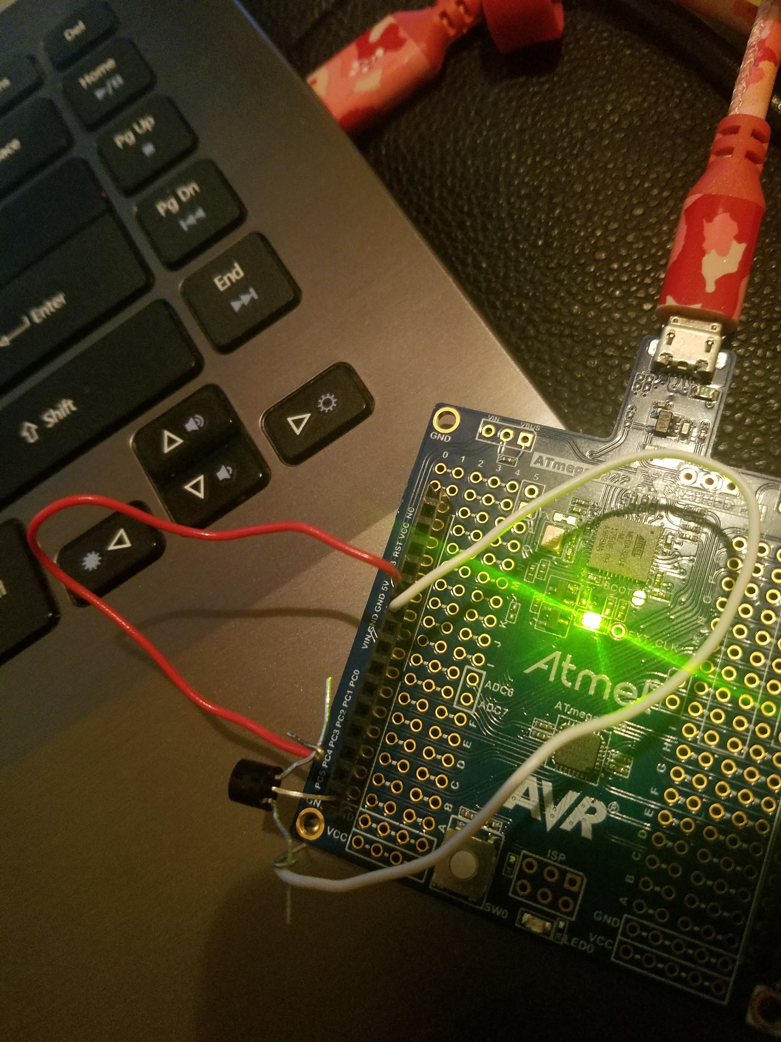

1. **VIDEO LINKS OF EACH DEMO**

https://youtu.be/VqqB7FipV-U

1. **GITHUB LINK OF THIS DA**

https://github.com/JohnGalanza/supersmashjoe/tree/master/DA3B

**Student Academic Misconduct Policy**

<http://studentconduct.unlv.edu/misconduct/policy.html>

“*This assignment submission is my own, original work*”.

John Galanza