**Memory in Operating System**

**Team Rinaldi**

**John Mark A. Gomez (Leader) | John Patrick Gasang (Rapporteur)**

**3-ECE**

**CPE355**

**Sir Ruiz**

**Table of Contents**

**Abstract ………………………………………………………………………… 1**

**Operating System ………………………………………………………… 2**

**Memory in Operating System ……….…………………………………………**

**Memory Management ………………………………………………………....**

**Swapping ………………………………………………………………….**

**Partitioning ………………………………………………………………….**

**Paging ………………………………………………………………….**

**Virtual Memory ………………………………………………………………….**

**Segmentation ………………………………………………………………….**

**Reference ………………………………………………………………….**

**Abstract**

An operating system, or "OS," is software that controls the execution of application programs and communicates between the computer hardware and other applications. It performs the basic tasks like handling Input and output "I/O", controlling peripherals, process management, file management and memory management.

One of the main functions of the Operating System is memory management, which is the process of controlling and coordinating computer memory to optimize the system's overall performance, which can also refer to as the management of Primary Memory or Main memory. Main memory is providing a fast storage that can be accessed by the CPU. Memory management helps the OS in allocating the main memory space to the processes and their data at the time of execution.which utilize the memory space. And it can execute multiple processes at the same time in the OS.

Memory management is a crucial function in an operating system that uses various techniques or methods to help manage the primary memory or main memory. Memory management techniques and methods such as segmentation in which the memory divides into multiple parts with different sizes, known as the segment. Paging, similarly to segmentation, the memory is broken into parts but with a similar size called pages. Lastly, swapping is a temporary exchange of a process between the main memory and secondary storage to make available memory for other processes.

The importance of memory management in an operating system is that it directly affects the execution time of the process, which depends on the availability of data in the main memory. For that reason, memory management must execute to which the essential data is always present in the main memory and must ensure the accuracy, availability, and consistency of the data imported to be effective.

1. **Operating System**

An Operating System (OS) is the most important system of the computer that interacts with the user and hardware. Some popular or common computer OS include Windows, Mac OS X developed by apple inc., and the open source OS is linux and nowadays we can also see an OS on our device like our smartphones that is operated by android or ios. They have different Graphical User Interface (GUI) but there are 3 main functions of OS 1st is to manage the computer’s resources. Examples of these are central processing units (CPU), memory, disk drives, and other computer peripherals such as mouse, keyboard and printers. The 2nd is to establish user interface, and the 3rd is to execute and provide services for applications software.

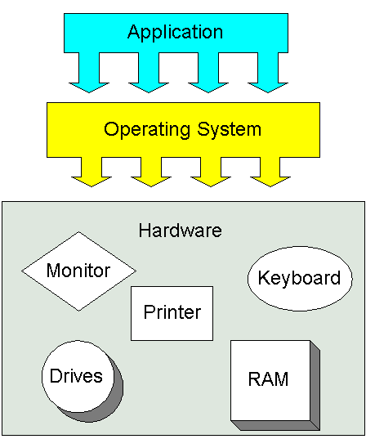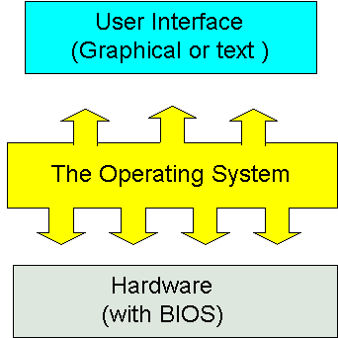

1. **Memory in Operating System**

1. **Memory Management**
2. **Swapping**

Swapping in memory management is a technique used to improve the main memory utilization by temporarily exchanging any process from the main memory to the secondary memory, which makes the main memory available for other processes. The purpose of swapping is to access the data in the hard disk and carry it to the RAM and only be used when the data is not already in the RAM by application programs. The performance of the system is usually affected due to the swapping process but, it helps in running large and multiple processes. That is the reason why swapping is called or referred to as memory compaction.

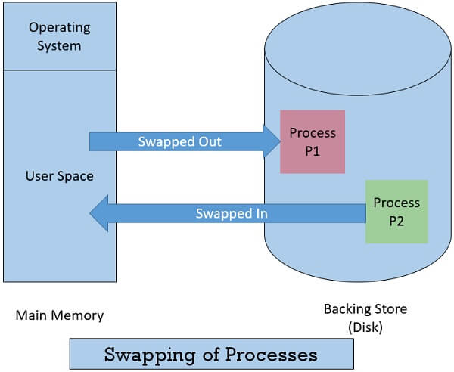

The concept of swapping is divided into two more concepts called Swap-in and Swap-out.

* Swap-out is to take the program from the RAM and bring them to the Hard disk.
* Swap-in is the opposite, where the programs are taken from the Hard disk then bringing them to the RAM.

1. **Partitioning**
2. **Paging**

Paging in memory management is a technique that allows the operating system to retrieve processes from the secondary memory to the main memory in the form of pages. To avoid external fragmentation and have maximum utilization, this technique divides the main memory into small fixed-size blocks of physical memory called frames, which are similar in size to pages.

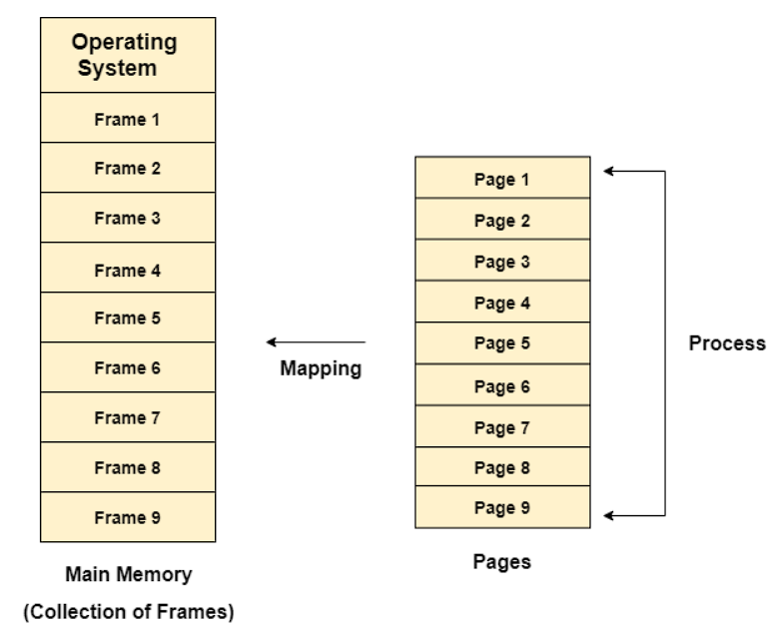

1. **Virtual Memory**
2. **Segmentation**
3. **Reference**

**Swapping reference link:**

[**https://www.includehelp.com/operating-systems/memory-management-techniques-in-operating-system.aspx**](https://www.includehelp.com/operating-systems/memory-management-techniques-in-operating-system.aspx)

[**https://www.tutorialspoint.com/operating_system/os_memory_management.htm**](https://www.tutorialspoint.com/operating_system/os_memory_management.htm)

[**https://www.javatpoint.com/swapping-in-operating-system**](https://www.javatpoint.com/swapping-in-operating-system)

**Memory management link:**

[**https://www.includehelp.com/operating-systems/memory-management-in-operating-system.aspx**](https://www.includehelp.com/operating-systems/memory-management-in-operating-system.aspx)

[**https://www.tutorialspoint.com/operating_system/os_memory_management.htm**](https://www.tutorialspoint.com/operating_system/os_memory_management.htm)

**Operating system reference link:**

[**https://www.tutorialspoint.com/operating_system/os_overview.htm**](https://www.tutorialspoint.com/operating_system/os_overview.htm)

[**https://techterms.com/definition/operating_system**](https://techterms.com/definition/operating_system)