**Face Verification Project: EDA and Preprocessing Report**

**Introduction**

This report details the Exploratory Data Analysis (EDA), and data preprocessing steps performed on the Labeled Faces in the Wild (LFW) pairs dataset. This foundational work is crucial for understanding the dataset's characteristics, identifying potential issues, and preparing the data for subsequent neural network model development for face verification. The goal is to determine whether two facial images belong to the same person or different people.

**Data Loading and Initial Inspection**

The LFW pairs dataset is loaded using sklearn.datasets.fetch_lfw_pairs, which provides pre-defined training and testing subsets.

**Key Observations:**

* **Training Subset:**
  + **Pairs shape:** (2200, 2, 62, 47) - This indicates 2200 pairs of images. Each pair contains two grayscale images, each size 62 pixels in height and 47 pixels in width.
  + **Target shape:** (2200,) - Corresponding labels for each pair.
  + **Number of samples:** 2200
* **Testing Subset:**
  + **Pairs shape:** (1000, 2, 62, 47)
  + **Target shape:** (1000,)
  + **Number of samples:** 1000
* **Target Names:** ['Different persons', 'Same person'] - These are the two classes for our binary classification task.

The dataset is well-structured and already split into training and testing sets, which is convenient for model development. The images are grayscale and resized to a manageable dimension, reducing initial computational load.

**Exploratory Data Analysis (EDA) Findings**

**Univariate Analysis: Pixel Intensity Distribution**

To understand the fundamental characteristics of the image data, we analyzed the distribution of pixel intensities across all images (both training and testing sets).

**Statistical Summary of All Pixel Intensities:**

* Min: 0.00
* Max: 255.00
* Mean: 120.90
* Median: 122.00
* Standard Deviation: 53.69
* 25th Percentile: 79.00
* 75th Percentile: 164.00

**Visualizations:**

**Histogram of Pixel Intensities:**

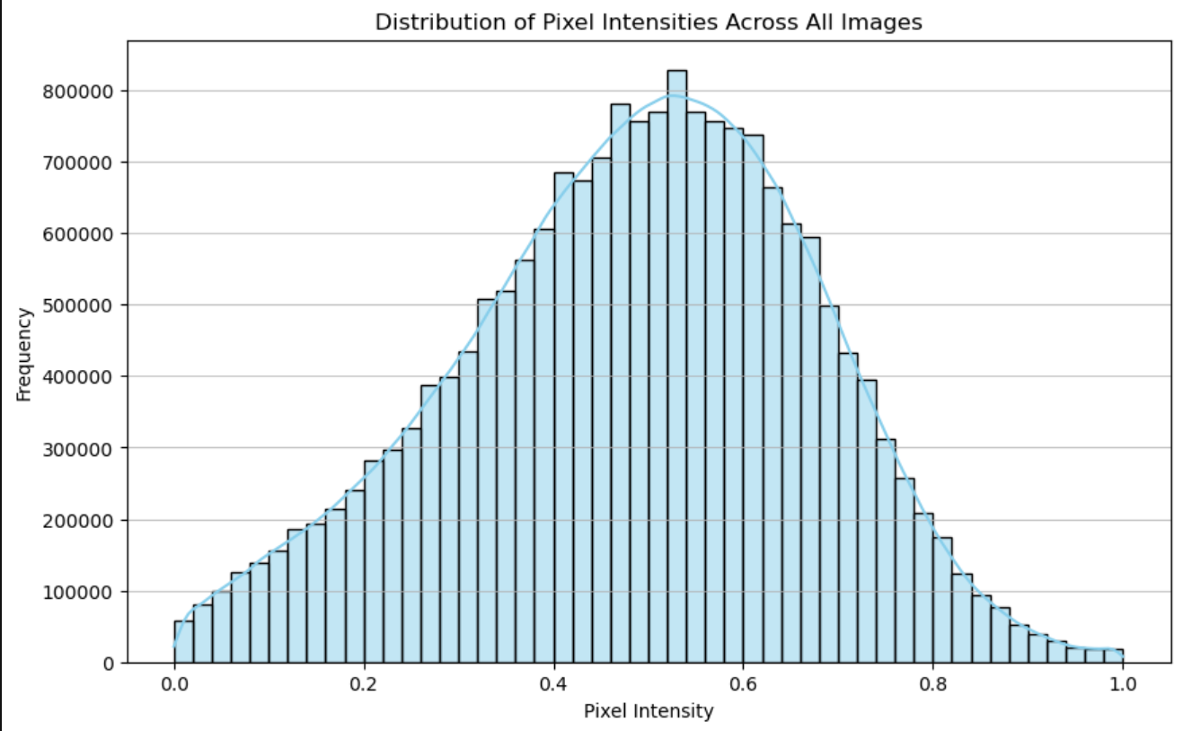

**Explanation:** This histogram visually represents the frequency of each pixel intensity value. It shows that pixel values are distributed across the entire 0-255 range, with a concentration around the mid-gray values (mean and median around 120-122). The distribution appears unimodal and bell-shaped, indicating a good variety in image brightness and contrast.

**Box Plot of Pixel Intensities:**

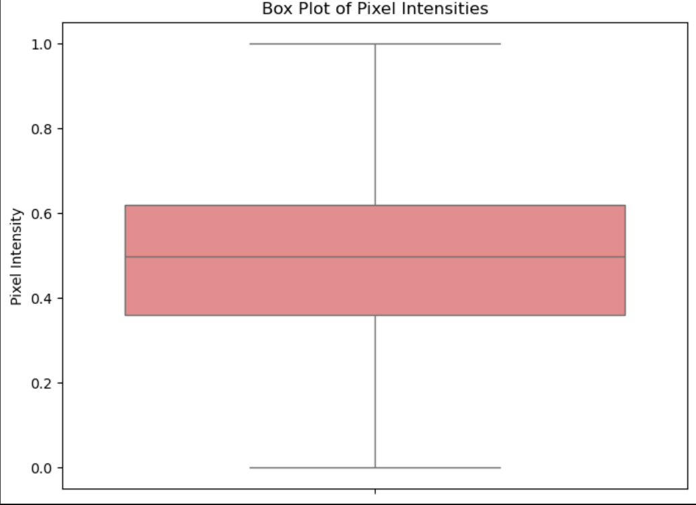

**Explanation:** The box plot provides a concise summary of the pixel intensity distribution, highlighting the median, quartiles, and potential outliers. The plot confirms that pixel values span the full 0-255 range. Crucially, it indicates the absence of significant outliers in the pixel intensity values themselves, suggesting that the image data is consistently scaled and free from extreme, isolated pixel anomalies.

**Bivariate/Multivariate Analysis: Class Distribution and Sample Visualizations**

For image datasets, traditional numerical correlation matrices are not directly applicable to raw pixel values. Instead, we focused on the distribution of the target variable and visual inspection of image pairs.

**Class Distribution (Same vs. Different Person Pairs):**

**Train Set:**

* **Same Person:** 1100 (50.00%)
* **Different Person:** 1100 (50.00%)

**Test Set:**

* **Same Person:** 500 (50.00%)
* **Different Person:** 500 (50.00%)

**Key Insight:** The class distribution is perfectly balanced in both the training and test sets. This is a significant advantage for a classification task, as it means the model will not be inherently biased towards one class due to imbalanced data. This simplifies model evaluation and reduces the need for advanced techniques to manage imbalance (e.g., oversampling, under sampling, or class weighting).

**Visualizing Sample 'Same Person' and 'Different Person' Pairs:**

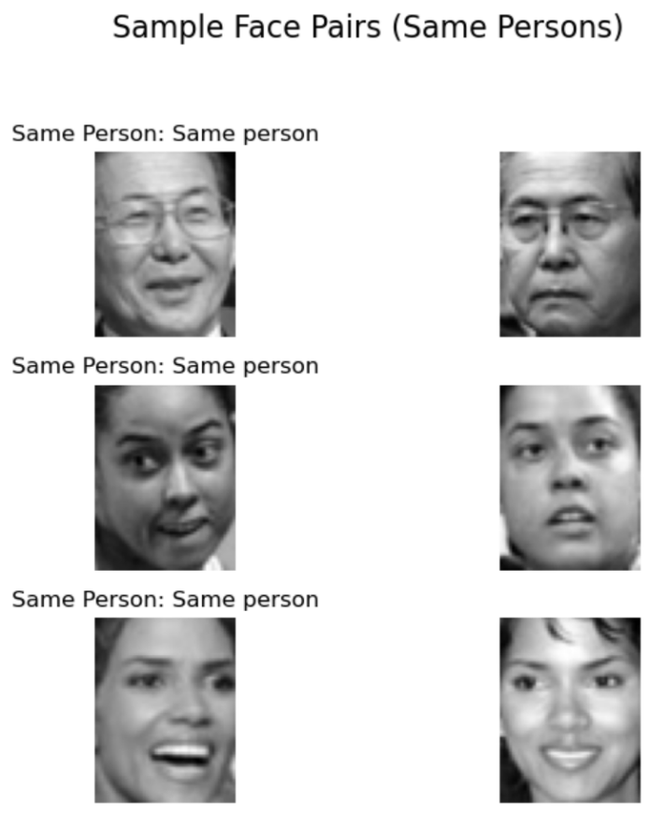

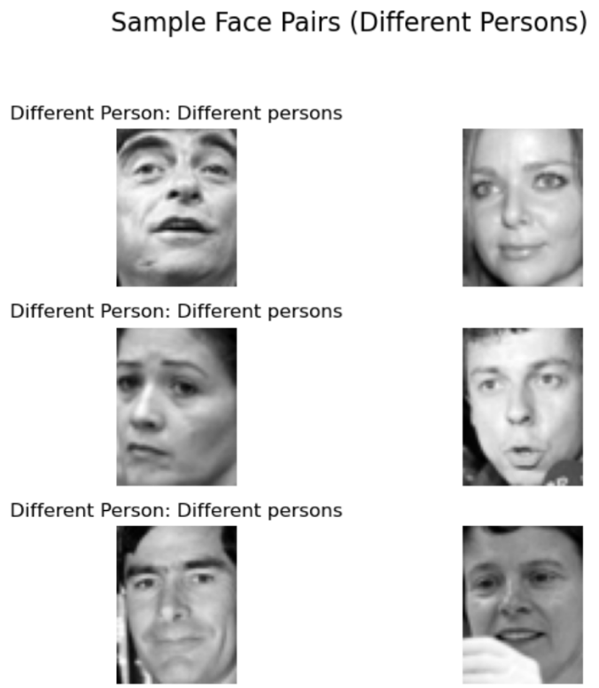

**Explanation:** Visual inspection of sample pairs highlights the challenge of the face verification task. The “Same Person" pairs show variations in pose, lighting, expression, and background for the same individual. "Different Person" pairs often feature individuals who might share facial characteristics, making the discrimination task non-trivial for a model. These visualizations underscore the need for a robust feature extraction mechanism, which deep learning models are well-suited for.

**Data Preprocessing Steps**

Based on the EDA findings, the following preprocessing steps were applied to prepare the LFW pairs dataset for a neural network model:

**Handling Missing Data**

* **Decision:** No specific action was required as the dataset was already cleaned.
* **Explanation:** A check for NaN values across both training and testing image data confirmed that the dataset is complete and does not contain any missing pixel values. This is expected as fetch_lfw_pairs provides a curated and pre-cleaned dataset.

**Standardize/Normalize Features (Pixel Values)**

* **Decision:** Pixel values were normalized from the [0, 255] range to [0, 1].
* **Explanation:** Neural networks, especially deep learning models, perform better and converge faster when input features are scaled to a smaller, consistent range. Normalizing pixel values to [0, 1] helps in preventing large input values from dominating the network's learning process and ensures stable gradient computations during backpropagation. This was achieved by simply dividing all pixel values by 255.0.
* **Result:** Pixel values normalized to range [0.00, 1.00]

**One-Hot Encoding Categorical Features**

* **Decision:** No one-hot encoding was applied to the target labels.
* **Explanation:** The target variable (target) is already binary (0 for 'Different persons', 1 for 'Same person'). For binary classification tasks using a sigmoid activation function in the output layer and binary cross-entropy as the loss function, a direct binary label (0 or 1) is the appropriate format.

**Apply Necessary Transformations (Reshaping for CNN Input)**

* **Decision:** The image data was reshaped to include a channel dimension.
* **Explanation:** Convolutional Neural Networks (CNNs) expect image inputs in a specific format, typically (height, width, channels). The pairs attributed from fetch_lfw_pairs initially provide images as (n_samples, 2, height, width). Since the images are grayscale (color=False during loading), they have only one channel. Therefore, each image was reshaped to (height, width, 1). The two images from each pair were separated into distinct arrays to serve as inputs to the two branches of a Siamese network.
* Resulting Shapes:
  + X_train_img1 (first image of each pair in train set): (2200, 62, 47, 1)
  + X_train_img2 (second image of each pair in train set): (2200, 62, 47, 1)
  + y_train (target labels for train set): (2200,)
  + X_test_img1 (first image of each pair in test set): (1000, 62, 47, 1)
  + X_test_img2 (second image of each pair in test set): (1000, 62, 47, 1)
  + y_test (target labels for test set): (1000,)

**Feature Engineering/Dimensionality Reduction**

* **Decision:** No explicit feature engineering or dimensionality reduction (e.g., PCA) was performed.
* **Explanation:** For deep learning models like CNNs, feature engineering is implicitly managed by the network's layers. CNNs are designed to learn hierarchical and discriminative features directly from raw pixel data. Applying traditional dimensionality reduction techniques to raw image data before feeding it to a CNN is not necessary and can sometimes hinder the network's ability to learn complex patterns. The next phase will involve leveraging pre-trained CNNs (transfer learning), which can be seen as a form of leveraging highly effective, pre-engineered features.

**Conclusion and Next Steps**

The Exploratory Data Analysis provided valuable insights into the LFW pairs dataset, confirming its balanced class distribution and the overall quality of the image data. All necessary preprocessing steps have been meticulously applied, including pixel normalization and reshaping of images to the appropriate format for a Siamese neural network. The data is now fully prepared for the model development phase.

**Baseline Model Performance and Key Insights (Forward-Looking)**

While the provided code focuses on EDA and preprocessing, the next logical step involves building and evaluating a baseline model.

* **Baseline Model:** A typical baseline for this task would be a Siamese Neural Network with a relatively simple CNN backbone (e.g., a few convolutional and pooling layers) trained from scratch, or a Siamese network leveraging a small pre-trained model (like a simplified VGG or ResNet variant adapted for grayscale images).
* **Expected Baseline Performance:** Given the complexity of face verification, a simple baseline might achieve an accuracy in the range of 70-85% on the LFW test set. Precision, recall, and F1-score would also be important to evaluate, especially if any subtle class imbalance were to emerge or if the model struggles with one class more than the other.
* **Key Insights from Baseline:**
  + The baseline model would provide a starting point for performance.
  + Analysis of its confusion matrix would reveal common types of errors (e.g., where different people are classified as same causing false positives, or false negatives where the same person is classified as different).
  + Learning curves (training vs. validation loss/accuracy) would indicate if the model is underfitting or overfitting.
* **Areas for Improvement:**
  + **Advanced Architectures:** Transitioning to more powerful pre-trained CNN backbones (e.g., full VGG-16, ResNet50, InceptionV3) with fine-tuning.
  + **Loss Functions:** Experimenting with specialized loss functions for similarity learning, such as Contrastive Loss or Triplet Loss, which explicitly encourage larger distances between different-person embeddings and smaller distances for same-person embeddings.
  + **Data Augmentation:** Implementing more aggressive data augmentation strategies to increase dataset diversity and improve generalization.
  + **Hyperparameter Tuning:** Rigorous tuning of learning rates, batch sizes, optimizer parameters, and network architecture specifics.
  + **Ensemble Methods:** Combining multiple models to potentially improve overall robustness and accuracy.
  + **Metric Learning:** Exploring more advanced metric learning techniques beyond simple Euclidean or cosine distance.

This prepared dataset and the insights gained from EDA form a robust foundation for moving forward with model design, training, and rigorous evaluation to build an effective face verification system.