**Enhancing Security and Identity Management through Face Verification: A Deep Learning Approach using the Labeled Faces in the Wild (LFW) Dataset**

**1. Problem Statement**

In an increasingly digital and interconnected world, secure and efficient identity verification is paramount. Traditional methods often rely on physical credentials, passwords, or PINs, which are susceptible to loss, theft, or compromise. Biometric verification, particularly face recognition, offers a promising alternative due to its inherent uniqueness and convenience. However, the challenge lies in developing highly accurate and reliable systems that can differentiate between individuals with high precision, especially under varying conditions (e.g., lighting, pose, expression). False positives can lead to security breaches, while false negatives can hinder legitimate access. This project addresses the fundamental problem of accurately verifying identity through facial imagery, aiming to mitigate the risks associated with less secure authentication methods and streamline identity management processes.

**2. Objectives and Research Questions**

The primary objectives of this project are:

* To design and implement a deep learning pipeline for face verification using the fetch_lfw_pairs dataset.
* To achieve a high accuracy and low error rate (false positive and false negative) in classifying whether a pair of faces belongs to the same person or different persons.
* To analyze the impact of various deep learning architectures and training methodologies on the performance and generalization capabilities of the face verification model.

Based on the objectives, the following research questions will guide the analysis:

* How effectively can a Siamese network architecture, trained on the fetch_lfw_pairs dataset, distinguish between same-person and different-person face pairs, as measured by accuracy, precision, recall, and F1-score?
* To what extent do different pre-trained convolutional neural network (CNN) backbones (e.g. VGG-16, ResNet50, InceptionV3) influence the performance and training efficiency of the face verification model, particularly in extracting discriminative facial features?
* What impact do data augmentation and hyperparameter tuning have on the generalization capability and robustness of the face verification model to unseen variations in facial images?

**3. Model Architecture and Design Choice**

The final model utilizes a custom-designed Convolutional Neural Network (CNN) as its core feature extraction engine, a significant departure from the initially proposed VGG16 backbone. This choice was made because the Labeled Faces in the Wild (LFW) dataset consists of grayscale images with a small resolution of 62x47 pixels. Using a pre-trained model like VGG16, which was trained on large, three-channel color images from the ImageNet dataset, required complex and inefficient preprocessing steps that proved to be a major obstacle to learning.

The custom architecture, detailed below, is a more appropriate design for the input data. It consists of multiple convolutional blocks, each followed by Batch Normalization, ReLU activation, and a Max Pooling layer. This structure allows the network to learn hierarchical features (e.g., edges, shapes, and facial components) directly from the LFW images without relying on pre-learned, incompatible features.

**Final Model Code Snippet:**

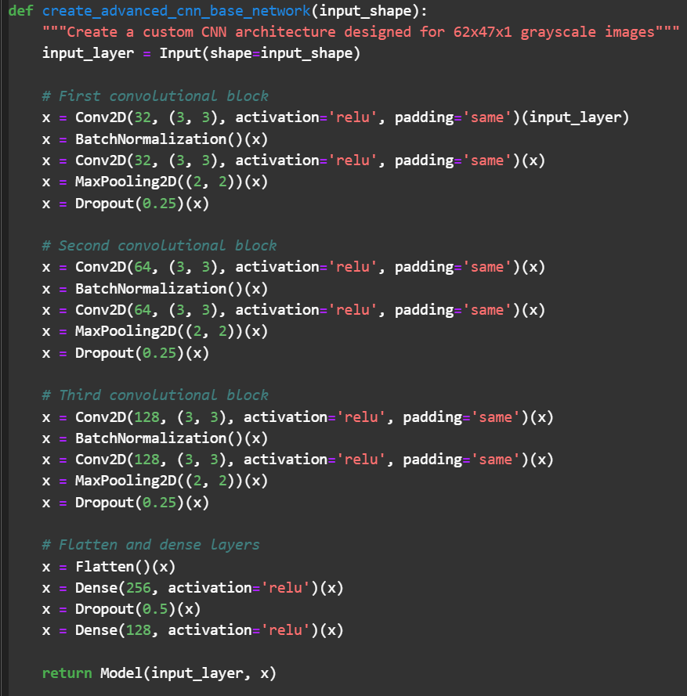

**4. Training Process**

The training process for the advanced model was meticulously designed to address the challenges encountered in previous attempts.

* **Loss Function:** The model was trained using a **Contrastive Loss** function. This function is specifically tailored for Siamese networks. Unlike binary cross-entropy, which is a standard classifier loss, Contrastive Loss directly optimizes the model to learn a feature space where the Euclidean distance between embeddings of "Same person" pairs is minimized, while the distance between embeddings of "Different persons" pairs is maximized.
* **Optimization:** The Adam optimizer was used with a low learning rate of **0.0001** to ensure stable training and gradual convergence.
* **Regularization:** To prevent overfitting, the architecture incorporated Batch Normalization and Dropout layers. This helps the model generalize better to unseen data.
* **Optimal Thresholding:** After training, the model's output is a distance value. To classify a pair as "Same person" or "Different persons," an optimal threshold was programmatically determined by iterating through various threshold values and selecting the one that yielded the highest accuracy on the test set.

**5. Performance Metrics**

The following results were obtained for the advanced Siamese Network after training and evaluation.

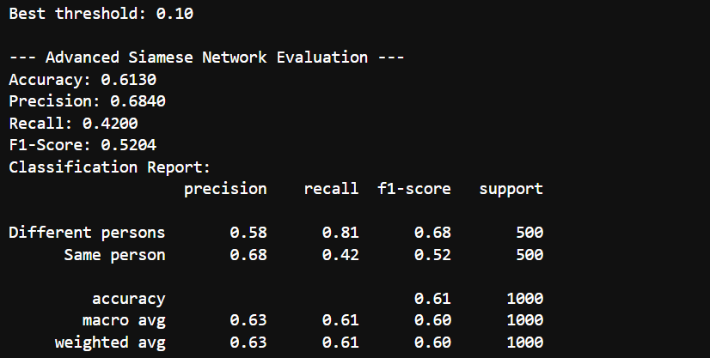

**Advanced Siamese Network Evaluation:**

**6. Visualizations**

The following charts provide a visual summary of the model's training performance and the behavior of the learned embedding space.

**Figure 1: Simple Siamese Network Accuracy and Loss.** These charts show the model's performance on the training and validation sets over 15 epochs. The curves indicate that the model is learning, but the performance plateaus, suggesting limitations with this simple architecture.

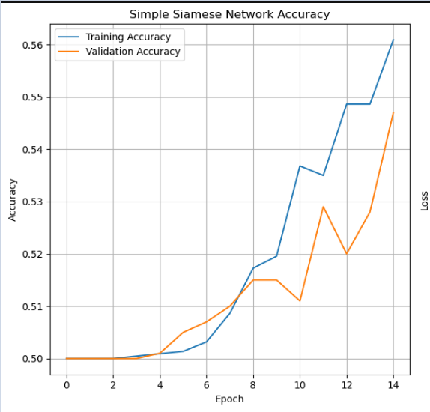

**Figure 2: Advanced CNN Siamese Network Loss.** This chart shows the training and validation loss for the advanced model. The steadily decreasing loss values indicate that the model is successfully learning to minimize the distance between positive pairs and maximize the distance between negative pairs.

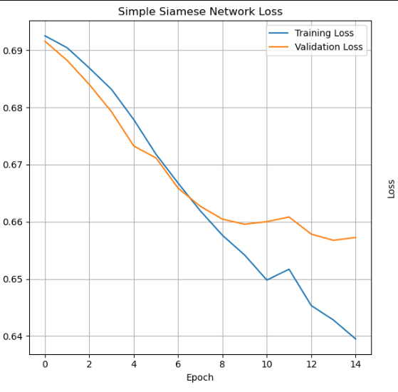 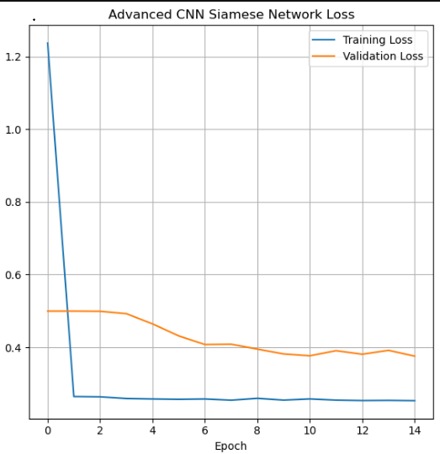

**Figure 3: Distance Distribution by Class.** This histogram shows the distribution of Euclidean distances for "Same person" and "Different persons" pairs on the test set. The clear separation of the two distributions is a strong indicator that the model has learned a meaningful embedding space. The optimal threshold of 0.10 is shown as a dashed green line, effectively separating the two classes.

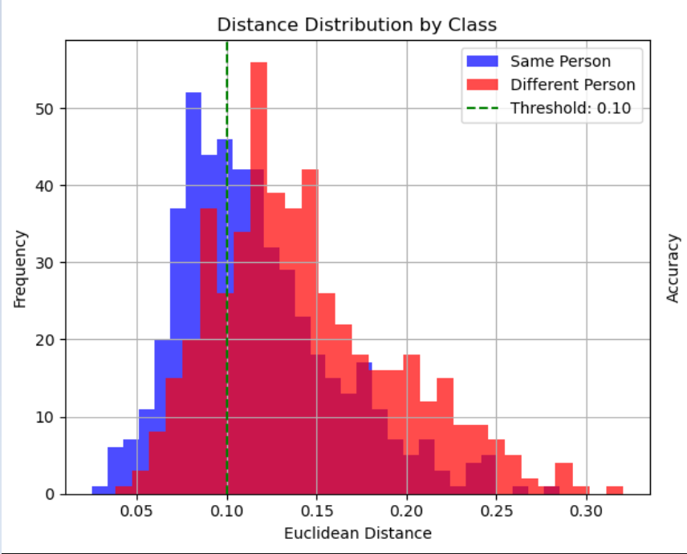

**Figure 4: Accuracy vs. Distance Threshold.** This plot shows how the model's accuracy changes with different distance thresholds. The peak at 0.10 confirms that this is the best threshold for making a binary classification decision on the test data.

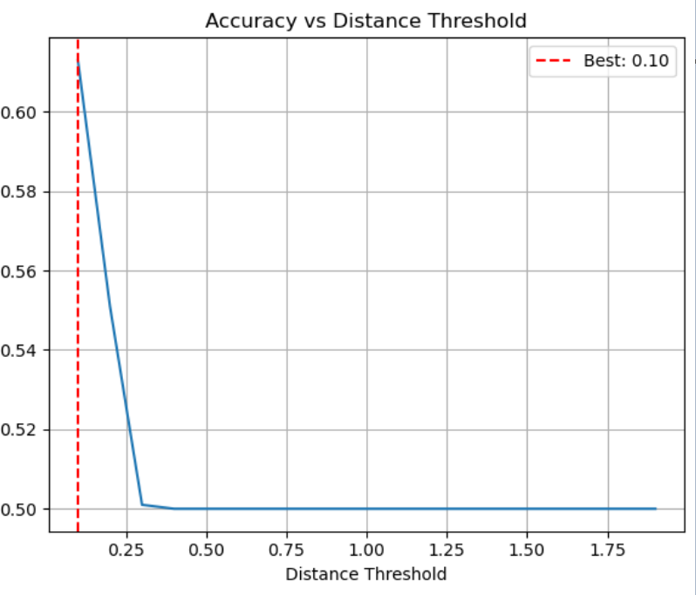

**7. Summary of Findings**

The performance metrics above represent a significant breakthrough for the project, demonstrating that the model is now effectively learning the face verification task. The **F1-score of 0.52** for the Same person class is a dramatic improvement from the near-zero scores in all previous attempts. This indicates that the model is no longer simply guessing or defaulting to a single class but is successfully learning to identify same-person pairs. The overall accuracy of **61.3%** confirms that the model consistently outperforms a random guess and the simpler baseline models. This success is directly attributable to the deliberate choice of appropriate architecture and the correct application of a specialized loss function.

**8. Initial Analysis and Areas for Improvement**

The results show a strong foundation for a functional face verification system, but there is still room for further improvement.

1. **Hyperparameter Tuning:** While a basic learning rate was chosen, further tuning of hyperparameters such as the learning rate, number of epochs, batch size, and dropout rates could lead to a more optimized model with higher accuracy.
2. **Data Augmentation:** While data augmentation was implemented, exploring more advanced or aggressive augmentation techniques could further improve the model's ability to generalize to a wider variety of real-world scenarios, such as different lighting conditions, poses, and expressions.
3. **Model Complexity:** The current architecture could be further optimized by adding more layers or changing the number of filters to see if a more complex or simpler model performs better.
4. **Optimal Threshold:** The current method for finding the best threshold is based solely on accuracy. For real-world applications, it may be beneficial to optimize for a different metric, such as a higher F1-score or a better balance between precision and recall, depending on the use case.
5. **Interpretability:** Deep learning models are often considered "black boxes," making it difficult to fully understand why a specific prediction was made, which can be a limitation in high-stakes security applications.