1. Introduction - storyboard

With our graphic, we would like to avoid the often overwhelming "show all you have" type of design. The challenge with data visualizations is that large datasets are visualized at once. The first problem with that is that a large number of elements confuses users. Second, there is not enough additional space for explanations nor legends and thus, as a consequence, the graphic is not readable.

The idea of introducing our interface using step-by-step animation is to simplify the main view. Going through the different steps, we can tell a story about W3C and at the same time introduce users to our different visual variables and what they represent.

Everything mentioned here is just a proposal based on our preliminary understanding of our data. We need to explore all data combinations in order to understand what will be, finally, the best approach for us.

|  |  |
| --- | --- |
| 1. Display W3C as one circle  2. Introduce working groups and specs per working group  3. From specs to overall W3C contribution  4. Represent overall W3C contribution. | A description... |

2. Main components

The W3C working groups, specs, test and authors will be presented with three separate parts:

- Sunburst

* simple sunburst (working groups only) - Compare overall contribution by using the amounts of existing pull requests (blue left) and issues (red right). Dark red are hard issues. The idea is to see the amount of work that has been done as compared to work still outstanding.
* full view (working groups, specs, issues, pull requests) - At this point we can compare working groups, issues per working group, issues per spec… The idea to visualize all at once is to assess the maximum amount of visual elements we might have at a particular moment. Data will be filtered by spec or working group, so that the information provided via the sunburst will be most meaningful.

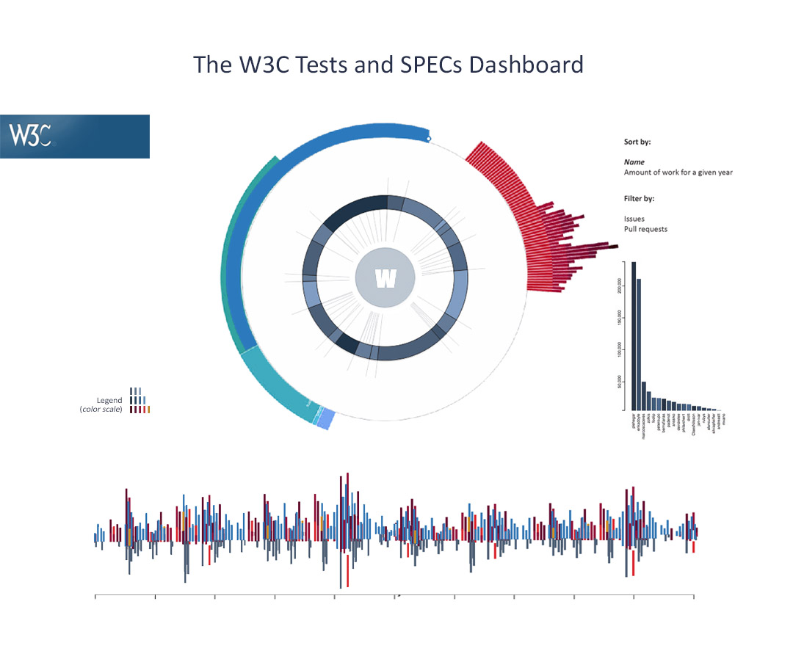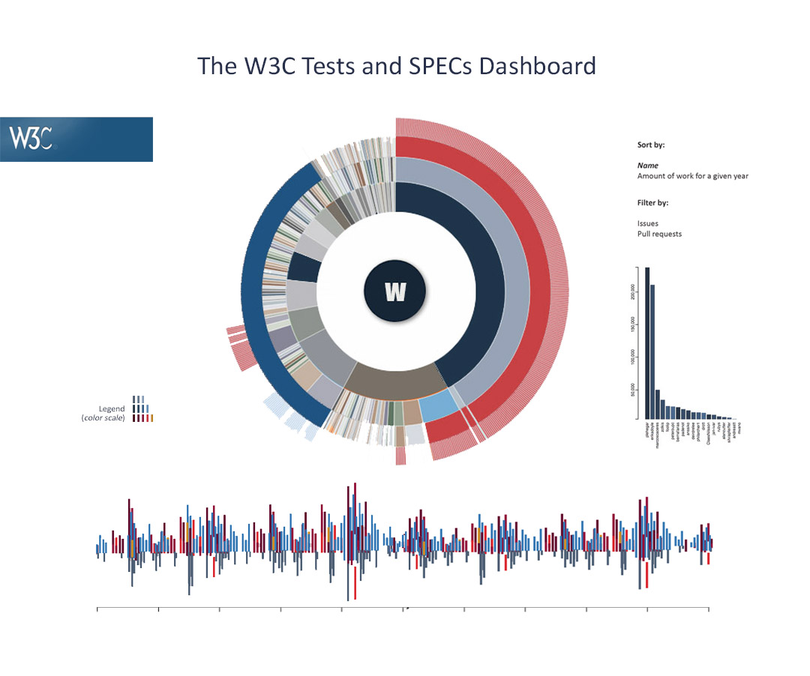



- Timeline

* Timeline needs to represent all easy issues, hard issues, pull requests and the number of lines merged via those pull requests by using different colors. First, we will present the total amount of issues, pull requests and lines merged (using the simple sunburst view). Second, when the user chooses to present specs per working group, the timeline will update accordingly. Also, timeline brushing will affect the number of elements shown on the sunburst. This part is still a work in progress.



- Authors

* The Authors list is a list of 20 highest contributors, organized in the same order as all other elements. First, the top 20 among all will be represented. The user's list will be updated accordingly (depending on spec, working group, period selected…).

- Proposed color scheme (hex values)

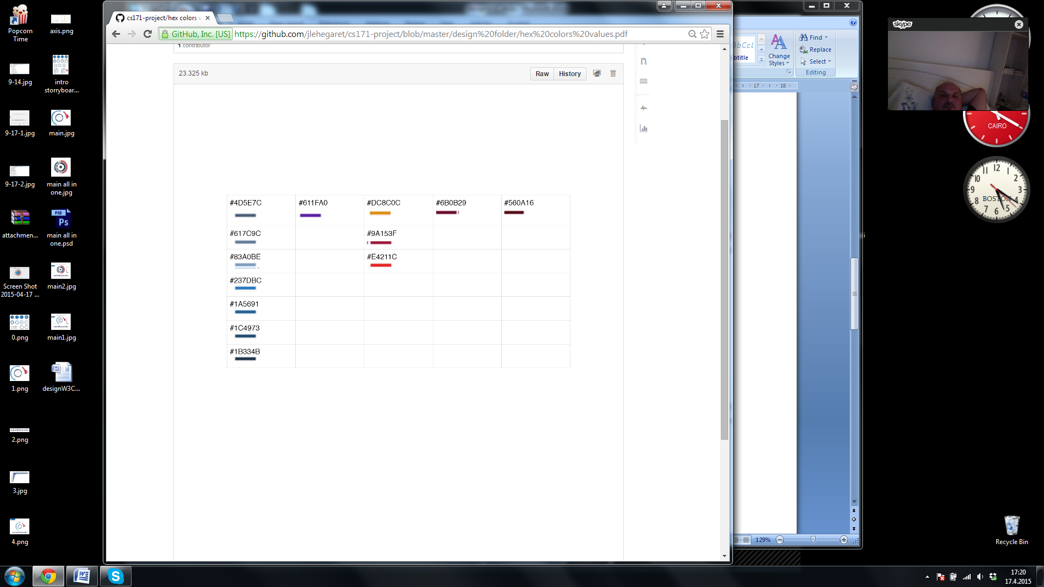

3. Interface

Finally, the idea of the main interface is presented in the next picture. By organizing components like this, we successfully establish a visual balance. By placing the W3C logo in the upper left corner and more of the components on the right, we followed the visual diagonal (upper left - lower right corner) that is natural to all users.

