1. **市场表现回顾**

1、股票市场表现回顾

上周股票市场，各大主要指数小幅收涨，沪深300周度收益为0.86%，较之于中小盘的1.67%和1.09%的涨幅较小。上周各大类风格因子涨跌参半，其中账面市值比、盈利率和成长因子录得显著正收益，剩余因子中流动性因子和动量因子的跌幅较大。上周沪深两市日均成交额9616亿元，较前一周下降4.85%。波动率方面，主流宽基指数截面波动率分化，沪深300上周截面波动率分别下降62BP，中证500、中证1000指数上周截面波动率分别提升67、101BP。

**图表1****：股票市场表现**

|  |  |  |
| --- | --- | --- |
| **主要指数** | **周度涨跌** | **今年以来涨跌** |
| **沪深300** | 0.86% | 5.35% |
| **中证500** | 1.67% | -0.64% |
| **中证1000** | 1.09% | -6.04% |
| **上证综指** | 0.92% | 3.61% |
| **深圳成指** | 1.16% | -3.06% |
| **创业板指** | 1.22% | -0.84% |

资料来源：Wind，数据截至2024.04.03

|  |  |
| --- | --- |
| 图表2：全市场股票风格因子收益（上周） | 图表3：全市场股票风格因子收益（今年以来） |
|  |  |
| 资料来源：Ricequant，数据截至2024.04.03 | 资料来源：Ricequant，数据截至2024.04.03 |

图表4：市场交投活跃度

资料来源：Wind，数据截至2024.04.03

图表5：主流宽基指数截面波动率

资料来源：Wind，数据截至2024.04.03

2、商品市场表现回顾

上周商品市场小幅收涨，南华综合指数-2.89%，分板块来看，农产品板块、能化板块、贵金属板块、有色金属板块和黑色板块上周收益分别为-0.36%、-1.65%、-6.39%、-3.48%和-3.31%。风格因子方面，上周因子多数收账，横截面动量因子、价值因子和偏度因子的涨幅较显著，其余因子中流动性因子等等跌幅显著，重点关注拐点引起的行情趋势。

**图表****6：商品市场表现**

|  |  |  |
| --- | --- | --- |
| **主要指数** | **周度涨跌** | **今年以来涨跌** |
| **南华综合指数** | 1.47% | 0.82% |
| **南华农产品指数** | 1.08% | 3.64% |
| **南华能化指数** | 1.04% | 1.26% |
| **南华贵金属指数** | 3.13% | 11.92% |
| **南华有色指数** | 1.52% | 4.21% |
| **南华黑色指数** | 0.28% | -17.95% |

资料来源：Wind，数据截至2024.04.03

|  |  |  |  |
| --- | --- | --- | --- |
| 图表7：商品市场风格因子收益（上周） | 图表8：商品市场风格因子收益（今年以来） | | |
|  | |  |
| 资料来源：Ricequant，数据截至2024.04.03 | 资料来源：Ricequant，数据截至2024.04.03 | | |

**图表9：商品指数波动率**

资料来源：Wind，数据截至2024.04.03

1. **私募策略表现回顾**

1、私募策略指数表现

上周私募策略指数多数上涨，股票量化和转债多头策略领涨，其中1000指增和500指增涨超1.4%，单周超额分别为0.39%、-0.01%；量化CTA略强于主观CTA，市场中性策略表现垫底，周度跌超0.04%。

**图表10：私募策略指数周涨跌**



数据截至2024.04.03

**图表11：近三年私募策略指数表现**



数据截至2024.04.03

2、重点跟踪产品表现

**图表12：500指增产品表现**

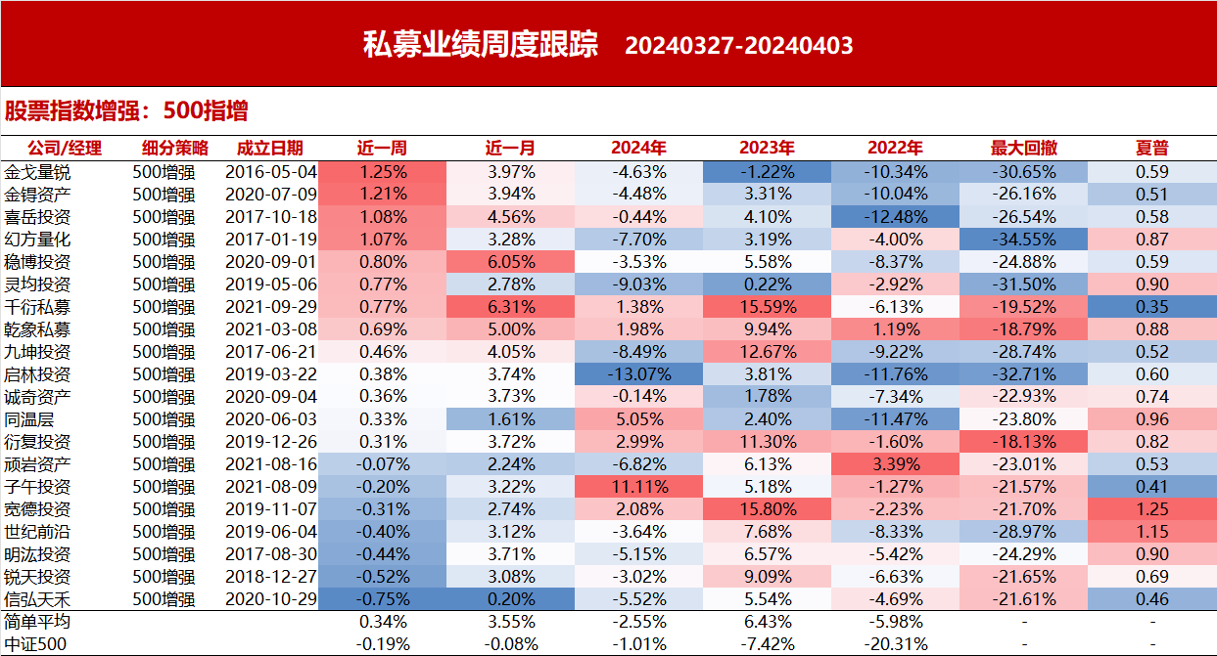

|  |  |  |  |  |  |  |  |  |
| --- | --- | --- | --- | --- | --- | --- | --- | --- |
| **管理人** | **上周超额收益** | **本月超额收益** | **上月超额收益** | **近半年超额收益** | **近一年超额收益** | **近三年超额收益** | **今年以来超额收益** | **去年超额收益** |
| **5%分位** | -0.64% | -0.64% | -12.08% | -5.16% | -1.23% | 12.61% | -9.04% | 4.07% |
| **25%分位** | -0.35% | -0.35% | -8.14% | -1.06% | 5.03% | 26.80% | -4.15% | 8.83% |
| **中位数** | -0.01% | -0.01% | -4.82% | 1.71% | 9.36% | 36.66% | -2.09% | 12.37% |
| **75%分位** | 0.32% | 0.32% | -2.05% | 4.59% | 12.82% | 47.59% | 1.13% | 17.12% |
| **95%分位** | 0.71% | 0.71% | 1.53% | 11.33% | 22.44% | 69.47% | 5.99% | 23.86% |

**图表13：1000指增产品表现**

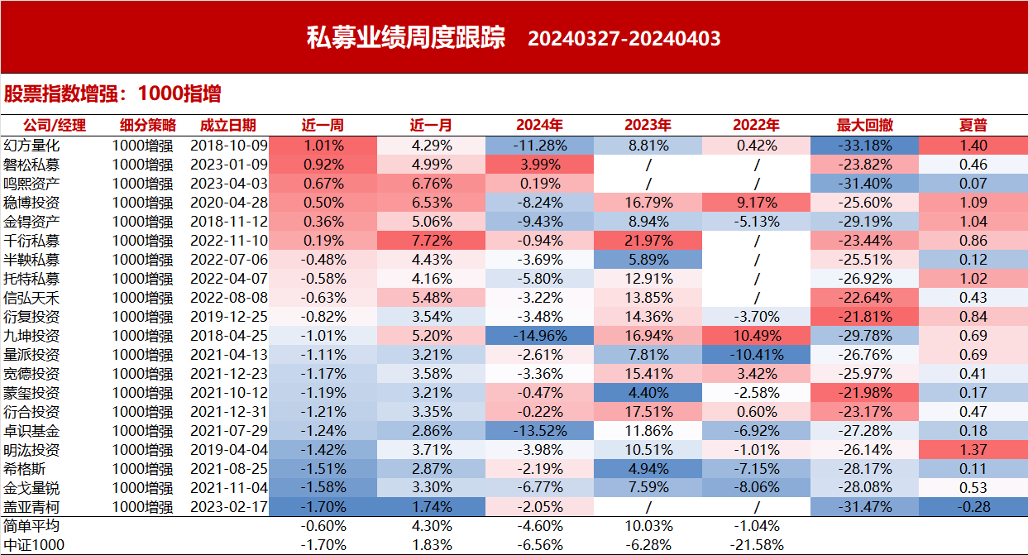

|  |  |  |  |  |  |  |  |  |
| --- | --- | --- | --- | --- | --- | --- | --- | --- |
| **管理人** | **上周超额收益** | **本月超额收益** | **上月超额收益** | **近半年超额收益** | **近一年超额收益** | **近三年超额收益** | **今年以来超额收益** | **去年超额收益** |
| **5%分位** | -0.44% | -0.44% | -13.05% | -5.19% | -1.24% | 18.62% | -8.84% | 5.06% |
| **25%分位** | 0.10% | 0.10% | -6.08% | 2.26% | 11.26% | 22.78% | -2.77% | 13.17% |
| **中位数** | 0.38% | 0.38% | -2.76% | 6.71% | 16.00% | 38.32% | 1.72% | 15.81% |
| **75%分位** | 0.74% | 0.74% | -0.60% | 9.72% | 21.64% | 53.96% | 4.49% | 20.85% |
| **95%分位** | 1.20% | 1.20% | 3.10% | 15.09% | 30.72% | 101.65% | 9.51% | 27.34% |

**图表14：股票中性产品表现**

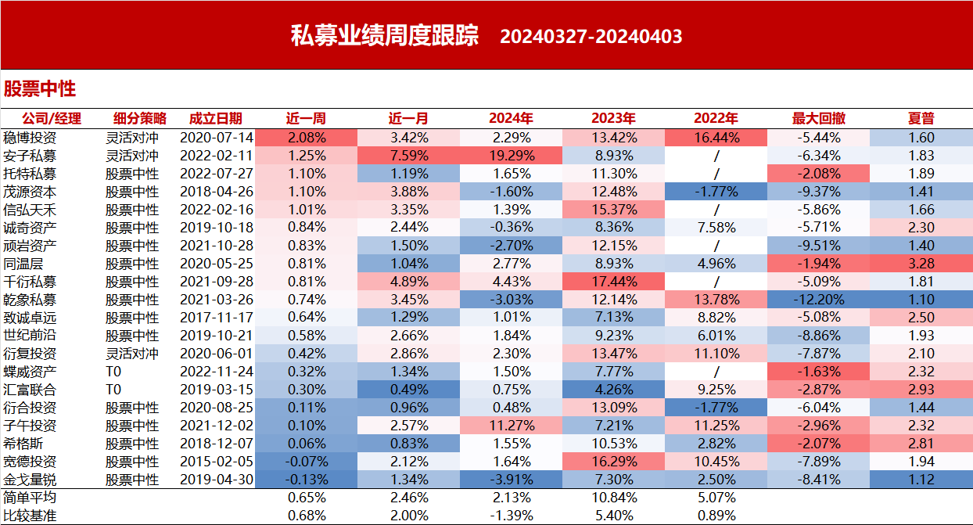

|  |  |  |  |  |  |  |  |  |
| --- | --- | --- | --- | --- | --- | --- | --- | --- |
| **管理人** | **上周收益** | **本月收益** | **上月收益** | **近半年收益** | **近一年收益** | **近三年收益** | **今年以来收益** | **去年收益** |
| **5%分位** | -0.60% | -0.60% | -0.05% | -5.20% | -1.87% | -1.56% | -8.01% | 2.21% |
| **25%分位** | -0.34% | -0.34% | 1.00% | 1.05% | 3.51% | 18.51% | -2.19% | 7.27% |
| **中位数** | -0.01% | -0.01% | 1.86% | 2.99% | 7.78% | 24.15% | 0.72% | 10.12% |
| **75%分位** | 0.20% | 0.20% | 2.61% | 5.86% | 11.68% | 31.21% | 2.96% | 12.65% |
| **95%分位** | 0.63% | 0.63% | 4.39% | 10.85% | 16.43% | 41.10% | 7.98% | 16.27% |

**图表15：CTA产品表现**

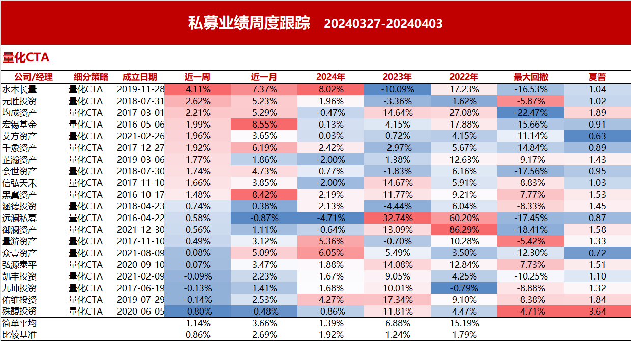

|  |  |  |  |  |  |  |  |  |
| --- | --- | --- | --- | --- | --- | --- | --- | --- |
| **管理人** | **上周收益** | **本月收益** | **上月收益** | **近半年收益** | **近一年收益** | **近三年收益** | **今年以来收益** | **去年收益** |
| **5%分位** | -0.86% | -0.86% | -0.95% | -10.50% | -5.72% | -3.65% | -6.85% | -10.09% |
| **25%分位** | -0.10% | -0.10% | 0.86% | -2.50% | -1.57% | 8.12% | -1.94% | -4.53% |
| **中位数** | 0.42% | 0.42% | 2.39% | -0.61% | 2.25% | 14.36% | 0.81% | 0.53% |
| **75%分位** | 0.80% | 0.80% | 5.15% | 3.29% | 8.33% | 25.17% | 3.37% | 8.54% |
| **95%分位** | 1.65% | 1.65% | 9.54% | 13.31% | 27.55% | 54.88% | 11.49% | 17.60% |

**图表16：套利策略产品表现**

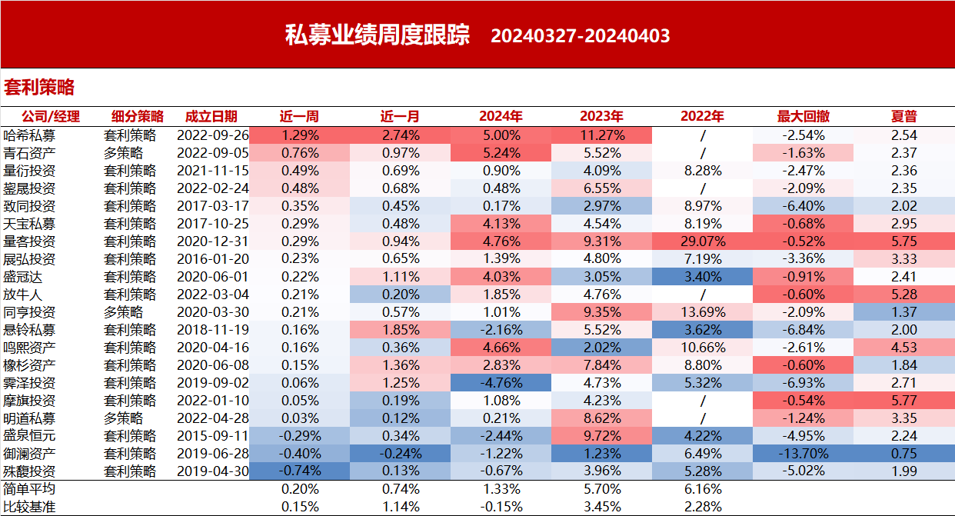

|  |  |  |  |  |  |  |  |  |
| --- | --- | --- | --- | --- | --- | --- | --- | --- |
| **股指/ETF套利管理人** | **上周收益** | **本月收益** | **上月收益** | **近半年收益** | **近一年收益** | **近三年收益** | **今年以来收益** | **去年收益** |
| **5%分位** | -0.42% | -0.42% | -0.10% | -3.52% | -4.37% | 8.86% | -4.81% | -0.03% |
| **25%分位** | -0.01% | -0.01% | 0.37% | 1.34% | 2.30% | 12.83% | 0.31% | 2.55% |
| **中位数** | 0.06% | 0.06% | 0.74% | 2.99% | 4.46% | 16.79% | 1.59% | 3.46% |
| **75%分位** | 0.20% | 0.20% | 0.99% | 5.55% | 7.28% | 20.33% | 4.24% | 4.71% |
| **95%分位** | 0.32% | 0.32% | 2.73% | 10.51% | 12.54% | 23.44% | 8.71% | 8.95% |
| **CTA套利管理人** | **上周收益** | **本月收益** | **上月收益** | **近半年收益** | **近一年收益** | **近三年收益** | **今年以来收益** | **去年收益** |
| **5%分位** | -3.65% | -3.65% | -9.10% | -15.11% | -14.80% | -4.00% | -8.84% | -18.38% |
| **25%分位** | -0.24% | -0.24% | -0.66% | -2.59% | 0.38% | 27.20% | -1.27% | 2.37% |
| **中位数** | 0.17% | 0.17% | 1.03% | -0.33% | 5.01% | 37.65% | 0.72% | 6.96% |
| **75%分位** | 1.31% | 1.31% | 3.89% | 3.57% | 11.11% | 52.58% | 4.25% | 13.63% |
| **95%分位** | 2.94% | 2.94% | 7.38% | 10.25% | 23.11% | 94.74% | 8.23% | 38.70% |

**图表17：期权策略产品表现**

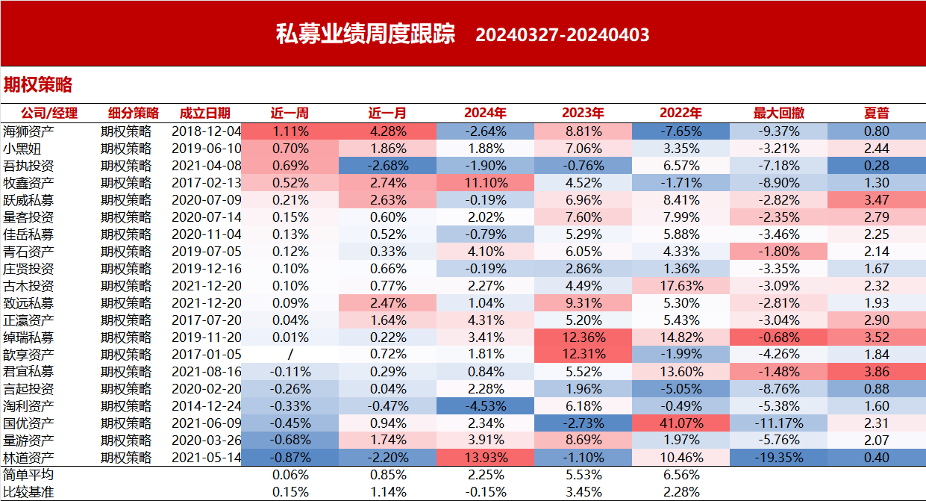

|  |  |  |  |  |  |  |  |  |
| --- | --- | --- | --- | --- | --- | --- | --- | --- |
| **管理人** | **上周收益** | **本月收益** | **上月收益** | **近半年收益** | **近一年收益** | **近三年收益** | **今年以来收益** | **去年收益** |
| **5%分位** | -0.38% | -0.38% | 0.04% | -0.68% | 0.80% | 13.46% | -3.42% | -1.41% |
| **25%分位** | 0.02% | 0.02% | 0.88% | 1.68% | 5.29% | 18.12% | 0.80% | 5.20% |
| **中位数** | 0.21% | 0.21% | 1.58% | 4.21% | 7.07% | 19.48% | 1.88% | 6.05% |
| **75%分位** | 0.33% | 0.33% | 2.33% | 6.40% | 8.04% | 23.60% | 3.66% | 8.49% |
| **95%分位** | 1.06% | 1.06% | 3.29% | 8.60% | 9.45% | 46.35% | 7.96% | 11.76% |

免责声明

**本文件仅用于初始信息交流之目的，并不构成广告或销售要约，或买入任何证券、基金或其它投资工具的建议。**

**本文件内的例子仅供参考，概不保证任何特定投资目标将会达成或任何期望达致该等目标的投资策略将会成功。**

**本文件内的产品过去的表现不一定是未来业绩的指标，潜在投资者不应仅仅依赖本文件的内容作出投资决定。**