# A-Cover sheet :

***Faculty of computers and AI Helwan U***

Selected Topics from CS2:

**Team no : 28**

|  |  |
| --- | --- |
| **Amira wael** | **202000163** |
| **Thomas fathy** | **202000232** |
| **Joseph Essa** | **202000240** |
| **John halim** | **202000242** |
| **Marina ezzat** | **202000699** |
| **Youssef salah** | **202001091** |
|  |  |

# **B-Paper Details:**

A:

Name : **GAN-based synthetic brain PET image generation**

Authors names : • [Jyoti Islam](https://link.springer.com/article/10.1186/s40708-020-00104-2#auth-Jyoti-Islam) & • [Yanqing Zhang](https://link.springer.com/article/10.1186/s40708-020-00104-2#auth-Yanqing-Zhang)

Publisher : Springer Link, [Published: 30 March 2020](https://link.springer.com/article/10.1186/s40708-020-00104-2#article-info)

**B: (Data Set details)**

* Name : ADNI1
* Implemented Algorithms :

**Generator:**

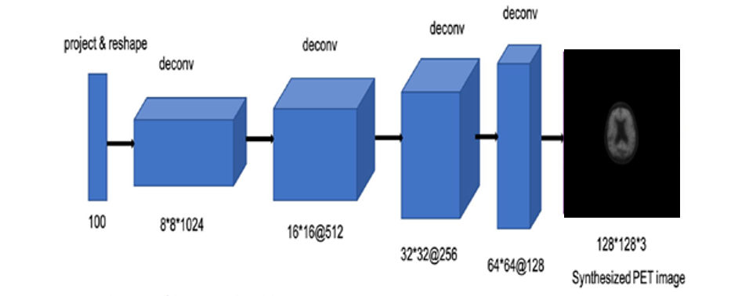

**Discriminator : صورة تحتوي على لقطة شاشة, رسم بياني, التصميم

تم إنشاء الوصف تلقائياً**

* Results
* 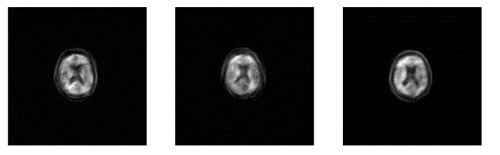

# **C-Description** document:

***A-General Information on dataset:***

## **-NAME :** AIBL

**-ABOUT DATA** :

- it is brain scanning for 160 patients each patient’s brain scanned into 148 layer (frame)

- dimension of images : (256, 256, 1)

***B-Implementation details:***

1. **Block diagram :**

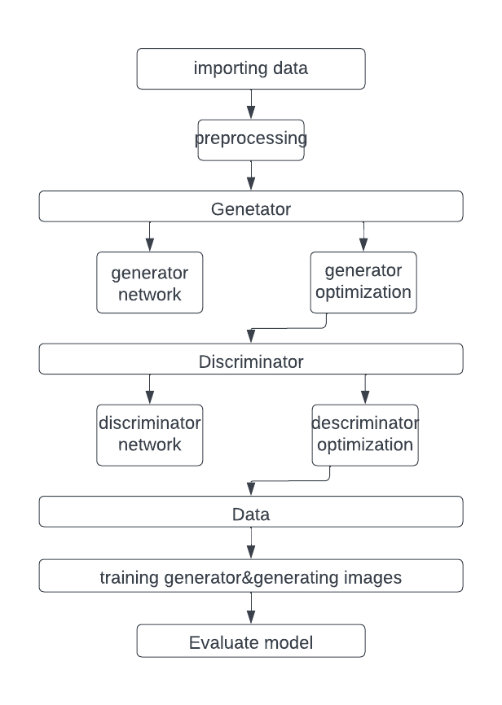

# **Data preprocessing :**

1. **Labeling real data with 1 and fake data with 0**
2. **Rescaling data into (-1, 1)**
3. **Hyper parameters :**

Generator optimizer

Discriminator optimizer

Learning rate

Batch size

Epochs

|  |  |  |  |  |  |  |
| --- | --- | --- | --- | --- | --- | --- |
| Hyper  parameter | Epochs | Batch Size | G_Optimiser | D_Optimiser | G_Learning  rate | D_Learning  rate |
| 1 | 100 | 10 | Adam | Adam | 0.0002 | 0.0001 |
| 2 | 50 | 20 | Adam | Adam | 0.0002 | 0.0001 |
| 3 | 150 | 20 | Adam | Adam | 0.0002 | 0.0001 |
| 4 | 120 | 15 | Adam | Adam | 0.002 | 0.001 |
| 5 | 200 | 10 | Adam | Adam | 0.002 | 0.001 |
| 6 | 200 | 10 | Adam | Adam | 0.0002 | 0.0001 |

OUTPUT :

{1}

PET Samples :

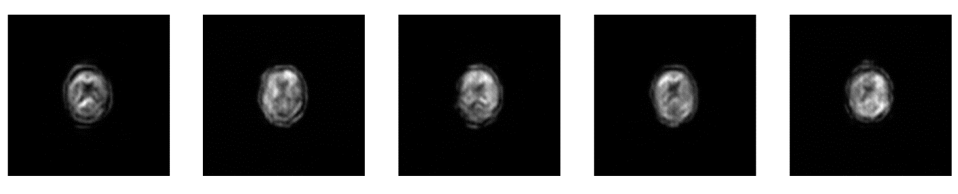

Loss :

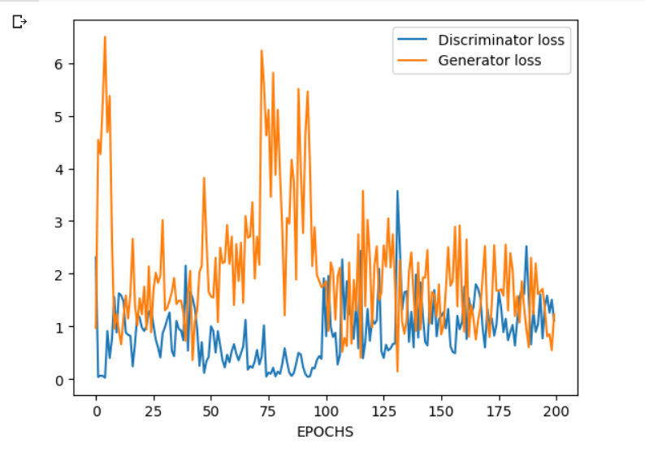

{2}

PET Samples :

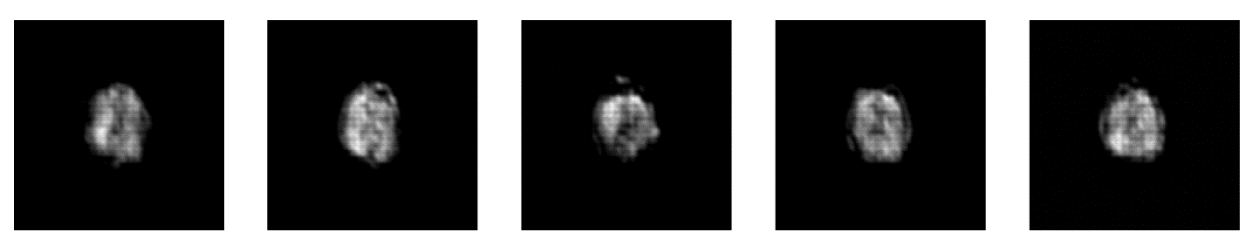

Loss :

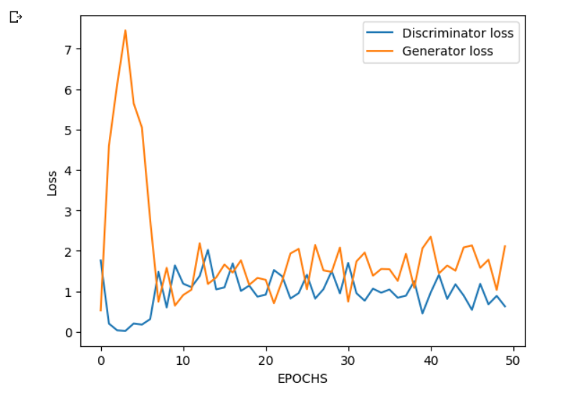

{3}

PET Samples :

صورة تحتوي على أسود وأبيض, أسود, أحادي اللون, فيلم التصوير بالأشعة السينية

تم إنشاء الوصف تلقائياً

Loss :

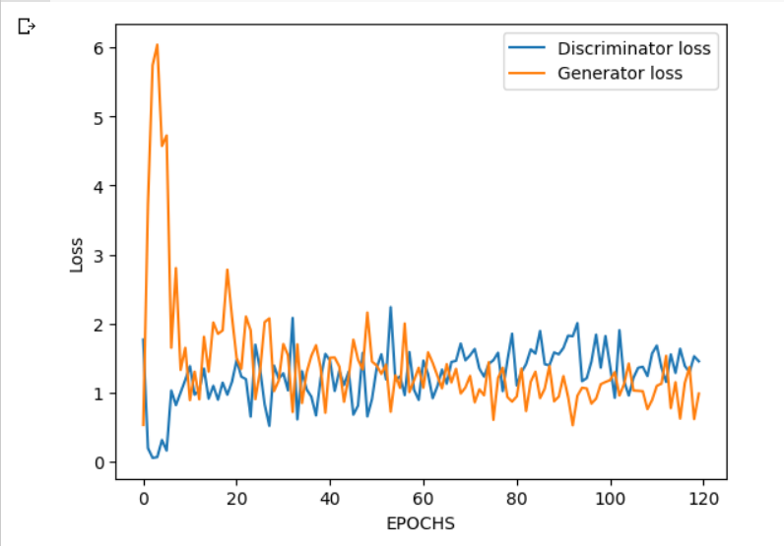

{4}

PET Samples :

صورة تحتوي على أسود, أسود وأبيض, لقطة شاشة, أحادي اللون

تم إنشاء الوصف تلقائياً

Loss :

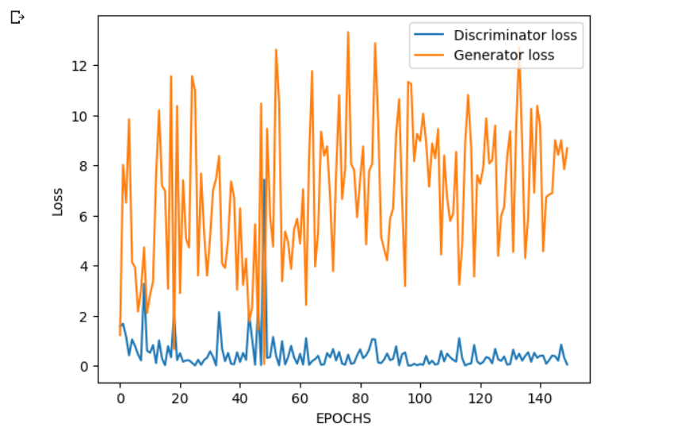

{5}

PET Samples :

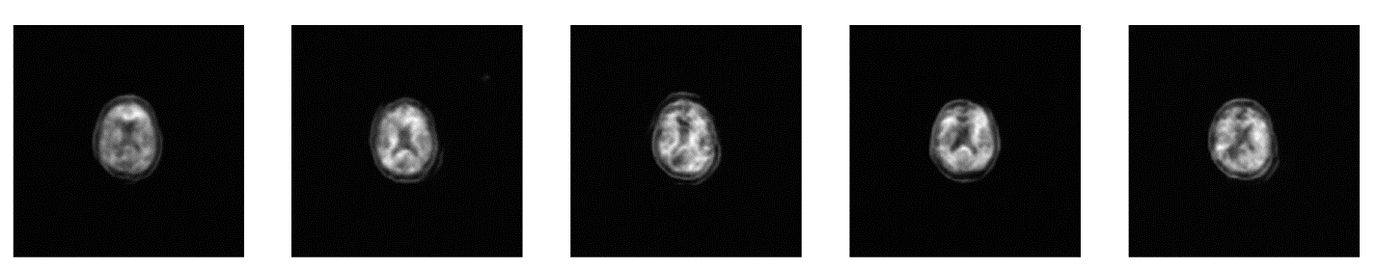

Loss :

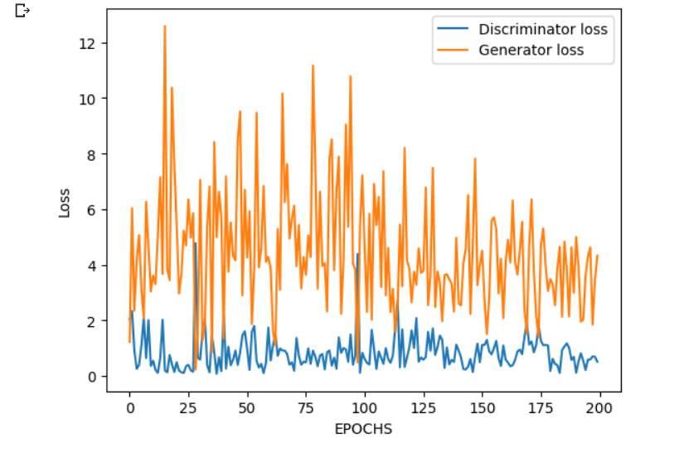

{6}

PET Samples :

Loss :

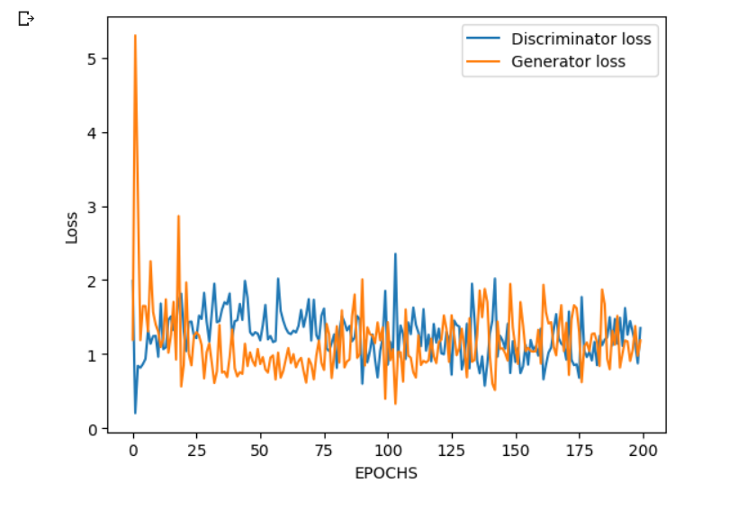

**C- Results details:**

**Generated images :**

**Model loss :**



**SSIM Check :**

