Cover sheet

***Faculty of computers and AI Helwan U***

Selected Topics from CS1:

**Team no : 14**

|  |  |
| --- | --- |
| **Amira wael** |  |
| **Thomas fathy** |  |
| **Joseph issa** |  |
| **John halim** |  |
| **Marina ezzat** |  |
| **Maer reda** |  |
| **Ramy** |  |

# **Description** document:

**2: SVM**

***A-General Information on dataset:***

## **-NAME : Traffic sign dataset**

**-CLASSES** : 62 classes and the outcome column

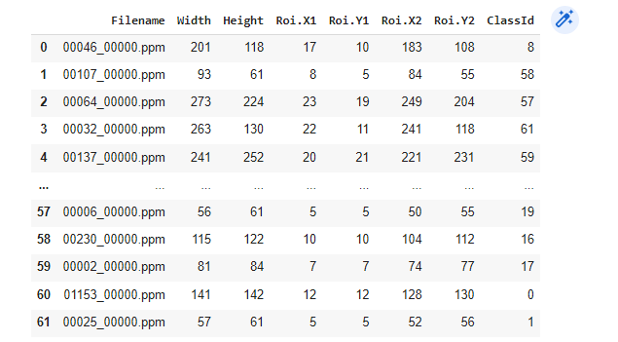

Total number of samples :2534

Their size :

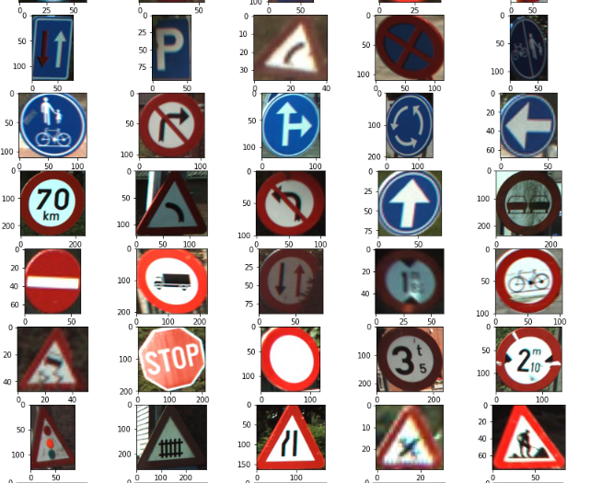

**-the number of samples used in training, validation and testing.**

NO of training samples : 90 %

NO of testig samples : 10%

***B-Implementation details:***

1. **Calling the training datasets**
2. **- read the CSV of the training**
3. **read the CSV of the testing**

# **Data preprocessing :**

1. **Return it to hog**
2. **Make the feature extraction**

* **Apply SVC model**

***C- Results details:***

**Accuracy :**



**Confusion matrix :**

