TRUCK LOADING SLIP SYSTEM
Technical Design Reference

ER Diagram, Data Flow Diagrams (Level 0 and 1),
Process Flowchart, and Use Case Diagram
Internal / developer reference - companion to the client-facing System Design Document
Version: 1.0 | Date: 25 June 2026

Purpose Of This Document
This is the internal technical companion to the client-facing System Design Document. It contains the standard software-engineering diagrams used to plan the Truck Loading Slip System: an Entity-Relationship (ER) Diagram, a Data Flow Diagram at Level 0 (Context) and Level 1, a process flowchart of the operator's journey through the application, and a Use Case Diagram.
These diagrams are intended for development and maintenance use - they assume familiarity with standard software design notation and are more technical in nature than the client-facing document.
RELATIONSHIP TO THE CLIENT DOCUMENT
Every diagram here describes the same system already agreed with the customer in the System Design Document. Nothing new is introduced - this document simply presents the same decisions in standard technical notation, for development and future maintenance reference.

1. Entity-Relationship (ER) Diagram
The ER Diagram shows the database tables that make up the system's data layer, and how they relate to one another. It reflects the schema agreed during planning: a central Slips table, a FieldConfig table driving customisable labels, seven lookup tables feeding dropdown suggestions, and a PrinterProfiles table.
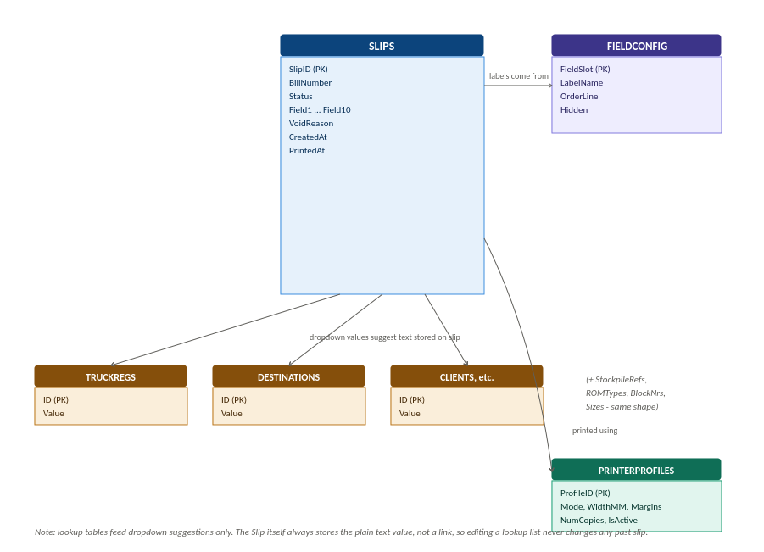

1.1 Key Design Notes
- Slips is the central table. SlipID is an auto-increment primary key; BillNumber is unique and protected from updates by a database trigger (see the System Design Document, Section 3).
- Field1 through Field10 are generic text columns. Their displayed labels, order, and visibility come from FieldConfig, not from the column names themselves - this is what allows the customer to relabel fields without a schema change.
- The seven lookup tables (TruckRegs, Destinations, Clients, StockpileRefs, ROMTypes, BlockNrs, Sizes) are intentionally not linked to Slips by foreign key. They only populate dropdown suggestions. The relationship is logical, not referential: a slip stores the plain text value at the time it was created, so editing or deleting a lookup entry later never alters a historical slip.
- PrinterProfiles is independent of any individual slip; a slip does not store which profile was used, since the requirement was to support reprinting under whatever the current active profile is, not to preserve historical print settings per slip.

2. Data Flow Diagrams
Data Flow Diagrams (DFDs) show how data moves through the system, rather than how the data is structured (that is the ER Diagram's job) or how the user navigates screens (that is the flowchart's job). Two levels are provided, per standard convention: Level 0 (Context) gives the simplest possible view, and Level 1 decomposes the single process into its main internal processes.

2.1 DFD Level 0 - Context Diagram
The Context Diagram treats the entire application as a single process (numbered 0) and shows only its two external entities: the Operator and the Printer. No internal detail is shown at this level - this is the standard starting point of DFD analysis.
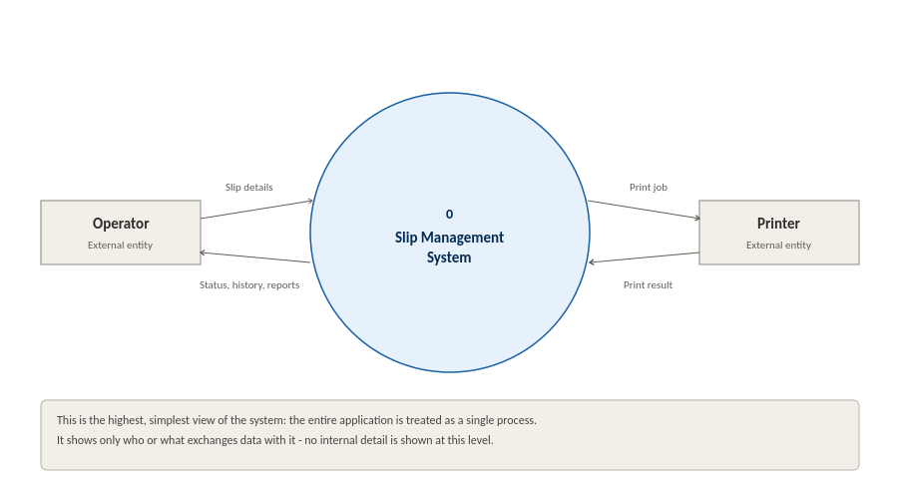

2.2 DFD Level 1
Level 1 decomposes process 0 into its five main internal processes, and introduces the data stores each process reads from or writes to. This corresponds directly to the screens and database tables already defined in the System Design Document and the ER Diagram above.
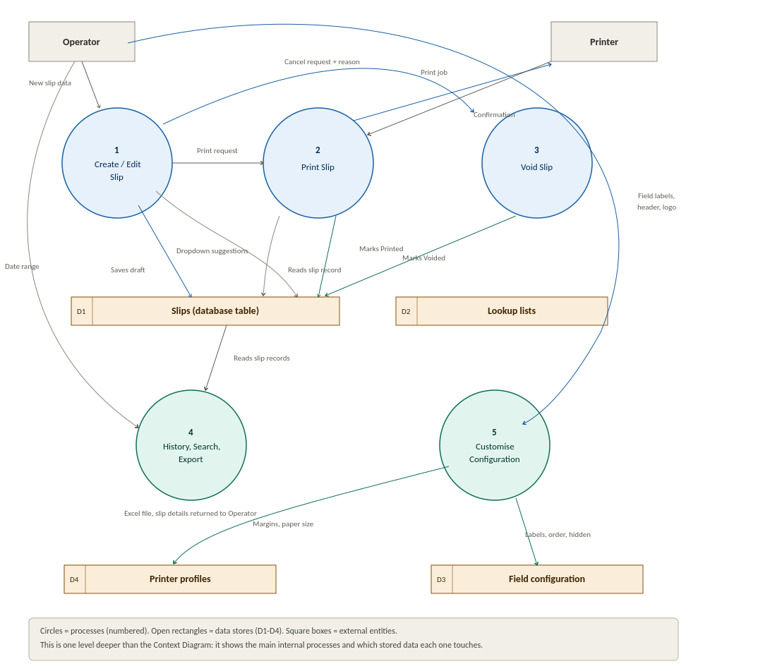

2.3 Process Notes
- Process 1 (Create/Edit Slip) is the only process that writes new rows to D1 (Slips). It also reads D2 (Lookup lists) to populate dropdown suggestions, and can write new values back to D2 when the operator types something not already in a list.
- Process 2 (Print Slip) reads the relevant slip from D1, sends the print job to the Printer, and on confirmation writes the Status change (to Printed) back to D1.
- Process 3 (Void Slip) is reachable from Process 1 for a slip that has not yet been printed, and from Process 4 for one that has. In both cases it writes the Voided status, the reason text and the time of the void back to D1, and in neither case does it remove the row.
- Process 4 (History, Search, Export) reads D1 for display and for the Excel export, and writes back in two controlled cases only: a field correction made on the Edit tab, and a void raised against a printed slip. SlipID and BillNumber are never among the columns it can write, and it never deletes a row.
- Process 5 (Customise Configuration) is the only process that writes to D3 (Field configuration) or D4 (Printer profiles). It never touches D1 directly.

3. Operator Process Flowchart
This flowchart traces the operator's actual journey through the application screens, from the Main Page through to either a saved draft, a voided slip, or a completed print. It formalises the original workflow sketch provided during planning, with explicit decision points for each branch the operator can take.
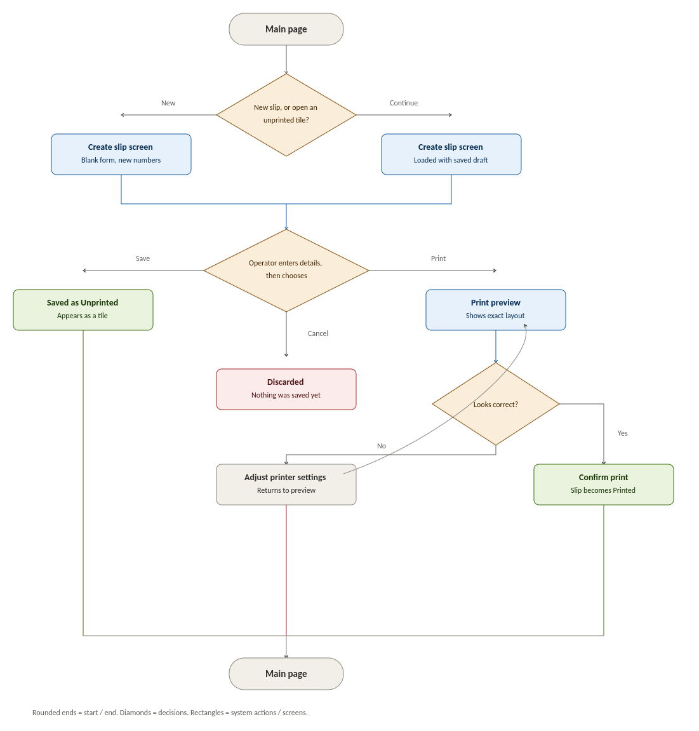

3.1 Flow Notes
- The two entry routes into the Create Slip screen (New, or Continue an existing unprinted tile) converge into the same screen and the same set of options - the only difference is whether the form starts blank or pre-filled.
- Save and Cancel are only available before printing. Once the operator moves to Print Preview, the only way back to an editable state is to adjust printer settings and return to the same preview - the underlying slip data is not re-opened for editing from that point in this flow.
- The Adjust Printer Settings step loops back to Print Preview rather than forward, since the operator needs to re-check the layout after any change before printing.
- All three terminal outcomes (Saved as Unprinted, Discarded, Confirm Print) return the operator to the Main Page, consistent with the requirement that the Main Page is always the home/starting screen.

4. Use Case Diagram
The Use Case Diagram lists the discrete actions available to the Operator (the system's only actor) and shows where the Printer is involved as a secondary actor. This view is useful for confirming functional completeness - every capability described in the System Design Document should appear here as exactly one use case.
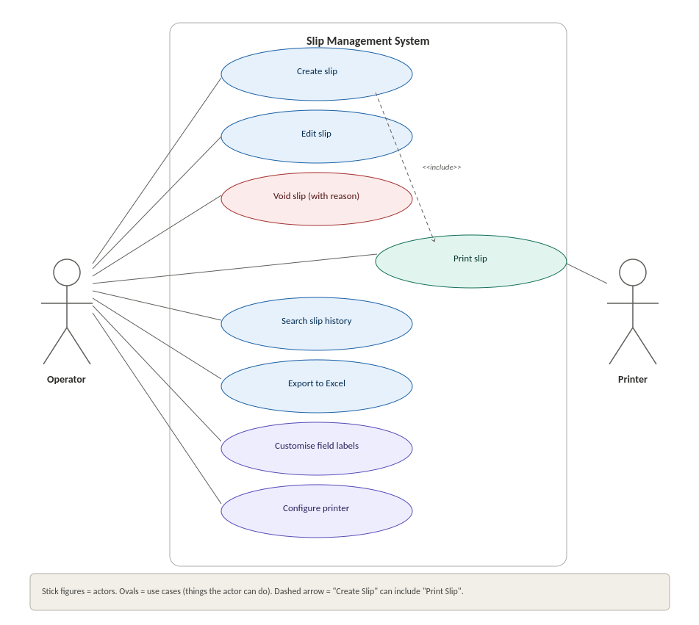

4.1 Use Case Notes
- Create Slip includes Print Slip as an optional extension (shown with the dashed <<include>> relationship) - printing is reachable directly from the slip creation flow, not only from History.
- Void Slip is shown as a distinct use case from Edit Slip, since voiding requires a mandatory reason and changes the slip's status, whereas editing changes only its contents (excluding the two locked fields). Both are available on printed slips as well as on drafts, and neither can delete a slip.
- Configure Printer and Customise Field Labels are grouped visually (same colour) as configuration-type use cases, distinct from the day-to-day data entry and reporting use cases.
- The Printer actor only participates in Print Slip - it has no association with any other use case, reflecting that it is a passive output device with no role in data entry, history, or configuration.

