**Business problem**

Productivity is key to the development of local businesses and the wider economy. Over the past decade, productivity has slowed down globally with the UK lagging behind some other developed economies.

*“****Productivity****is commonly defined as a ratio between the output volume and the volume of inputs. In other words, it measures how efficiently production inputs, such as labour and capital, are being used in an economy to produce a given level of output.” - OECD*

In this project you’ll be looking at the relationship between productivity and investment. You’ll be comparing a range of countries to understand what factors influence both investment levels and productivity. What can we learn from high productivity nations?

**Our main business question is generally: How can we improve productivity within Scotland and the UK overall?**

Some targeted questions we are interested in for this specific project:

* Does government spending on factors such as mental health, education, and research and development affect productivity in the UK?
* Is there a relationship between government investment and productivity?
* Can you predict productivity based on investment?

**Challenges**

This data was donated by Deloitte, which comes from the Equifax Ignite Direct data platform which hosts over 50 open data sources.

As this is real data, there are some challenges to bear in mind, and the data will need cleaned and narrowed down appropriately. You will be provided with the full open source dataset list in excel format. On the following page are a list of some of the potential estimates & factors for productivity that could be explored. Your task will be to figure out how to answer the questions above using the wealth of data provided.

You should consider the following as part of the challenges:

* **Data & Challenge Insight** – the depth of your investigation into the data and the maturity of your understanding of how productivity can be improved.
* **Insight Quality** – the quality and level of detail expressed in your data insight including visualisations.
* **Concept Feasibility** – the viability of your solution/concept in the wider context of the market such as practicality, cost & impact.

**Audience**

For this project, please consider the audience to be a general audience who aren’t familiar with the project.

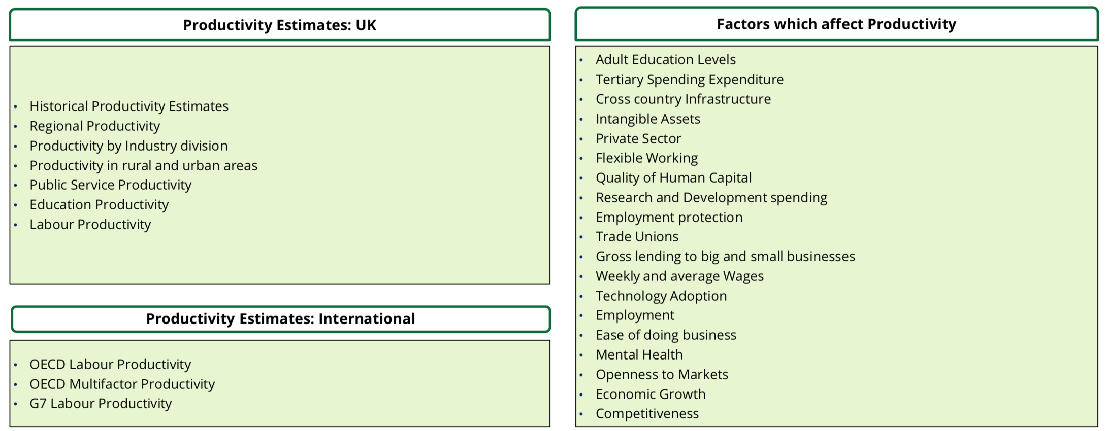

Useful links:

<https://www.oecd.org/sdd/productivity-stats/40526851.pdf>