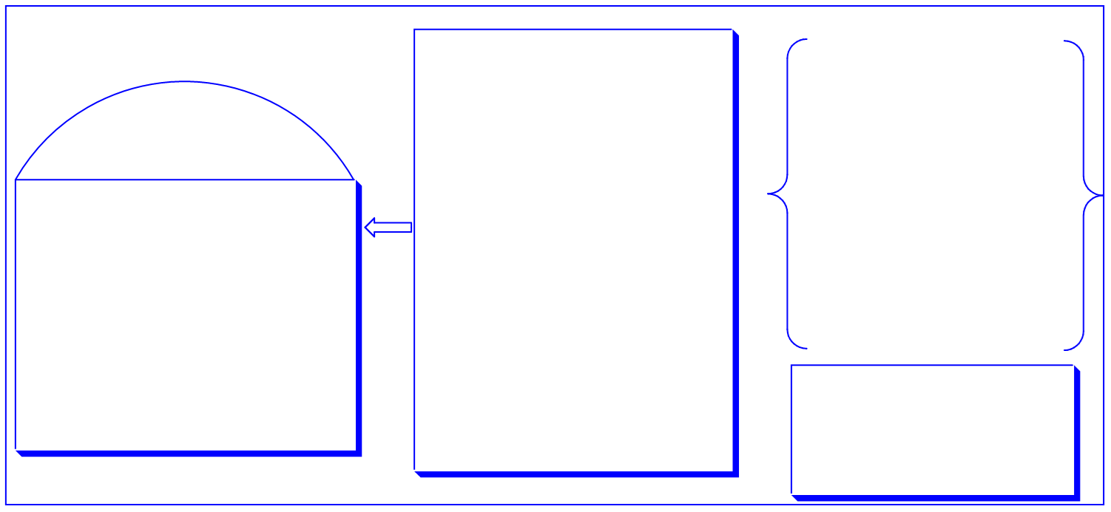

Conclusion:

Public knowledge of electric cars would need to be increased if it is to be used most efficiently in the future.

* Go over survey results and public opinion regarding topic
* List ways to educate public
* List how education improves situation

Earth.org “The environmental impact…”

CBS Los Angeles “Experts say significant…”

MDPI “The comparative assessment…”

Valerdi “Unintended Consequences…”

Choudhury “Are electric cars ‘green’...”

Lane “What will happen…”

Bio Friendly Planet “electric Vehicles and…”

The environmental impact that the manufacturing of electric cars has is a major concern and needs to be fixed.

* Go over issue to give context to sub argument
* Go over potential solutions to sub-argument
* Go over details and arguments that have been made regarding sub-argument

Power grids across the world are not prepared for the use of electric cars of the predicted magnitude.

* List details for power grids capabilities
* List potential improvements to power grid
* List problems between power grid and electric vehicles

Display and briefly analyze all given sub-arguments, restate thesis, Engage audience final time.

Q1: Do you possess any previous knowledge on the subject of electric cars?

Q2: Do you believe that electric cars are a good option?

Q3: Did you know that Electric Cars create no tailpipe emissions over its lifetime?

Q4: Are you aware that the cost of making a battery for an electric car requires many resources that can be difficult to obtain?

Q5: Did you know electric cars require no repairs or maintenance to be operational?

As the debate surrounding electric cars continues to grow, its widespread use can either be the best or worst decision for the future of transportation.

Hook:

Subarguments & Evidence:

The widespread use of electric vehicles can only be considered if the technology undergoes several improvements in the future.

Electric Vehicle, Battery, Power Grid, Concerns for electric vehicle technology

Field Research:

Library Research:

OUTLINE

Argument:

Specificity

(Key Words)