
9th Senate

Database
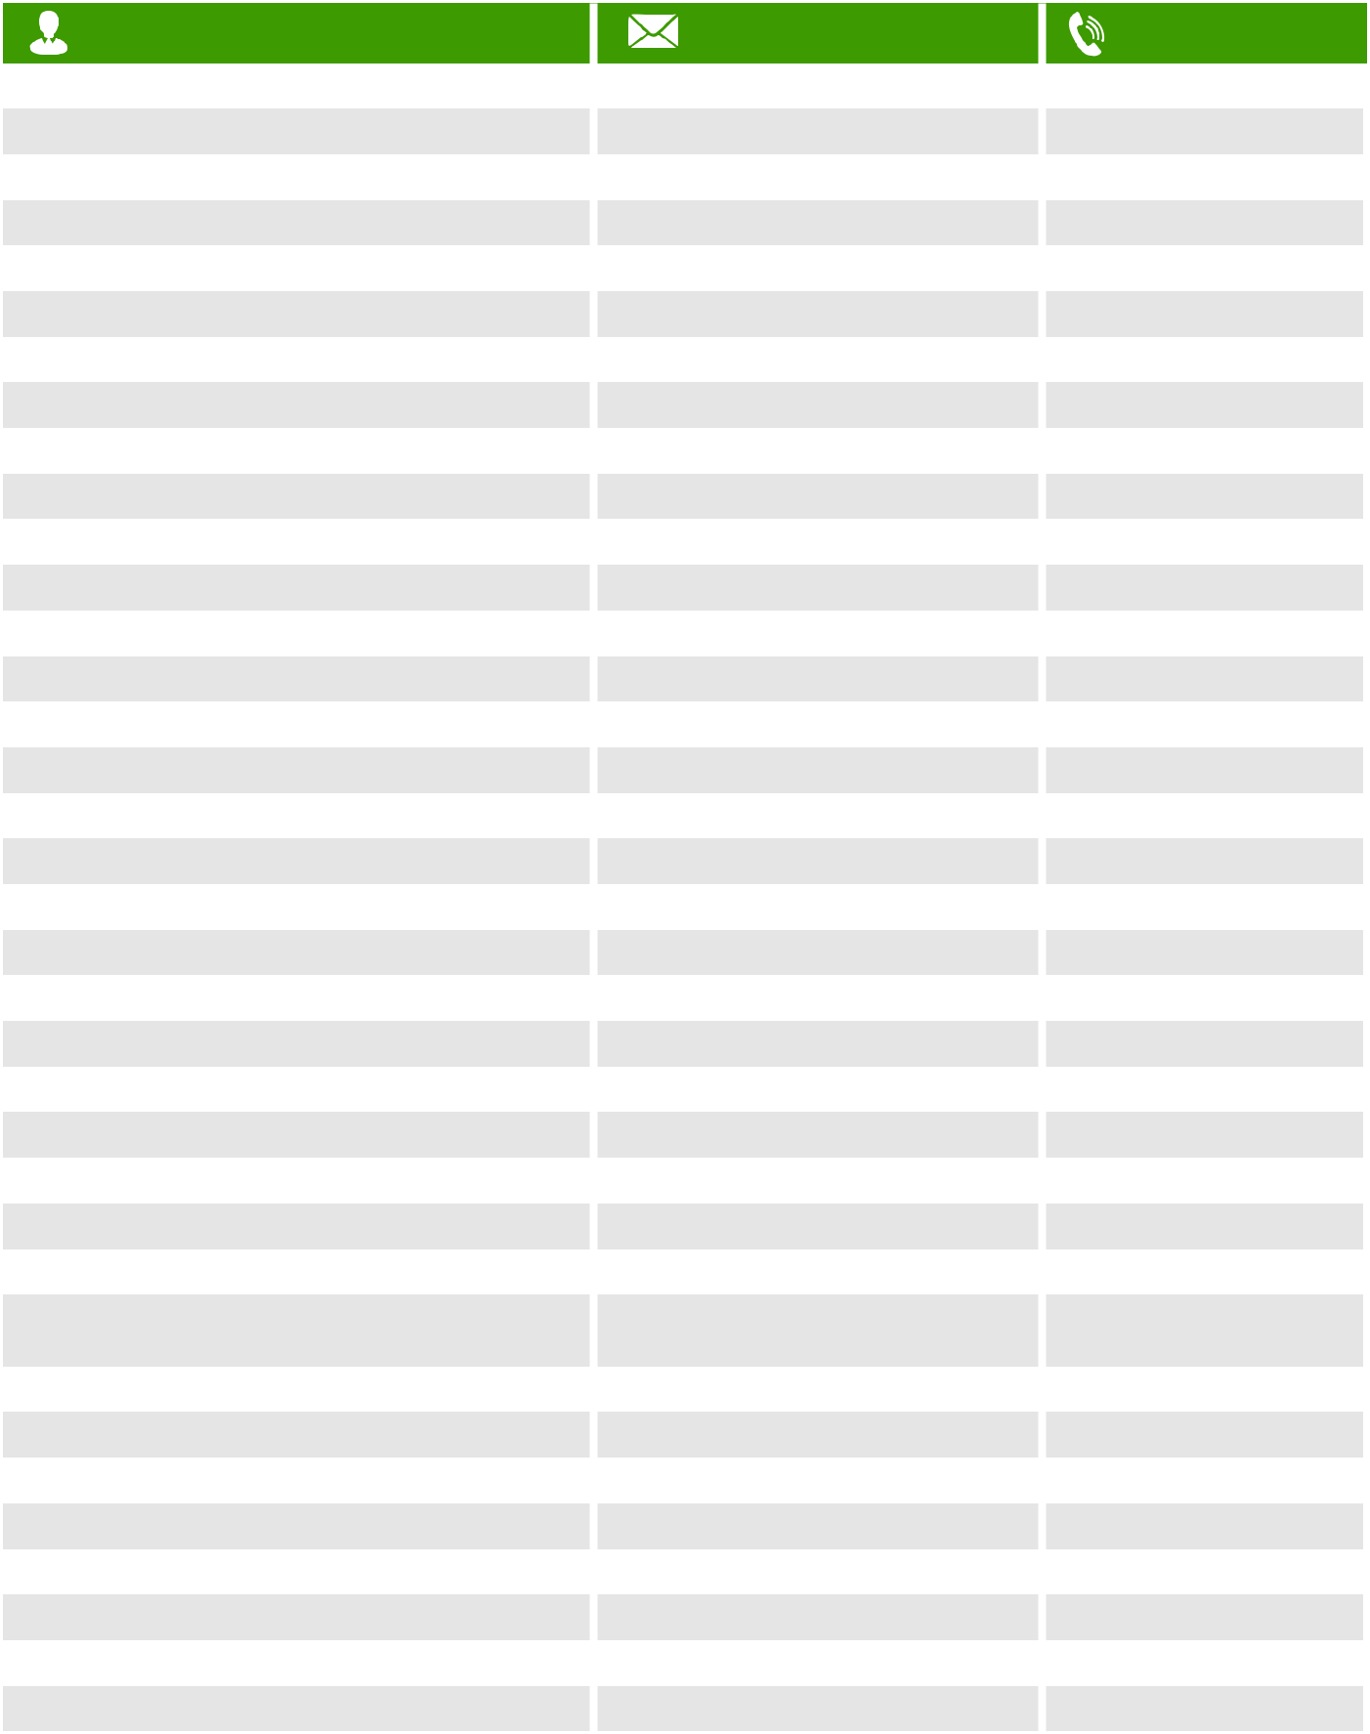

NAME | EMAIL ADDRESS | PHONE NO
Kalu Orji Uzor - Chief Whip | okalu@orjikalu.com | 08034000001
Orji Theodore Ahamefule | senatortaorji@gmail.com | 07082800000
Enyinnaya H. Abaribe - Minority Leader | enyiabaribe@yahoo.com | 08033129452
Ishaku Elisha Cliff | faradugun@gmail.com | 08066285112
Yaroe Binos Dauda | bdyaroe@gmail.com | 08034050460
Dahiru Aishatu Ahmed
Akpan Bassey Albert | akpanalbert@hotmail.com | 08055555188
Ekpenyong Christopher Stephen | chrisekpesg@yahoo.com | 08027785234
Eyakenyi Akon Etim | konssie@yahoo.com | 08035054282
Oduah Stella Adaeze Princess | senatorstella@gmail.com | 08036007525
Uche Lilian Ekwunife | u.ekwunife@yahoo.com | 08037620002
Patrick Ifeanyi Ubah | capoilmd@yahoo.com | 09096655596
Lawal Yahaya Gumau | lawal.gumau@nass.gov.ng
Jika Dauda Halliru | jikahalliru@gmail.com | 08038666690
Bulkachuwa Adamu Muhammed | smnszif@yahoo.com
Degi Eremienyo Biobaraku Wangagra | bwdegi@yahoo.com | 08033104612
Diri Douye | douyediri@gmail.com | 08036668698
Ewhrudjakpo Lawrence O.
Gabriel Torwua Suswam | gabtorsuawam1@yahoo.com | 08188821440
Emmanuel Yisa Orker-Jev
Patrick Abba Moro | abahmoro@yahoo.com | 08068870606
Kyari Abubakar Shaib |  | 08022907124
Shettima Kashim | kashimshettima@gmail.com | 08034459047
Ndume Mohammed Ali | mohammed.ndume@nass.gov.ng | 08109480004
Oko Rose Okoji
Onor Sandy Ojang | irunandu@yahoo.com | 08030998460
Bassey Gershom Henry | gershombassey@gmail.com | 08034444555
Omo-Agege Ovie Augustine - | senator.ovieomoagege@gmail.com | 07033399937
Deputy Senate President | senator.ovieomoagege@gmail.com | 07033399937
Nwaoboshi Peter Onyeluka | pnwaoboshi@yahoo.com | 08037200999
Manager James Ebiowou | jamesmanager2013@gmail.com | 08143103829
Egwu Samuel Ominiyi | drsamominyiegwu@gmail.com | 08039665848
Ogba Joseph Obinna | onwaigboasa@yahoo.com | 08037791346
Micheal Ama Nnachi | michaelamannachi@gmail.com | 08034528595
Ordia Akhimienmona Clifford | engineercliffordordia@gmail.com | 08038403877
Alimikhena Francis Asekhame | falimikhena@yahoo.com | 08155555884
Urhoghide Matthew Aisagbonriodion | matthewurhoghide@yahoo.com | 08033855557

9th Senate
Database
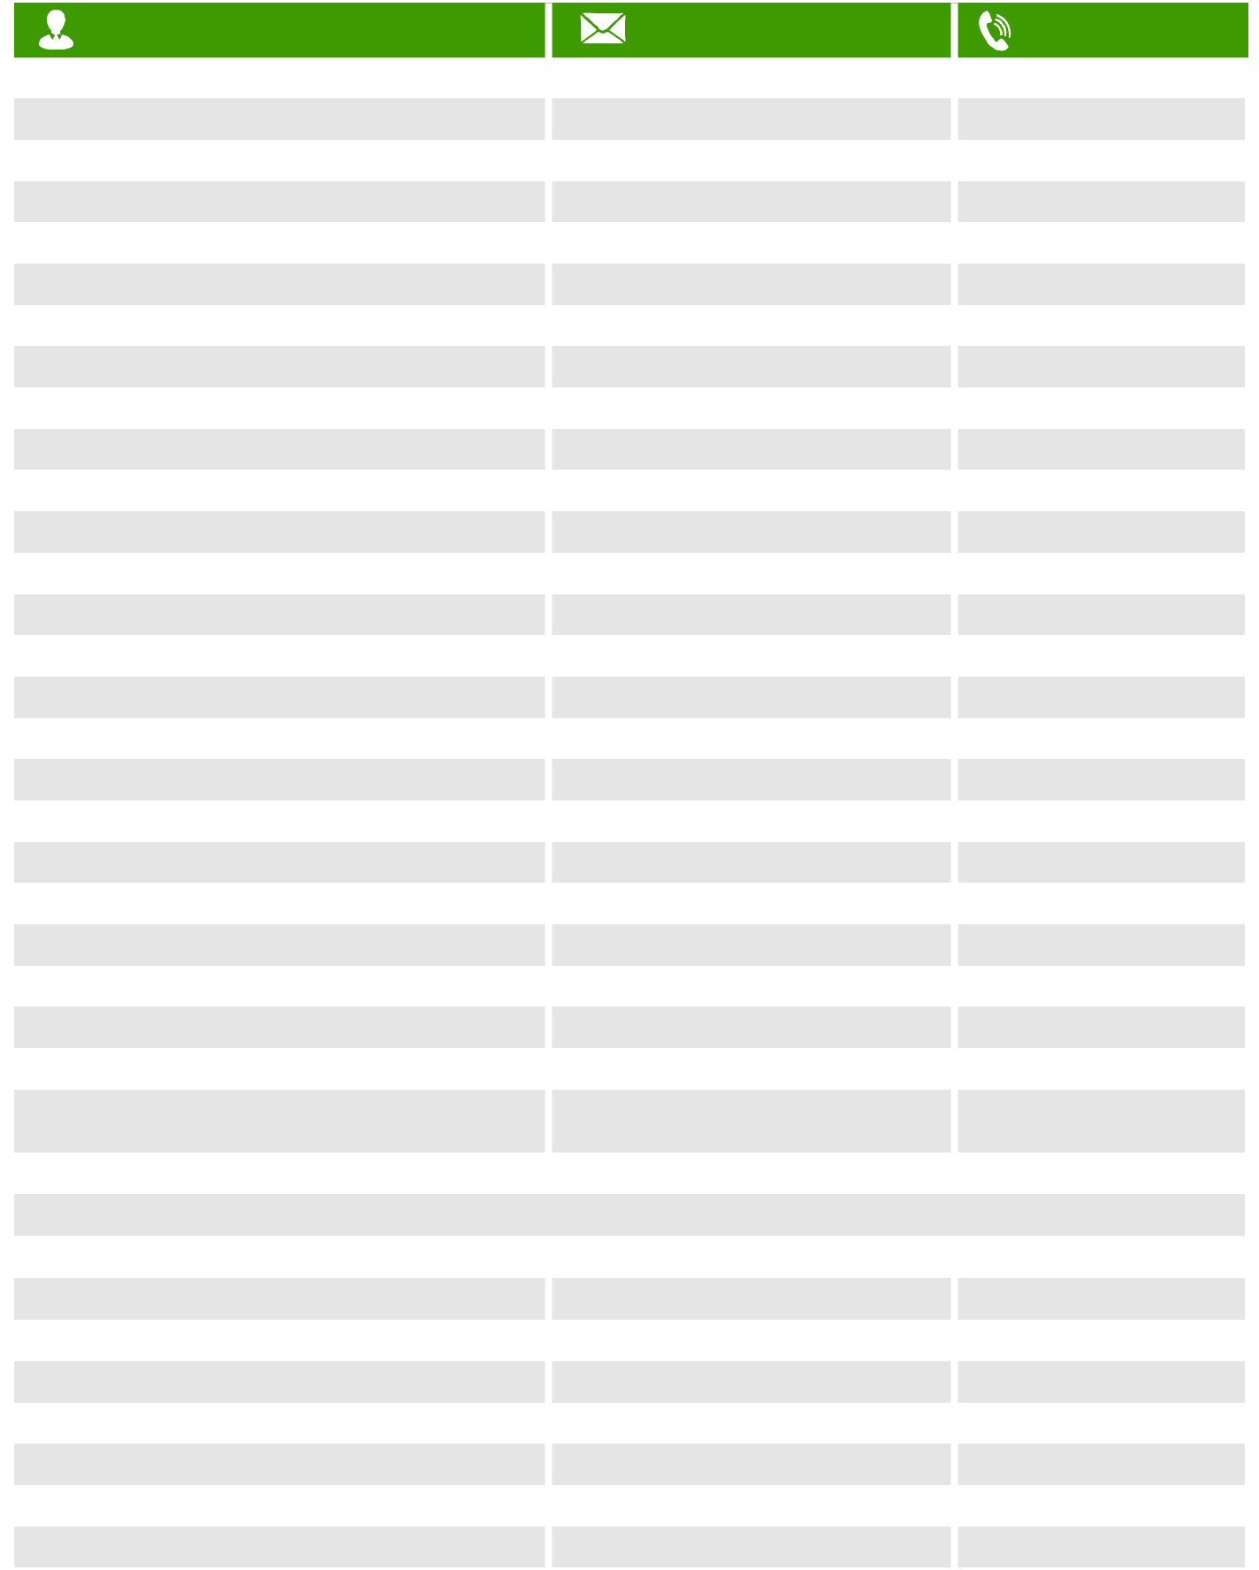

NAME | EMAIL ADDRESS
Adetunmbi Olubunmi Ayodeji | biodunolujimi@yahoo.com
Bamidele Micheal Opeyemi | amicusng@gmail.com
Olubunmi Adetunmbi | senator.adetunmbi@gmail.com
Nnamani Chimaroke Ogbonna | ebeanoglobal875@gmail.com
Ekweremadu Ike | ikeekweremadu@yahoo.com
Utazi Godfrey Chukwuka | gcutazi@gmail.com
Tanimu Philip Aduda - Minority Whip | philipaduda2@yahoo.com
Goje Mohammed Danjuma | mdgoje1@gmail.com
Amos Bulus Kilawangs | amos.kilawangs@nass.gov.ng
Alkali Saidu Ahmed | saidualkali905@gmail.com
Onyewuchi Ezenwa Francis | ezeonyewuchi@gmail.com
Okorocha Ethelbert Anayo Rochas
Benjamin Uwajimogu
Mohammed Sabo | muhammaduadamufagengawo@gmail.com
Hassan Ibrahim Hadeja | dsankara@yahoo.co.uk
Sankara Danladi Abdullahi | nakudu@yahoo.com
Kwari Suleiman Abdu | suleimankwari@yahoo.com
Sani Uba | ubasani@aol.com
Laah Danjuma Tella | laahdanjuma@yahoo.com
Shekarau Ibrahim | ishekarau55@yahoo.com
Barau Jibrin I. | barauiji@yahoo.com
Gaya Ibrahim Kabiru
Babba Ahmad Kaita
Mandiya Bello | bellom2001@yahoo.com
Abdullahi Engr. Kabir Barkiya | barkamazadu00@gmail.com
Abdullahi Abubakar Yahaya -
Majority Senate Leader
Adamu Mainasara Aliero Muhammad | senatoraliero@yahoo.com
Na Allah Bala Ibn | balaibu@informant.com
Yakubu Oseni | yakubu.oseni75@yahoo.com
Isah Jibrin | isahj@ymail.com
Smart Adeyemi
Umar Suleiman Sadiq
Oloriegbe Yahaya Ibrahim | oloridoc@yahoo.com
Ashiru Oyelola Yisa | ashiru@gmail.com
Tinubu Oluremi | info@oluremitinubu.com
Osinowo Sikiru Adebayo | bayoosinowo@gmail.com

PHONE NO

08033141536

08064487689

08022255522

08075757000

08037226187

08034509106

07068686699

08026032222

0803 201 2132

0706 777 7077

0802 290 2648

0705 417 7706

0803 703 2577

0803 301 9005

0809 911 1119

0703 339 9992

0809 919 9111

0813 836 0742

0706 684 7000

0803 963 9999

0703 264 2674

0818 565 1909

0803 358 1695

0705 522 1111

0809 530 0251

0803 304 9369

9th Senate
Database
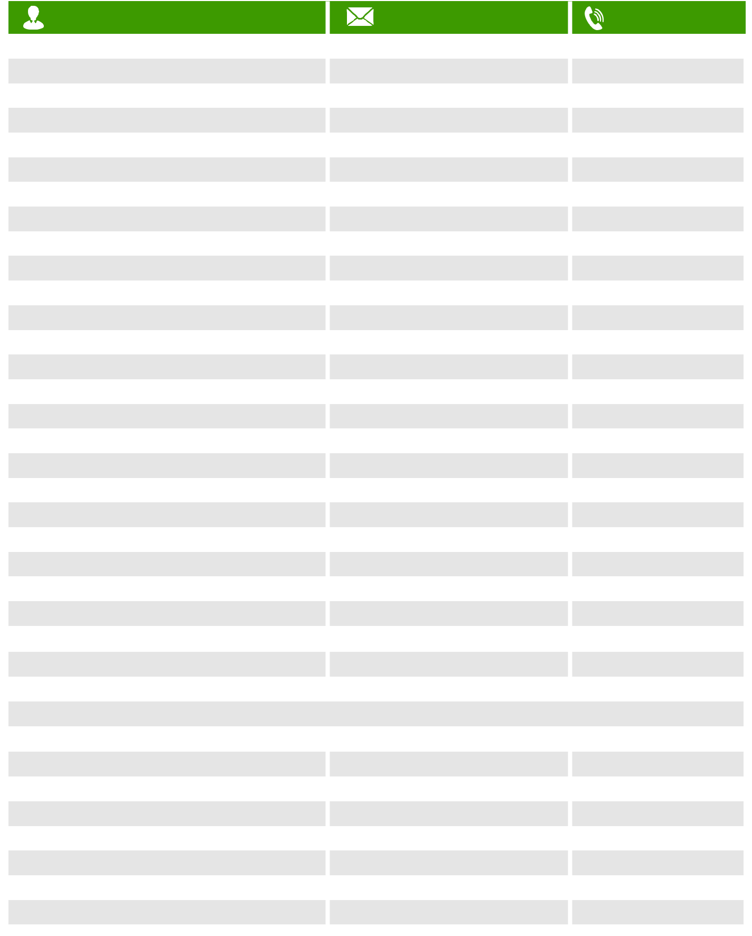

NAME | EMAIL ADDRESS
Adeola Soloman Olamilekan | adeolaolamilekan2005@yahoo.com
Akwashiki Godiya | godiyaakwashiki123@gmail.com
Abdullahi Adamu | adamu.abdullahi@gmail.com
Al-makura Umaru Tanko | tankoalmakura@yahoo.co.uk
Mohammed Sani Musa | sani-313@hotmail.com
Abdullahi Aliyu Sabi - Deputy Chief Whip | abdul_i@ygmail.com
Bima Muhammed Enagi | sangibima@gmail.com
Amosun Ibikunle Oyelaja | amks2@yahoo.com
Mustapha Ramoni Olalekan | adeoshy@gmail.com
Odebiyi Tolulope Akinremi | toluodebiyi@gmail.com
Boroffice Robert Ajayi - Deputy Majority Leader | rboroffice@yahoo.com
Akinyelure Patrick Ayo | akinyelure1@yahoo.com
Tofowomo Nicholas Olubukola | tofowomo_1960@yahoo.com
Surajudeen Ajibola Basiru | olaafolabii@yahoo.com
Fadahunsi Francis Adenigba | adefadahunsi19@gmail.com
Oriolowo Adelere Adeyemi | yemlee12@gmail.com
Folarin Teslim Kolawole | teslimkfolarin@yahoo.com
Buhari Abdulfatai | rabab1004@yahoo.com
Kola Ademola Balogun | kbalogun7707@gmail.com
Longjan Ignatius | talk2longjan@gmail.com
Dimka Hezekiah Ayuba | dewansamson4@gmail.com
Gyang Istifanus Dung | dridgyang@gmail.com
Thompson Sekibo | george.sekibo@nass.gov.ng
Mpigi Barinada | mpigib@yahoo.com
Apiafi Jocelyn
Gobir Ibrahim Abdullahi | ibrahimgabir1@yahoo.com
Wamako Aliyu Magatakarda | amwamakko@yahoo.com
Shehu Abubakar Tambuwal | abubakarshehu5225@gmail.com
Bwacha Emmanuel - Deputy Minority Leader | info@senatorbwacha.com
Yusuf Abubakar Yusuf | yusufawakili@gmail.com
Bako Dahiru Gassol
Gaidam ibrahim Alhaji | emma.iwueke@yahoo.com
Ibrahim Ahmad Lawan - President of the Senate
Bomai Ibrahim Mahammed
Kaura Tijjani Yahaya
Aliyu Ikra Bilbis
Abubakar Abdul'aziz Yari

PHONE NO

0807 400 0040

0809 932 1703

0806 518 6557

0807 725 3989

0803 311 4615

0706 777 7044

0817 347 9797

0803 321 3993

0803 304 7403

0803 605 8080

0817 640 6557

0809 170 7000

0805 454 6666

0803 304 1938

0805 224 2211

0803 356 5979

0803 316 0587

0803 705 3375

0813 295 6057

0704 444 2045

0803 335 9443

0809 777 7712

0803 741 9000

0703 318 1818

0706 961 9523

0706 379 5588

0803 310 9493

08036591699

0705 509 0323

