**Front-End UI/UX Mini Project**

**1. Title Page**

**Project Title:** My Favourite City— a Blog   
**Submitted By:**  
Team Members: [Johny Anjilvelil Mathew], [John Joby C],[Albert Liju]  
Roll Number: [2460382], [2460380],[2460317]  
College E-mail ID: [[johny.anjilvelil@btech.christuniversity.in](mailto:johny.anjilvelil@btech.christuniversity.in)], [[john.joby@btech.christuniversity.in](mailto:john.joby@btech.christuniversity.in)], [albert.liju@btech.christuniversity.in]  
**Course:** UI/UX Design Fundamentals  
**Instructor Name:** [Mrs.Nagaveena]  
**Institution:** [Christ University]  
**Date of Submission:** [13/08/2025]



**2. Abstract**

The *My Favourite City Blog* is a multi-page, responsive website showcasing the attractions, culture, visuals, and contact information of New York City. Designed with semantic HTML5 structure, it features a consistent navigation bar across all pages, a visually engaging hero section, and organized content sections. The home page introduces the city with an overview and featured articles, while dedicated pages highlight top attractions, cultural highlights, a gallery of city images, and a contact form for visitor engagement. Image-rich layouts, descriptive headings, and a uniform card and grid structure create a clean, user-friendly browsing experience. The output demonstrates fundamental front-end design principles, including consistent branding, intuitive navigation, and content segmentation, resulting in a polished and accessible city blog interface.



**3. Objectives**

* Create a visually appealing, multi-page website to showcase New York’s attractions, culture, and lifestyle.
* Implement a consistent navigation system across all pages for intuitive browsing.
* Present information in a clear, organized layout using semantic HTML5 structure.
* Use engaging imagery in hero sections, cards, and galleries to enhance visual storytelling.
* Include a functional contact form for visitor interaction.
* Ensure a uniform design style across pages for cohesive branding.
* Lay the foundation for a responsive design adaptable to different devices and screen sizes.
* Apply best practices for accessibility with descriptive alt text and proper heading hierarchy.



**4. Scope of the Project**

* This project focuses exclusively on front-end UI/UX design with **no JavaScript or server-side scripting**
* It includes a static HTML page styled entirely with CSS for layout, filtering interactivity, and animations
* Designed to be accessible and visually consistent across all common devices and screen sizes
* Utilizes only open-source fonts and modern CSS features, avoiding external libraries or frameworks



**5. Tools & Technologies Used**

| Tool/Technology | Purpose |
| --- | --- |
| HTML5 | Markup and semantic structure |
| CSS3 | Styling, animations, layout |
| VS Code | Code editing and development |
| Chrome DevTools | Testing, debugging, responsiveness verification |



**6. HTML Structure Overview**

* Utilized semantic tags including <header>, <main>, <aside>, <article>, and <footer>
* The header contains the logo, brand name, and interactive category Elements with relevant classes for the category. The main content area uses a CSS Grid layout
* Accessibility roles are added for improved usability.



**7. CSS Styling Strategy**

* External CSS organized with clear comments and modular sections for better maintainability
* Employed **CSS Grid** for the main layout with uniform fixed card height using grid-auto-rows
* Used **Flexbox** for header layout and sidebar content for flexible spacing
* Defined **CSS variables** for theme colors, shadows, and typography for consistent branding (dark background with gold accents)
* Added smooth **hover animations** and images for engaging UI feedback
* Implemented filtering interactivity with pure CSS selectors using:checked pseudo-class, styled labels as pill and toggle buttons
* Applied **media queries** for responsive behavior ensuring stacking and readable layout on tablets and mobiles
* Ensured **typography scaling** with readable font sizes and accessible color contrast



**8. Key Features**

| Feature | Description |
| --- | --- |
| Responsive Design | Seamless adaptation from large desktops down to small mobile screens |
| CSS-Only Filtering | Category and filtering using radio buttons and checkboxes without any JavaScript |
| Uniform Grid Layout | Fixed-height, visually uniform dish cards using CSS Grid grid-auto-rows |
| Elegant Theming | Dark background, gold highlights, and refined typography for upscale restaurant aesthetics |
| Hover Effects | Smooth scale and text shadow transitions on dish cards and images |
| Accessibility | ARIA roles, keyboard navigability, and descriptive alt attributes for images and cards |



**9. Challenges Faced & Solutions**

| Challenge | Solution |
| --- | --- |
| Horizontal container overflow and cutoff | Used viewport-relative widths (95vw), added container padding, and overflow-x: hidden |
| Uneven sizes impacting layout | Applied grid-auto-rows for fixed card height and adjusted internal content spacing |
| Implementing interactivity without JavaScript | Leveraged CSS selectors :checked on hidden inputs and styled labels for toggle/filter effect |
| Managing a large dataset statically | Encapsulated dishes with semantic classes for filtering, maintained a clear repeatable card structure |
| Ensuring image visibility on dark backgrounds | Selected visually suitable food photography and enforced object-fit: cover with hover zoom |
| Accessibility enhancements | Added appropriate ARIA roles and descriptive labels; ensured keyboard operability |



**10. Outcome**

* Delivered a clean, professional, and visually engaging city favourite blog UI using **only HTML and CSS**
* Fully responsive and accessible front-end with dynamic filtering
* Uniform dish cards with consistent sizing elevate visual perfection and user experience
* Gained practical experience in complex CSS layout techniques, theming, and UI/UX best practices



**11. Future Enhancements**

* Add **JavaScript for enhanced interactivity** like price filtering, search, or live cart updates
* Integrate a **backend system** for online ordering and reservation management
* Implement **advanced animations** and transitions to engage users further
* Build a **light/dark theme toggle** via CSS variables and JavaScript
* Optimize images and assets for improved page load speed
* Improve accessibility further using ARIA live regions for live filter updates



**12. Sample Code**

**Sample: Category filter HTML & CSS**

/* Basic Reset and Global Styles */

* {

margin: 0;

padding: 0;

box-sizing: border-box;

}

body {

font-family: Arial, sans-serif;

line-height: 1.6;

background-color: #f4f4f4;

color: #333;

}

.container {

max-width: 1100px;

margin: auto;

overflow: hidden;

padding: 0 2rem;

}

/* Header and Navigation */

.navbar {

display: flex;

justify-content: space-between;

align-items: center;

background: #333;

color: #fff;

padding: 1rem 2rem;

}

.navbar .logo {

font-size: 1.5rem;

}

.navbar ul {

list-style: none;

display: flex;

}

.navbar ul li a {

color: #fff;

text-decoration: none;

padding: 0.5rem 1rem;

transition: background 0.3s ease;

}

.navbar ul li a:hover,

.navbar ul li a.active {

background: #555;

border-radius: 5px;

}

/* Main Content and Page Specific Styles */

.page-content {

padding: 2rem;

text-align: center;

}

.page-content h2 {

margin-bottom: 2rem;

font-size: 2.5rem;

}

.hero {

position: relative;

height: 60vh;

overflow: hidden;

}

.hero img {

width: 100%;

height: 100%;

object-fit: cover;

filter: brightness(70%);

}

.hero-text {

position: absolute;

top: 50%;

left: 50%;

transform: translate(-50%, -50%);

color: #fff;

text-align: center;

}

.hero-text h2 {

font-size: 3rem;

margin-bottom: 1rem;

}

.hero-text p {

font-size: 1.2rem;

}

.intro {

text-align: center;

padding: 2rem;

background: #e9e9e9;

}

.featured-posts {

padding: 2rem;

text-align: center;

}

.card-container {

display: flex;

justify-content: center;

flex-wrap: wrap;

gap: 20px;

margin-top: 2rem;

}

.card {

background: #fff;

border: 1px solid #ddd;

border-radius: 8px;

overflow: hidden;

width: 300px;

text-align: left;

}

.card img {

width: 100%;

height: 200px;

object-fit: cover;

}

.card h3 {

padding: 1rem;

}

.card p {

padding: 0 1rem;

}

.card a {

display: inline-block;

background: #333;

color: #fff;

padding: 0.5rem 1rem;

margin: 1rem;

text-decoration: none;

border-radius: 5px;

}

/* Gallery Styles */

.gallery-grid {

display: grid;

grid-template-columns: repeat(auto-fit, minmax(300px, 1fr));

gap: 1rem;

padding: 2rem;

}

.gallery-grid figure img {

width: 100%;

height: 250px;

object-fit: cover;

border-radius: 8px;

}

/* Contact Form Styles */

.contact-form {

max-width: 600px;

margin: 2rem auto;

padding: 2rem;

background: #fff;

border-radius: 8px;

box-shadow: 0 0 10px rgba(0, 0, 0, 0.1);

}

.contact-form label {

display: block;

margin-bottom: 0.5rem;

}

.contact-form input,

.contact-form textarea {

width: 100%;

padding: 0.5rem;

margin-bottom: 1rem;

border: 1px solid #ccc;

border-radius: 4px;

}

.contact-form button {

display: block;

width: 100%;

padding: 0.75rem;

background: #333;

color: #fff;

border: none;

cursor: pointer;

border-radius: 4px;

}

/* Footer */

footer {

text-align: center;

padding: 1rem;

background: #333;

color: #fff;

margin-top: 2rem;

}



**13. Screenshots of Final Output**

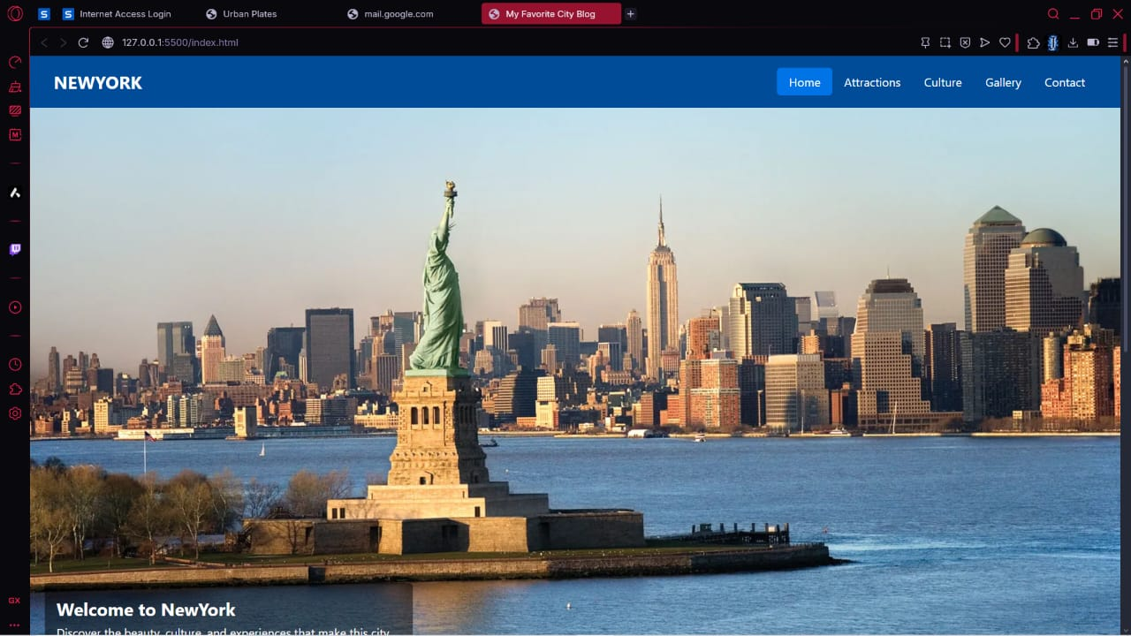

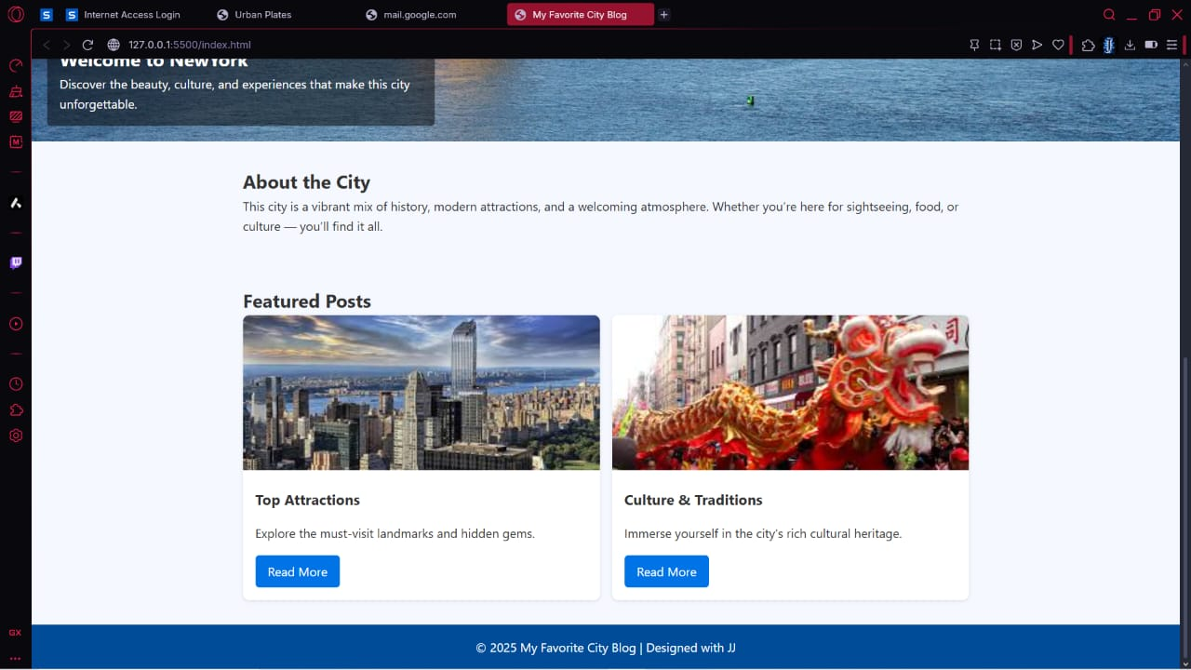

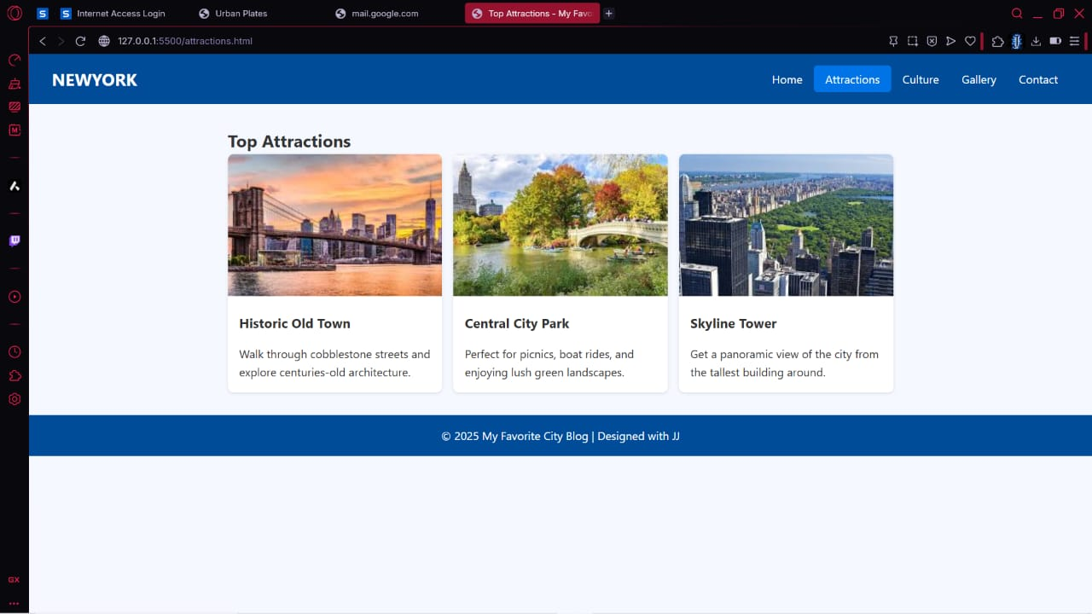



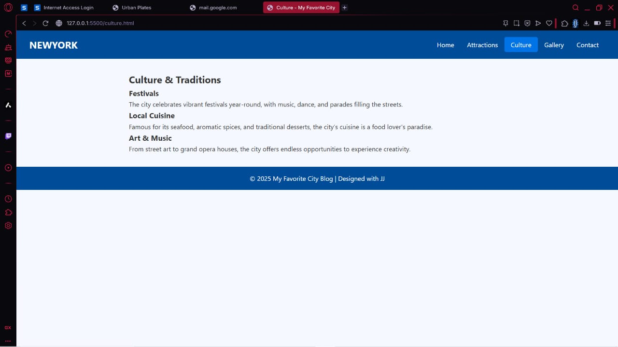

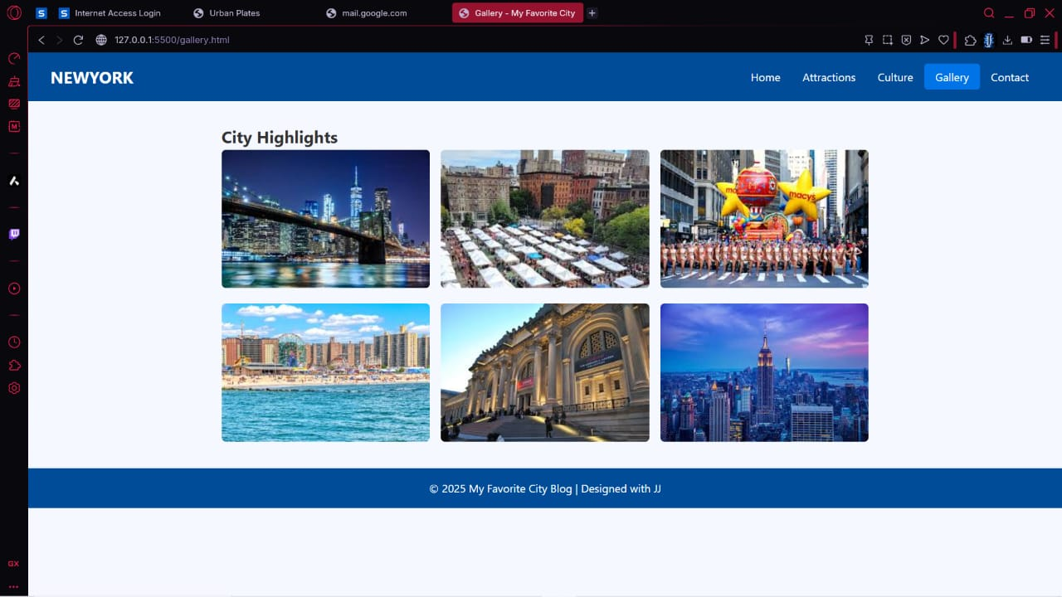

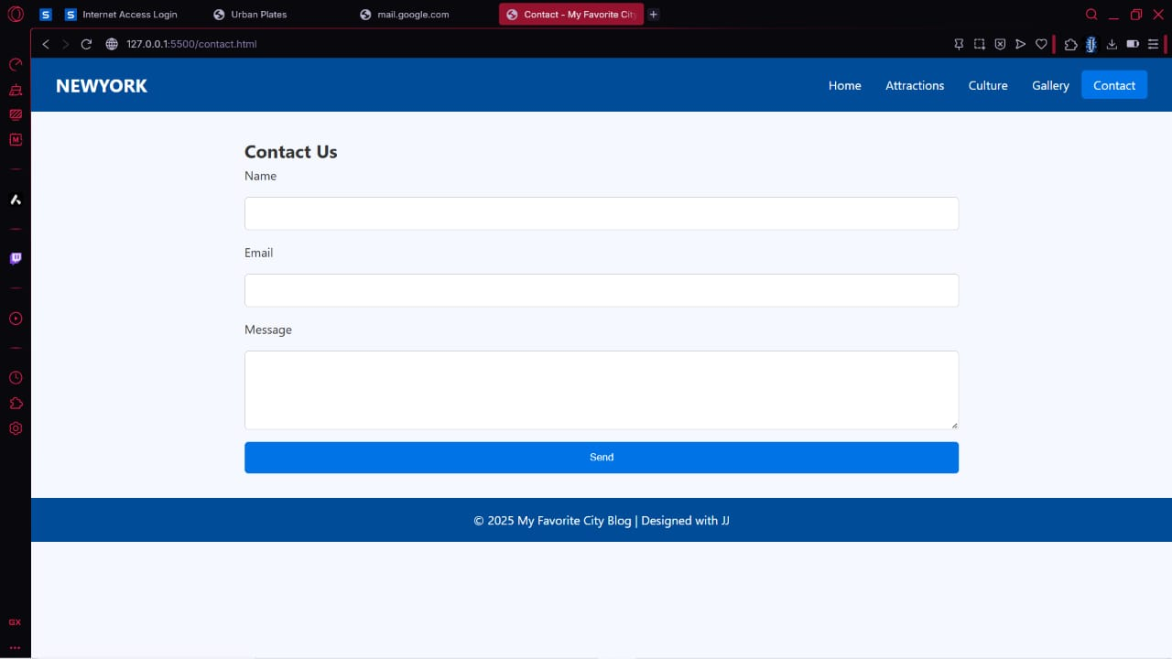



**14. Conclusion**

This project involved designing and implementing an elegant, responsive blog webpage using **pure HTML and CSS**. It strengthened my understanding of semantic markup, CSS Grid and Flexbox layouts, and achieving interactive functionality with CSS selectors. The challenge of maintaining uniform card sizes, accessibility, and beautiful visual theming was successfully met. This mini project enhanced my front-end skills, particularly in user-centric web design for food service applications.



**15. References**

* L&T LMS: <https://learn.lntedutech.com/Landing/MyCourse>
* MDN Web Docs: <https://developer.mozilla.org/en-US/>
* Google Fonts and Material Design Guidelines
* CSS-Tricks: <https://css-tricks.com/>



⁂