John Kulp

CS 1632 Deliverable 4

Property-Based Testing

<https://github.com/Otterpaw/CS1632_Deliverable_4>

I chose to do property testing for this project because it is something that has caused me a lot of grief in the past. When I implement my own searches and sorts. For example, at one point during my internship I implemented a method that sorted version numbers. I made an extensive test case for it featuring a pile of different specific possible comparisons when it would have been much easier, and still effective, to test for certain properties of input and output along with the base cases of comparison.

During the project itself I did not encounter too much trouble because the code was rather simple. However, I finally got my intellij testing environment working to my satisfaction and decided that Groovy was far more trouble than it was worth.

I didn’t learn anything new from the implementation of the project, but that does not mean that it wasn’t helpful for me. Learning about property testing itself was very helpful and will be useful for the future. Having an opportunity to practically apply that knowledge immediately after learning it certainly will cement it in my memory.

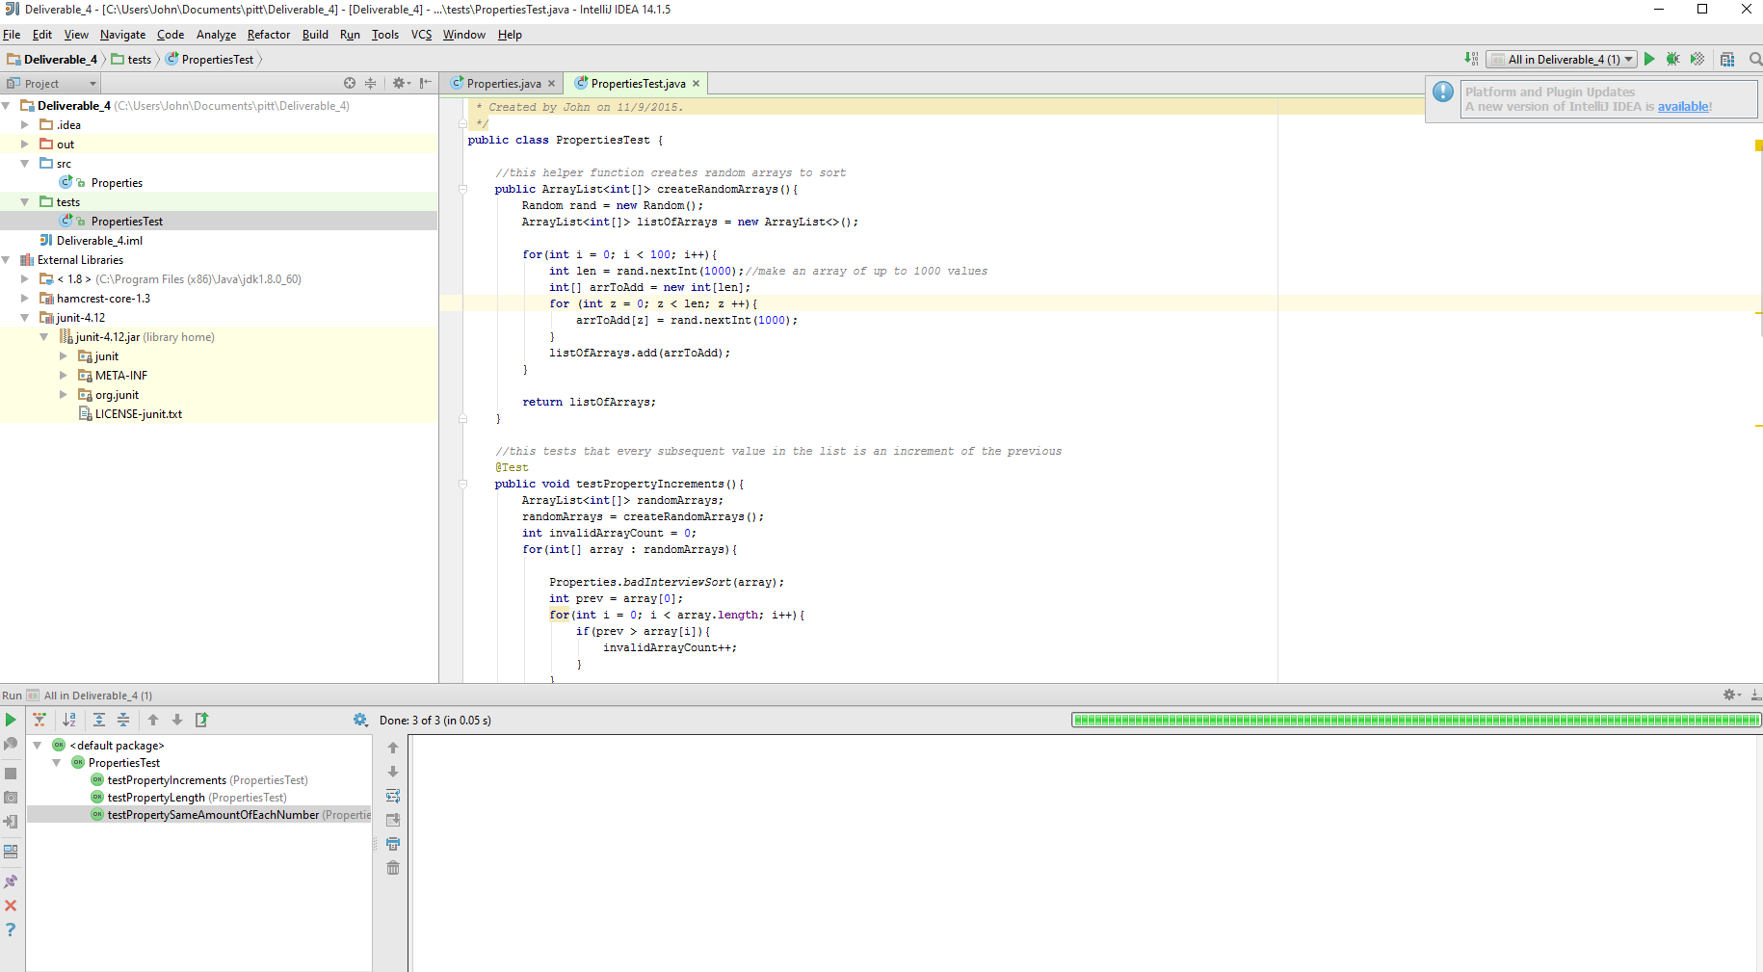

(The picture is available in better quality on my github)