COP3331 Final Project

John Cameron – [Redacted]

University of South Florida

April 16, 2018

**File Names**

* src/
  + main.cpp
  + FinalProject.h
  + commands/
    - types/
      * AuthenticatedCommand.h
      * Command.h
    - CommandAvgScoreOfExam.h
    - CommandAvgScoreOfStudent.h
    - CommandChangePassword.h
    - CommandCreateNewUser.h
    - CommandCurveExamScores.h
    - CommandDisplayScoresOfExam.h
    - CommandDisplayScoresOfStudent.h
    - CommandInsertNewStudent.h
    - CommandInsertScoresNewExamAll.h
    - CommandUpdateStudentExamScore.h
  + databases/
    - AuthenticationDataBase.cpp
    - AuthenticationDataBase.h
    - StudentDatabase.cpp
    - StudentDatabase.h
  + objects/
    - Pwdg.h
    - Student.h
    - User.h
* Data/
  + scores.txt
* User/
  + passwords.txt

**UML Class Diagram**

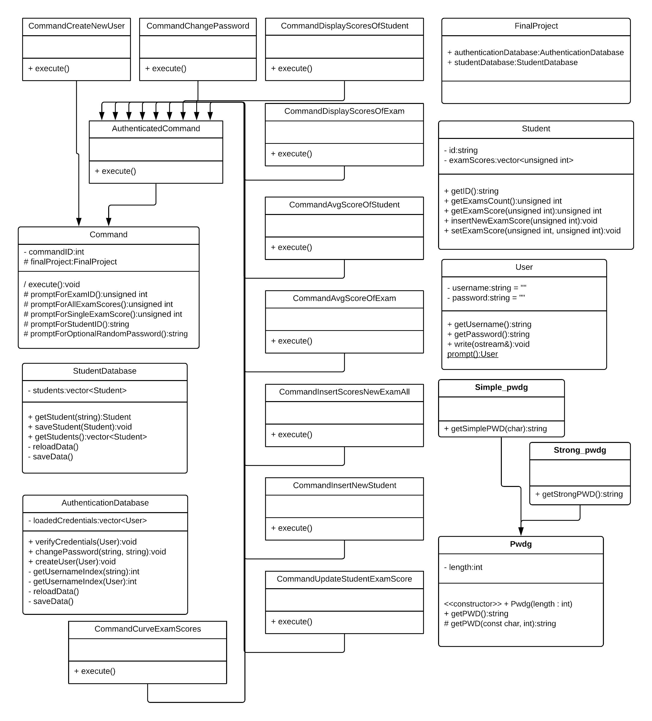

**Compilation commands**

**Makefile**

The Makefile is automatically generated by using CMake, which is a cross-platform free and open-source software for managing the build process of software using a compiler-independent method (g++ in this case).

cd myprogram/ *Switch to the directory of the program source code*  
 cmake . *Generate the Makefile*  
 make *Compile the program* ./3331project *Execute the target*

**Additional Notes**

This program was developed using the C++98 standard in order to maintain maximum compatibility.

**Screenshots**

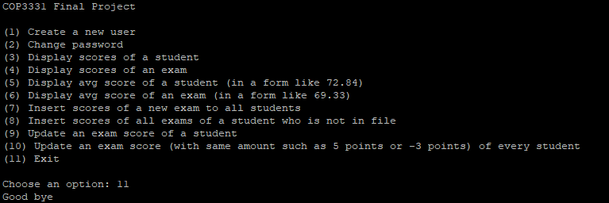  
*Exiting the program, menu list displayed at start-up*

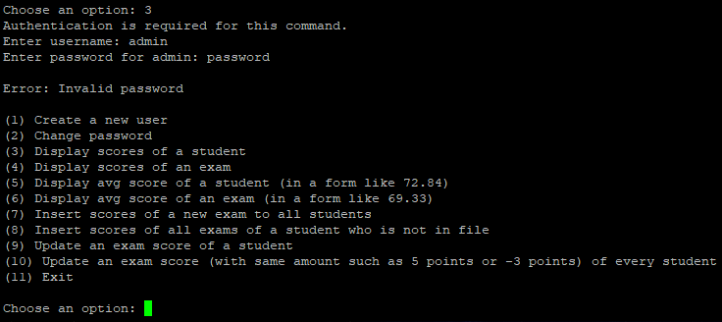

*Option 3 is selected. Authentication is required and prompts the user. In this case, the password is incorrect and an error is displayed to inform the user. It then returns to the state of displaying the menu and prompts for an option.*

|  |  |  |
| --- | --- | --- |
| *Contents of User/passwords.txt* ***before*** *execution of option 1* | *A new user, “prof”, is created with the password “cop3331”* | *Contents of User/passwords.txt* ***after*** *execution of option 1* |

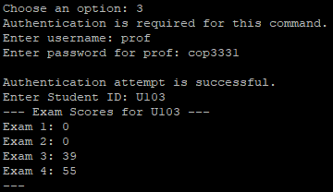  
*Authentication attempt was successful with the newly created user.   
Scores are displayed for a student.*

|  |  |  |
| --- | --- | --- |
| *Contents of User/passwords.txt* ***before*** *execution of option 2* | *The password for the admin user has been changed to just “password”* | *Contents of User/passwords.txt* ***after*** *execution of option 2* |

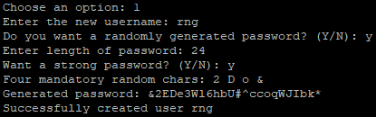  
*Creating a new user named “rng” with a strong, randomly generated password*



*A group of screenshots showing the three possible input validation error messages upon entering a student ID when prompted*

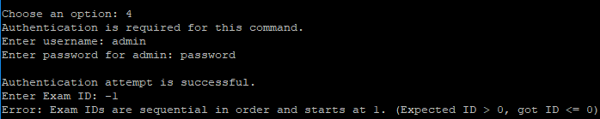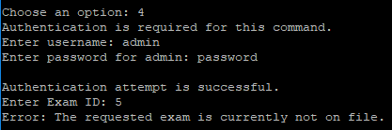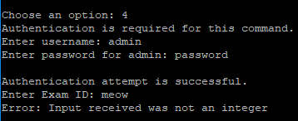

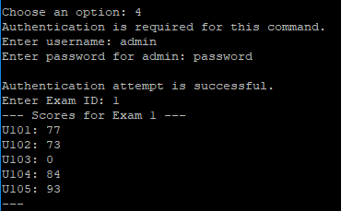

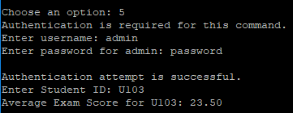

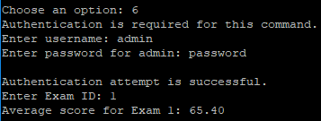

|  |  |  |
| --- | --- | --- |
| *Contents of Data/scores.txt* ***before*** |  | *Contents of Data/scores.txt* ***after*** |
|  |  |  |

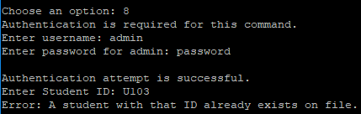

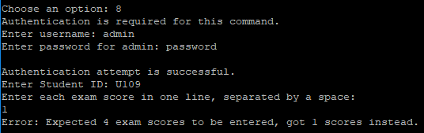

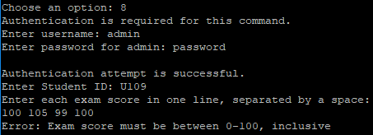

|  |  |  |
| --- | --- | --- |
| *Contents of Data/scores.txt* ***before*** |  | *Contents of Data/scores.txt* ***after*** |
|  |  |  |
| *Contents of Data/scores.txt* ***before*** |  | *Contents of Data/scores.txt* ***after*** |
|  |  |  |
|  |  |  |

|  |  |  |
| --- | --- | --- |
|  |  |  |

|  |  |  |
| --- | --- | --- |
|  |  |  |