Enhancer–Promoter Interaction Prediction in K562 (cis)
ABC-model features fused with Genos sequence embeddings | Reference: hg19 (GRCh37)

1. Background & Objective
Enhancers are cis-regulatory elements that activate gene transcription, often from large genomic distances and across chromosomes. Identifying which enhancer regulates which promoter is central to understanding gene regulation. Here we build a binary classifier that predicts enhancer–promoter (E–P) interaction from sequence-derived features, focusing on cis (same-chromosome) interactions in the K562 cell line.

2. Data
Positive pairs (n=1,263) are E–P interactions in K562 supported by RIC-seq or KARR-seq experiments (EP-ATLAS resource). Negative pairs (n=1,263) are generated by shuffling the cis enhancer and promoter pools under a same-chromosome constraint, stratified by genomic-distance bin to match the positive distance distribution, and filtered to exclude any pair present in the full interaction set (91,310 records) so negatives carry no experimental evidence. The final set is a balanced 2×2 design (cis/trans × positive/negative); only the cis arm is analysed here.

3. Methods

3.1 Features
ABC features (194-dim): per-sequence composition features (93-dim each for enhancer and promoter: nucleotide frequencies, GC content, CpG/GpC density, Shannon entropy, 16 dinucleotide and 64 trinucleotide frequencies, TATA/CAAT motifs, homopolymer runs, log-length, AT/GC skew), seven joint features (Hi-C contact from a power-law distance-decay model C(d)=d^−0.87·exp(−d/3Mb), cosine similarities, GC/CpG similarity, Euclidean similarity), log10 distance, and the ABC score (activity × contact, per-gene normalized).
Embedding features (2049-dim): enhancer and promoter sequences independently embedded with Genos (Genos-1.2B, mean pooling, 1024-dim), concatenated with their cosine similarity. Reduced to 100 principal nonlinear components via KernelPCA (RBF) fitted on the training set only.
Final feature vector = ABC(194) ⊕ KernelPCA-embedding(100) = 294-dim.

3.2 Models & Evaluation
Four classifiers were compared: Gradient Boosting (GB), Logistic Regression (LR), Random Forest (RF), and a multilayer perceptron (MLP). Data were split by enhancer identity into train+val (70/15) and test (15), ensuring no enhancer spans folds. All feature reductions and scalers were fitted on the training set only to prevent leakage. The held-out test set (n=377) was used for final evaluation. Reported metrics: AUC, PR-AUC, accuracy, F1, and confusion matrix.

4. Results
Table 1. Test-set performance (cis, n=377).
Model | AUC | PR-AUC | Accuracy | F1 | Best?
Gradient Boosting | 0.7526 | 0.7845 | 0.6684 | 0.6334 | ★
Logistic Regression | 0.7268 | 0.7297 | 0.6605 | 0.6322
Random Forest | 0.6771 | 0.7420 | 0.6313 | 0.6106
MLP | 0.6509 | 0.6662 | 0.6207 | 0.6286

4.1 Model comparison
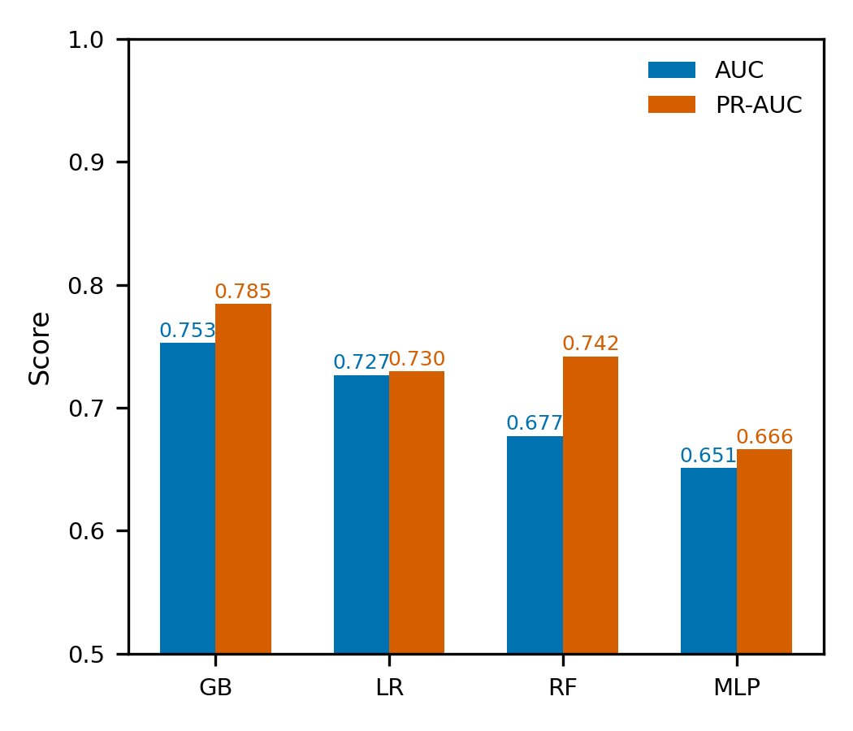

4.2 ROC and PR curves
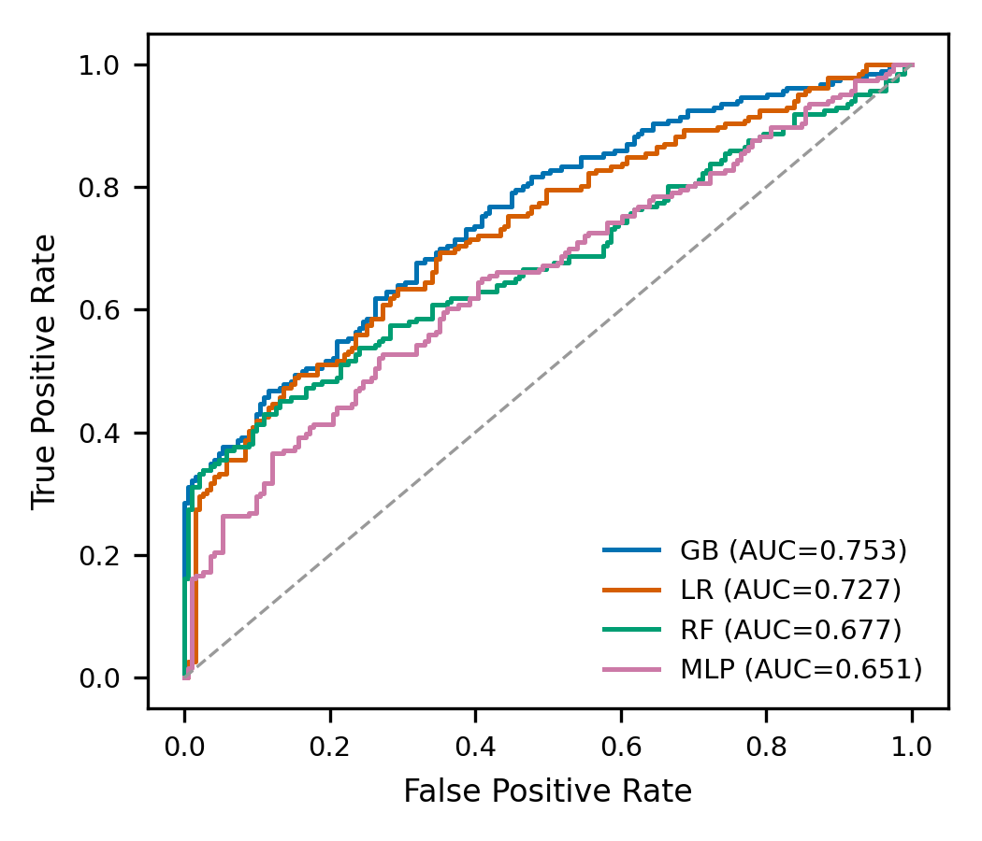
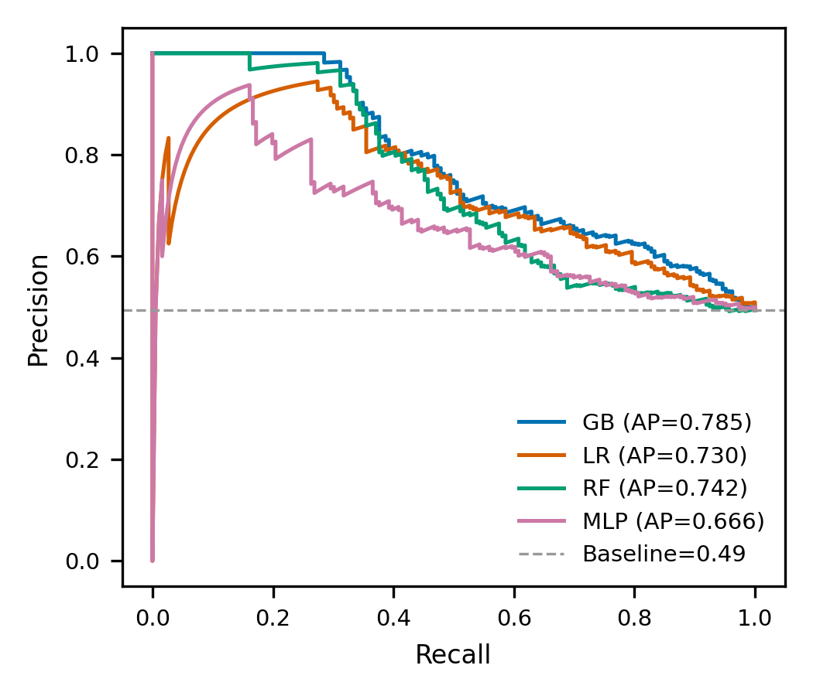

4.3 Confusion matrix (best model)
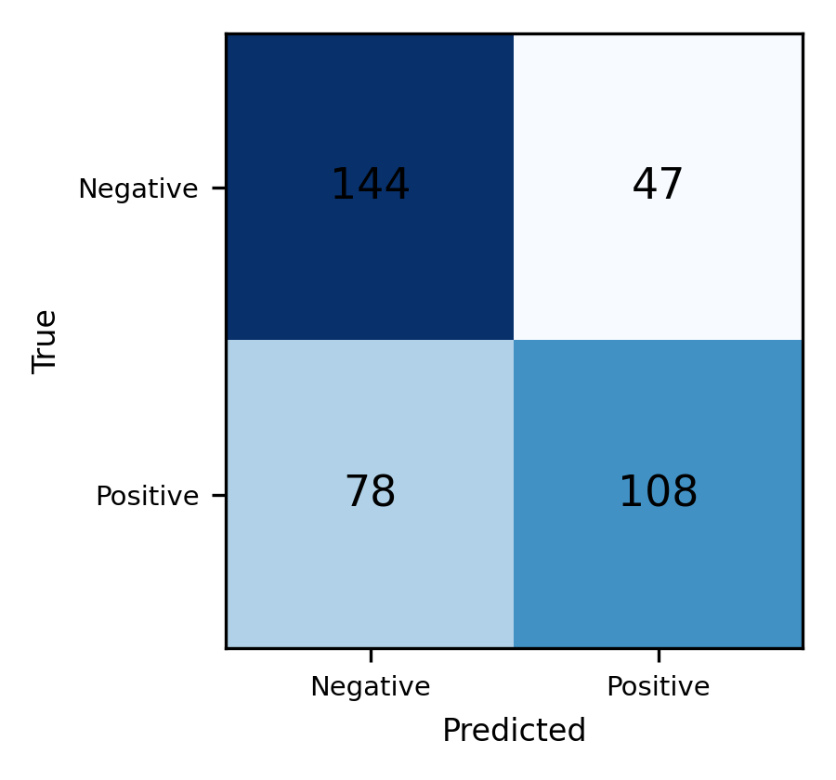

4.4 Feature importance
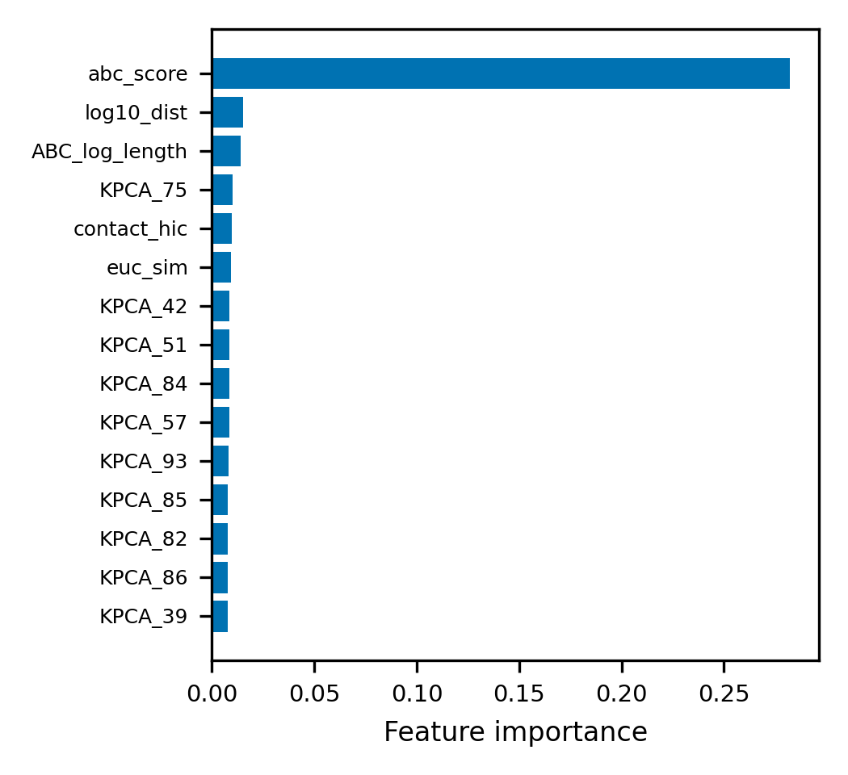

4.5 Score and feature distributions
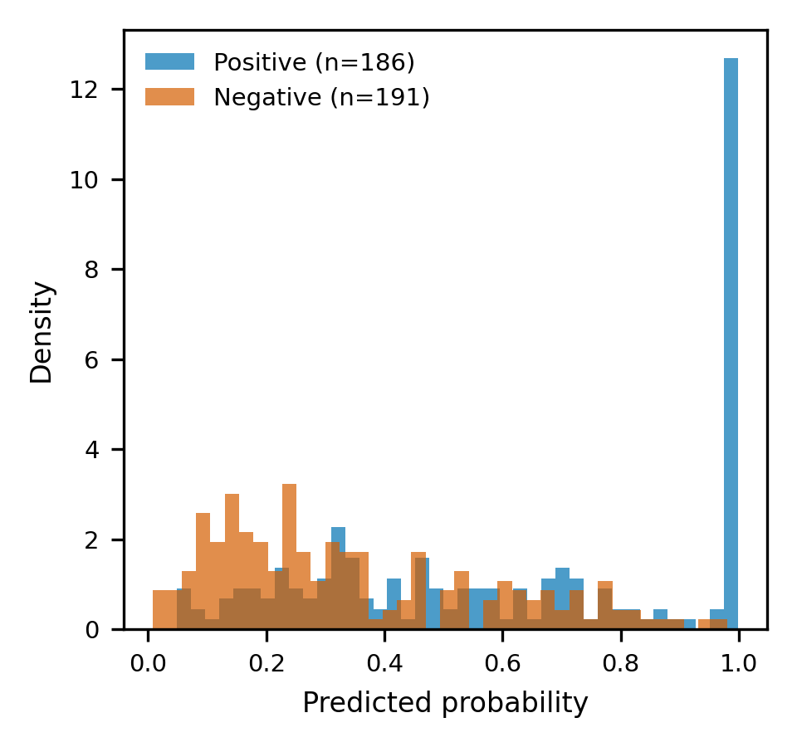
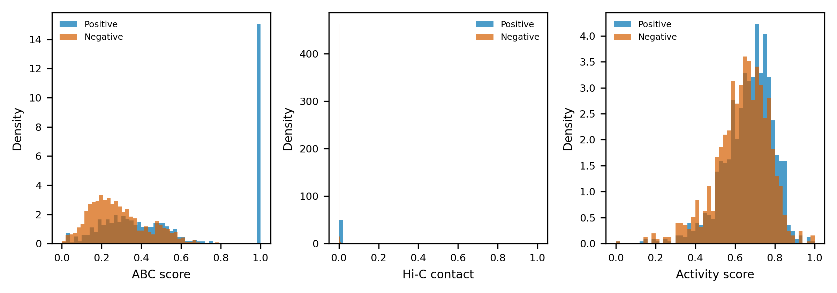

5. Discussion
The best model (Gradient Boosting) reached a test AUC of 0.753 and PR-AUC of 0.785, substantially above chance (0.5). ABC features (genomic distance, Hi-C contact, activity, sequence composition) carried the dominant signal, confirming that cis E–P interaction is strongly encoded by proximity and enhancer activity. Fusing Genos embeddings reduced to 100 KernelPCA components added a modest but consistent improvement over ABC alone (GB: AUC 0.702→0.753), indicating the deep embeddings capture complementary sequence information beyond composition features. Nonlinear reduction (KernelPCA) outperformed linear PCA, and tree-based models exploited the embedding features best; linear LR gained little from the embeddings.

6. Conclusions
A hybrid ABC+embedding classifier predicts cis enhancer–promoter interactions in K562 with an AUC of ~0.75 on held-out enhancers. The approach confirms the importance of genomic distance/contact and adds complementary signal from learned sequence embeddings. This pipeline can be extended to trans interactions and to other cell lines.

7. Limitations
(i) "Negative" denotes absence of experimental evidence rather than confirmed non-interaction. (ii) Only cis interactions are evaluated here; trans requires the analogous protocol. (iii) The embedding contributes a modest gain; whether larger benefits require co-embedding enhancer and promoter jointly remains open. (iv) Chromatin state (e.g., ATAC/H3K27ac) was not directly included.

