# 灰度变换及直方图均衡化算法实现

## 1. 图像灰度拉伸

pkg load image;  
f=imread('pout.tif');  
subplot(1,2,1);imshow(f);title('pout');  
subplot(1,2,2);imshow(imadjust(f));title('imadjust');

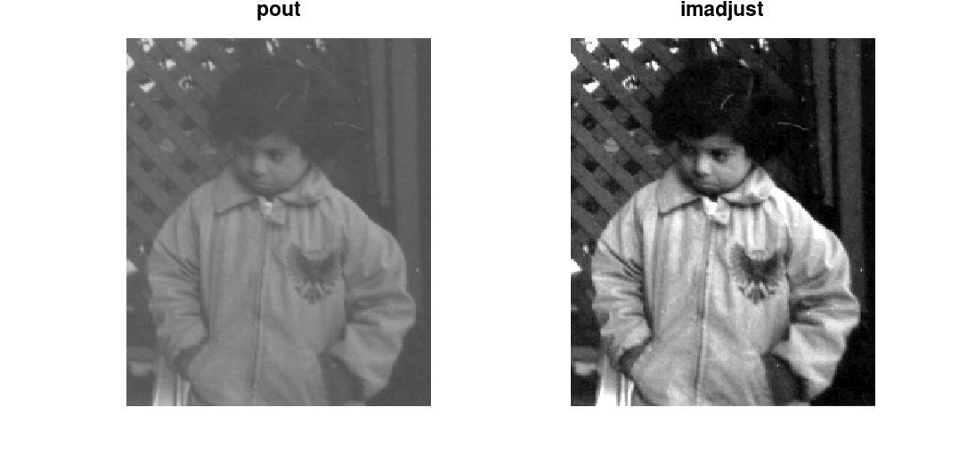

## 2.实现图像线性灰度变换

f=imread('pout.tif');  
a=min(min(f));  
b=max(max(f));  
g=uint8(double(f-a)/double(b-a)*255);  
subplot(2,2,1);imshow(f);title('pout');  
subplot(2,2,2);imshow(g);title('linear');  
subplot(2,2,3);hist(f);title('pout-hist');  
subplot(2,2,4);hist(g);title('linear-hist');

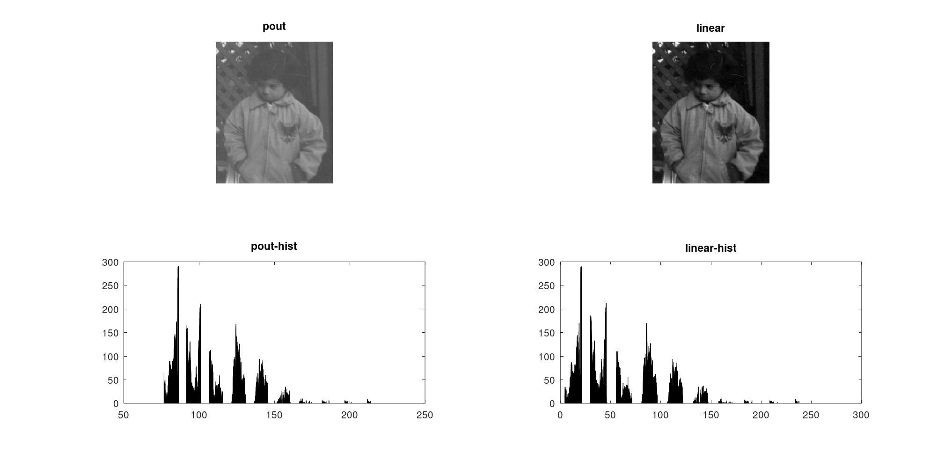

## 3.实现图像灰度对数变换、指数变换

f1=imread('0308.bmp');  
g1=log(f1+1);  
g1=uint8(g1*(255.0/max(max(g1)))+0.5);  
subplot(2,2,1);imshow(f1);title('0308');  
subplot(2,2,2);imshow(g1);title('log');  
subplot(2,2,3);hist(f1);title('0308-hist');  
subplot(2,2,4);hist(g1);title('log-hist');

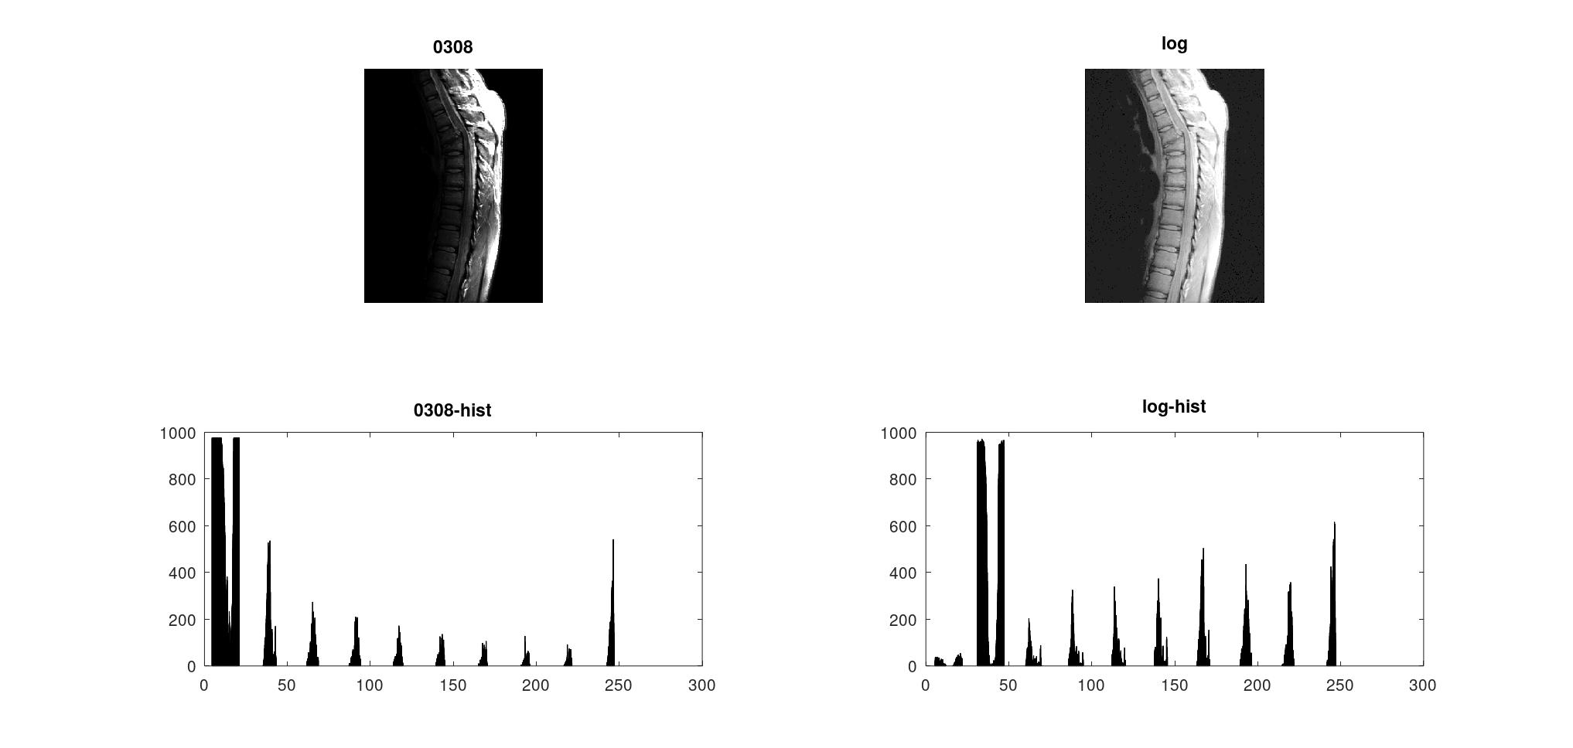

f2=imread('0309.bmp');   
g1=double(f2)/255.0;   
g1=uint8(g1.^2*255+0.5);   
g2=double(f2)/255.0;   
g2=uint8(g2.^5*255+0.5);   
subplot(2,3,1);imshow(f2);title('0309');   
subplot(2,3,2);imshow(g1);title('power-2');   
subplot(2,3,3);imshow(g2);title('power-5');   
subplot(2,3,4);hist(f2);title('0309-hist');   
subplot(2,3,5);hist(g1);title('power-2-hist');   
subplot(2,3,6);hist(g2);title('power-5-hist');

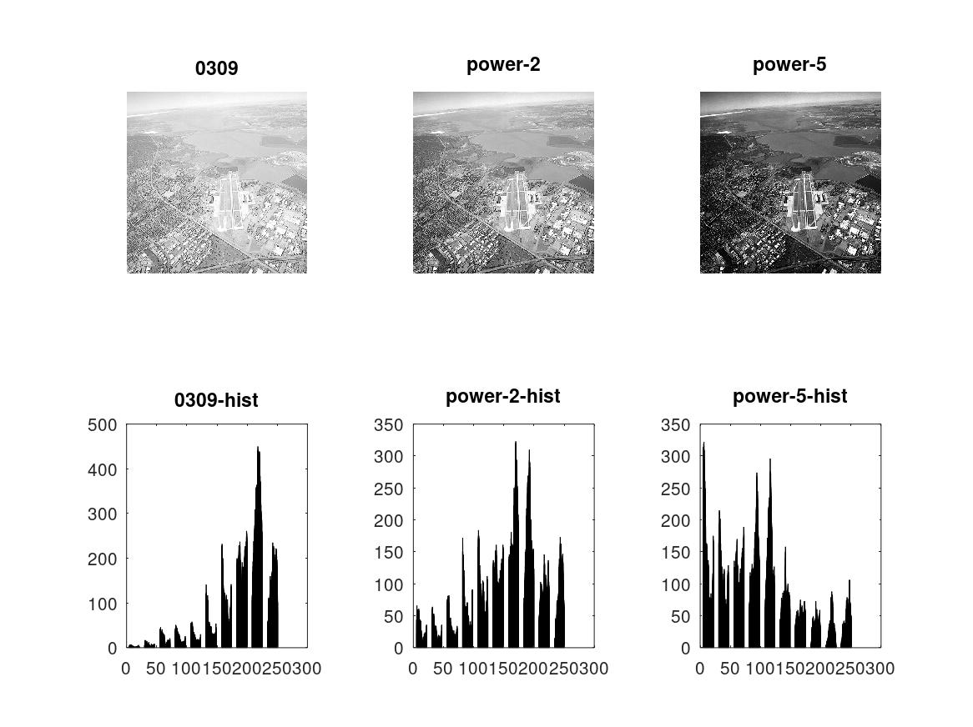

## 4.实现直方图均衡化

f=imread('pout.tif');   
[x,y]=size(f);   
p=zeros([256,1]);   
for i=f   
 for j=i.'   
 p(j+1)=p(j+1)+1;   
 end   
end   
p=double(p)/double(x*y);   
c=zeros([256,1]);   
c(1)=p(1);   
for i=2:256   
 c(i)=c(i-1)+p(i);   
end   
c=round(c*255);   
g=f;   
for i=1:x   
 for j=1:y   
 g(i,j)=c(f(i,j)+1);   
 end   
end   
subplot(2,2,1);imshow(f);title('pout');   
subplot(2,2,2);imshow(g);title('hist-equal');   
subplot(2,2,3);hist(f);   
subplot(2,2,4);hist(g);

