Tips for Teaching App

This document will help you install the Teaching App.
Teaching App is designed to be installed on a USB drive so you can easily move it from computer to computer. Of course, you can install it on a computer's hard drive or any removable drive. It is not limited to USB drives.
When you run the installer (TeachingAppSetup.exe) and click "Next" twice, you will see a screen like this:
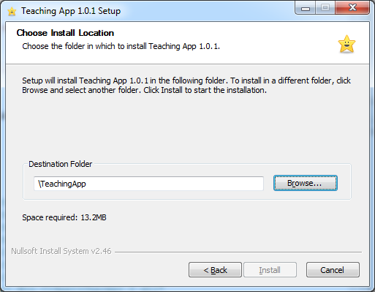

You can see the Install button is disabled. The reason is that the Destination folder is not set. You must choose the drive letter for installation. For example, if you have a USB drive connected to your computer and it is drive H: then you could put H:\TeachingApp in where it says "Destination folder."
Now, having selected a valid path, you will see the Install button is enabled and can be clicked. Click it and then Teaching App will install into the location you selected.
Once Teaching App is installed, you can navigate to that folder using Windows as you would normally find any folder. Teaching App is a little different that you can just run it from its install folder; there is no need to use the Start Menu.
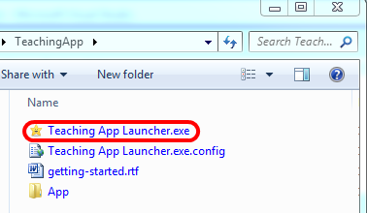

Just run the “Teaching App Launcher” file (the one with the star icon) from the install folder.
Read the “getting-started” file for a brief introduction on using the application.
If you have any questions, just email me at John@JohnMAndre.com.

