MSSE672 – Component Based Software

Week 2 Submission Guide

Student: John Michael Kreski

Instructor: Mohammad Abu Matar

Assignment: JUnit Testing

Date: 07/13/2025

## Summary

Unit tests were expanded to verify new collection-based functionality added to the QuadService and QuadController. The following features were covered:

* Posting and retrieving all quads
* Filtering square quads
* Aggregating quad statistics

Tests confirm correct Stream filtering logic and ensure controller endpoints handle these collections properly.

**JUnit Test Results**

**Screenshot 1 – Controller JUnit Tests**

***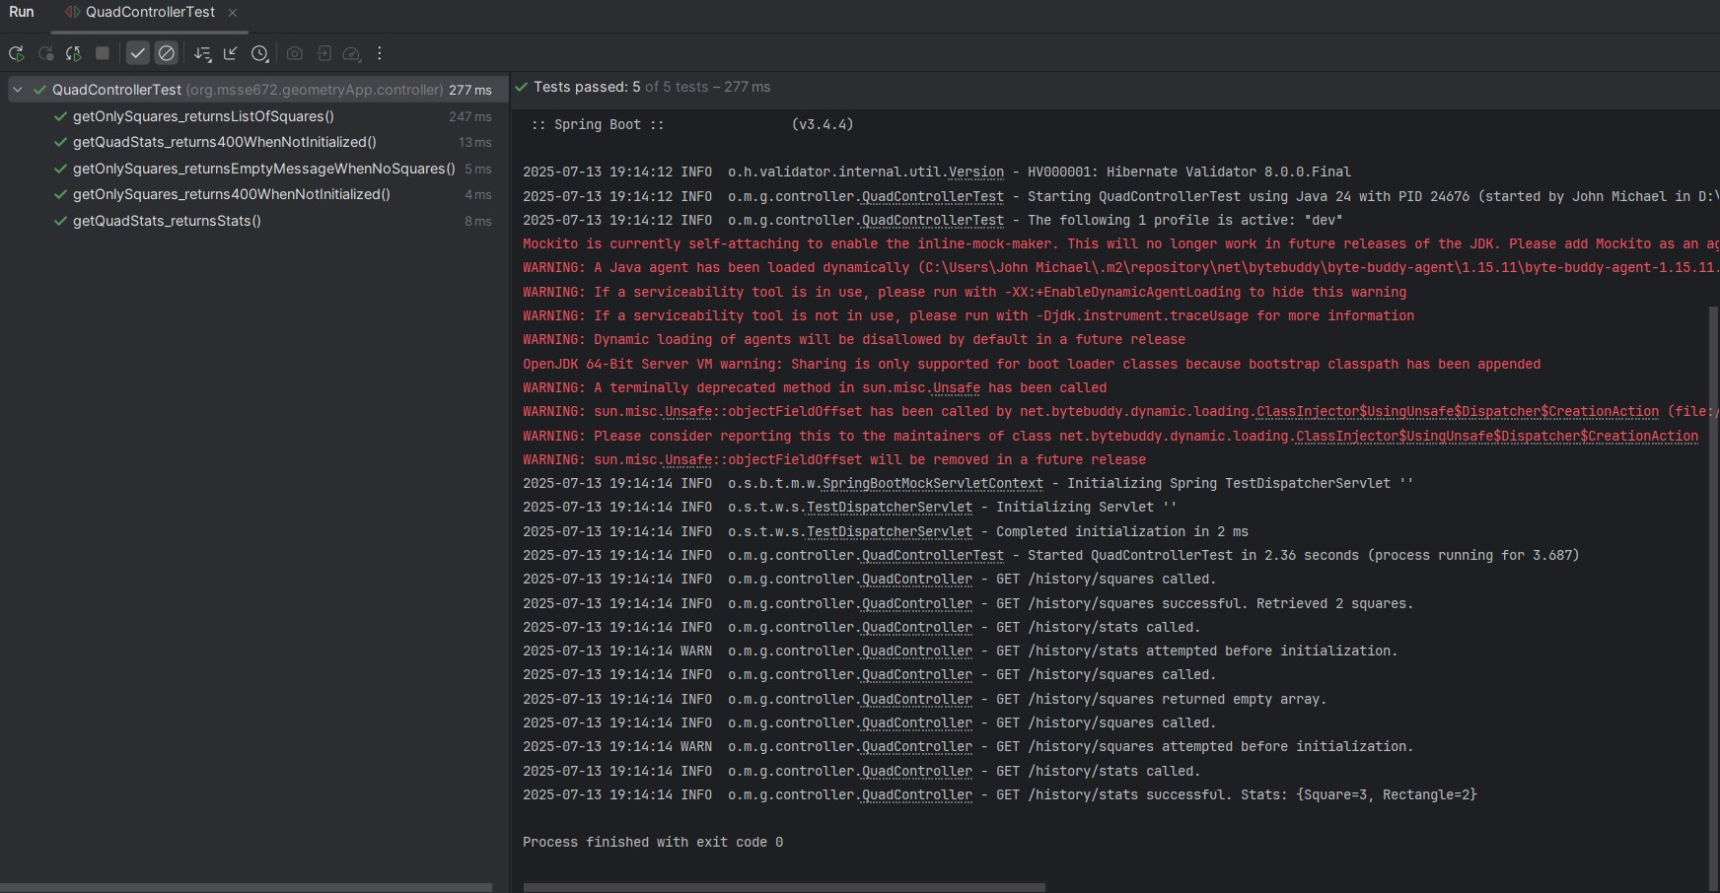****This screenshot shows successful execution of JUnit tests for the QuadController, validating REST endpoints and integration with service logic****.***

**Screenshot 2 – Service Layer JUnit Tests**

*This screenshot shows successful execution of unit tests for the service layer, including those that validate collection-handling.*

**JUnit Coverage Table**

|  |  |  |
| --- | --- | --- |
| **Test Class** | **Method Tested** | **Purpose** |
| QuadServiceTest | getAllQuads() | Validates storage and return of all posted quads |
| QuadServiceTest | getOnlySquares() | Ensures filtering by shape type using Stream API |
| QuadServiceTest | getQuadStats() | Verifies aggregation of type counts and total count |
| QuadControllerTest | GET /quad/all | Confirms HTTP 200 and full list is returned |
| QuadControllerTest | GET /quad/stats | Confirms HTTP 200 and correct stats returned in JSON |

**Notes**

* This project will be maintained in a public GitHub repository for version control and learning practice.
* A `.zip` file containing only `.java` files and the `/Docs` folder is submitted as per course instructions.
  + Docs/week2
* Screenshots are provided in this single document for clarity, as per the professor’s recent guidance.
* All screenshots referenced in this document are included in the project ZIP file under the directory: Docs/Week2/assets/.