MSSE672 – Component Based Software

Student: John Michael Kreski

Instructor: Mohammad Abu Matar

Assignment: Week 5 - JUnit Test Execution – XML-Based ServiceFactory

Date: 08/03/2025

File Name: HWUnitTestExecution.doc

## Summary

This week's tests focused on validating the functionality of the new ServiceFactory class and its ability to dynamically instantiate a QuadService implementation defined in an external XML file. A custom DummyQuadServiceImpl class was used to support isolated, Spring-free testing of the factory pattern and related service methods.

All tests were written using JUnit 5 and verify the correctness of:

* XML parsing and validation against XSD
* Reflection-based instantiation of a service class
* Core methods from the QuadService interface (e.g., insertQuad(), getOnlySquares(), getLargestSideEverSubmitted())

Print statements were included in each test to confirm behavior and visualize execution in the console. These outputs were captured as screenshots and are included in this document.

**JUnit Test Results**

**Screenshot 1 – Test Runner Screenshot**

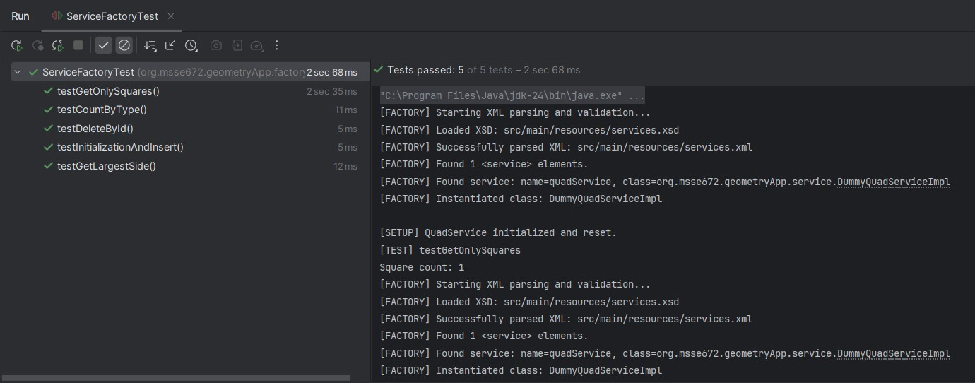 *Full JUnit test panel showing all green checkmarks for the ServiceFactoryTest class.*

**Screenshot 2 – Individual Test Output**

*Test console output for test method as well as ServiceFactory instantiation*

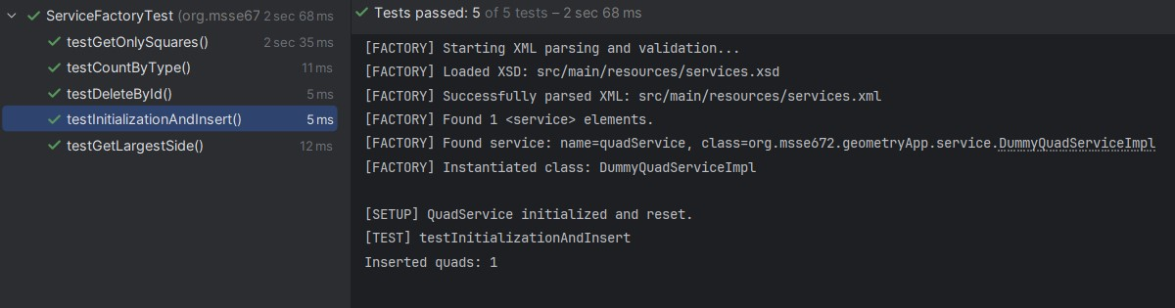

**JUnit Coverage Table (ServiceFactoryTest.java)**

|  |  |
| --- | --- |
| **Test Method** | **Purpose** |
| testInitializationAndInsert() | Verifies that inserting a quad initializes the service and adds an entry |
| testGetOnlySquares() | Confirms filtering logic correctly returns only square-shaped entries |
| testGetLargestSide() | Ensures the correct largest side is computed from inserted quadrilaterals |
| testCountByType() | Checks the classification counts by type in the dummy service |
| testDeleteById() | Confirms that quads can be deleted by ID and the list reflects the change |
|  |  |
|  |  |
|  |  |
|  |  |
|  |  |

**Notes**

* The ServiceFactoryTest.java test class uses a test-local ServiceFactory to load the DummyQuadServiceImpl defined in services.xml.
* The factory is tested independently from the main Spring Boot application and does not rely on any Spring context.
* Console print statements are used for clarity and output visibility during test execution.
* All tests passed successfully.