MSSE672 – Component Based Software

Student: John Michael Kreski

Instructor: Mohammad Abu Matar

Assignment: Week 6 - JUnit Test Execution – Authentication

Date: 08/10/2025

File Name: HWUnitTestExecution.doc

## Summary

This week’s unit and integration testing focused on the new auth module for handling session-based authentication. The following test classes were created to verify correct behavior of the authentication service and its integration with the application:

* **InMemAuthServiceImplTest**  
  Verifies logic for successful and failed authentication attempts, logout behavior, and session tracking. Tests confirmed that valid credentials grant access while invalid inputs return expected false values and do not authenticate the session.
* **AuthControllerTest**  
  Integration tests for /auth/authenticate and /auth/logout endpoints. These tests ensure that login returns a 200 OK with correct credentials and that logout properly invalidates the session.
* **AuthQuadControllerTest**  
  End-to-end tests for authentication enforcement on the /quad/type endpoint. One test verifies a 401 Unauthorized response when no authentication is present; another confirms a 200 OK response after logging in.

All tests were executed successfully using Spring Boot's integration test environment. Where appropriate, MockMvc was used to simulate HTTP requests, and session state was preserved to ensure accurate simulation of user interaction flows.

**JUnit Test Results**

**Screenshot 1 – InMemAuthServiceImplTest**

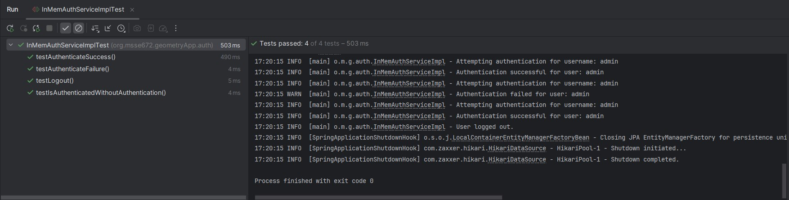 *Full JUnit test panel showing all green checkmarks for the InMemAuthServiceImplTest class.*

**Screenshot 2 – AuthControllerTest**

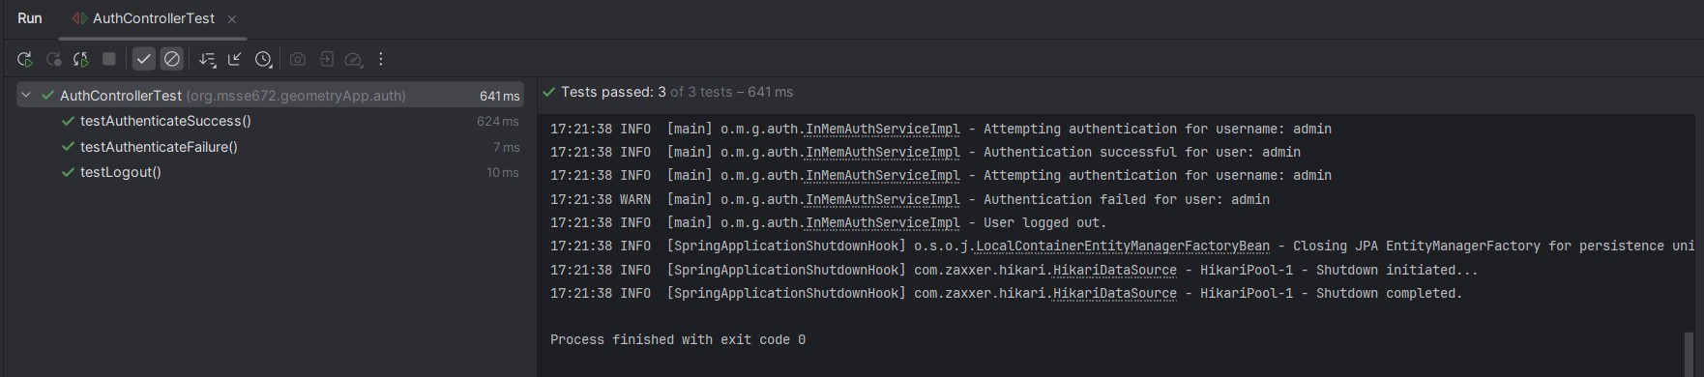 *Full JUnit test panel showing all green checkmarks for the AuthControllerTestclass.*

**Screenshot 3 – AuthQuadControllerTest**

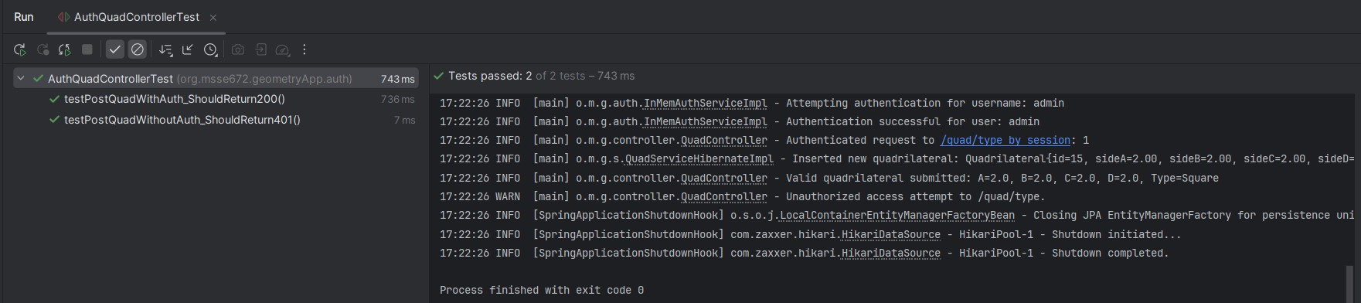 *Full JUnit test panel showing all green checkmarks for the AuthQuadControllerTestclass.*

**JUnit Test Coverage Summary**

* **InMemAuthServiceImplTest**
  + testAuthenticateSuccess — Confirms valid login sets session to authenticated
  + testAuthenticateFailure — Confirms invalid credentials fail to authenticate
  + testLogout — Verifies session is invalidated and no longer authenticated
* **AuthControllerTest**
  + testAuthenticate_ValidCredentials_ShouldReturn200 — Auth endpoint returns 200 with correct credentials
  + testAuthenticate_InvalidCredentials_ShouldReturn401 — Auth endpoint returns 401 with incorrect credentials
  + testLogout_ShouldReturn200 — Logout endpoint works and returns 200 OK
* **AuthQuadControllerTest**
  + testPostQuadWithoutAuth_ShouldReturn401 — Unauthorized user is blocked from POST
  + testPostQuadWithAuth_ShouldReturn200 — Authenticated user can successfully POST

**Notes**

* The full tests/ folder is included in the submission and contains only .java files as required.
* Each week's documented tests are specific to that week's activity and follow a consistent Spring Boot testing structure using JUnit 5.
* Logging within this week's tests was done using System.out.println() or MockMvc console output for clarity and traceability during test runs.
* Tests were run using the Spring Boot context with @SpringBootTest and MockMvc, simulating session handling for authentication.
* All test classes passed except for a deprecated approach in the logout test, which was corrected by switching to session-based checks instead of calling session.invalidate() directly.