MSSE672 – Component Based Software

Student: John Michael Kreski

Instructor: Mohammad Abu Matar

Assignment: Week 7 - JUnit Test Execution – Threading

Date: 08/17/2025

File Name: HWUnitTestExecution.doc

## Summary

This week’s unit testing focused on verifying the refactored authentication architecture (migrated from Week 6’s REST/session-based logic to threaded socket-based token authentication) and ensuring correctness of threading, token management, and gated access to protected endpoints.

Tests validate:

* Token issuance and invalidation via socket server on test port 9191.
* Thread-safe credential handling in InMemAuthServiceImpl.
* Gating filter (SocketAuthFilter) behavior under valid/invalid token conditions.
* Regression of Week 6 REST-based tests, updated to operate against the new token-based model.

**JUnit Test Results**

**Screenshot 1 – AuthControllerTest**

*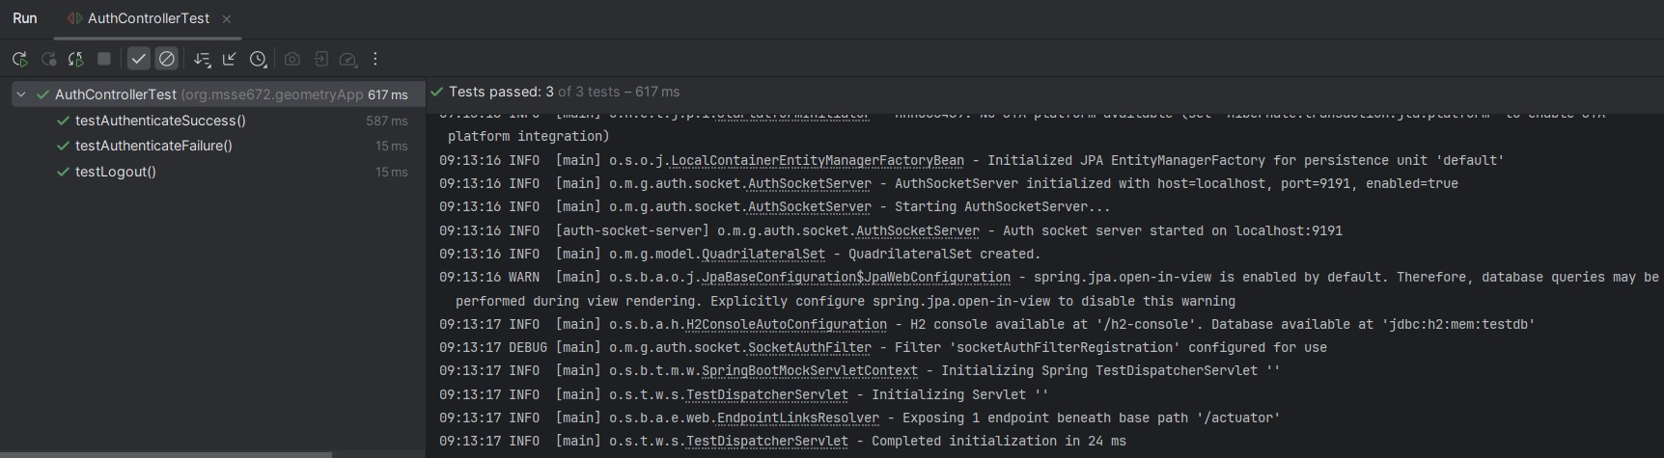Token issuance/invalidation verified*

**Screenshot 2 – InMemAuthServiceImplTest**

*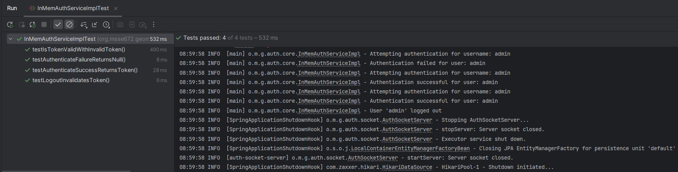Validation of token storage and invalid login path.*

**Screenshot 3 – AuthSocketServerTest**

*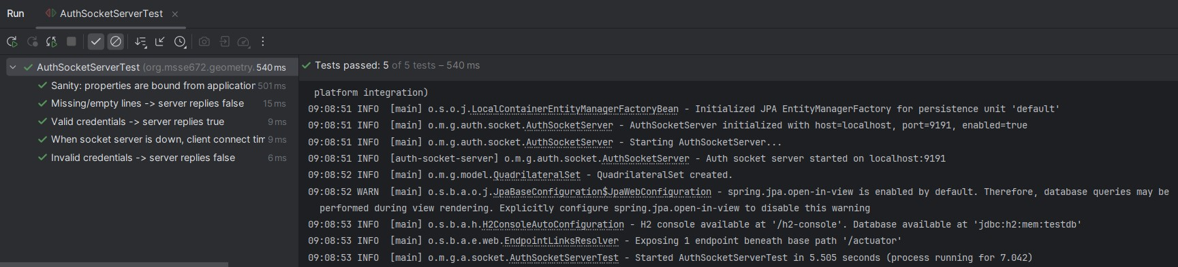Threaded socket login success/failure handling.*

**Screenshot 4 – AuthQuadControllerTest**

*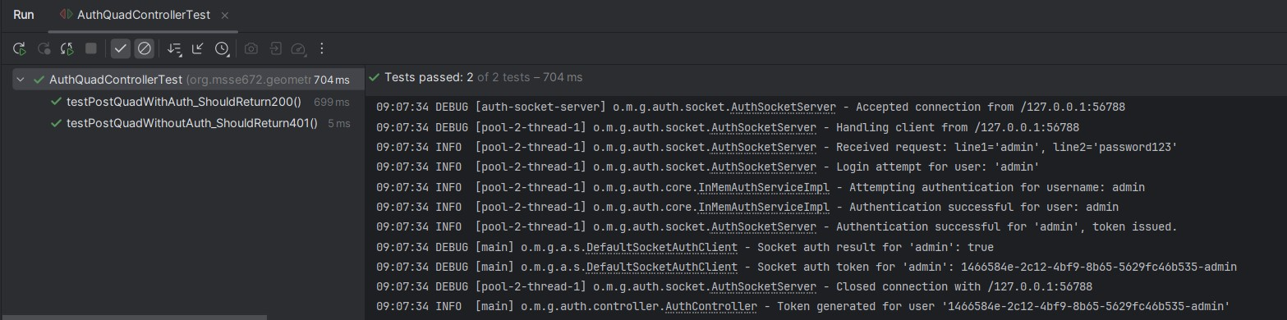Enforcement of token gating on /quad.*

**JUnit Test Coverage Summary**

1. **AuthControllerTest**
   * Verifies /auth/authenticate issues a valid UUID token.
   * Verifies /auth/logout invalidates token.
   * Refactored from Week 6’s session-based tests to validate token workflow.
2. **InMemAuthServiceImplTest**
   * Validates credential-based login and token issuance.
   * Ensures invalid credentials return null and no token is stored.
   * Confirms ConcurrentHashMap storage and retrieval of active tokens.
3. **AuthSocketServerTest**
   * Tests threaded socket server issuing tokens on valid credentials.
   * Verifies multiple parallel connections handled correctly.
   * Confirms invalid credentials return denial without token.
4. **AuthQuadControllerTest**
   * Verifies /quad endpoints require a valid Auth-Token header.
   * Passing case: request with valid token succeeds.
   * Negative case: missing/invalid token returns HTTP 401.

**Notes**

* @ActiveProfiles("test") is used on test classes that utilize the socket server so the application-test.properties with port 9191 and auth.socket.enabled=true is used
* Tests from Week 6 were refactored to align with token-based authentication and socket threading, replacing prior HTTP session logic.
* Additional socket-focused tests were introduced to satisfy Week 7 objectives.
* Full src/test/java directory is included in the submission archive to provide continuity across weeks.