|  |
| --- |
|  |
|  |
|  |

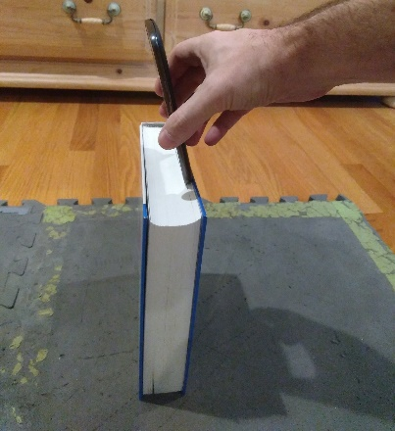

Red taped 2" square centered on tile.

17.5 inches from tile to frontmost edge of book. Book dimensions: 1.75 inches thick, 9.5 inches tall. Motorola G4 placed on top of book. Phone leaning forward the width of the book (1.75 inches). Front camera used with lens center 5.25 inches from bottom edge and 2.3 inches from left edge.