John Vanhessche

Web 335

November 13, 2022

Assignment 4.2

Web335DB.users

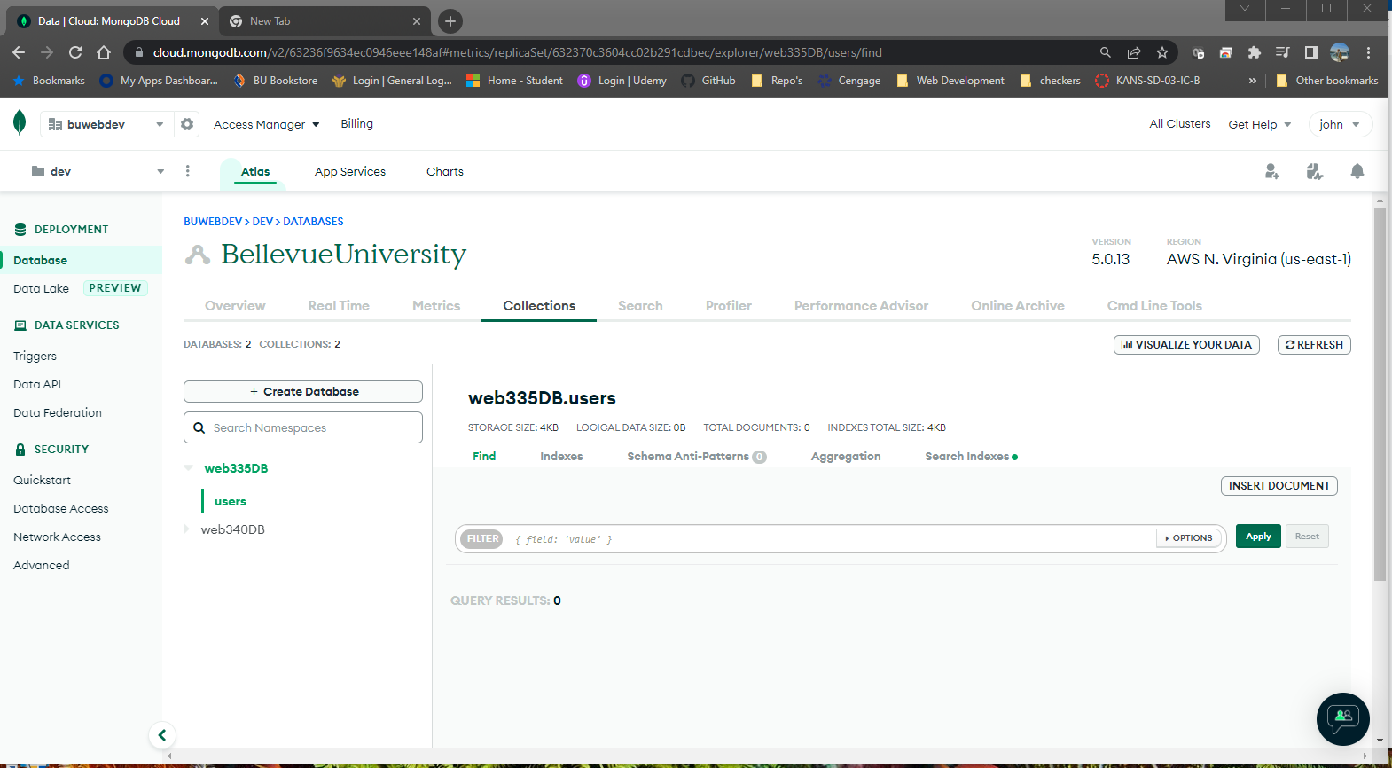

Web335.users.roles

Web335_user

Mongosh –help

