John Vanhessche

Web 420

11/16/2022

Assignment 4

findComposerById

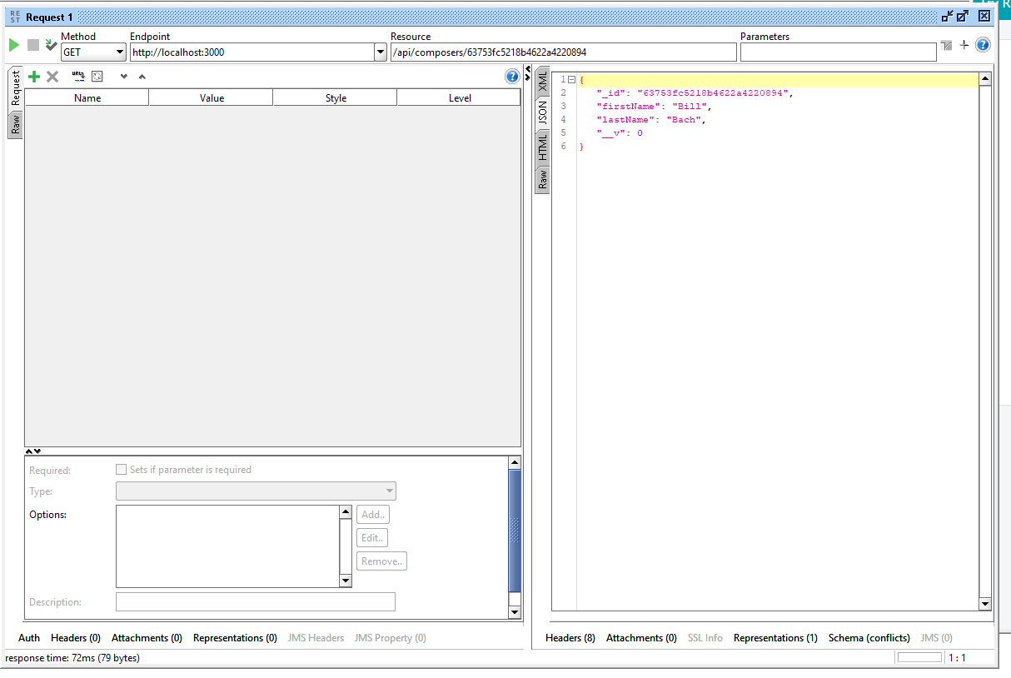

findAllComposers

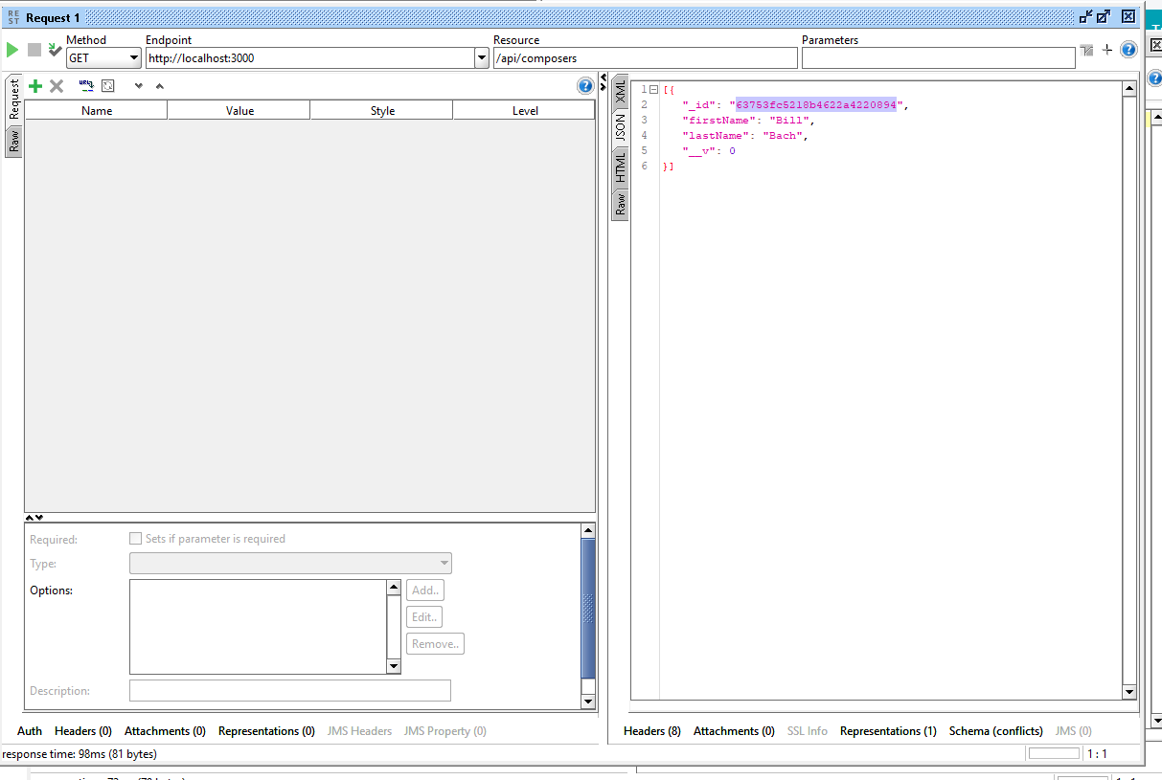

createComposer

