Part 1/2:

Github name is jtp098

Part 3:

What is GitHub? When was it created? Why? By who? What similar platforms exist? Why would you use such a platform? (Answer between 5 and 10 lines)

Answer:

GitHub is a cloud-based Git repository hosting service; it is built around Git and offers all of the distributed version control features and code management functionality included with Git. GitHub was founded in 2008 by Chris Wanstrath, Tom Preston-Werner, Hyett and Chacon. It was created to provide to provide a distributed storage system for source code built on top of Git. Some similar platforms to git are GitLab and Atlassian’s Bitbucket, which are SaaS and PaaS. You would use this platform in order to store and manage your code, on GitHub in a distributed format, and provide with version control using Git.

Part 4

All notes and screenshots in the attached.

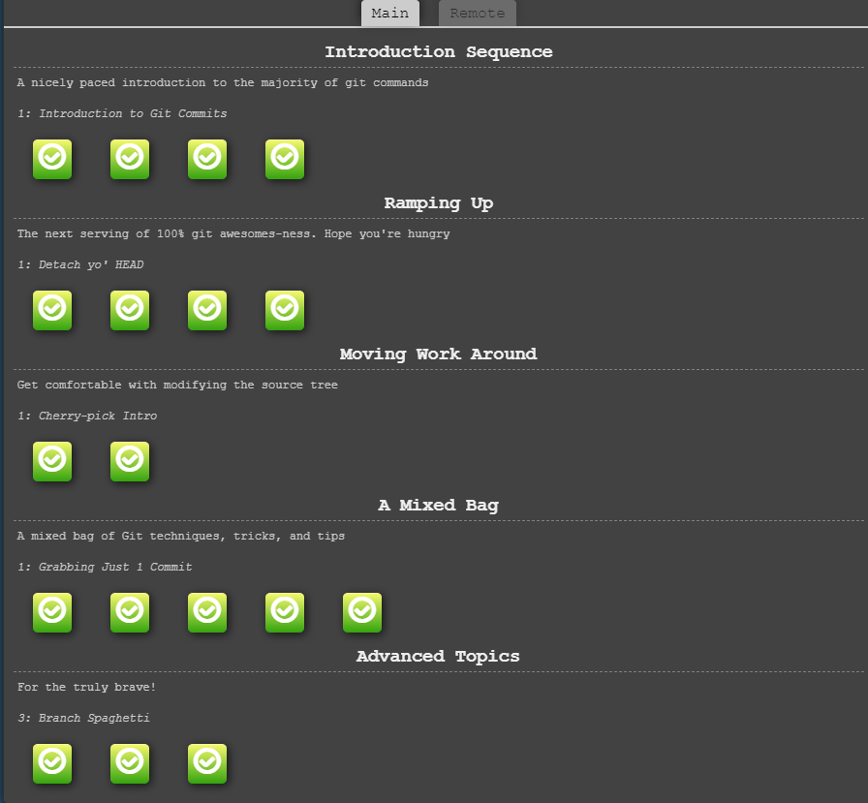

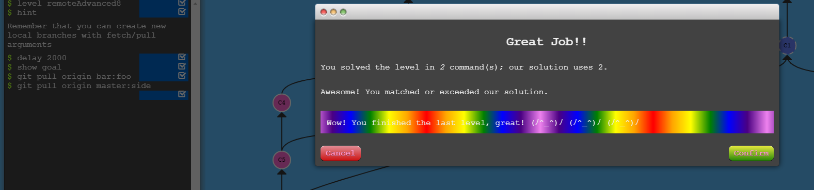

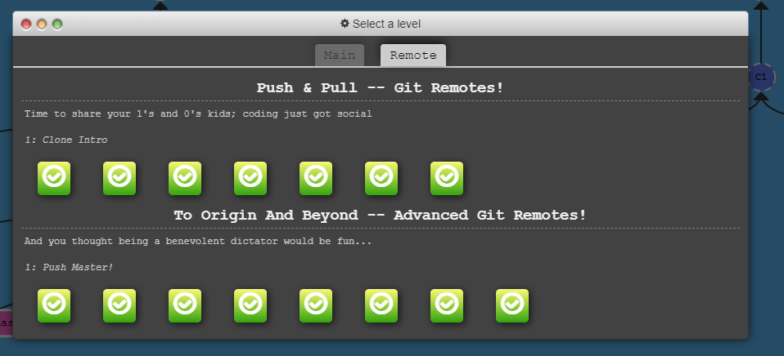

Part 5

Define the following terms in the context of Git (2 lines maximum):

* Repository
  + Is a folder inside of a project where all changes are tracked that are made to the project overtime to create a history of all the commits.
* Commit –
  + Is a snapshot of all the files in a directory in a lightweight version that is like a copy of the whole folder. On each commit the set of changes compressed into a delta and copied each time.
* Push
  + The command used for uploading your changes to a specified remote and update that remote to incorporate your new commits
* Branch
  + Branches are pointers to a specific commit. They can be used to divide up bigger projects where you need include the current commit and the parent commits.
* Fork
  + Is different from clone in that you copy a repo where you can make changes and not affect the original project
* Merge
  + Is used to create a special commit that has two unique parents. For example, if you branch off to fix a feature merge is used to combine the fix back into the master.
* Clone
  + Is used to create a local copy of a GitHub repository.
* Pull
  + Is a combination of a git fetch and a merge. So essentially fetching from the master and then merge that into the remote master ie. “o/master”
* Pull request
  + Is used by teams where everyone shares a single repo. They are used to manage changes from contributors since you can notify project maintainers of changes.