

**Program: Specialized**

***Course Code: CSE 131***

***Course Name: Computer Programming***

***Examination Committee***

**Dr. Bassem Amin**

**Dr. Mohamed Sobh**

**Ain Shams University**

**Faculty of Engineering**

**Spring Semester – 2020**

RESEARCH & PROJECT SUBMISSIONS

**Student Personal Information for Group Work**

|  |
| --- |
| **Student Codes:** |
| 1801656 |
| 1807040 |
| 1803485 |
| 1808270 |
| 1801700 |

|  |
| --- |
| **Student Names:** |
| Mariz Sabry Zaki |
| Mario Effat Ezzat |
| Menna-Tullah Hesham Mohamed |
| John Mgady William |
| Mahitab Mohamed Emara |

**Plagiarism Statement**

I certify that this assignment / report is my own work, based on my personal study and/or research and that I have acknowledged all material and sources used in its preparation, whether they are books, articles, reports, lecture notes, and any other kind of document, electronic or personal communication. I also certify that this assignment / report has not been previously been submitted for assessment for another course. I certify that I have not copied in part or whole or otherwise plagiarized the work of other students and / or persons.

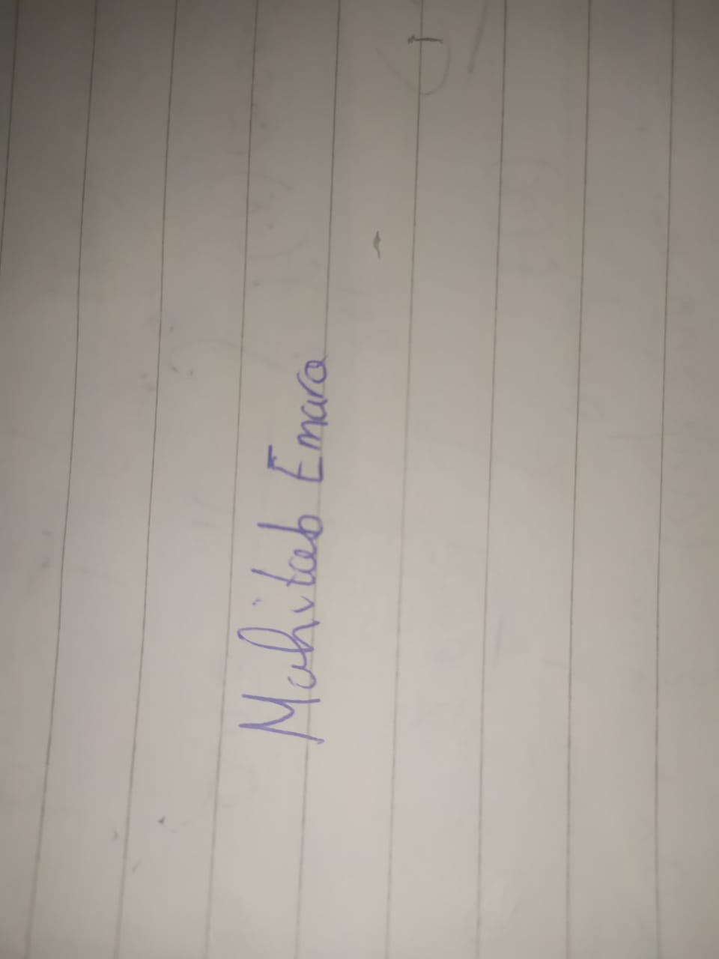

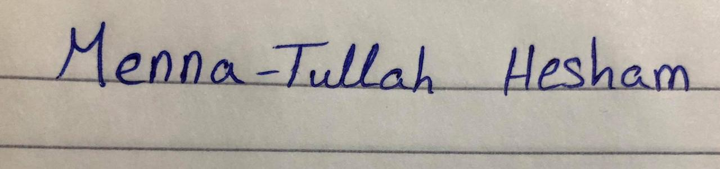

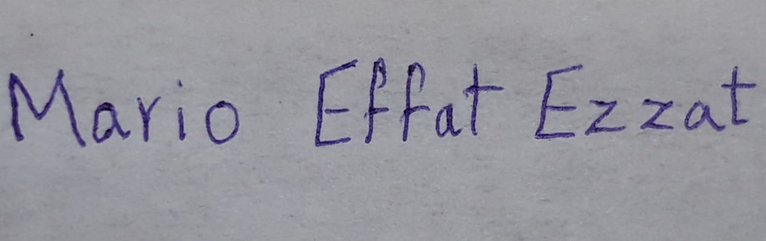



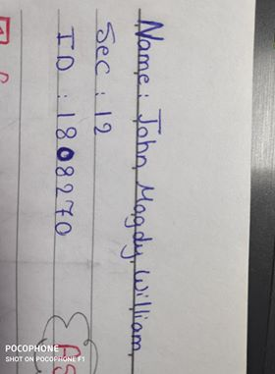

**Date:**

**6/6/2020**

**Signature/Student Name:**

## **Participation:**

Each individual participated by 20%, we have divided the project task into 5 smaller tasks,

1. Taking the matrix from the user and saving it.
2. Performing the addition/subtraction/multiplication.
3. Finding the inverse Matrix.
4. Performing the Division/Transpose.
5. The interface with the user.

Each participant chose one task.