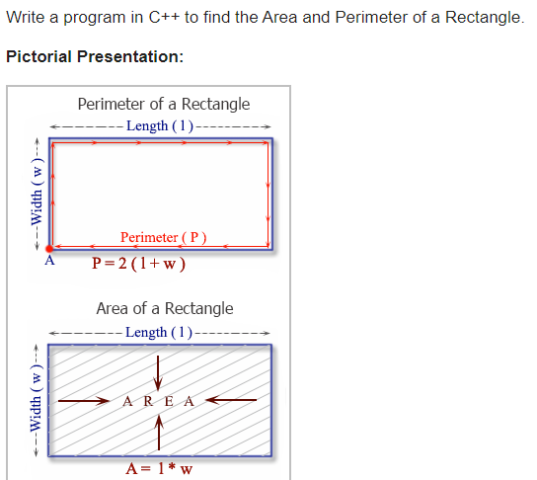

Your program should prompt the user for the length and the width to use. Your final solution should print out the result. An example is shown below

------------------------------------------------------------------------------------------------------------------------------------------

Please enter in the length of the rectangle: 10

Please enter in the width: 15

The perimeter of the rectangle is: 50

The area of the rectangle is: 150