# TITLE PAGE

|  |
| --- |
| **CAGAYAN STATE UNIVERSITY CARIG CAMPUS** |
| **HEALTH-MET V.2: AN AUTOMATED ACCIDENT PREVENTION AND DETECTION INTEGRATED WITH MOBILE APPLICATION AND ANTI-THEFT** |
| **JONET ABELIDO BERNARDEZ**  **JESSICA PACQUING CONCORDIA**  **CARL MARK ABBATUAN DOMINGO**  **OLIVIA UGADDAN** **LUMAUAN** |
| **SUBMITTED TO THE FACULTY OF THE**  **DEPARTMENT OF ELECTRONICS ENGINEERING**  **COLLEGE OF ENGINEERING**  **CAGAYAN STATE UNIVERSITY CARIG CAMPUS**  **IN PARTIAL FULFILLMENT OF THE REQUIREMENTS**  **FOR THE DEGREE OF** |
| **BACHELOR OF SCIENCE IN ELECTRONICS ENGINEERING** |
| **DECEMBER 2023** |

**This thesis/field practice manuscript can be accessed:**

|  |  |
| --- | --- |
| **By the general public** | **Yes** |
| **Only after consultation with author/thesis adviser** | **No** |
| **Only to those bound by confidentiality agreement** | **No** |

**Signature of Student:**

**Signature of Adviser:**

# APPROVAL PAGE

ABSTRACT

**AUTHORS’ NAMES (LAST, FIRST MIDDLE; LAST, FIRST MIDDLE)**. College of Engineering, Cagayan State University Carig Campus. Month and Year of Manuscript Submission. **Thesis Title.**

Major Adviser: Prof. ____________

The abstract shall not be more than 350 words and shall be written in third person point of view. The abstract or executive summary shall be single-spaced and limited to one paragraph only. The first line of the paragraph shall be indented ½ inch to the right and shall start three (3) spaces below the line containing the name of the major adviser. Also, include around 3-6 keywords after the abstract. Keywords are a tool to help indexers and search engines find relevant papers. Keywords must be chosen carefully. They should represent the content of the manuscript and they should be specific to the field or sub-field of the study. For example, consider the topic “Direct observation of nonlinear optics in an isolated carbon nanotube.” Examples of poor keywords are molecule, optics, lasers, energy lifetime. Better keywords would be single-molecule interaction, Kerr effect, carbon nanotubes, energy level structure.

Keywords: manuscript formatting, guidelines, examples

# INTRODUCTION

## Background of the Study

Nowadays, using a motorcycle is one of the most in-demand means of transportation, as it is one of the most essential and fastest ways of transport. A motorcycle is a two-or three-wheeled vehicle used for long-distance travel, commuting, sports racing, and also as a means of public transportation.

In the Philippines, a motorcycle is one of the most convenient forms of transport, and it is rapidly becoming the most common means of transportation. Due to its size and speed, motorcyclists prefer it for daily commuting. Together with the increasing number of motorcycle users, cases of motorcycle accidents have also increased over the years. According to the Land Transportation Office (LTO), motorcycle accidents are currently the ninth (9th) leading cause of death among Filipinos (Diaz, 2019). According to the latest Metro Manila Accident Recordingand Analysis System**(**MMARAS) report, the Metropolitan Manila Development Authority (MMDA) recorded a total of 26,768 motorcycles involved in road accidents last year, which was an increase of 1,560 from the previous year. The grand total number of vehicles involved in incidents, however, was down from 125,010 in 2020 to just 112,228 in 2021 (Grecia, 2022).

In motorcycle accidents, the most common mechanism of injury was blunt trauma (67%). There were 18 cases of vehicular crashes, 89% of the patients were not wearing helmets. All work-related injuries reported absence of protective gear. Alcohol intoxication was reported in 30% of assault cases and 72% of vehicular crashes (Macenas and Tan, 2021).  As stated in a paper published by the World Health Organization, over 90% of motorcycle deaths didn't wear helmets. In the Philippines, it is stated under Republic Act No. 10054, or the Motorcycle Helmet Act of 2009, that it is mandated that every motorcycle rider should wear their helmet. The said law mandates all motorcycle riders to wear standard motorcycle helmets while driving and provides penalties for violations.

One factor that contributes to road accidents is driving drunk, especially while driving a two-wheeled motorcycle. If a driver or motorcycle rider is found to have a blood alcohol content of at least 0.05 percent, RA 10586 imposes serious punishments, including prison time and the permanent loss of their driver's license (Rosales, 2021). A small amount of alcohol in the body can reduce coordination, slow down reactions, affect vision, and impair judgment.

Getting the right medical attention is another problem that motorcycling accident victims face. In a significant number of vehicular accident scenarios, the victims are unable to call for assistance. In such situations, a plan of action is required which includes informing relevant authorities and rapid provision of medical assistance to the victims (Kumar and Deepak, 2017). The same is true for those who arrive at a medical facility too late for treatment. A victim's golden hour for survival is sixty minutes after suffering a traumatic injury. This period of time is crucial since survival depends on it.

Wearing a helmet is one way to protect yourself from accidents. A helmet is a type of protective gear worn on the head to protect it from injuries. It is used in a variety of activities, including sports, hazardous work activities, and transportation (e.g., motorcycle and bicycle helmets). Motorcycle helmets come in six (6) different types. Each type has its own individual purpose and form. The full-face helmet provides the most coverage around the head and neck and is considered t he safest type of motorcycle helmet. The other five (5) helmets offer less protection than the full-face helmet but differ in terms of comfort and ventilation. According to a study on helmet damage and motorcycle head injuries, the chin receives fifty percent (50%) of the severe impacts during an accident, and only a full-face helmet can protect your chin and jaw.

However, motorcycle helmet theft is a growing concern that poses a significant problem in various communities. The theft of helmets not only results in financial losses for motorcycle owners but also compromises the safety of riders who may be forced to use substandard or improperly fitted helmets. This issue is particularly prevalent in urban areas, where the anonymity provided by crowded spaces can embolden thieves. The ease with which helmets can be taken from parked motorcycles makes them attractive targets.

Currently, the concept of Smart Helmet has been implemented in a variety of ways. One notable study for smart helmets in the Philippines is by Tayag and Capuno, where the system and hardware development are a combination of many features from previous Smart Helmet projects, integrating IoT with cloud-based infrastructure. The said features are IoT, Cloud Infrastructure, GPS, Location Tracking, Short Message Service (SMS)/Push Notification, and an alcohol level breath analyzer, integrated with the anti-theft features by sending the GPS location of the motorcycle when stolen. The system's implementation lacks a feature that prevents the motorcycle from starting if the rider is not wearing a helmet or if the rider's alcohol level is too high.

For these reasons, this study proposed adapting the said system and integrating a smart locking feature. The proposed system aims to make it necessary for motorcycle riders to wear helmets and to provide a safety feature that contributes to road safety and accident detection, as well as to prevent accidents beforehand by detecting the rider's alcohol level and sending messages to emergency contacts, notifying them of the situation and allowing them to take rescue steps ahead of time. The researchers also aim to address the need for proper implementation of helmets when riding a motorcycle, especially when there is a possibility of an accident in remote areas where it may be difficult to locate the rider. Also, it aims to minimize helmet robbing incidents by integrating anti-theft system features. This will be possible with the use of Global System for Mobile Communication (GSM) and Global Positioning System (GPS) technology, microcontrollers, sensors, and a system immobilizer.

With the advancement of technology, the researchers aim to develop a mobile application for the system which will serve as the user interface. This will feature real-time tracking, anti – theft control feature, and battery management.

The focal point of this study is the development and integration of a mobile application designed to complement and enhance the functionalities of Health – Met v.1. By incorporating a mobile application, the research endeavors to provide users with a seamless and intuitive interface for monitoring, controlling, and receiving updates on the status of the system. This strategic integration aims to bridge the gap between the Health – Met and end-users, fostering a more user-centric and technologically advanced experience.

## Conceptual Framework/Theoretical Framework

The Input-Process-Output (IPO) framework will guide the researchers in visualizing the required processes and output of the study. Immobilizing the motorcycle's engine based on whether a motorcycle rider is wearing a helmet and the rider's alcohol level, as well as monitoring the rider's well-being, will require the input of multiple sensors. These sensors will include a touch sensor to determine whether the rider is wearing a helmet, an alcohol sensor to detect the rider's sobriety, a reset button for reinitializing the systems, an accelerometer to detect and confirm the occurrence of an accident, a tilt sensor to detect if the motorcycle is parked properly, and a GPS to track the motorcycle's location by means of its longitude and latitude. Additionally, the GPS and GSM module will be utilized as the anti–theft system for the helmet and motorcycle.

Data gathered from the sensors will be sent to the microcontroller for processing. The outputs will be the automatic locking of the ignition switch and the monitoring of the motorcycle rider's current location and real-time status.Top of Form

**OUTPUT**

**PROCESS**

**INPUT SIGNALS**

Detect rider’s presence by wearing the helmet and disarm ignition switch if no presence is detected.

Detect alcohol presence in breath and disarm ignition switch if alcohol concentration is above threshold.

Detect force caused by vibration and send SMS to relatives and rescuers.

Notice an abrupt shift in acceleration and confirms accident occurred through SMS.

Motorcycle engine ignition immobilization

* Touch Sensor
* Breath Analyzer
* Tilt Sensor
* Accelerometer
* GPS
* Reset Button

Real-time crash detection for motorcycle riders

Implementation of alert notification

GPS route tracking

**Figure 1.2.1. Conceptual Framework**

## Statement of the Problem

The alarming surge in motorcycle accidents across the Philippines has thrust the imperative need to prioritize safety measures for riders into the spotlight. Contributing factors, such as impaired driving and the neglect of helmet use, have fueled this worrisome trend, resulting all too often in tragic and fatal outcomes. Compounding the gravity of these accidents is the unfortunate reality of victims facing delays in seeking assistance or the tardy arrival of medical rescuers.

Moreover, the issue of motorcycle theft further compounds the challenges faced by both riders and communities in the Philippines. The increasing incidence of motorbike theft not only places a substantial economic burden on individuals but also amplifies overall safety concerns on the roads. Stolen motorcycles become potential tools for various criminal activities, serving as getaway vehicles in other crimes and thereby elevating risks for both riders and the broader public.

In addition to the critical road safety concern, the escalating problem of motorcycle helmet theft has emerged as a significant worry within communities. The theft of helmets not only strips riders of a crucial safety accessory but also undermines efforts to foster responsible riding habits. Communities grappling with this multifaceted issue find themselves navigating a complex landscape where the security of essential safety gear is compromised, significantly intensifying the risks associated with motorcycle riding.

## Objectives of the Study

The main objective of the study will be to enhance and develop the previous smart helmet by integrating an anti – theft feature and mobile application.

It will specifically aim to achieve the following:

1. To design and implement a control system that can be easily attached to a helmet.
2. It will send a notification and location when the helmet is out of range.
3. To customize an application program that will track the location of helmet in real-time.
4. Assess the performance and effectiveness of the “Health – Met v.2.: An Automated Accident Prevention and Detection Integrated with Mobile Application and Anti-Theft” in terms of:

a. functionality c. reliability

b. accuracy d. comfortability

## Hypothesis of the Study

The "Health – Met v.2.: An Automated Accident Prevention and Detection Integrated with Mobile Application and Anti-Theft" system does not show any significant difference in terms of functionality, reliability, accuracy, and comfortability compared to “Health – Met: An Automated Accident Prevention and Detection Gear for Motorcycle Riders”.

## Scope and Limitations of the Study

This study will focus on developing the hardware and software systems to prevent accidents by making it necessary for motorcycle riders to wear helmets and detecting accidents by monitoring the status of the motorcycle rider. The applied pressure to the touch sensor when the rider wears the helmet will determine whether the rider is properly wearing the helmet or not. The alcohol sensor will detect if the rider is drunk by the values that will be set according to road safety laws. A relay will be used to control the ignition switch of the motorcycle based on values received from the microcontrollers. The motorcycle unit system will only use the ignition switch and the battery of the motorcycle and not the motorcycle itself. To detect or report an accident, the accelerometer will detect a sudden change in acceleration, or the helmet will tilt beyond a certain angle. The system will not be able to identify if the wearer is the driver or a passenger.

An SMS notification notice will be sent with the necessary information, such as the rider's current location, to the registered mobile number/s of the first responder/s if the rider is drunk or an accident occurs. The location link sent by the system can be accessed using Google Maps. The first responders can be the rider's family, relatives, or emergency personnel.

The box where all the necessary components will be stored will be placed inside the helmet and the compartment box. The helmet unit system will be powered by rechargeable batteries, wherein the battery level indicator will be programmed in the mobile application to send alerts and notifications to the rider if it reaches a set threshold. It cannot be used while charging. Meanwhile, the motorcycle unit system will be powered by the motorcycle’s battery converted into a three (3) volt power supply.

The mobile application of the smart helmet will feature real-time tracking, an anti-theft control feature, and battery management. Alerts and notifications will also be displayed, allowing the user to determine possible happenings with the system. The mobile application's connection with the Arduino Mega 2560 will only range from 40 – 50 meters, in which the rider will not be receiving alerts and notifications from the mobile application if the rider is outside the range.

The helmet unit system will be installed in a free-size (57-60 cm) HNJ 855 full-face helmet. Given that the study's respondents will be motorcycle riders aged 18 to 40, the normal helmet size for them is likely to be medium to large.

Medical treatment of the motorcycle rider at the scene of an accident will not be covered and will be beyond the scope of this study.

**Research Locale**

This study will be conducted in Tuguegarao City, Cagayan. Motorcycle riders will be selected as respondents in the test of the prototype showing the device’s functionality and performance. This study will be conducted in the academic year 2023 – 2024.

## Significance of the Study

The integration of mobile application and anti-theft feature to the Health - Met v.2. significantly empowers users by providing convenient access to the real-time tracking, anti – theft control feature, and battery management of the system. This study could benefit different members of society:

**Authorities** – They will be informed automatically and will take appropriate action. This study will also help traffic enforcers in their primary mission of implementing various transportation laws, rules, and regulations.

**Motorists** - This study could be useful for them by requiring them to use the smart helmet whenever they ride their motorcycles in order to avoid fatal accidents and ensure that the rider gets proper and immediate medical assistance in the event of an accident. The motorists' preferred first responders can track the motorist's location and will be notified immediately if the rider has consumed an excessive amount of alcohol or is involved in an accident.

**Helmet Manufacturers and Suppliers** - If fully implemented, the demand for smart helmets will increase, and manufacturers or suppliers will benefit from it.

**Future Researchers** - This study may serve as a useful reference and help society in conducting future relevant studies. As a result, the research's success might help future researchers in developing wearable technologies that could be beneficial for safe transportation.

## Definition of Terms

1. Accelerometer - It is an electronic sensor used to detect the sudden change of acceleration of the motor.
2. Alcohol Sensor - It is used to determine if the rider is under the influence of alcohol.
3. Arduino - Arduino is an open-source electronics platform based on easy-to-use hardware and software. It is the primary microcontroller that will be used in the proposed system where sensors and other components will be connected.
4. Buzzer - An electronic device that makes a buzzing noise and is used for signaling if accident happens.
5. Global Positioning System (GPS) - It is used for real - time location for helmet theft and pinpoint the location of the rider if an accident happens.
6. Global System for Mobile Communication (GSM) - It is a digital cellular technology used to transmit the alerts and location of the rider to the rescuers and relatives if an accident occurs.
7. Google Maps - It is used to access the location link and track the real-time location of the rider.
8. Ignition Switch – It is a [switch](https://en.wikipedia.org/wiki/Electrical_switch) in the control system of a [motor vehicle](https://en.wikipedia.org/wiki/Motor_vehicle) that activates the main electrical systems for the vehicle,
9. Microcontroller - It serves as the central processing unit that manages and controls various functionalities and features integrated into the helmet.
10. Relay – It is an electrically – controlled switch that open and close the circuits by receiving electrical signals from outside sources.
11. Reset button - It is a button that will be used to indicate the accident is not serious and to avoid the possibility of a false positive when pressed.
12. Security - The state of being free from unauthorized access, or damage of the smart helmet.
13. Sensor - These are the devices integrated in the microcontroller and used to enhance safety.
14. SMS (Short Message Service) - It is a form of text messaging that will be sent to the registered mobile number/s with the necessary information.
15. Sobriety - It is the condition of not having any measurable levels or effects of alcohol.
16. Wi-Fi - It is used as the data transmission module of the system.

# REVIEW OF LITERATURE

## Motorcycle accidents in the Philippines

According to Statista, a market and consumer data provider, motorcycle ownership increased from around 720,000 in 2001 to slightly more than 1.7 million in 2019. This number is expected to exceed 2 million this year. However, according to a Metro Manila Development Authority report, an average of 86 motorcycle accidents occurred daily on Metro Manila streets in 2019. Argusino (2021) states that 31,279 accidents of varying severity were reported, a 17 percent increase from 2018 statistics. There were 221 deaths reported in the 31,279 accidents.

Based on the World Health Organization Global Status on Road Safety 2018, 1.28 million people died in road accidents globally in 2018, with motorcycle riders accounting for 28% of those deaths. Motorcycle riders account for more than half of those killed in road accidents in the Philippines. Data from the Philippine Statistics Authority (PSA) indicate that road traffic deaths increased by 39% from 7,938 deaths in 2011 to 11,096 deaths in 2021. Road traffic injuries are the leading cause of death among Filipinos 15-29 years old, and a major killer among children.

In a study conducted by Punsalang (2020), motorcycle riders often get the most serious injuries, followed by passengers and pedestrians. Few injuries were recorded among occupants of passenger vehicles, which is understandable given that motorcycles lack the protection provided by an enclosed four- wheeled vehicle.

According to Laurel (2017), the legal limit for a driver's blood alcohol concentration (BAC) in the Philippines is 0.05% (0% for bus drivers and motorcycle riders). With a lower BAC limit, it is expected that the Anti-Drunk Driving Law (Republic Act No. 10586) will be enforced more strictly in the Philippines.

**2.2. Motorcycle and Helmet Theft**

Motorcycle theft is a common issue worldwide, and helmets are often targeted along with the entire motorcycle. In an article by Reyes (2017), Highway Patrol Group (HPG) reported about 150 motorcycles are stolen every week in Metro Manila alone or an average of 21 per day. HPG spokesman Superintendent Elizabeth Velasquez also reported that in 2014, a total of 11,870 motorcycles were stolen, while 10,771 were taken in 2013.

 In fact, during the past four years, the highest number of motor napping (motor theft) in the country has consistently been recorded. As per National Capital Region Police Office’s (NCRPO) Regional Investigation and Detection Management Division (RIDMD) that in 2015, over 3,000 motorcycles have been stolen from January-March alone. The figures show a massive 11.89% jump from the statistics during the same period the previous year with only a little over 2,500 units were taken.

**2.3. Types of Motorcycle Helmets**

A helmet is one of the most critical pieces of safety gear when riding a motorcycle. Since motorcycles lack the structural protection that a car provides, riders must take additional precautions to protect their bodies, especially their heads, which is where helmets come in.

Padway (2023) states that motorcycle helmets come in various styles. Each tailored to specific preferences and riding conditions. The full-face helmet, a versatile choice suitable for most motorcycles, offers unparalleled head protection with extensive coverage around the head and neck. On the other hand, the modular helmet combines the benefits of a full-face helmet with the option to flip up the chin protection, providing adaptability for various riding scenarios.

For those who prefer a more open feel, the open-face helmet, often referred to as the "3/4 helmet," is popular for city riding and daily commuting. While it allows for easier breathing and a greater sense of freedom, it doesn't provide the same level of chin protection as a full-face helmet. Half helmets cover only a portion of the skull, making them less advisable for serious motorcycle racing but suitable for riders seeking minimalistic coverage.

Motocross helmets find their niche in trail riding, motocross races, and even street riding for those who use dirt bikes for daily transportation. Offering enhanced ventilation and a distinct visor design, these helmets cater to off-road enthusiasts. On the other hand, dual-sport helmets strike a balance, designed for regular road use while accommodating the option to use goggles for more robust off-road adventures. The diversity in helmet styles allows riders to choose based on their riding preferences, ensuring a combination of comfort, protection, and style on their journeys.

**Synthesis:** Full face helmet can be reliable for head protection with extensive coverage around the head and neck. Additionally, the impact absorbing liner is designed to absorb and disperse the energy of an impact if accident happens. The development of the Health – Met is to protect and help the rider in case of emergencies.

**2.4. Smart Helmet**

In 2019, Tayag et.al., proposed an IoT based Smart Helmet that can be used as a tool in helping a motorcycle rider when an accident happens. to inform the first responder of the accident location and inform the family of the motorcycle rider. Multiple sensors, such as a crash sensor for detecting a crash, an accelerometer used in conjunction with the crash sensor for detecting speed and impact, GPS to track the motorcycle's location by means of its longitude and latitude, and data for anti-theft are used to monitor the motorcycle's well-being in real-time. All data is sent to the cloud infrastructure for processing for real-time monitoring of the motorcycle rider's current status. The main components of the system are the Raspberry Zero-W for the helmet unit and the Arduino Uno for the motorcycle unit.

Layderos et al., (2019) explores the idea of maximizing the frequent use of helmets in motorcycle riding where it leads them to devise a system that makes use of microcontrollers and sensors to identify a variety of factors, including the rider's alcohol consumption and present location. It is compulsory to wear the helmet, without which the ignition switch cannot turn on thereby encouraging the use of helmets on a regular basis.

In the study of Ahuja and Bhavsar (2018), due to some of the late arrival of emergency rescuers in rural areas where there are no facilities to help, an idea to inform the responsible persons at the earliest if an accident occurs so that they can take the required actions to save the life of the injured person is integrated in smart helmets. It is composed of an Arduino microcontroller, GSM technology for transmitting information by sending messages to the registered mobile numbers, GPRS for tracking purposes, and multiple sensors for detecting accidents. The messages sent to the registered phone will include a precise location and time stamp for the accident. The system detects an accident and sends a text message along with a voice message within a minute to the registered number.

Suman’s et. al (2020) exploration in the development of smart helmet led to adding an alert system, which consists of an accident detection system and a messaging system, which gets triggered in emergency situations and accidents and consists of an accelerometer (BMA222) and a GSM/GPRS unit, a buzzer to indicate an action or alert in case of presence detection, alcohol detection, and accident detection and a reset button that is used when there is some kind of accident but it is not fatal enough that the rider needs immediate medical care or the rider's emergency contacts need to be informed.

**Synthesis:** The implementation of sensors in modern helmet has witnessed substantial advancements contributing significantly to motorcycle safety measures. The researchers will adopt the concept of Tayag et. al. (2019) having two units of the system: helmet unit and motorcycle unit. In addition, the idea of obligatory wearing of helmet at which the ignition switch will not turn on if the helmet is not worn from the study of Layderos et. al. (2019) will also be used in the development of Health – Met adding the gas sensor as an input for ignition switch immobilization. The substantial studies by Ahuja and Bhavsar, focusing on the ability to automatically call an ambulance at the time of the accident and Suman et al. emphasis on adding buzzer, and reset button will be collectively used in the development of the Health – Met.

**2.5. Mobile Application**

In the study of Pawar et.al. (2019), the concept of having a user interface to promote the usage of helmet through its features like connectivity with a phone, sharing clips of a journey with friends and family, weather updates and GPS direction is integrated in the smart helmet using IoT. The android application is created to connect the user’s mobile to the helmet. User enters the hotspot credentials to get connected with helmet and allow helmet to use the internet. Through the mobile application user can get location and weather updates as well as connectivity status and notifications for helmet. Start button consists of the functions like enabling accident detection as well as setting the emergency contacts. Location button gives the current location as well as provides access to maps through which directions to the required destination can be set.

IoT technology has been used in the project because it allows to utilize the internet services to make the system smarter and more accurate. The feature in helmet makes the journey of riders safe, comfortable and convenient. For further convenience of the riders, an Android application has been designed which provides additional functionality to the helmet.

Torad (2021) emphasizes the significance of having a tracker system in smart helmet in deterring helmet theft. Android mobile application is initiated and connected to the proposed helmet through Firebase real-time database (DB). DB utilized by the Android application to save the users data acquired from the app. The main target of implementation of tracking system is to help users in finding the location of helmet in case of theft based on the latitude and longitude of mobile GPS.

Ambrosino (2022) presents the development of prototype for a smart motorcycle helmet device integrated with accelerometer, photoplethysmography, and Bluetooth modules were integrated onto a motorcycle helmet to sense crash-related impacts and then notify emergency services with a victim’s GPS location and heart rate using a smartphone app. The components needed to complete the project were various input power and regulators, creating an algorithm for the analog PPG, setting a threshold for the accelerometer in SPI, and creating an app to take in the data from the sensors and communicate it to emergency services.

In a study conducted by Anandh, et.al. (2021), they proposed a mobile application based smart helmet. The main purpose is to implement research correlation on GSM, GPS with ‘ubidots’ IoT mobile application. Whenever the rider meets with the accident the vibration sensor senses the impact and sends the signals to the microcontroller. The microcontroller is ready to sends the message to the number which is stored in the EEPROM that is configured saying about the accident location. If the rider doesn’t vulnerable to the accident, this operation can be stopped by the rider manually using ubidots mobile application.

**Synthesis:** Integrating a mobile application with a smart helmet can significantly enhance the functionality and user experience, providing riders with a range of features for safety, communication, and convenience. The substantial studies by Ambrosino and Anandh will be a good concept to be integrated in the Health – Met v.2. focusing on providing a user interface to monitor the data from the microcontrollers.

**2.6. Anti – Theft**

Helmet anti-theft systems have become a crucial feature in modern motorcycle safety, addressing the need to protect this essential gear when not in use. These systems typically incorporate advanced technologies to thwart unauthorized access and enhance the security of the helmet. One prevalent approach involves the integration of smart locks and electronic locking mechanisms, which can be controlled via a dedicated smartphone app or a key fob. In addition to physical deterrents, some anti-theft systems leverage proximity sensors and alarms to alert the rider if someone attempts to tamper with or remove the helmet improperly.

Mittal, et.al. (2013) states that one of the reasons why people avoid wearing helmet may be the problem of handling or storing. Their research accentuates the effectiveness of integrating an alarm when any suspicious activity is detected by the external environment. With the word suspicious activity, it means that if someone tries to touch or try to move the helmet away from the bike an alarm will be set ON. The system has two types of alarms, first is the voice alarm to attract the security guard at the parking lot and other is a short text message send to the owner of the bike with the help of a GSM (Global System for mobile communication) module attached.

The implementation of anti – theft system in helmets has witnessed substantial advancements, contributing significantly to security measures. In their comprehensive study published in the International Research Journal of Engineering and Technology, Kurkute et.al. (2019) emphasizes the design of a smart system which will be one of the part of two wheeler which will control the ignition system of bike and allow to start if and only if biker will wear the helmet.

In an article published by Theresa, et.al. (2022), riders are not showing interest in following the safety measures and rules. This led them to develop a real time system that compromises into three parts: helmet unit, vehicle unit, and anti – theft and speed control mode. The antitheft mode protects the vehicle from unauthorized users.

According to Song, et.al. (2008), vehicle theft rate is very high, thus tracking/alarming systems are being deployed with an increasingly popularity. These systems however bear some limitations such as high cost, high false-alarm rate, and easy to be disabled. The implementation and evaluation of a Sensor-network-based Vehicle Anti-Theft System (SVATS) to address these limitations. In this system, the sensors in the vehicles that are parked within the same parking area first form a sensor network, then monitor, and identify possible vehicle thefts by detecting unauthorized vehicle movement. When an unauthorized movement is detected, an alert will be reported to a base station in the parking area, which sends warning messages to the security office.

Hu, et.al. (2012) design an automobile anti-theft system based on GSM and GPS module. The system is developed based on the high-speed mixed type of single-chip C8051F120 and detect automobile stolen to the automobile owner by vibration sensor. Automobile location can be obtained with the GPS module integrated in anti-theft system. The system can keep in touch with automobile owner through the GSM module, to monitor the safety and reliability of automobile.

In Dhanya's 2018 study, various vehicle tracking devices were examined. Passive devices store GPS data but only transmit it when the vehicle reaches a specific point, posing a limitation in theft prevention. To address this, active systems enable real-time tracking by instantly transmitting data to monitoring stations via satellite networks or remote stations. Modern automatic tracking systems efficiently locate vehicles, sending precise coordinates to remote stations, and have become integral for enhancing vehicle security and management.

**Synthesis:** A smart helmet's integration of an alarm and anti-theft system has several advantages that improve user safety and security. Providing security for the motorbike rider's helmet is one of the objectives of this study. Taking into account the study of Hu, et.al. (2012) the Health – Met v.2 will modify the concept of a GPS- and GSM-based anti-theft system by set upping a trigger of an alarm if the GPS moves outside the designated area. In addition, iven the findings from study of Dhanya (2018), opting for an active tracking system appears to be a prudent choice for enhancing motorcycle and helmet security and management.

**3. MATERIALS AND METHODS**

**3.1. Overview of the Study**

**Figure 3.1.1 Block Diagram of the System**

The system will comprise two main sections: the helmet unit and the motorcycle unit. The helmet unit will incorporate various sensors responsible for gathering essential rider information, which will then be transmitted to the microcontroller (Arduino Nano) for processing. Key components will include a touch sensor embedded in the helmet cheek pads to detect whether the rider is wearing the helmet, an alcohol sensor for breath analysis, a reset button for sensor reinitialization, and an RF module for wireless communication with the motorcycle unit. The helmet unit will be powered by a battery and designed for comfort, with strategically placed sensors such as the alcohol sensor in the mouth vent and the touch sensor in the cheek pads. The prototype will be discreetly positioned at the back of the helmet along with the battery compartment, ensuring both functionality and rider comfort. Data collected by the sensors will be wirelessly transmitted to the motorcycle unit for further processing.

The motorcycle unit, an integral component of the two-wheeler, will be seamlessly integrated with the ignition system through the ignition key lock and wirelessly connected to the helmet unit. It can be strategically positioned on the motorcycle in a location less susceptible to damage. Featuring a dedicated microcontroller (Arduino Mega 2560), its primary function will be to prevent the motorcycle from starting under specific conditions, such as when the rider is not wearing the helmet or if the rider's alcohol level exceeds the acceptable limit.

Communication between the two units will be facilitated by an RF module, ensuring seamless data transfer from the helmet to the motorcycle unit. Safety features will include an accelerometer and tilt sensor to detect potential accidents. In the case of a non-fatal accident, a reset button will indicate the rider's ability to resume operation.

A relay system will control the motorcycle's ignition based on input received from the microcontrollers. To enhance connectivity, a Wi-Fi module will be integrated into the motorcycle unit, enabling wireless communication with a mobile application. This interface will empower users to monitor potential theft and track the real-time location of both the helmet and motorcycle, providing an added layer of security and control.

In the event of an accident or theft, a buzzer will be employed to notify individuals in the vicinity. This additional safety measure will ensure that people around the motorcycle are promptly informed, promoting a safer environment in such situations.

Both units will be equipped with GSM/GPS modules to track the real-time location of the motorcycle. In the event of an accident, these modules will send crucial information via SMS. Moreover, they will function as an anti-theft system by employing logic implemented in the microcontroller to identify potential theft scenarios. This logic will include monitoring for unauthorized movement and determining if the helmet is taken beyond a predefined location.

When the system detects a potential theft, the GSM module will be capable of promptly sending SMS alerts to the owner's phone, ensuring immediate notification and intervention. This integrated anti-theft feature will add an extra layer of security, providing owners with peace of mind and the ability to take swift action in case of any unauthorized access or movement of the helmet or motorcycle.

**3.2. Research Design**

This study will employ an exploratory research design to investigate the impact of the "Health-Met V.2: An Automated Accident Prevention and Detection Integrated with Mobile Application and Anti-Theft" on enhancing rider safety, helmet security, and overall promotion of helmet usage. The research will aim to assess the effectiveness of this innovative system in contributing to a safer riding environment and fostering a culture of responsible helmet use.

The researchers will be using quantitative approach in the study. This study will fall under this process due to the researchers' need to get feedback from selected respondents of the smart helmet on their experience using it and its accuracy and effectiveness based on its functionality.

The data to be gathered will be evaluated and analyzed to see if there will be changes or improvements to the device.

**3.3. Respondents of The Study**

The research will employ purposive homogeneous sampling to ensure the robustness of the collected data. A total of forty-five (45) motorcycle riders will be selected as respondents to evaluate the prototype's functionality and performance. The respondent pool will consist of thirty-five (35) males and ten (10) females, aged between 18 and 40 years. The decision to include a higher number of male participants is grounded in the prevalent usage of motorcycles by males, supported by a 2018 report from the Transport Accident Commission. The report suggests that, although female injuries have seen an increase, male injuries are more likely to result in fatal outcomes in the event of an accident.

**3.4. Statistical Tools**

The **Likert Scale** will be used to determine the significant difference of the “Health - Met v.2: Integrated by Mobile Application and Anti – Theft Security” to the previous study.

The survey responses will be graded on a Likert Scale of Strongly Agree, Agree, Neutral, Disagree, and Strongly Disagree.

**Table 3.4.1. Likert Scale**

|  |  |  |
| --- | --- | --- |
| **SCALE** | **STATISTICAL LIMIT** | **INTERPRETATION** |
| 5 | 4.01-5.00 | Strongly Agree |
| 4 | 3.01-4.00 | Agree |
| 3 | 2.01-3.00 | Neutral |
| 2 | 1.01-2.00 | Disagree |
| 1 | 0.00-1.00 | Strongly Disagree |

Table 3.4.1 presents the Likert scale, a valuable tool for feedback assessment in the study. The scale spans from 1 to 5, with corresponding statistical limits and interpretations for each level. A score of 5 corresponds to a statistical range of 4.01 to 5, indicating a "Strongly Agree" interpretation. Similarly, a score of 4 falls within the statistical range of 3.01 to 4, signifying an "Agree" interpretation. A score of 3, within the statistical range of 2.01 to 3, represents a "Neutral" interpretation. For a score of 2, falling within the statistical range of 1.01 to 2, the interpretation is "Disagree." Finally, a score of 1, with a statistical limit from 0 to 1, is interpreted as "Strongly Disagree."

**Table 3.4.2. Questionnaires**

|  |  |  |  |  |  |
| --- | --- | --- | --- | --- | --- |
| **Functionality** | | | | | |
|  | 5 | 4 | 3 | 2 | 1 |
| 1. The system effectively identifies and prevents potential accidents. |  |  |  |  |  |
| 1. The features within the mobile application are user-friendly and easy to navigate. |  |  |  |  |  |
| 1. The integration of accident prevention and detection mechanisms works seamlessly. |  |  |  |  |  |
| 1. The system provides real-time alerts and warnings in case of potential accidents. |  |  |  |  |  |
| 1. Overall, how satisfied are you with the functionality of the "Health – Met v.2" system? |  |  |  |  |  |
| **Accuracy** | | | | | |
|  | 5 | 4 | 3 | 2 | 1 |
| 1. The system accurately detects and reports accidents. |  |  |  |  |  |
| 1. The information provided by the system is reliable and trustworthy. |  |  |  |  |  |
| 1. The accuracy of location tracking and accident identification is commendable. |  |  |  |  |  |
| 1. The system minimizes false alarms and provides precise information. |  |  |  |  |  |
| 1. Overall, how satisfied are you with the accuracy of the "Health – Met v.2" system? |  |  |  |  |  |
| **Reliability** | | | | | |
|  | 5 | 4 | 3 | 2 | 1 |
| 1. The system operates consistently without significant disruptions. |  |  |  |  |  |
| 1. The anti-theft features are reliable and effectively secure the device. |  |  |  |  |  |
| 1. The system's performance remains stable under varying conditions (e.g., different weather or network conditions). |  |  |  |  |  |
| 1. The mobile application functions reliably without crashes or glitches. |  |  |  |  |  |
| 1. Overall, how satisfied are you with the reliability of the "Health – Met v.2" system? |  |  |  |  |  |
| **Comfortability** | | | | | |
|  | 5 | 4 | 3 | 2 | 1 |
| 1. The user interface and experience of the mobile application are comfortable. |  |  |  |  |  |
| 1. The system's notifications and alerts are clear and easy to understand. |  |  |  |  |  |
| 1. The overall usage of the system enhances the comfort and convenience of the user. |  |  |  |  |  |
| 1. The anti-theft features do not interfere with the normal use of the mobile device. |  |  |  |  |  |
| 1. Overall, how satisfied are you with the comfortability of the "Health – Met v.2" system? |  |  |  |  |  |

**3.5. Hardware Development**

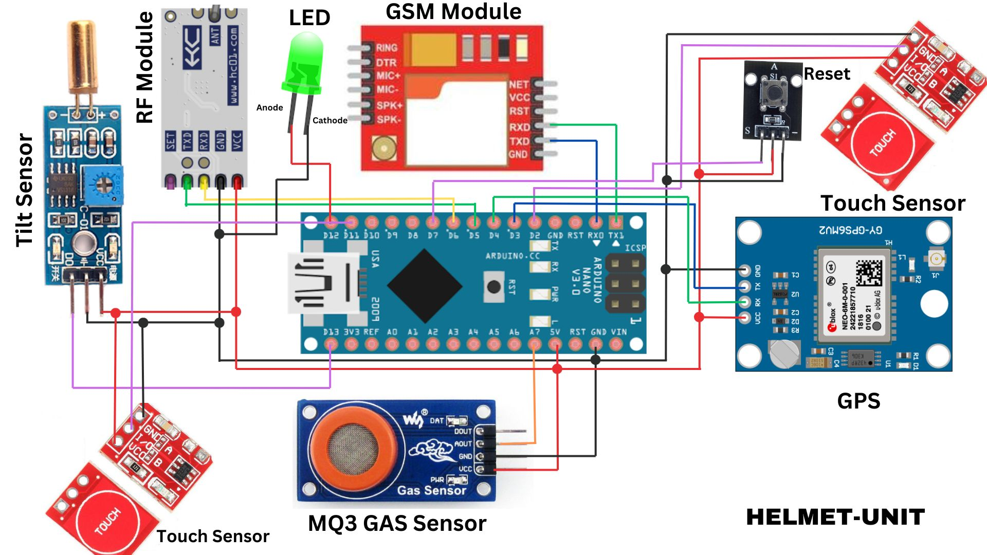

**Figure 3.5.1. Schematic Diagram of Helmet Unit**

In Figure 3.5.1, the schematic diagram of the helmet unit will showcase the upcoming integration of various modules, sensors, and peripherals into the Arduino Nano. This depiction will provide a clear visualization of the connections that will seamlessly come together in the final setup.

To power and ground the components, the VCC and ground of the GPS, GSM module, RF module, Tilt sensor, MQ3 gas sensor, reset button, and touch sensors will be linked to the 5V pin of the Arduino Nano. Specific connections will include the GSM module's RX pin, which will be linked to the TX1 pin, and its TX pin will be connected to the RX0 pin of the Arduino Nano. Similarly, the GPS module's RX pin will be linked to the Digital 4 pin, and its TX pin will connect to the Digital 3 pin of the Arduino Nano. For the RF module, the RX pin will connect to the Digital 6 pin, and its TX pin will be connected to the Digital 5 pin of the Arduino Nano.

In addition, the Tilt sensor's D0 pin will be connected to the digital 13 pin of the Arduino Nano, and the MQ3 gas sensor's analog pin will be linked to the Analog 7 pin of the Arduino Nano. Two touch sensor I/O pins will be connected to the digital 11 pin and digital 2 pin.

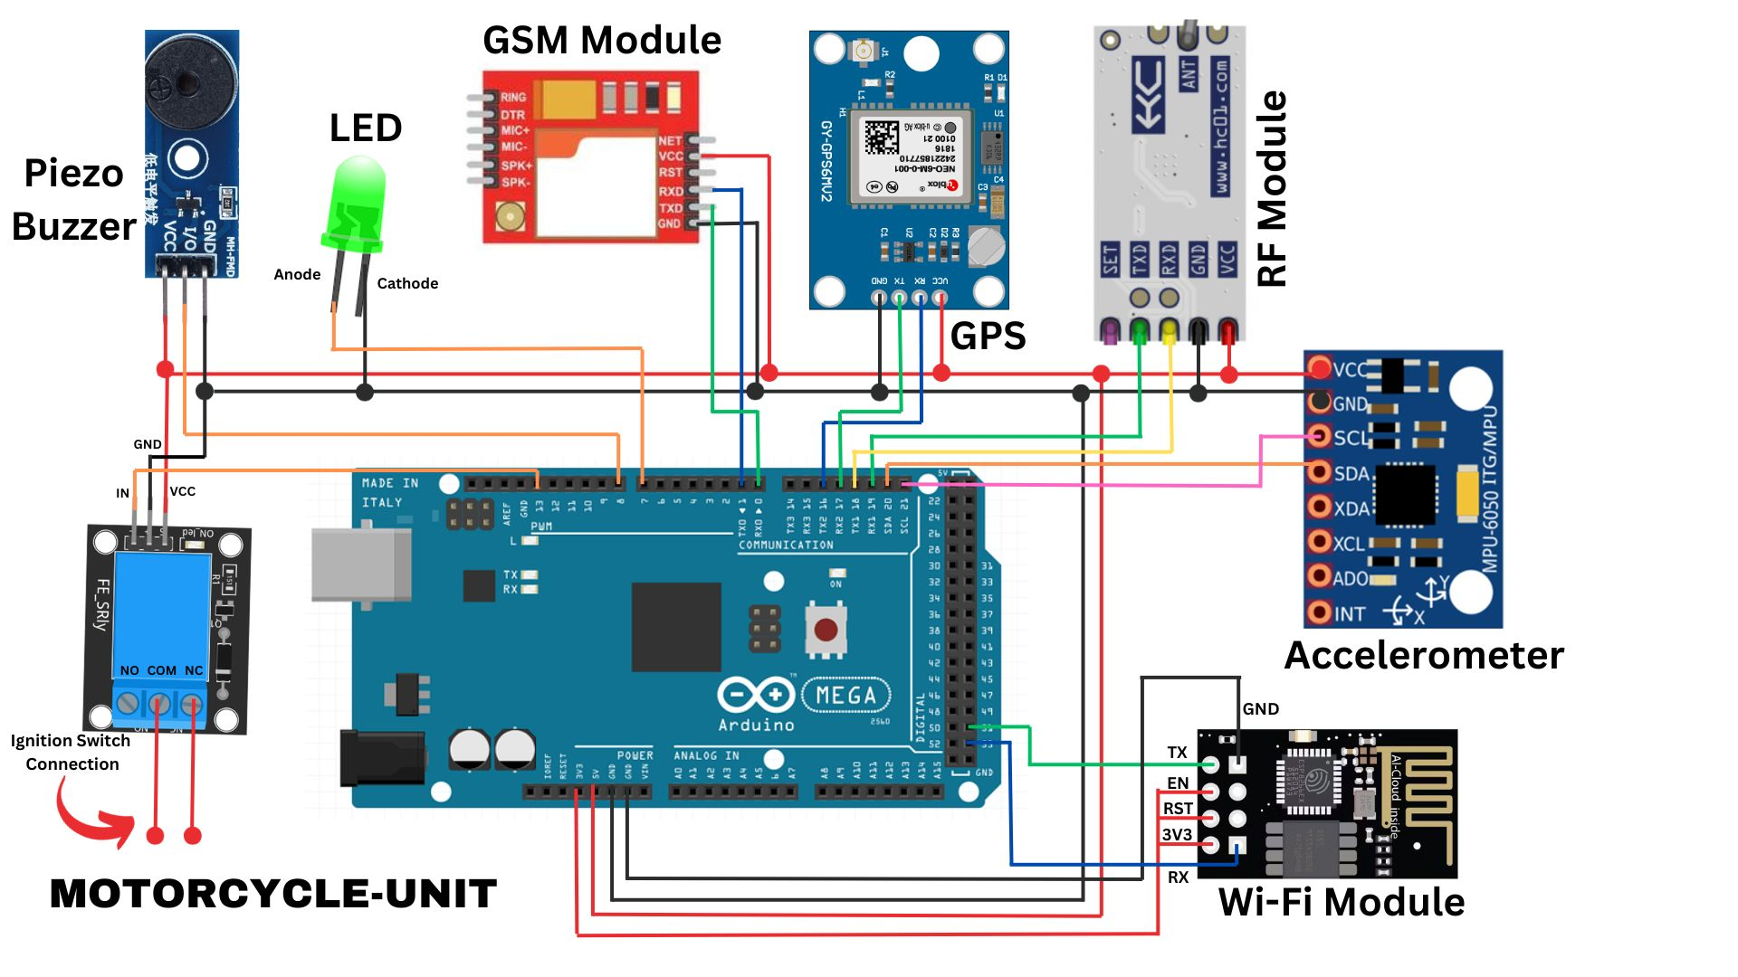

**Figure 3.5.2. Schematic Diagram of Motorcycle Unit**

In Figure 3.5.2, the schematic diagram of the Motorcycle Unit will illustrate the future integration of various modules, sensors, and peripherals seamlessly into the Arduino Mega. To power and ground these components, the VCC and Ground pins of the GSM Module, GPS module, RF Module, Accelerometer, and the piezo buzzer will be connected to the 5V power pin and ground pin of the Arduino Mega 2560. Additionally, the Wi-Fi module's 3V3 pin will be connected to the 3V3 power pin of the Arduino Mega 2560.

In terms of specific connections, the RX pin of the GSM module will be linked to the TX0 pin, and its TX pin will connect to the RX0 pin of the Arduino Mega 2560. Similarly, the RX pin of the GPS module will be connected to the TX2 pin, and its TX pin will be linked to the RX2 pin of the Arduino Mega 2560. For the RF module, the RX pin will connect to the TX1 pin, and its TX pin will be connected to the RX1 pin of the Arduino Mega 2560. As for the Wi-Fi module, its RX pin will connect to digital 53, and its TX pin will be linked to digital 51 of the Arduino Mega 2560.

For sensor integration, the Accelerometer's SCL (Serial Clock Line) will be connected to the Microcontroller's SCL, while its SDA (Serial Data Line) will be connected to the Arduino's SDA. Additionally, the LED will be connected to the PWM 7 pin and ground of the Arduino Mega 2560, the IO pin of the buzzer will be linked to the PWM 8 pin, and the signal pin of the relay will be connected to the PWM 13 pin. This comprehensive setup anticipates the seamless integration of the Motorcycle Unit's electronic system in the future.

**3.6. Materials**

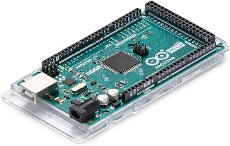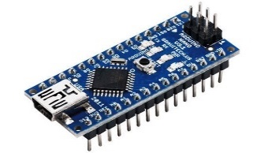The **Arduino Mega 2560** is a microcontroller board based on the ATmega2560. It has 54 digital input/output pins (of which 15 can be used as PWM outputs), 16 analog inputs, 4 UARTs (hardware serial ports), a 16 MHz crystal oscillator, a USB connection, a power jack, an ICSP header, and a reset button. It is the primary microcontroller that will be used in the proposed system where sensors and other components will be connected.

**Figure 3.6.1. Arduino Mega 2560**

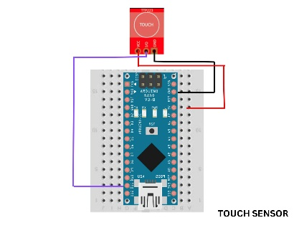The Arduino Nano is a small, complete, and breadboard-friendly board based on the ATmega328 (Arduino Nano 3.x). It is the microcontroller that will be used in the helmet unit to gather data from the user and send it to the motorcycle unit.

**Figure 3.6.2. Arduino Nano**

A touch sensor is an electronic sensor used in detecting and recording physical touch. It is used to sense the contact between the helmet and the rider’s cheek, signaling the system that the helmet is in use.

**Figure 3.6.3. Touch Sensor**

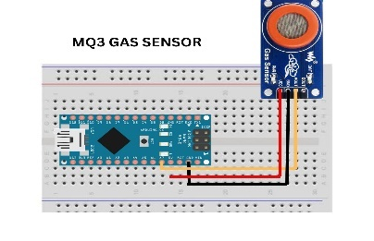The MQ3 alcohol gas sensor is a module used for detecting alcohol, CH4, benzene, gasoline, hexane, CO, and LPG. It is used to determine if the rider is under the influence of alcohol.

**Figure 3.6.4. Alcohol Sensor**

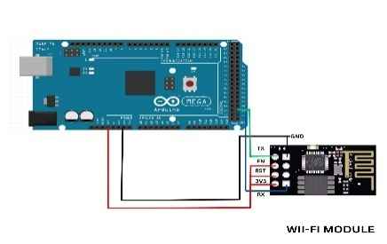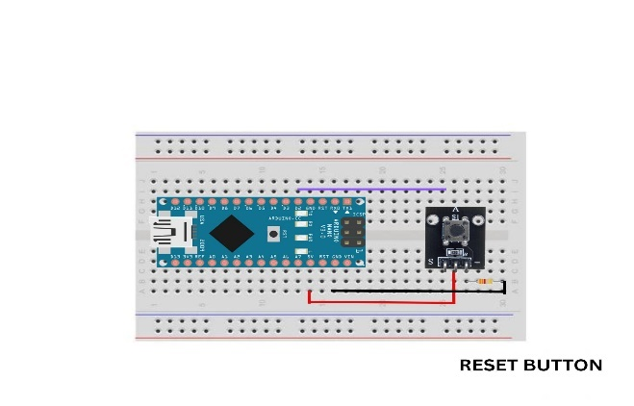The reset button will initiate the reinitialization process for a range of sensors embedded within the smart helmet. This will allow users to restore the sensors to their default state, optimizing their performance.

**Figure 3.6.5. Reset Button**

Wi-Fi is an electronic component used in many products to achieve a wireless connection to the internet. It is used as the data transmission module of the system.

**Figure 3.6.6. Wi – Fi Module**

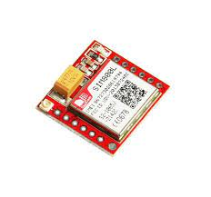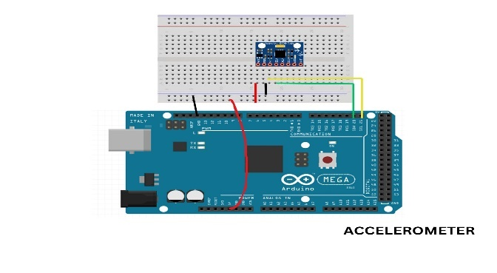An accelerometer is a device that measures the vibration, or acceleration of motion, of a structure.  It measures the static acceleration of gravity in tilt-sensing applications, as well as dynamic acceleration resulting from motion or shock. It is used to detect the sudden change of acceleration of the motorcycle.

**Figure 3.6.7. Accelerometer**

A GSM module is a device that allows electronic devices to communicate with each other over the GSM network. It is a digital cellular technology used to transmit the alerts and location of the rider to the rescuers and relatives if an accident occurs.

**Figure 3.6.8. GSM Module**

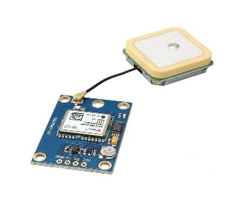The GPS module is a wireless chip module combined on the mainboard of a mobile phone or machine. It can communicate with the global satellite positioning system in the United States.  It is used for real - time location for helmet theft and pinpoint the location of the rider if an accident happens.

**Figure 3.6.9. GPS Module**

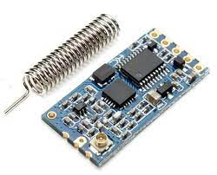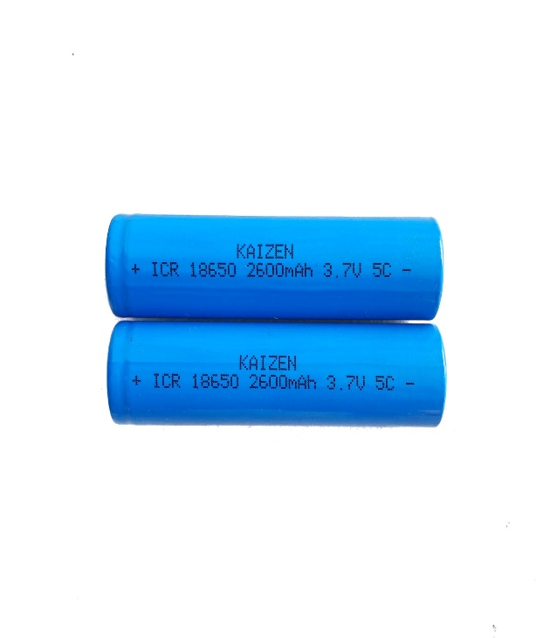An 18650 battery is a rechargeable lithium-ion battery. The capacity of lithium-ion 18650 batteries can vary widely, ranging from a few hundred milliampere-hours (mAh) to well over 3000mAh. It is used as the power supply for the helmet unit system.

**Figure 3.6.10. 18650 Battery**

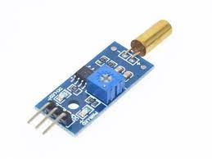An RF module is a small PCB sub-assembly capable of transmitting a radio wave and modulating that wave to carry data.  It is used to transmit and receive data from the mobile application to the microcontroller and vice versa.

**Figure 3.6.12. RF Module**

A tilt sensor is used to measure angles or the slope of an object. This will be installed in the helmet to determine if the rider is involved in an accident.

**Figure 3.6.13. Tilt Sensor**

**Table 3.6.1. Voltage of Materials in Helmet Unit**

|  |  |  |
| --- | --- | --- |
| **HELMET UNIT** | | |
| **Materials** | **Nominal Voltage** | **Operating Voltage** |
| Arduino Nano | 7 – 12 V | 5 V |
| Touch Sensor  (**TTP223B**) | N/A | 3.3 - 5 V |
| Alcohol Sensor  (**MQ3**) | N/A | 5 V |
| GPS Module  (**ublox NEO - 6M**) | N/A | 2.7 – 3.6 V |
| GSM Module  (**SIM800L**) | N/A | 3.6 – 5.20 V |
| 18650 Battery | 3.7 V | N/A |
| LED Indicator | 2 – 2.2 V | N/A |
| Tilt Sensor  (**SW - 520D**) | N/A | 3.3 – 5 V |
| RF Module  (**HC – 12 Transceiver**) | N/A | 3.2 – 5.5 V |

Table 3.6.1 provides a comprehensive overview of the operating voltages for the various components integrated into the helmet unit of the system, with data sourced directly from their respective datasheets. The Arduino Nano, serving as a central processing unit, operates within the voltage range of 7-12 volts, while its operational voltage is maintained at a stable 5 volts. The TTP223B touch sensor requires a power supply between 3.3 volts and 5 volts, while the MQ3 alcohol sensor functions optimally at 5 volts. The u-blox NEO-6M GPS module operates on a narrow voltage range of 2.7 to 3.6 volts, providing location data for the system. The SIM800L GSM module, responsible for communication, requires a power supply within the range of 3.6 to 5.20 volts. The 18650 battery, serving as the primary power source, has a nominal voltage of 3.7 volts. The LED indicator, used for visual signaling, operates within the voltage range of 2 to 2.2 volts. The SW-520D tilt sensor, employed for detecting helmet orientation, has an operating voltage range of 3.3 volts to 5 volts. Finally, the RF module HC-12 transceiver, facilitating wireless communication, has an operating voltage between 3.2 and 5.5 volts.

**Table 3.6.2. Voltage of Materials in Motorcycle Unit**

|  |  |  |
| --- | --- | --- |
| **MOTORCYCLE UNIT** | | |
| **Materials** | **Nominal Voltage** | **Operating Voltage** |
| Arduino Mega 2560 | 7 – 12 V | 5 V |
| GPS Module  (**ublox NEO - 6M**) | N/A | 2.7 – 3.6 V |
| GSM Module  (**SIM800L**) | N/A | 3.6 – 5.20 V |
| Accelerometer  (**MPU 6050**) | N/A | 3 – 5 V |
| RF Module  (**HC – 12 Transceiver**) | N/A | 3.2 – 5.5 V |
| Wi – Fi Module  (**ESP8226)** | N/A | 2.5 – 3.6 V |
| Buzzer | N/A | 2 – 5 V |
| LED Indicator | 2 – 2.2 V | N/A |

In Table 3.6.2, essential operating voltage specifications for components within the motorcycle unit are detailed, drawing from their respective datasheets. The Arduino Mega 2560 is designed for a broader range of 7 to 12 volts but effectively operates at 5 volts, contrasting with the u-blox NEO-6M GPS module, which functions within a more specific range of 2.7 to 3.6 volts. The SIM800L GSM module operates between 3.6 to 5.20 volts, offering a stable power range. The MPU-6050 accelerometer accommodates voltages between 3 to 5 volts for accurate acceleration measurements. The RF module HC-12 transceiver operates in the 3.2 to 5.5 volts range, ensuring reliable wireless communication. The WiFi module ESP8226 is compatible with voltages ranging from 2.5 to 3.6 volts. Additionally, components like the buzzer and LED indicator require voltage inputs of 2 to 5 volts and 2 to 2.2 volts, respectively, underscoring the need for meticulous attention to these specifications for seamless integration and optimal performance within the motorcycle unit.

**3.7. Software Development**

*****Figure 3.7.1. Flowchart of the Helmet Unit**

The helmet unit will operate based on a systematic system. The process will initiate with the initialization of essential variables. Subsequently, it will continuously monitor the status of the reset button, ensuring that the system proceeds only when the button is pressed. Upon detecting a reset button press, the system will read GPS data to determine if the helmet has exceeded a distance of 5 meters from the reference point. If the threshold is breached, indicating a potential theft, the system will promptly send a "Helmet is robbed" signal to alert the user. Conversely, if the helmet remains within the permissible distance, the system will progress to assess whether the helmet is worn by reading the touch sensor. If the helmet is not worn, a "Helmet not worn" RF signal will be transmitted to the motorcycle unit. In the event the helmet is worn, the system will then evaluate the alcohol sensor to ascertain if the rider is under the influence. If a positive reading is obtained, indicating intoxication, the system will send a "Rider is drunk" RF signal to the motorcycle unit. Additionally, the system will incorporate a check on the helmet's tilt angle using a tilt sensor. If the angle exceeds 15 degrees, a corresponding "Potential Accident occurred here. Location” message will be transmitted to the registered number. The system will conclude by looping back to the variable initialization, ensuring a continuous monitoring and evaluation cycle.

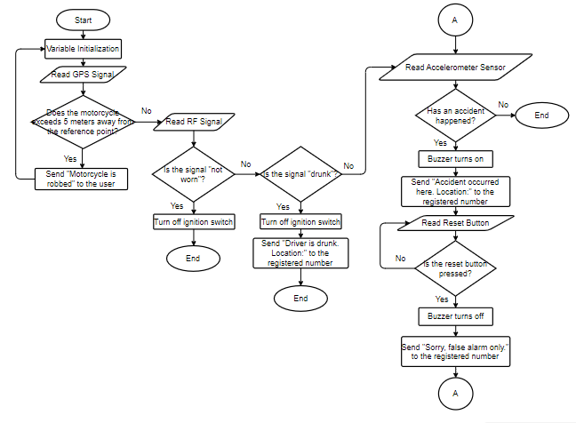

**Figure 3.7.2. Flowchart of the Motorcycle Unit**

The system for the motorcycle unit in the smart helmet will follow a well-defined process. It will begin with the initialization of variables and proceed to acquire GPS signals, checking if the motorcycle exceeds 5 meters from the reference point. If this condition is met, indicating a potential theft, the system will promptly send a "Motorcycle is robbed" alert to the user. In the absence of such an event, the system will read RF signals from the helmet unit.

Upon receiving a signal indicating "Not worn," the system will turn off the ignition switch. Subsequently, it will evaluate whether the signal corresponds to a "Drunk" indication. If confirmed, the ignition switch will be turned off, and a message declaring "Driver is drunk. Location:" will be dispatched to the registered number. If the signal does not indicate intoxication, the system will read the accelerometer sensor to determine if an accident has occurred. If the accelerometer detects an accident, a buzzer will be activated, and a message proclaiming "An accident occurred here. Location:" will be transmitted to the registered number. Following this, the system will read the reset button to ascertain if it has been pressed. If confirmed, the buzzer will turn off, and a notification conveying "Sorry. False alarm only." will be sent to the registered number. The system will then loop back to read the accelerometer sensor again.

If the reset button remains unpressed, the system will continually read the reset button. If the accelerometer sensor does not detect an accident, the system will conclude its operation.

**3.8. Data Processing**

**Gathering of Components**

The research team will gather electronic components, sensors, and communication modules for their upcoming project. The helmet unit will include an Arduino Nano, alcohol sensor for rider sobriety, touch sensor for rider presence, tilt sensor for accident detection, RF module for data transmission, reset button for reinitialization, GPS/GSM for location tracking, and an LED indicator for helmet status.

For the motorcycle unit, an Arduino Mega 2560 will be paired with an RF module for communication with the helmet unit. It will also feature a GPS/GSM module, accelerometer sensor for accident detection, reset button, relay for ignition switch control, buzzer for alerts, LED indicator, and a Wi-Fi module for communication with the mobile application.

**Designing of Circuitry**

The researchers will sketch a circuit diagram to demonstrate the integration of components. In the helmet unit, the Arduino Nano will connect to the alcohol sensor, touch sensor, tilt sensor, RF module, reset button, GPS/GSM, and LED indicator. The motorcycle unit, in turn, will see the Arduino Mega 2560 linking up with the RF module, GPS/GSM module, accelerometer sensor, reset button, relay, buzzer, LED indicator, and Wi-Fi module. This diagram will serve as a guide, ensuring a smooth assembly process and seamless functionality.

**Integration of Components**

The researchers will carefully position all the components, utilizing methods like soldering for robust connections. They will also employ secure fastening techniques to ensure that every part remains firmly in place, preventing any potential shifting or damage. This meticulous approach guarantees not only the proper functionality of each element but also ensures the overall durability and reliability of the integrated system.

**Software Integration**

The researchers will write a code to handle data from the sensors in the helmet and motorcycle unit. Additionally, they will create code to set up and control communication between the two units. This involves making sure the data flows smoothly between them. Their work ensures that the helmet and motorcycle can exchange information effectively, making the entire system run smoothly.

**Sensor Simulation**

The researcher will conduct simulations to evaluate the performance of sensors in both the helmet and motorcycle units. They will conduct rigorous testing of the embedded software, exploring different scenarios and use cases. In the process, any issues identified during testing will be debugged and resolved. This systematic approach aims to ensure the stability and reliability of the software, guaranteeing optimal functionality of the sensors in real-world situations.

**Housing and Installment**

The researcher will put the helmet unit inside the helmet. They'll create a safe space for the electronic parts, making sure it fits well without making the helmet uncomfortable or unsafe. They will then carefully install the unit, securing it in a way that keeps the helmet strong. The motorcycle unit will also be enclosed and placed in the motorcycle's compartment box.

**User Feedback Assessment**

The researchers will conduct a survey using a questionnaire to gather feedback from participants. The goal is to assess the functionality, accuracy, reliability, and comfort of the smart helmet. Respondents will be asked specific questions to gauge how well the helmet performs, how accurate its features are, how reliable it is in various situations, and how comfortable it feels during use. This survey testing will provide valuable insights into the user experience and help improve the smart helmet's design and performance based on user feedback.

# REFERENCES

Grecia, L. (2022, September 13). There were 22,924 reported motorcycle accidents in Metro Manila last year. *https://www.topgear.com.ph*. <https://www.topgear.com.ph/news/motoring-news/motorcycle-accidents-mmaras-2021-a4354-20220913>

Macenas, J. C. E., & Tan, A. D. (2021). Epidemiology of Eyelid Trauma Among Filipino Patients in a Tertiary Hospital. *Philippine Journal of Ophthalmology*, *46*(2).

Rosales, B. (2021, June 7). How much are the fines if you ‘drink and ride’?. [*https://www.motopinas.com*](https://www.motopinas.com)*.* <https://www.motopinas.com/motorcycle-feature/how-much-are-the-fines-if-you-drink-and-ride.html>

Kumar, H. N., & Deepak, G. (2017). Accident detection and intelligent navigation system for emergency vehicles in urban areas using IoT. *Int. J. Eng. Tech*, *3*(6), 330-334.

Tayag, M. I., & De Vigal Capuno, M. E. A. (2019). Smart Motorcycle Helmet: Real-Time Crash Detection With Emergency Notification, Tracker and Anti-Theft System Using Internet-of-Things Cloud Based Technology. *International Journal of Computer Science & Information Technology (IJCSIT) Vol*, *11*.

Biswas, J. R., Kachroo, S., Chopra, P., & Sharma, S. (2018, August). Development of an app enabled smart helmet for real time detection and reporting of accidents. In *2018 7th International Conference on Reliability, Infocom Technologies and Optimization (Trends and Future Directions)(ICRITO)* (pp. 703-708). IEEE.

Ahmed, S. U., Uddin, R., & Affan, M. (2020, September). Intelligent gadget for accident prevention: smart helmet. In *2020 International Conference on Computing and Information Technology (ICCIT-1441)* (pp. 1-4). IEEE.

Gahane, P., Lambat, Y., Rathi, P., Sahare, S., & Raut, A. R. (2022, December). Smart Helmet: A New Generation Helmet. In *2022 International Conference on Recent Trends in Microelectronics, Automation, Computing and Communications Systems (ICMACC)* (pp. 54-59). IEEE.

Rahman, M. A., Ahsanuzzaman, S. M., Rahman, I., Ahmed, T., & Ahsan, A. (2020, June). Iot based smart helmet and accident identification system. In *2020 IEEE Region 10 Symposium (TENSYMP)* (pp. 14-17). IEEE.

Ahuja, P., & Bhavsar, K. (2018, May). Microcontroller Based Smart Helmet Using GSM & GPRS. In *2018 2nd International Conference on Trends in Electronics and Informatics (ICOEI)* (pp. 1-9). IEEE.

Mittal, A. K., Bhatia, A., & Mittal, A. K. (2013). System to Prevent Helmet Theft and Wireless Monitoring of Health Status of the Bike. *International Journal of Computer Applications*, *67*(21).

Kurkute, S., Ahirao, N., Ankad, R. G., & Khatal, V. B. (2019, February). IOT based smart system for the Helmet detection. In *Proceedings of International Conference on Sustainable Computing in Science, Technology and Management (SUSCOM), Amity University Rajasthan, Jaipur-India*.

Hu, J. M., Li, J., & Li, G. H. (2012, November). Automobile anti-theft system based on GSM and GPS module. In *2012 Fifth International Conference on Intelligent Networks and Intelligent Systems* (pp. 199-201). IEEE.

Song, H., Zhu, S., & Cao, G. (2008, April). Svats: A sensor-network-based vehicle anti-theft system. In *IEEE INFOCOM 2008-The 27th Conference on Computer Communications* (pp. 2128-2136). IEEE.