Introduction
Once upon a time, there was prior work [1, 2, 3, 4].
Next consider math. Inline math is nice, α=2, as are stand-alone equations,
(1)
Finally, a figure. See Fig. 1 below.
References
[1] R. R. Ernst, G. Bodenhausen, and A. Wokaun, Principles of Nuclear Magnetic Resonance in One and Two Dimensions, Clarendon Press, Oxford, 1987.
[2] D. Rugar, R. Budakian, H. J. Mamin, and B. W. Chui, Single spin detection by magnetic resonance force microscopy, Nature, 2004, 430, 329 – 332, URL http://dx.doi.org/10.1038/nature02658.X
[3] C. E. Isaac, C. M. Gleave, P. T. Nasr, H. L. Nguyen, E. A. Curley, J. L. Yoder, E. W. Moore, L. Chen, and J. A. Marohn, Dynamic nuclear polarization in a magnetic resonance force microscope experiment, Phys. Chem. Chem. Phys., 2016, 18, 8806 – 8819, URL http://dx.doi.org/10.1039/C6CP00084C, PMC http://www.ncbi.nlm.nih.gov/pmc/articlerender.fcgi?artid=PMC5609491.X
[4] C. E. Isaac, E. A. Curley, P. T. Nasr, H. L. Nguyen, and J. A. Marohn, Cryogenic positioning and alignment with micrometer precision in a magnetic resonance force microscope, Rev. Sci. Instrum., 2018, 89, 013707, URL http://dx.doi.org/10.1063/1.5008505.X

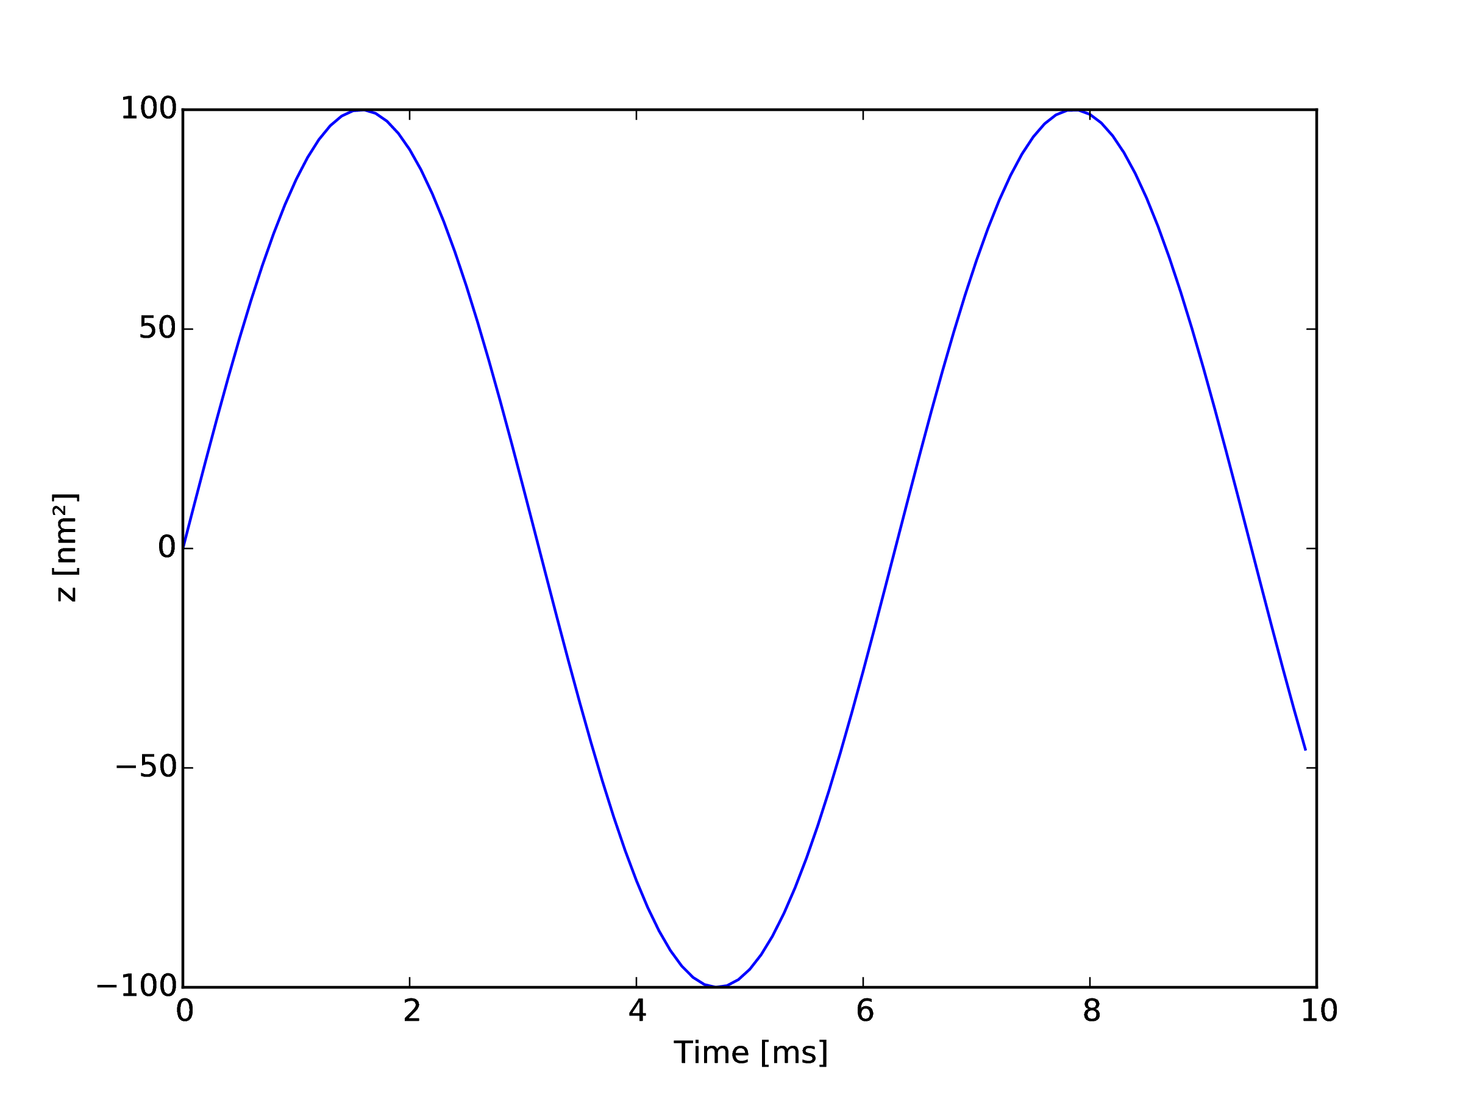
Figure 1: This is a figure.

