**GUIDE POKERLAND CASINO APPLICATION**

Close session as an employee.

**EMPLOYEE**

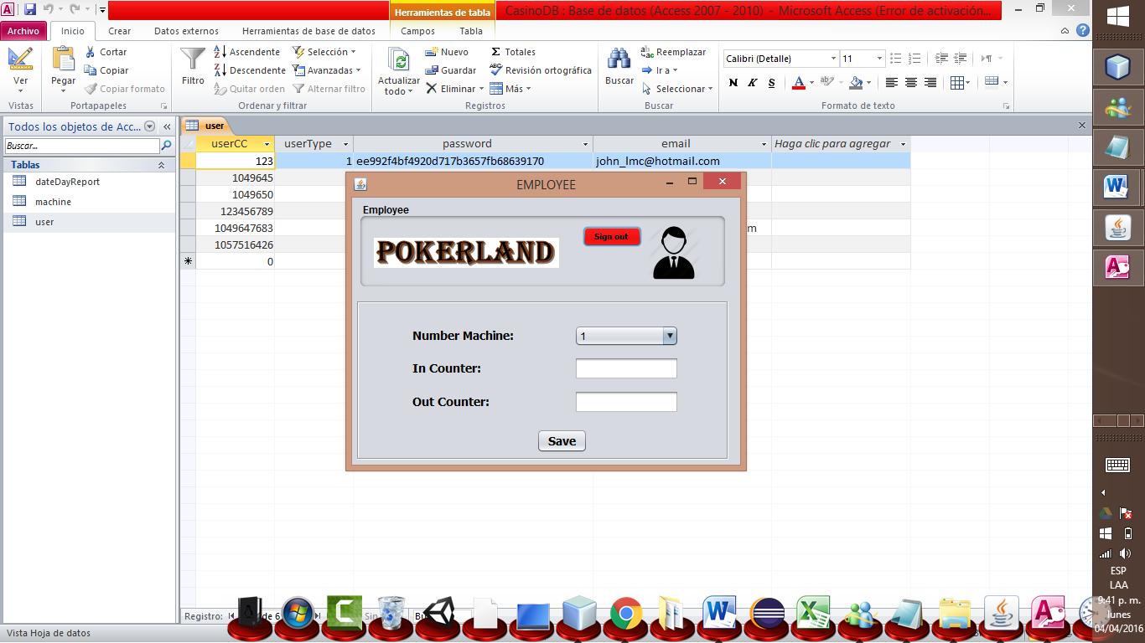

You can save the data entered.

You can enter the out counter machine current day.

You can enter the in counter machine current day.

You can select the machine existing number.