**GUIDE POKERLAND CASINO APPLICATION**

**ADD DELETE MACHINES**

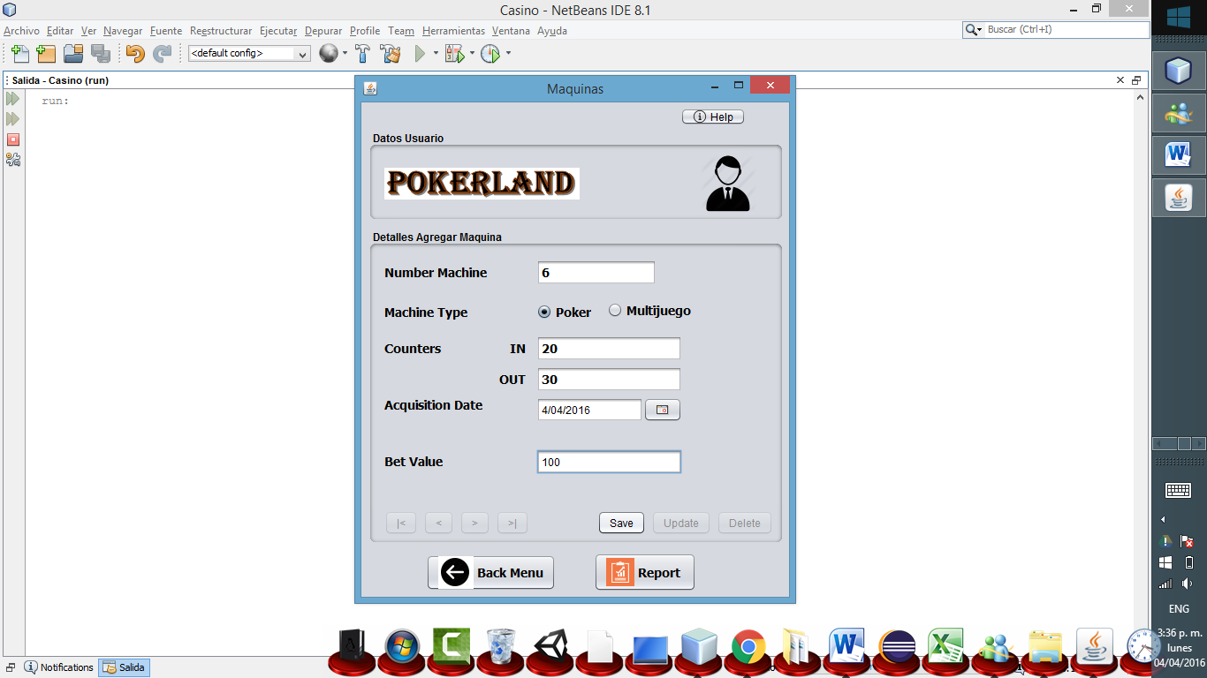

You can save the data entered.

You can enter the bet value of the machine.

You can select acquisition date of the machine.

You can enter the Counters of the machine.

You can select the machine type you want to save.

You can enter the number of the machine you want to save.

The application generates a report with the machines entered.

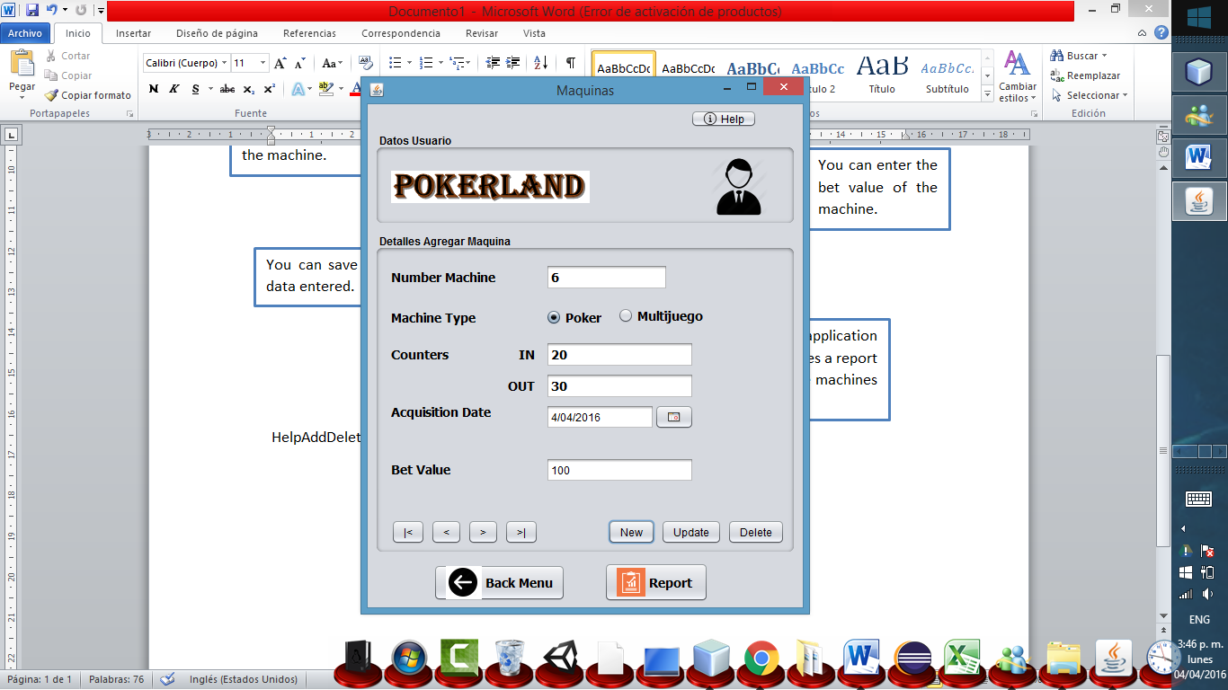

You can go to back register of machine.

You can go to first register of machine.

You can delete the information entered from the machine.

You can change the information entered.

You can do a new report to enter.

You can go to last register of machine.

You can go to next register of machine.