**GUIDE POKERLAND CASINO APPLICATION**

**REPORTS**

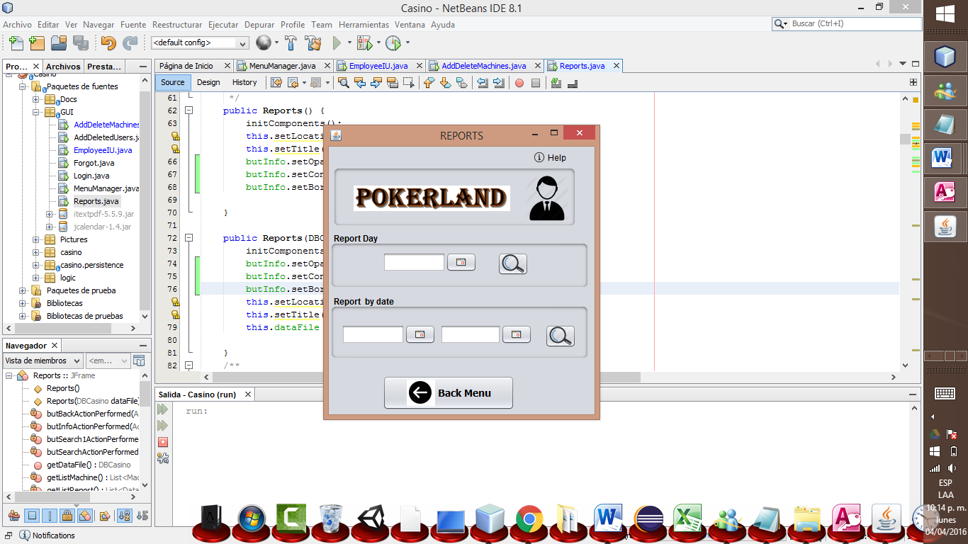

You can select dates and see the report of those dates

You can select the date and view the daily report.

Search selected date