<MAK.OX.>
OVerall Report
Version <1.0>

ΜΠΑΡΖΑΣ ΓΙΑΝΝΗΣ 2765

Table of Contents
Introduction 4
Design Recovery 4
Architecture 4
Detailed Design 4
Implementation 4
Tests 5
Quality Assessment 5
Style Violations 5
More General Problems 5
Refactored Design 6
Architecture 6
Detailed Design 6
Implementation 6

Introduction
The objectives of the second phase of the project was to refactor the application so as to fix some general problems concerning the data management and the input output packets. So that it is easier to use and expand the project. And solve some checkstyle violations.

Design Recovery

Architecture

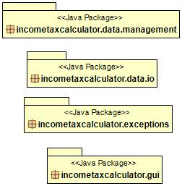

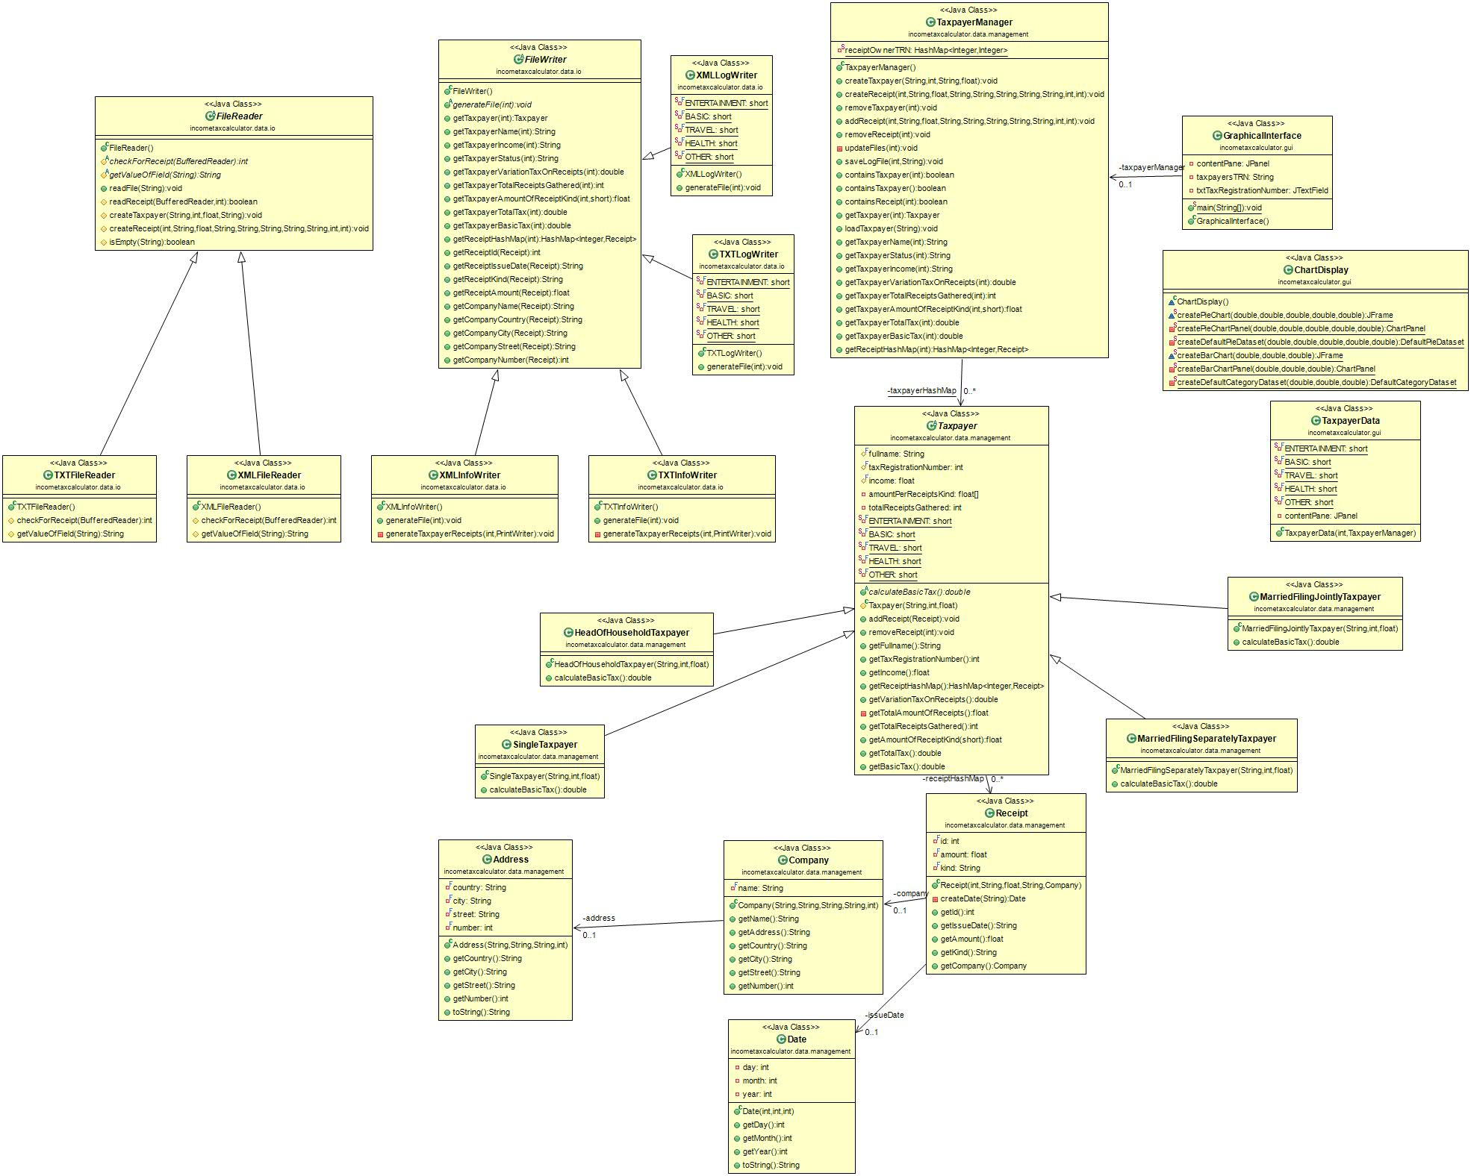

Detailed Design

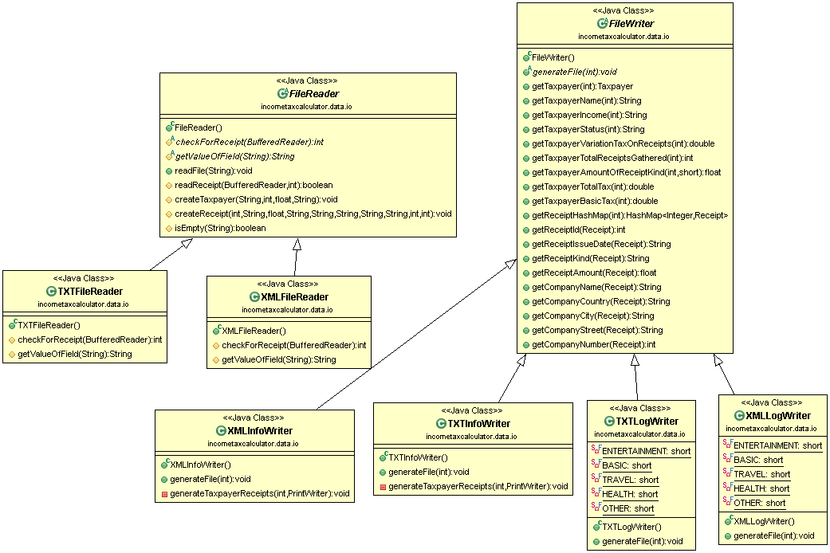
- incometaxcalculator.data.io

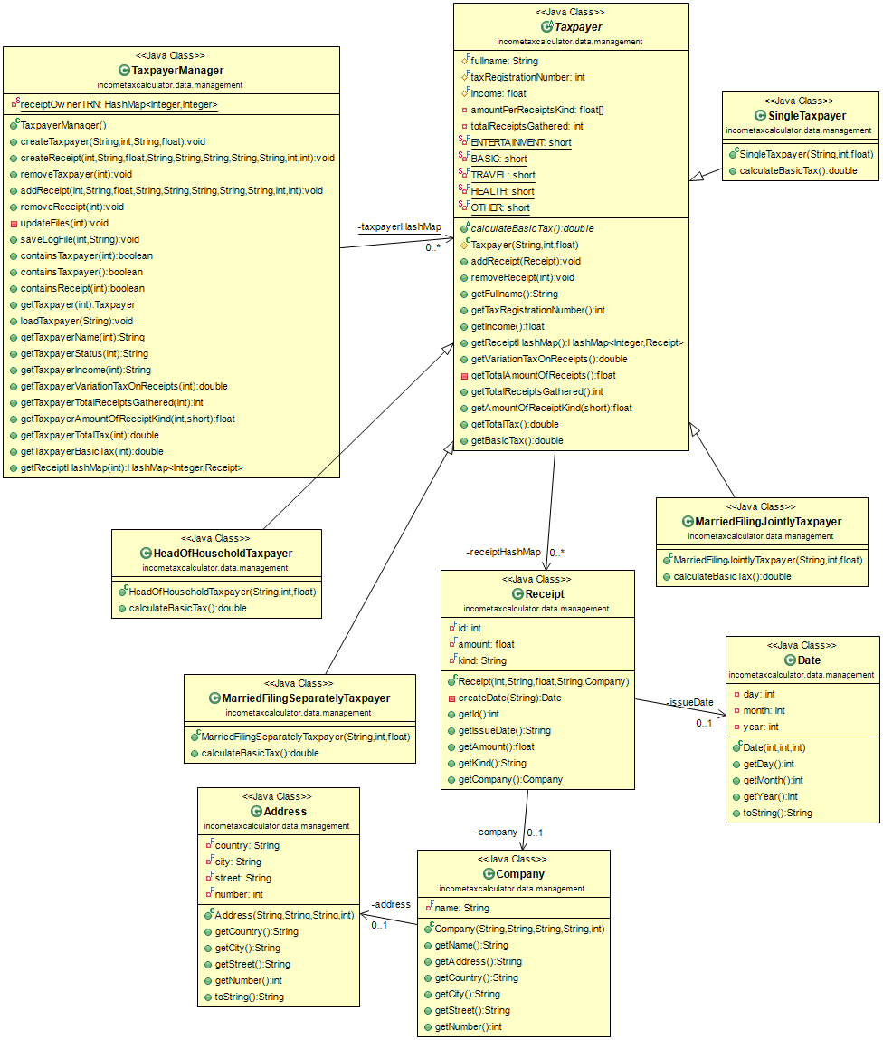
- Incometaxcalculator.data.management

- Incometaxcalculator.exceptions
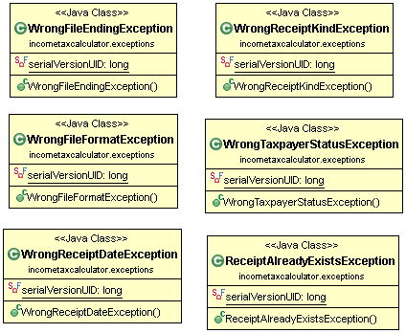

- Incometaxcalculator.gui
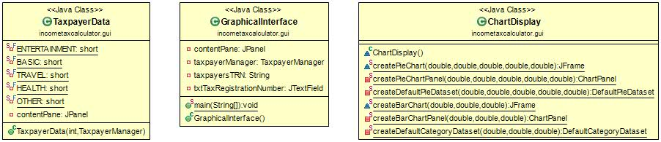

Implementation

Class Name: FileReader
Responsibilities | Collaborations
- This class is responsible for reading files  - This class inserts information to the program about the tax payers and their receipts | - TXTFileReader extends this class  - XMLFileReader extends this class

Class Name: TXTFileReader
Responsibilities | Collaborations
.  - This class is responsible for inserting and separating the information about the tax payers and their receipts from txt files | - This class extends FileReader

Class Name: XMLFileReader
Responsibilities | Collaborations
- This class is responsible for inserting and separating the information about the tax payers and their receipts from XML files | - This class extends FileReader

Class Name: FileWriter
Responsibilities | Collaborations
- This class is responsible for writing the taxpayer, receipts and tax information on files  - This class has functions that give it all the necessary information to store | - TXTInfoWriter extends this class  - TXTLogWriter extends this class  - XMLInfoWriter extends this class  - XMLLogWriter extends this class

Class Name: TXTInfoWriter
Responsibilities | Collaborations
- This class is responsible for writing the taxpayer and receipts information on TXT files | - This class extends FileWriter

Class Name: TXTLogWriter
Responsibilities | Collaborations
- This class is responsible for writing the taxpayer, receipts and tax information on TXT files  - This class gives more specific information about the tax and the receipt types | - This class extends FileWriter

Class Name: XMLInfoWriter
Responsibilities | Collaborations
- This class is responsible for writing the taxpayer and receipts information on XML files | - This class extends FileWriter

Class Name: XMLLogWriter
Responsibilities | Collaborations
- This class is responsible for writing the taxpayer, receipts and tax information on XML files  - This class gives more specific information about the tax and the receipt types | - This class extends FileWriter

Class Name: Taxpayer
Responsibilities | Collaborations
- This class manages all the information about the taxpayer, his receipts and his taxes  - This class calculates the tax variation based on the taxpayers receipts and his income | - HeadOfHouseholdTaxpayer extends this class  - MarriedFilingSeparatelyTaxpayer extends this class  - MarriedFilingJointlyTaxpayer extends this class  - SingleTaxpayer extends this class  - TaxpayerManager uses taxpayerHashMap which has Taxpayer type objects  - This class uses receiptHashMap which has Receipt type objects

Class Name: HeadOfHouseholdTaxpayer
Responsibilities | Collaborations
- This class calculates the basic tax for the HeadOfHousehold category taxpayer | - This class extends the Taxpayer class

Class Name: MarriedFilingSeparatelyTaxpayer
Responsibilities | Collaborations
- This class calculates the basic tax for the MarriedFilingSeparately category taxpayer | - This class extends the Taxpayer class

Class Name: MarriedFilingJointlyTaxpayer
Responsibilities | Collaborations
- This class calculates the basic tax for the MarriedFilingJointly category taxpayer | - This class extends the Taxpayer class

Class Name: SingleTaxpayer
Responsibilities | Collaborations
- This class calculates the basic tax for the Single category taxpayer | - This class extends the Taxpayer class

Class Name: TaxpayerManager
Responsibilities | Collaborations
- This class manages the taxpayers, and the receipts  - This class updates the files and saves the Log files in XML, TXT format | - This class uses the taxpayerHashMap which has Taxpayer type objects

Class Name: Receipt
Responsibilities | Collaborations
- This class manages the receipt information | - Taxpayer uses the receiptHashMap which has Receipt type objects  - Receipt uses the issueDate field which is a Date object  - Receipt uses the company field which is a Company object

Class Name: Date
Responsibilities | Collaborations
- This class creates the date | - Receipt uses the issueDate field which is a Date object

Class Name: Company
Responsibilities | Collaborations
- This class manages the company information | - Receipt uses the company field which is a Company object  - Company uses the address field which is an Address object

Class Name: Address
Responsibilities | Collaborations
- This class manages the address information | - Company uses the address field which is an Address object

Class Name: ChartDisplay
Responsibilities | Collaborations
- This class displays the charts of the information (receipt category amounts, basic tax, total tax) that are saved in the Log files. | - TaxpayerData class uses this class in order to display the information (receipt category amounts, basic tax, total tax) in the Log files.

Class Name: TaxpayerData
Responsibilities | Collaborations
- This class manages (Add Receipt, Delete Receipt, View Report, Save Data)the receipts of the taxpayer | - This class uses ChartDisplay in order to display the information (receipt category amounts, basic tax, total tax) in the Log files.  - GraphicalInterface uses this class to manage the receipts.

Class Name: GraphicalInterface
Responsibilities | Collaborations
- This class manages Load Taxpayer, Select Taxpayer, Delete Taxpayer) the taxpayers and shows the tax registration number of each taxpayer. | - GraphicalInterface uses TaxpayerData to manage the receipts.

Quality Assessment

Style Violations
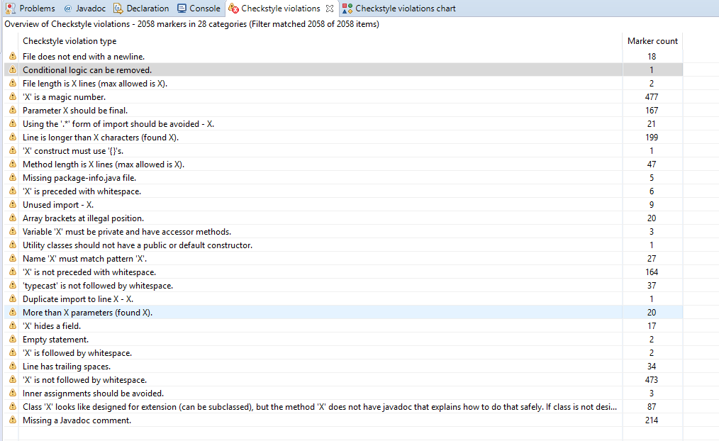
All the check style violations of the program are shown on this picture
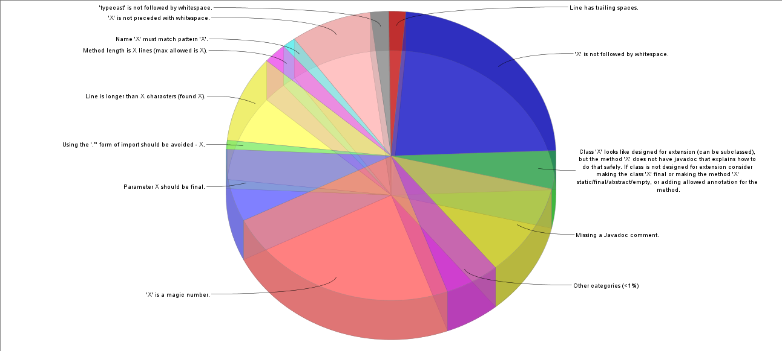
Graph

As it is shown in both the picture and the graph most of the check style violations are found in the following categories.
- X is a magic number : 477 violations
- X is not followed by a whitespace : 473 violations
- Missing a Javadoc comment : 214 violations
- Line is longer than X characters (found X): 199 violations
Specifically in the size violation category we have found the following check style violation types.
- File length is X lines (max allowed is X):
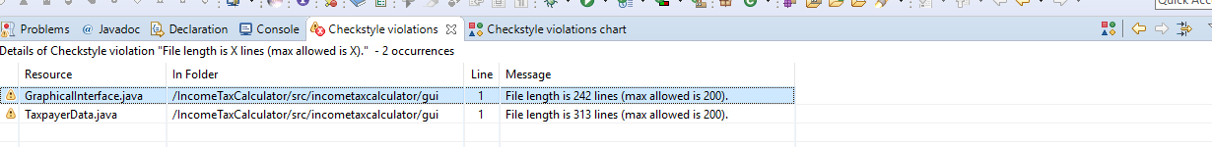
We checked with 200 lines as the limit and found 2 violations.

- Line is longer than X characters (found X):
We checked with 80 characters as the limit and found 199 violations.
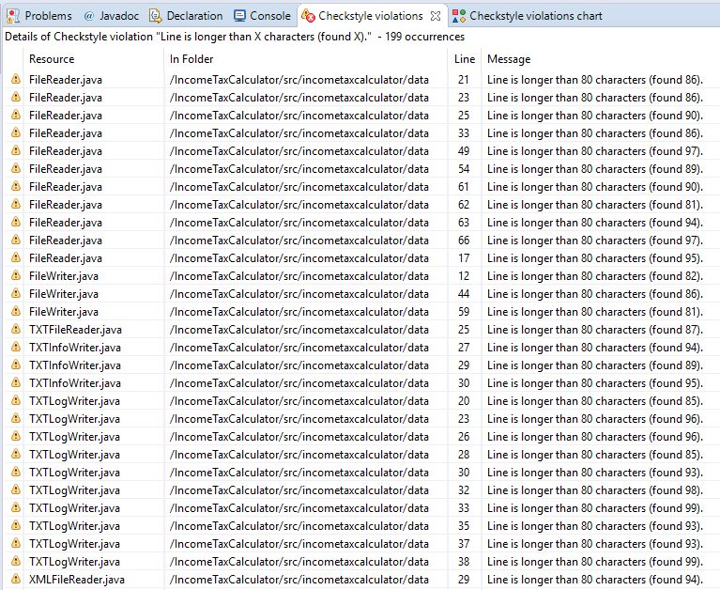

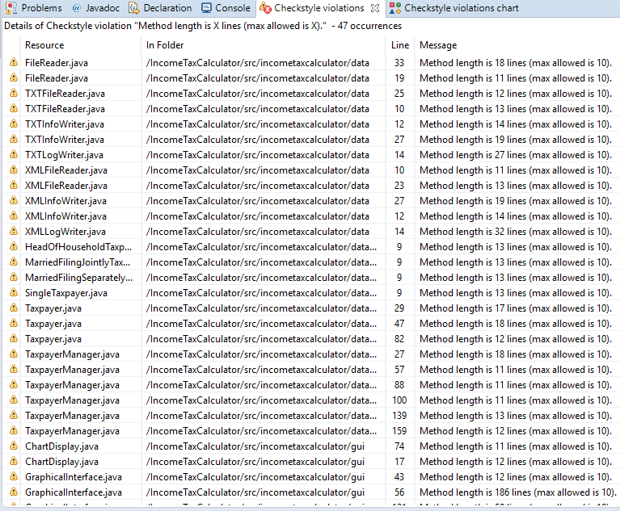

- Method length is X lines (max allowed is X):
We checked with 18 lines as a limit and found 47 violations.

- More than X parameters (found X):
We checked with 2 parameters as a limit and found 20 violations.
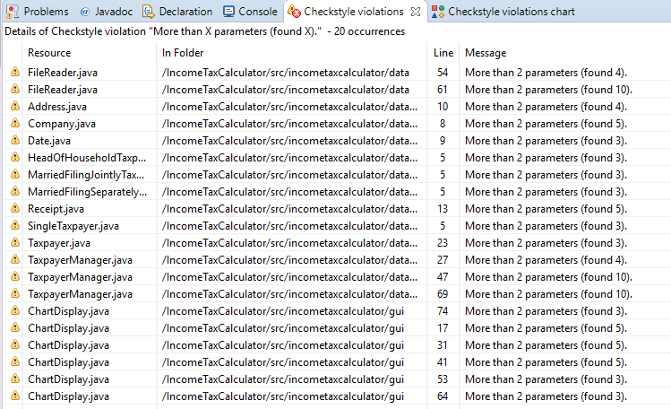

In the Naming Conventions category we have found the following check style violations.
- Name ‘X’ must match pattern ‘X’: 27 violations.
In the Import category we have found the following check style violations.
- Unused import – X : 9 violations.
- Duplicate import to line X – X: 1 violation.

Refactored Design

Architecture
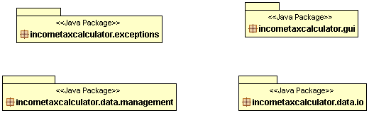
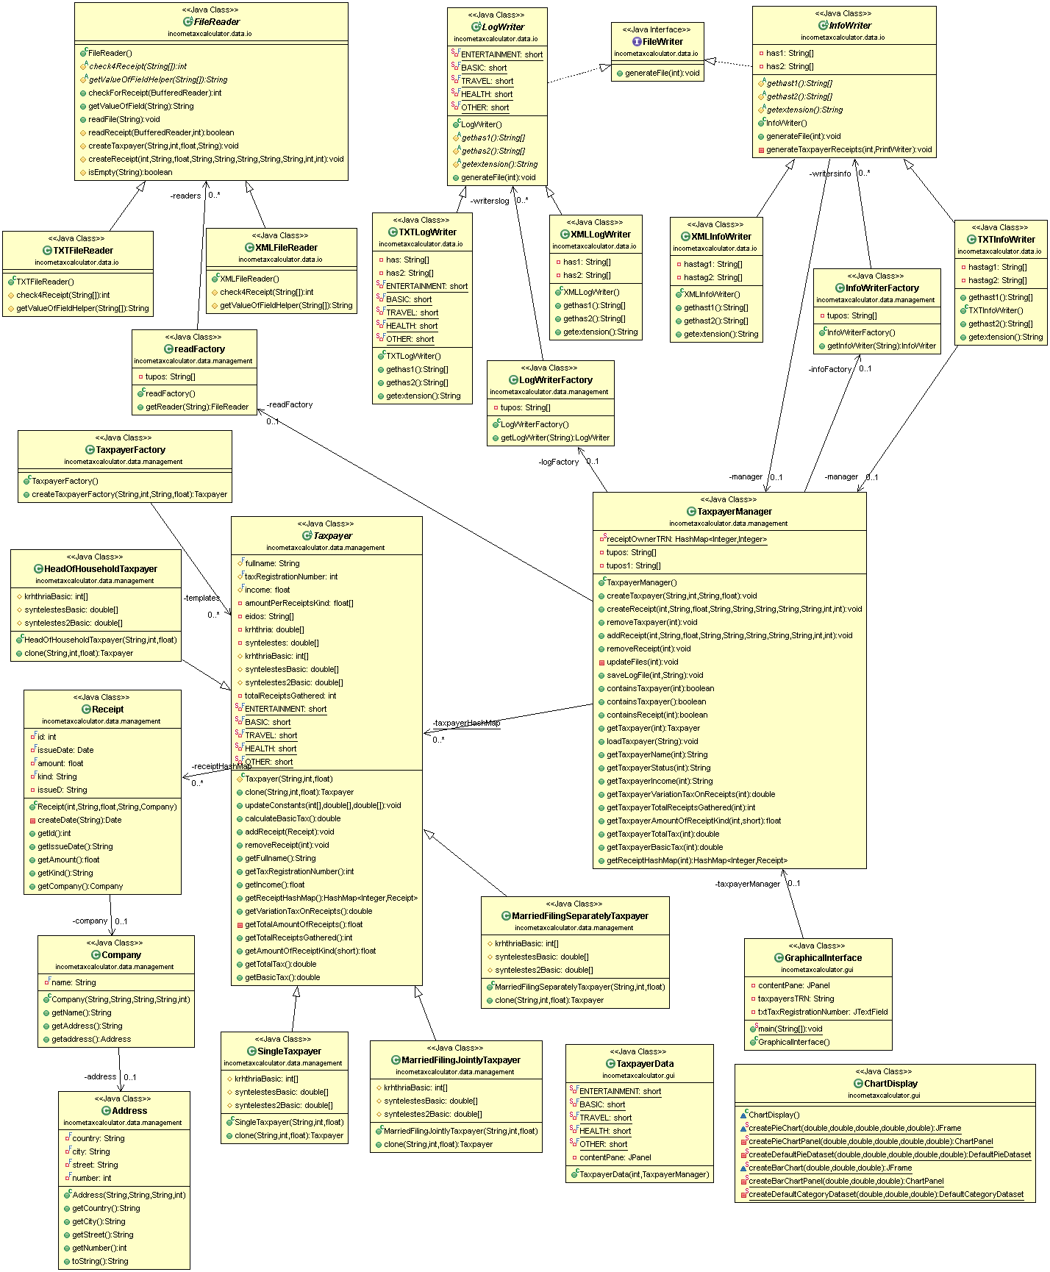

Detailed Design
- incometaxcalculator.data.io
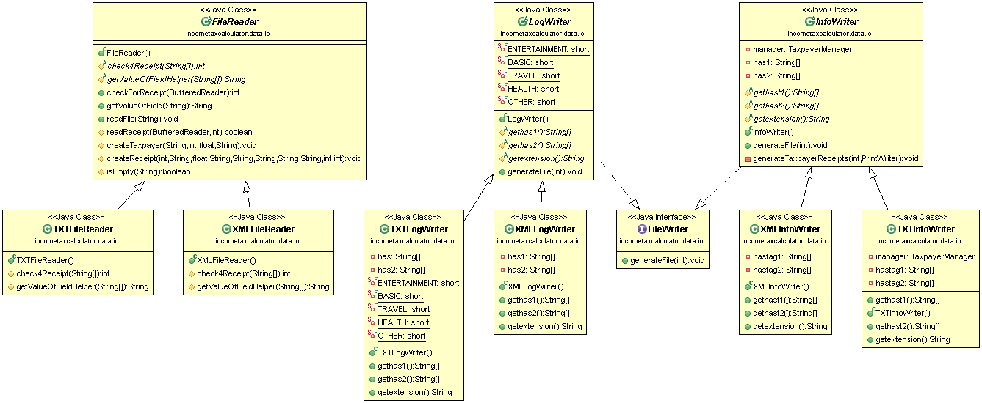

- incometaxcalculator.data.management
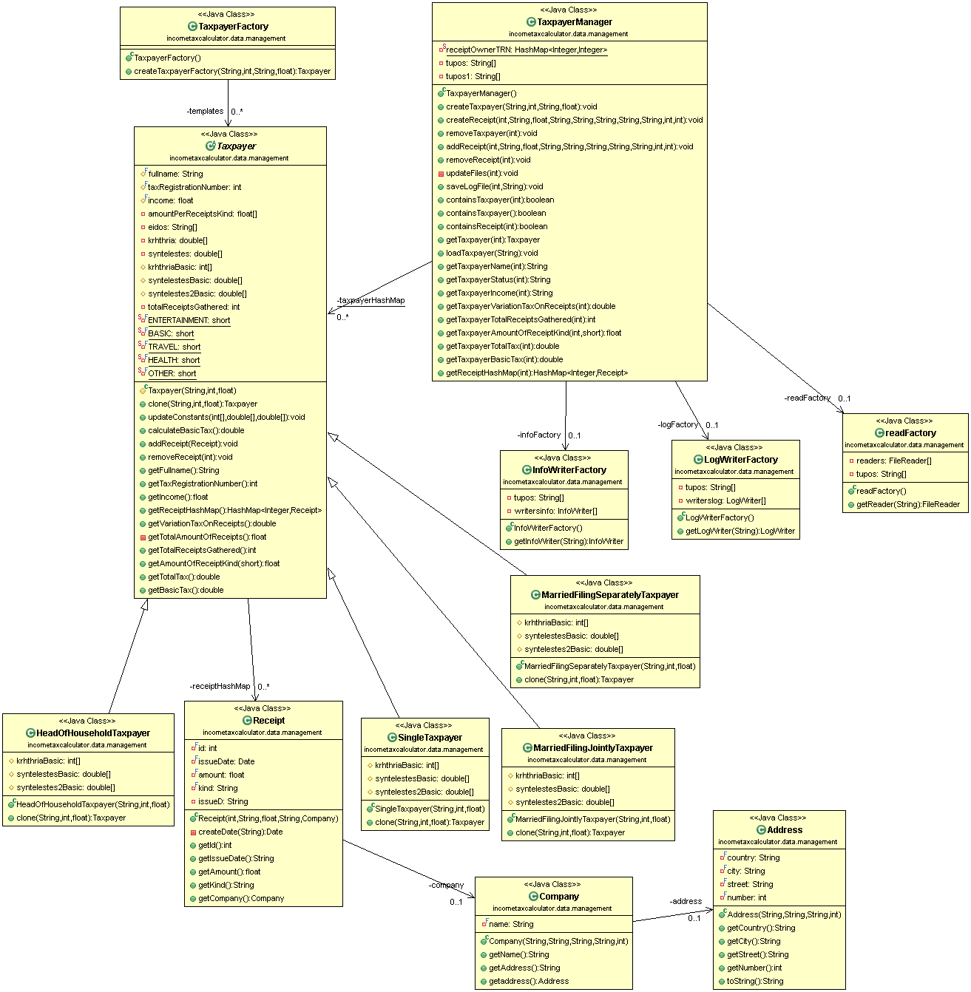

- Discuss here how you addressed the different problems of the old design
- Date class: we deleted this class because java provides us a date class so we used this one.
- In Company class: the problem here was Unnecessary Complexity. The Company class was containing dead code so we removed it.
- In Taxpayer class: addReceipt(), removeReceipt(), getVariationTaxOnReceipts() we changed the chained if-else statements with for loops, in order to simplify the algorithm.
- Subclasses of the Taxpayer class: There was duplicate code in every subclass. In the superclass Taxpayer we pulled up the calculateBasicTax() method from the subclasses. We changed the calculateBasicTax() body to use these data structures instead of the constants The subclasses are used only to initialize the values of the simple data structures in the respective constructors.
- TaxpayerManager class: This is a Large Class with many responsibilities:
  - createTaxpayer(): we moved the conditional logic that creates different types of Taxpayer objects to a simple parameterized factory.
  - updateFiles():we moved common parts out of the complex if-else logic and moved the conditional logic that creates different types of FileWriter objects to a simple parameterized factory.
  - saveLogFile(): we moved common parts out of the complex if-else logic also we movedthe conditional logic that creates different types of FileWriter objects to a simple parameterized factory.
  - loadTaxpayer(): we moved common parts out of the complex if-else logic also we moved the conditional logic that creates different types of FileReader objects to a simple parameterized factory.
- TXTFileReader, XMLFileReader classes: The problem here was Duplicate Code. We formed template methods in the FileReader super class and abstracted the parts of the code that are different with simple abstract methods implemented in the subclasses.
- FileWriter class: It is a Middle Man for TaxpayerManager. Also some of it’s methods are used only by some of the subclasses. We removed the delegating methods and call directly the TaxpayerManager methods. Also we pushed down methods to the classes that need them. Lastly we made FileWriter an interface instead of an abstract class.
- TXTInfoWriter and XMLInfoWriter classes: The problem here was Duplicate Code. We removed the code duplication. We formed template methods in an abstract InfoWriter super class and abstracted the parts of the code that are different with simple abstract methods implemented in the subclasses.
- TXTLogWriter and XMLLogWriter classes: The problem here was Duplicate Code. We removed the code duplication. We formed template methods in an abstract LogWriter super class and abstracted the parts of the code that are different with simple abstract methods implemented in the subclasses.

Implementation
- For each class that has been ADDED or CHANGED give a brief description in terms of a CRC card (see the format below)

Interface Name: FileWriter
Responsibilities | Collaborations
- This interface contains an abstract method generateFile | - InfoWriter implements this interface  - LogWriter implements this interface

Class Name: InfoWriter
Responsibilities | Collaborations
- This abstract class implements the generateFile method. It creates the TXT or XML info file.  - This abstract class implements the generateTaxpayerReceipt method. It writes to the output file the information about the receipts. | - This class implement the FileWriter interface  - TXTInfoWriter is a subclass of this class  - XMLInfoWriter is a subclass of this class

Class Name: TXTInfoWriter
Responsibilities | Collaborations
- This class implements the gethash1 and gethash2 method. It returns the begin and end tag hashmaps.  - This class implements the getextension method. It returns the the info txt file extension | - This class is a subclass of InfoWriter  - It is used in the InfoWriterFactory class.

Class Name: XMLInfoWriter
Responsibilities | Collaborations
- This class implements the gethash1 and gethash2 method. It returns the begin and end tag hashmaps.  - This class implements the getextension method. It returns the info xml file extension | - This class is a subclass of InfoWriter  - It is used in the InfoWriterFactory class.
Class Name: LogWriter
Responsibilities | Collaborations
- This abstract class implements the generateFile method. It creates the TXT or XML log file. | - This class implement the FileWriter interface  - TXTLogWriter is a subclass of this class  - XMLLogWriter is a subclass of this class

Class Name: TXTLogWriter
Responsibilities | Collaborations
- This class implements the gethas1 and gethas2 method. It returns the begin and end tag hashmaps.  - This class implements the getextension method. It returns the the log txt file extension | - This class is a subclass of LogWriter  - It is used in the LogWriterFactory class.

Class Name: XMLLogWriter
Responsibilities | Collaborations
- This class implements the gethas1 and gethas2 method. It returns the begin and end tag hashmaps.  - This class implements the getextension method. It returns the log xml file extension | - This class is a subclass of LogWriter  - It is used in the LogWriterFactory class.

Class Name: FileReader
Responsibilities | Collaborations
- This class is responsible for reading files  - This class inserts information to the program about the tax payers and their receipts  - This Class implements the getValueofField method. Separating the information about the tax payers and their receipts from txt and loffiles | - TXTFileReader extends this class  - XMLFileReader extends this class

Class Name: TXTFileReader
Responsibilities | Collaborations
.  - This implements the check4Receipt and getValueOfFieldHelper method which check if there are receipts in the input file and send the txt info that are read. | - This class extends FileReader

Class Name: XMLFileReader
Responsibilities | Collaborations
- This implements the check4Receipt and getValueOfFieldHelper method which check if there are receipts in the input file and send the xml info that are read. | - This class extends FileReader

Class Name: readFactory
Responsibilities | Collaborations
- This class is a factory for txt and xml reader and creates the readers and return the right one according a String | - This class used in taxpayerManager

Class Name: InfoWriterFactory
Responsibilities | Collaborations
- This class is a factory for txt and xml indo writers and creates the info writers and return the right one according a String | - This class used in taxpayerManager

Class Name: LogWriterFactory
Responsibilities | Collaborations
- This class is a factory for txt and xml Log writer and creates the log writers and return the right one according a String | - This class used in taxpayerManager

Class Name: TaxpayerManager
Responsibilities | Collaborations
- This class manages the taxpayers, and the receipts  - This class updates the files and saves the Log files in XML, TXT format | This class uses the readFactory , LogWriterFactory,InfoWriterFactory,TaxpayerFactory.

Class Name: Taxpayer
Responsibilities | Collaborations
- This class manages all the information about the taxpayer, his receipts and his taxes  - This class calculates the tax variation based on the taxpayers receipts and his income  - This class implements the calculateBasicTax that calculate the basic tax according to the arrays initialized in the respective child. | - HeadOfHouseholdTaxpayer extends this class  - MarriedFilingSeparatelyTaxpayer extends this class  - MarriedFilingJointlyTaxpayer extends this class  - SingleTaxpayer extends this class  - TaxpayerManager uses taxpayerHashMap which has Taxpayer type objects  - This class uses receiptHashMap which has Receipt type objects

Class Name: HeadOfHouseholdTaxpayer
Responsibilities | Collaborations
- This class used only to create the object and to initialize the array with the respective constants that is given to super class In order to calculate the basic tax | - This class extends the Taxpayer class

Class Name: MarriedFilingSeparatelyTaxpayer
Responsibilities | Collaborations
- This class used only to create the object and to initialize the array with the respective constants that is given to super class In order to calculate the basic tax | - This class extends the Taxpayer class

Class Name: MarriedFilingJointlyTaxpayer
Responsibilities | Collaborations
- This class used only to create the object and to initialize the array with the respective constants that is given to super class In order to calculate the basic tax | - This class extends the Taxpayer class

Class Name: SingleTaxpayer
Responsibilities | Collaborations
- This class used only to create the object and to initialize the array with the respective constants that is given to super class In order to calculate the basic tax | - This class extends the Taxpayer class

Class Name: TaxpayerFactory
Responsibilities | Collaborations
- This class is a factory for taxpayers. Specifically it creates all different types of taxpayer and return the respective clone of Taxpayer according the respective string. | - This class called by TaxpayerManager  - This class uses the Taxpayer class and all his children.

