Final Project

Matthew Bentham and John Murrowood

2023-04-30

# Energy Demand Victoria

##### MATH1318: Final Project

Matthew Bentham 3923076 John Murrowood 3923075

# Contents

# 1. Introduction

**Research Question**: What are the most accurate forecasts for monthly averaged total daily electricity demand in Victoria for the next 10 months?

With the resurrection of the SEC , announcement of offshore wind farms in south east Victoria and Victoria’s renewable energy target of 50% by 2030, being able to accurately predict energy demand on a continual basis is becoming more and more important. As renewable energy sources like wind and solar do not produce constant energy outputs, accurate forecasting of energy demand throughout the day is essential to ensure renewable energy sources are utilized efficiently. Although demand forecasting is increasingly relevant when incorporating renewable into the grid, demand forecasting in general reduces over and underproduction of energy and minimizes energy waste as a whole.

**Data Source:**<https://www.kaggle.com/datasets/aramacus/electricity-demand-in-victoria-australia>

This data set contains the total daily energy demand across Victoria in MWh from 1st Jan 2015 to 6 Oct 2020 which consists of 2016 days. Although the additional features of this data set may not be directly relevant to this report, below is a list of variables contained in the data and their description:

* **date** : datetime, the date of the recording
* **demand** : float, a total daily electricity demand in MWh
* **RRP** : float, a recommended retail price in AUD$ / MWh
* **demand_pos_RRP** : float, a total daily demand at positive RRP in MWh
* **RRP_positive** : float, an averaged positive RRP, weighted by the corresponding intraday demand in AUD$ / MWh
* **demand_neg_RRP** : float, an total daily demand at negative RRP in MWh
* **RRP_negative** : float, an average negative RRP, weighted by the corresponding intraday demand in AUD$ / MWh
* **frac_at_neg_RRP** : float, a fraction of the day when the demand was traded at negative RRP
* **min_temperature** : float, minimum temperature during the day in Celsius
* **max_temperature** : float, maximum temperature during the day in Celsius
* **solar_exposure** : float, total daily sunlight energy in MJ/m^2
* **rainfall** : float, daily rainfall in mm
* **school_day** : boolean, if students were at school on that day
* **holiday** : boolean, if the day was a state or national holiday

*Note* : All code provided is written in Rstudio using R 4.2.0

# 1.1 Functions used

# 2. Preliminary Analysis

## 2.1 Import and Analyse Dataset

To further investigate the time series data, the data set is first imported and converted to a time series object. This time series object is then plotted using the plot() function in order to visualize its main characteristics.

Data <- read_csv("complete_dataset.csv")  
  
# Convert Dataframe to Timeseries:  
  
Data_xts <- xts(Data$`demand`, Data$date)   
  
head(Data)

## # A tibble: 6 × 14  
## date demand RRP demand_pos_…¹ RRP_p…² deman…³ RRP_n…⁴ frac_…⁵ min_t…⁶  
## <date> <dbl> <dbl> <dbl> <dbl> <dbl> <dbl> <dbl> <dbl>  
## 1 2015-01-01 99635. 25.6 97319. 26.4 2316. -7.24 0.0208 13.3  
## 2 2015-01-02 129606. 33.1 121082. 38.8 8524. -47.8 0.0625 15.4  
## 3 2015-01-03 142301. 34.6 142301. 34.6 0 0 0 20   
## 4 2015-01-04 104331. 25.0 104331. 25.0 0 0 0 16.3  
## 5 2015-01-05 118132. 26.7 118132. 26.7 0 0 0 15   
## 6 2015-01-06 130672. 31.3 130672. 31.3 0 0 0 17.7  
## # … with 5 more variables: max_temperature <dbl>, solar_exposure <dbl>,  
## # rainfall <dbl>, school_day <chr>, holiday <chr>, and abbreviated variable  
## # names ¹​demand_pos_RRP, ²​RRP_positive, ³​demand_neg_RRP, ⁴​RRP_negative,  
## # ⁵​frac_at_neg_RRP, ⁶​min_temperature

#Plot the Time Series:  
plot(Data_xts,type="o",ylab="Total daily electricity demand (MWh)",xlab="Year",  
 main="Figure 1:Time Series of Victoria energy demand")

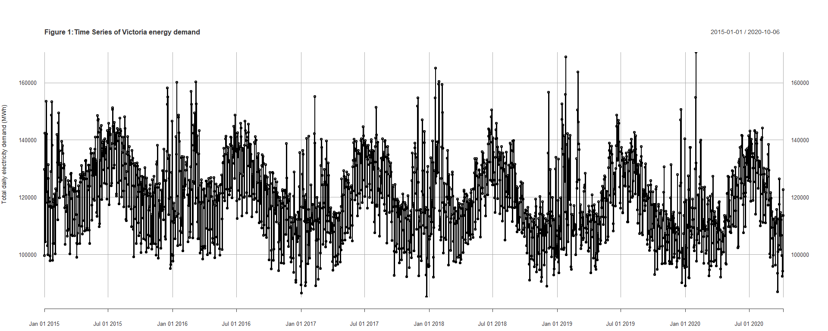

* **Trend**: A very slight downward trend.
* **Variance**: No obvious changing variance.
* **Seasonality**: It can be seen all the peaks occurring around July each year with short spikes occurring every January a This is as expected as generally more electricity is used during winter with the exception of very hot days during January aswell that is likely to cause large uptake in cooling systems.
* **Change Point**: No clear change point observed

As you can see in the plot above the time series data has relatively high granularity due to the fact daily data points are used. Because of this, this data is likely to contain multiple seasonal components on the day , week and month level. As the main objective of this report is to identify and forecast trends in the electricity demand on a monthly basis, this time series data will be aggregated on monthly basis.

# remove last 6 data points as they belong to separate month and will skew the summations  
n<-dim(Data)[1]  
df<-Data[1:(n-6),]  
Data_xts <- xts(df$`demand`, df$date)   
  
Data_xts_agg <- apply.monthly(Data_xts,sum)  
  
#Plot the Time Series:  
plot(Data_xts_agg,type="o",ylab="Total monthly electricity demand (MWh)",xlab="Year",  
 main="Figure 2:Time Series of Victoria energy demand (aggregated monthly)")

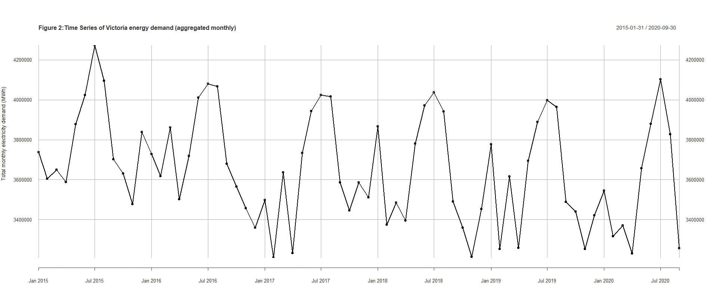

Time series characteristics observed from the above plot:

* **Trend**: A very slight downward trend.
* **Variance**: No obvious changing variance.
* **Seasonality**: Needs to be further investigated, however annual repeating patterns can be seen around every January and july each year which strongly suggests the existence of seasonality.
* **Change Point**: No clear change point observed.

# Summary Stats  
summary(Data_xts_agg)

## Index Data_xts_agg   
## Min. :2015-01-31 Min. :3209217   
## 1st Qu.:2016-06-30 1st Qu.:3453621   
## Median :2017-11-30 Median :3631206   
## Mean :2017-11-29 Mean :3654578   
## 3rd Qu.:2019-04-30 3rd Qu.:3877235   
## Max. :2020-09-30 Max. :4273538

As seen in the summary data above, the data has a mean of 3654578 and a median of 3631206 , which is relatively similar indicating that the distribution is roughly symmetric if not slightly right-skewed. The min and max have a difference of 1064321 which is relatively large, indicating that there is significant variability in the data. The IQR of the data set is 423614 which indicates a moderate spread of data points around the mean. As both q1 and q3 are similar distance away from the median it can be concluded the data is relatively symmetric , however the slightly greater difference between q3 and the median does further indicate a slight positive skew.

# ACF and PACF  
par(mfrow=c(1,2))  
acf(Data_xts_agg,lag.max=30, main="Figure 3: ACF plot of daily Victorian electricity \nconsumption time series")  
pacf(Data_xts_agg,lag.max=30, main="Figure 4: PACF plot of daily Victorian electricity \nconsumption time series")

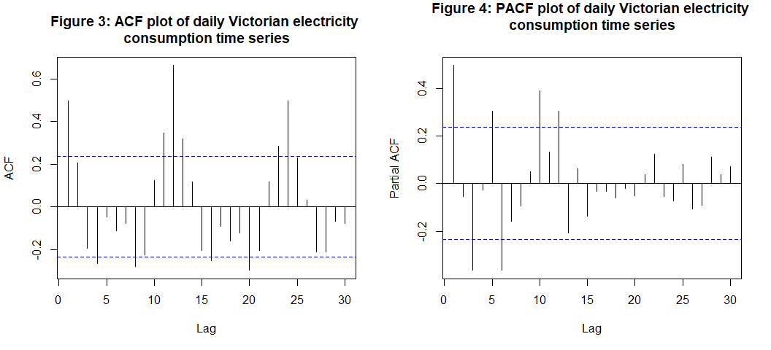

From the ACF plot above we can see a very clear wave-like pattern which indicates the presence of seasonality in our data.The Pacf exhibits a slowly decreasing pattern which suggests a gradual decay of autocorrelation , suggesting the presence of a long-term/weak auto-regressive trend in the data. From this one can roughly deduce that a SARIMA model is likely going to be the best model-type for this data.

# ADF test to test for stationarity  
Stationary_tests(Data_xts_agg)

##   
## Augmented Dickey-Fuller Test  
##   
## data: data  
## Dickey-Fuller = -3.2417, Lag order = 4, p-value = 0.08841  
## alternative hypothesis: stationary  
##   
##   
## Phillips-Perron Unit Root Test  
##   
## data: data  
## Dickey-Fuller Z(alpha) = -36.579, Truncation lag parameter = 3, p-value  
## = 0.01  
## alternative hypothesis: stationary  
##   
##   
## KPSS Test for Level Stationarity  
##   
## data: data  
## KPSS Level = 0.31195, Truncation lag parameter = 3, p-value = 0.1

For the ADF test, a p-value less 0.05 indicates that under the 95% confidence interval the null hypothesis of non-stationarity can be rejected.The ADF test above shows a p-value of 0.088 which is greater than 0.05 , meaning the null hypothesis cannot be rejected and the time series is assumed to NOT be stationary. The Phillips-Perron also supported this with a p-value less than 0.05 , meaning under the general consesus non-stationarity can be assumed.

# Check the degree of normality   
Normalitytests(Data_xts_agg,"Figure 5: QQ plot of Victorian electricity consumption time series")

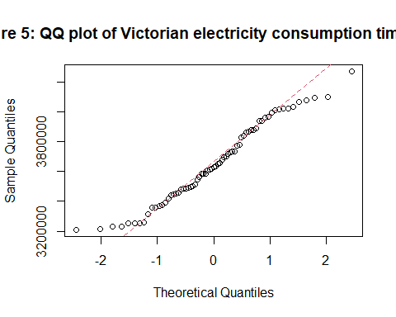

##   
## Shapiro-Wilk normality test  
##   
## data: as.numeric(data)  
## W = 0.96648, p-value = 0.06078

In order to test for normality in the data, Both a shaprio-wilk test and Q-Q plot was used. The shapiro-wilk test achieved a p-value of 0.06 and as this is greater than 0.05 we cannot reject the null hypothesis of normality. The Q-Q plot does show that the data follows the centre-line for the majority of points , however there still is deviation at the ends of the data meaning this data likely skirts on the edge of normality.

## 2.2 Impact of previous days

Another useful initial analysis to conduct is to determine whether or not previous years share a strong correlation or not.

# plot lag 1 scatterplot  
plot(y=Data_xts_agg,x=zlag(Data_xts_agg),ylab="Total monthly electricity demand (MWh)", xlab='Previous months values', main = "Figure 6: Lag 1 Plot.")

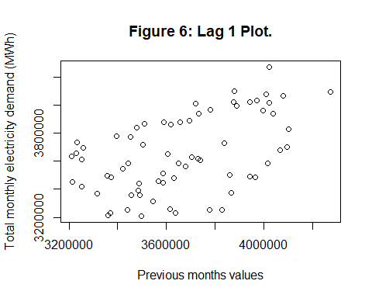

y = Data_xts_agg   
x = zlag(Data_xts_agg) # Generate first lag of the series  
index = 2:length(x) # Create an index to get rid of the first NA value in x  
cor(y[index],x[index]) # Compute correlation coefficient of the data with its first lag

## [,1]  
## [1,] 0.5041434

The scatter plot above shows that there is a weak positive correlation between the energy demand on a given month and its succeeding months. the correlation coefficient of 0.50 shows that the correlation is relatively weak and confirms that the time series data exhibits some form of positive autocorrelation however not a significant amount and the data is NOT randomly distributed.

# 3. Identifying seasonality

#Plot acf plot of time series data  
acf(Data_xts_agg, lag.max = 70,main="Figure 7: ACF plot of Victorian electricity consumption time series")

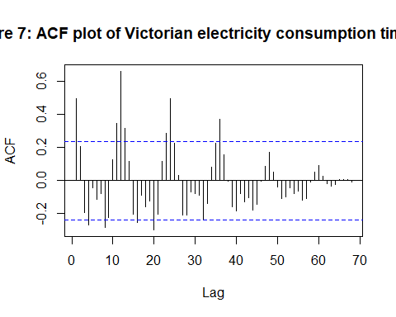

Because a wave pattern with clear significant lags was seen in the acf plot above and because the general time series plot shows clearly repeating patterns in July and January each year it and therefore non-stationary which will be further investigated.Using the ACF plot the amount of lags between each peak in the observed ossification pattern can be used to determine frequency.

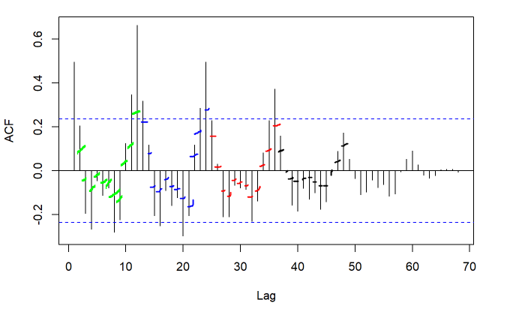

Figure X: Calculating frequency

It can be seen that peaks occur at lags 1 , 12 , 24 etc. which suggest the seasonality of the series exhibits a frequency of approximately 12. This also is expected in terms of the context of the problem as energy usage is likely to go up every winter and start of summer. Because of this the frequency of 12 will be embdedded into the time series itself.

# Convert to ts object so that we can add frequency:  
Data <- df # Duplicate data  
Data$year <- strftime(Data$date, "%Y") # Create year column  
Data$month <- strftime(Data$date, "%m") # Create month column  
  
Data_agg <- aggregate(`demand` ~ month + year, # Aggregate data  
 Data,  
 FUN = sum)  
# Convert data into a time series object  
Data_ts_agg = matrix(Data_agg$`demand`)  
Data_ts_agg = as.vector(t(Data_ts_agg))  
  
  
Data_ts_agg <- ts(Data_ts_agg,frequency=12,start =c(2015,1),end =c(2020,9) )  
plot(Data_ts_agg,type="o",ylab="Total monthly electricity demand (MWh)",xlab="Year",  
 main="Figure 8:Time Series of Victoria energy demand (aggregated monthly)")

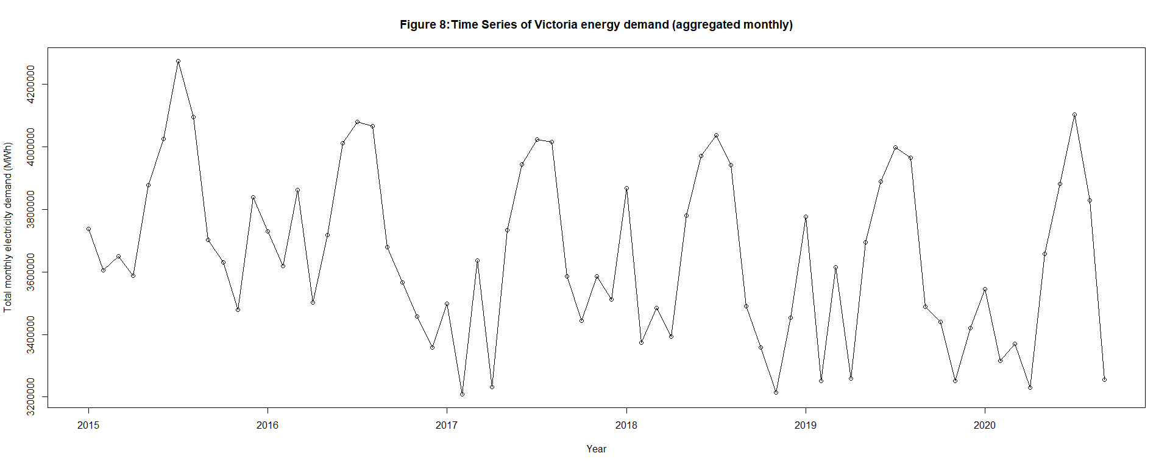

# 4. Data transformations

Because the acf and pacf plots indicate the presence of trends in the data (downward trends) and because the days exhibited both non-stationarity and non-normality, it will be likely transformations will need to be performed to remove this trend. Because Log transformations are generally used for variance stabilisation, a more general transformation called Box-Cox was tested.

# As the data is not normal a box cox transformation will be used to see if this improves normality  
BC = BoxCox.ar(Data_ts_agg, lambda = seq(-2, 6, by = 0.1))  
title(main = "Figure 9: Optimal BoxCox transformation")

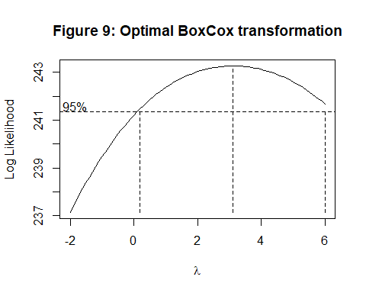

lambda <- BC$lambda[which(max(BC$loglike) == BC$loglike)]  
lambda

## [1] 3.1

The optimal value of lambda in this instance is 3.1

# Apply box cox transformation to time series and see if normality has improved  
Data_ts_agg_BC = (Data_ts_agg^lambda-1)/lambda  
#Plot the Time Series:  
plot(Data_ts_agg_BC,type="o",ylab="Total monthly electricity demand (MWh)",xlab="Year",  
 main="Figure 10:Time Series of Victoria energy demand (aggregated monthly)")

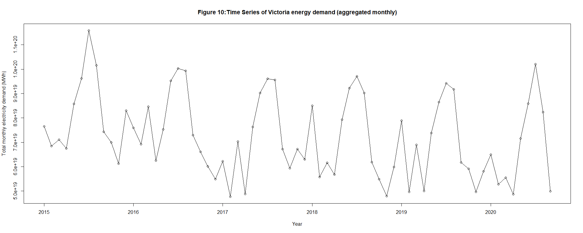

As can be seen in figure X above, the BoxCox transformation does not appear to have had much effect on the time series.

Stationary_tests(Data_ts_agg_BC)

##   
## Augmented Dickey-Fuller Test  
##   
## data: data  
## Dickey-Fuller = -3.3056, Lag order = 4, p-value = 0.07819  
## alternative hypothesis: stationary  
##   
##   
## Phillips-Perron Unit Root Test  
##   
## data: data  
## Dickey-Fuller Z(alpha) = -34.509, Truncation lag parameter = 3, p-value  
## = 0.01  
## alternative hypothesis: stationary  
##   
##   
## KPSS Test for Level Stationarity  
##   
## data: data  
## KPSS Level = 0.28542, Truncation lag parameter = 3, p-value = 0.1

It can be seen in both the ADF and pp test above, the BoxCox transformation slightly increased the stationary of the time series.

# Check if normality has been improved  
Normalitytests(Data_ts_agg_BC,"Figure 11: QQ plot of BC Victorian electricity consumption time series")

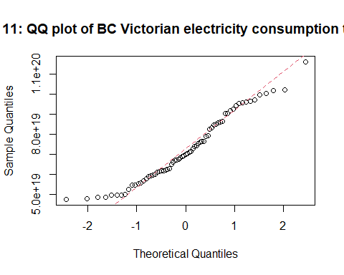

##   
## Shapiro-Wilk normality test  
##   
## data: as.numeric(data)  
## W = 0.95668, p-value = 0.01762

Based on the results of the Shapiro-Wilk test, it is observed that the Box-Cox transformation has made the time series less normal, as indicated by a p-value of 0.02. Consequently, since the transformation has had minimal impact on achieving stationarity and improving normality, it will not be utilized for the model.

Given that the model was not stationary, an initial first differencing will be employed. This differencing approach aims to remove any underlying trend present in the data and make it stationary, which is a crucial requirement for many time series models.

# applying first differencing  
diff.Data_ts_agg <- diff(Data_ts_agg)  
par(mfrow=c(1,1))  
plot(diff.Data_ts_agg,type='o',ylab = "Demand (MWh)", main='Figure 12: Time series plot of differenced  
 Electricity demand.')

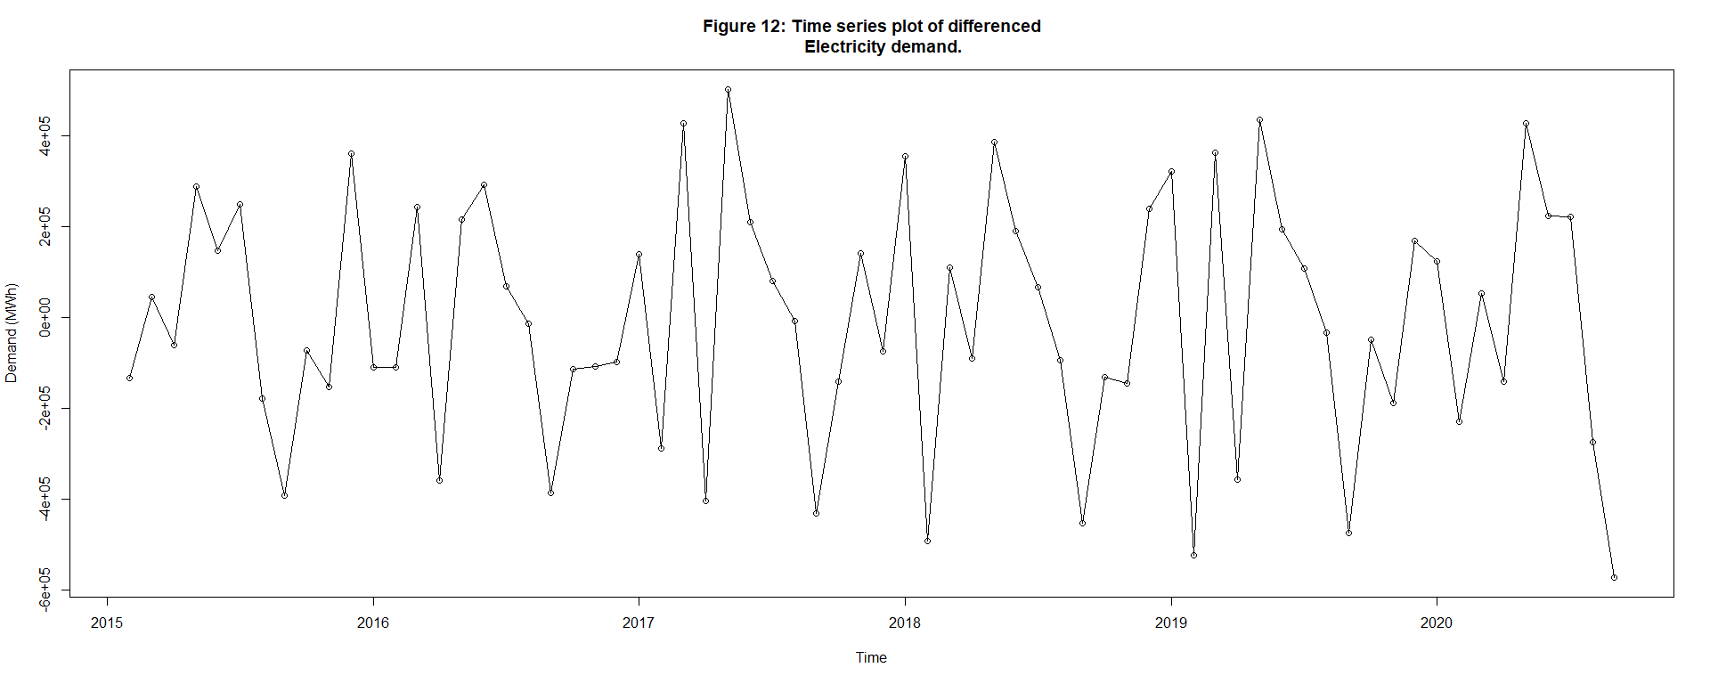

Upon initial inspection of the first differenced time series plot, it is observed that there are no apparent trends or changing variances. This suggests that the first differencing alone might be sufficient to make the time series stationary.

# Use adf test on differenced series  
Stationary_tests(diff.Data_ts_agg)

##   
## Augmented Dickey-Fuller Test  
##   
## data: data  
## Dickey-Fuller = -4.345, Lag order = 4, p-value = 0.01  
## alternative hypothesis: stationary  
##   
##   
## Phillips-Perron Unit Root Test  
##   
## data: data  
## Dickey-Fuller Z(alpha) = -74.581, Truncation lag parameter = 3, p-value  
## = 0.01  
## alternative hypothesis: stationary  
##   
##   
## KPSS Test for Level Stationarity  
##   
## data: data  
## KPSS Level = 0.028624, Truncation lag parameter = 3, p-value = 0.1

Based on the results of the Augmented Dickey-Fuller (ADF) test, the p-value of 0.01 is less than the significance level of 0.05. Thus, the null hypothesis of non-stationarity can be rejected, and the differenced series can be considered stationary at a 95% confidence level.

While the Phillips-Perron (PP) test may have yielded a p-value less than 0.05, it is important to note that the ADF and KPSS tests both agree on the stationarity of the differenced series. When multiple tests produce conflicting results, it is common practice to rely on the consensus among different tests. In this case, since the ADF and KPSS tests align in indicating stationarity, it is reasonable to assume the series is stationary.

# Test for normality of difference plot   
Normalitytests(diff.Data_ts_agg,"Figure 13: QQ plot of difference time series")

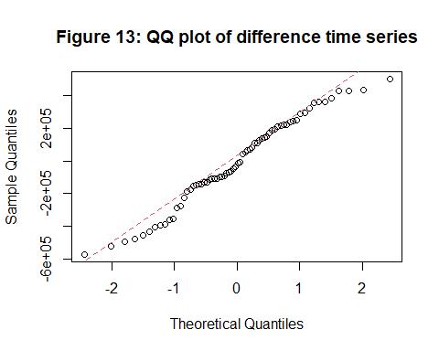

##   
## Shapiro-Wilk normality test  
##   
## data: as.numeric(data)  
## W = 0.97446, p-value = 0.1759

The Shapiro-Wilk test resulted in a p-value greater than 0.05, indicating that, under the 95% confidence level, we can assume normality of the data. This is beneficial when fitting time series models because many models, such as SARIMA (Seasonal Autoregressive Integrated Moving Average), assume normality of the residuals.

# ACF and PACF to find period of differenced series  
par(mfrow=c(1,2))  
acf(diff.Data_ts_agg, lag.max = 70, main="Figure 14: ACF plot of \ndifferenced daily Victorian electricity \nconsumption time series")  
pacf(diff.Data_ts_agg, lag.max = 70,main="Figure 15: PACF plot of \ndifferenced daily Victorian electricity \nconsumption time series")

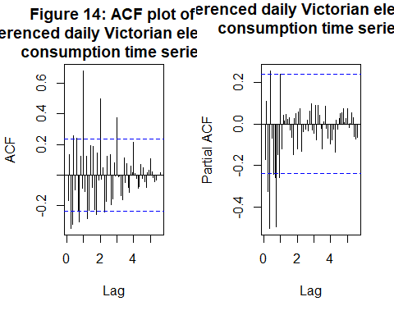 from the acf and pacf plots above you can see that significant lags are still occurring at with slightly reduced wave-like pattern. The significant lags in the ACF plot indicate that past values of the time series are correlated with the current value, further indicating the presence of a seasonal pattern. Considering both the ACF and PACF, it becomes evident that the data still exhibits seasonality and trend components. These components need to be properly accounted for in subsequent modeling steps to ensure accurate forecasting and capturing the underlying patterns.

Therefore, it is crucial to incorporate appropriate seasonal and trend models, such as SARIMA (Seasonal Autoregressive Integrated Moving Average) or other techniques designed to handle time series data with seasonal and trend components.

# 5. Simple deterministic model (Linear + Seaonal model)

Before delving into more complex SARIMA models, we will start by fitting and analyzing a simpler deterministic model. The chosen model for this initial analysis is a hybrid additive model, which combines a seasonal model to capture yearly seasonality and a linear model to capture the decreasing trend.

t <- time(Data_ts_agg)  
month.=season(Data_ts_agg) # period added to improve table display and this line sets up indicators  
Hybridmodel=lm(Data_ts_agg~month.+t-1) # -1 removes the intercept term  
summary(Hybridmodel)

##   
## Call:  
## lm(formula = Data_ts_agg ~ month. + t - 1)  
##   
## Residuals:  
## Min 1Q Median 3Q Max   
## -220520 -41803 3449 52567 218496   
##   
## Coefficients:  
## Estimate Std. Error t value Pr(>|t|)   
## month.January 108231300 14946905 7.241 1.38e-09 ***  
## month.February 107939393 14947522 7.221 1.49e-09 ***  
## month.March 108150783 14948139 7.235 1.41e-09 ***  
## month.April 107919614 14948757 7.219 1.50e-09 ***  
## month.May 108300373 14949374 7.244 1.36e-09 ***  
## month.June 108514093 14949992 7.258 1.29e-09 ***  
## month.July 108650996 14950609 7.267 1.25e-09 ***  
## month.August 108554887 14951226 7.261 1.28e-09 ***  
## month.September 108107398 14951844 7.230 1.44e-09 ***  
## month.October 108040260 14948768 7.227 1.46e-09 ***  
## month.November 107953793 14949386 7.221 1.49e-09 ***  
## month.December 108077317 14950003 7.229 1.45e-09 ***  
## t -51816 7409 -6.994 3.54e-09 ***  
## ---  
## Signif. codes: 0 '***' 0.001 '**' 0.01 '*' 0.05 '.' 0.1 ' ' 1  
##   
## Residual standard error: 101400 on 56 degrees of freedom  
## Multiple R-squared: 0.9994, Adjusted R-squared: 0.9992   
## F-statistic: 6921 on 13 and 56 DF, p-value: < 2.2e-16

This hybrid model archived an adjusted R squared score of 0.9992 , this overly high score is very worrying and is a good indication of over fitting. Additionally, all the coefficients archive p-values higher than 0.05, meaning they are found to be statistically significant.

plot(Data_ts_agg, main = "Figure 16: Hybrid model",ylab="Demand (MWh)",xlab='Year'  
 ,type='o')  
points(t,predict.lm(Hybridmodel),type='l',col='red') # superimpose the fit of model reg0 on the plot of the data  
# Add legend  
legend("topright", legend = c("Time series plot", "Fitted hybrid model"),  
 col = c("black", "red"), lwd = 1, pch = c(1, NA))

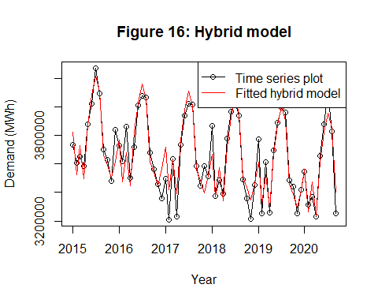 The plot of the trend model shows that the hybrid model fits the time series to a moderate extent. it has some trouble fitting the seasonal trends in the summer months which is likely due to the stochastic nature of these trends. ## 5.1 Residual analysis

# Get standardized residuals   
Hybridmodel.res=rstudent(Hybridmodel)  
  
  
residual.analysis(Hybridmodel,'17')

##   
## Shapiro-Wilk normality test  
##   
## data: res.model  
## W = 0.97373, p-value = 0.1542

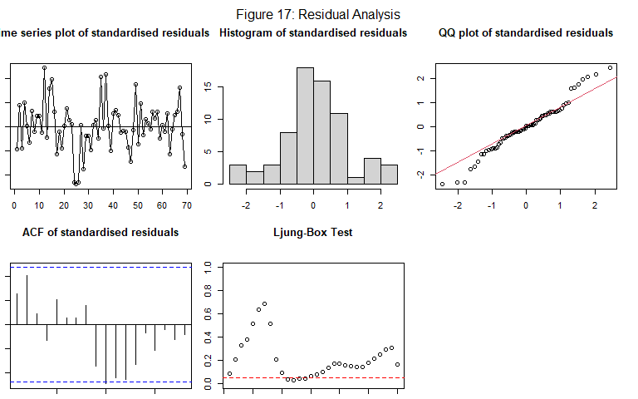 - **Histogram**: The histogram is relatively normal.  
- **QQ Plot**: The qqplot observed in this model at the tails of the data still significant deviates from the center line.  
- **ACF**: the lack of a wave-like pattern and significant lags shows that the models was able to significantly capture the seasonality and correlation present in the data.  
- **Shapiro-wilk test**: The shapiro-wilk normality test produced a p-value of 0.154. This value is greater than 0.05, meaning under a 95% confidence level and the null hypothesis is NOT rejected, meaning no significant departure from normality was found.

## 5.2 Forecast

h <- 0.8333333333333334 # 10 months ahead forecasts  
increment <- 12 # Frequency is 7  
original.t <- t  
n <- length(original.t) # Find the length of observation period  
lastTimePoint <- original.t[n] # Find the last time point  
ts <- seq(lastTimePoint ,  
lastTimePoint + h, 1/12)  
new<- factor(rep(month.,1))[1:11] # Introducing the seasonal value for forecasting\\  
daysahead <- data.frame(month. = new,t=ts)  
pred <- predict.lm(Hybridmodel,daysahead,interval='prediction') # Computing the prediction as well as prediction interval

# plot forcasted values  
par(mfrow=c(1,1))  
plot(Data_ts_agg, main = "Figure 18: 10 month forcast",ylab="Demand (MWh)",xlab='Year'  
 ,type='o',ylim = c(min(c(fitted(Hybridmodel)-800000, as.vector(Data_ts_agg))),  
 max(c(fitted(Hybridmodel)+800000, as.vector(Data_ts_agg)))),xlim=c(2015,2021.500))  
  
points(t,predict.lm(Hybridmodel),type='l',col='green') # superimpose the fit of model reg0 on the plot of  
lines(ts(as.vector(pred[,1]), start = c(2020.667,1),frequency = 12), col="red", type="l")  
lines(ts(as.vector(pred[,2]), start = c(2020.667,1),frequency = 12), col="blue", type="l")  
lines(ts(as.vector(pred[,3]), start = c(2020.667,1),frequency = 12), col="blue", type="l")  
# Add legend  
legend("topright", legend = c("Data","5% forecast limits", "Forecasts","Fitted model"),  
 col = c("black", "blue","red","green"), lwd = 1, pch = 1)

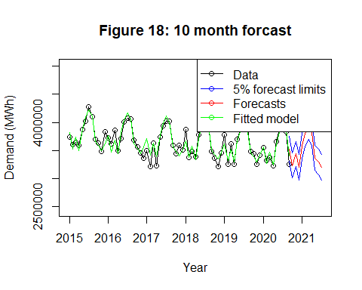

From the above plot we can see that the predictions do seem to follow the same very slow downward trend and the rough seasonal variations in the data. The red line represents the fitted values for the next 10months , while the blue lines indicate the upper and lower confidence intervals for the fitted values. For the simplicity of the model this is an adequate forecast , however its precision is effected by the stochastic nature of the seasonal trends as the difference in peaks between years does not seem to follow a specific trend.

# 6. SARIMA model

The more complex model that will be used to forecast this dataset will be a SARIMA model. This is because there is clear seasonality in the monthly aggregated time series with a period of 12 months. There is also constant variance with no clusters of high variance and therefore a GARCH model is not suitable for this time series. This model is therefore more likely to pick up on the slight year deviations in values.To begin finding possible PDQ and pdq parameters for the SARIMA model, first the seasonal component must be modeled by finding the P and Q values. The residuals analysis approach was used to find possible seasonal P and Q values.

## 6.1 Residual Approach

To deal with the season trend effect, we will fit an initial plain model (model 1) with the first seasonal difference to see if the seasonal trend is affected and to what extent.

# Model 1 with first seasonal differencing  
m1.ts<-Plot_Model(Data_ts_agg,1,"19",0,0,0,0,1,0)

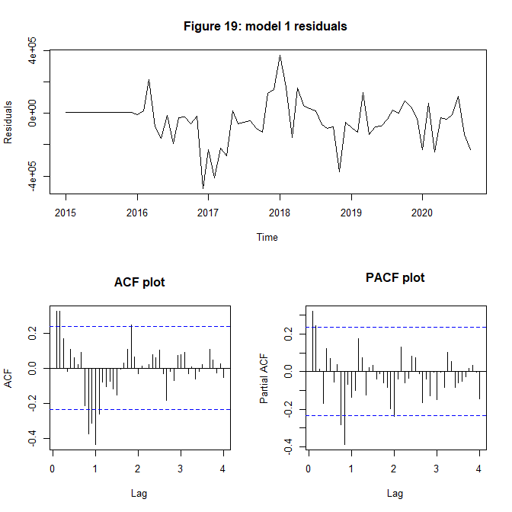 It can be seen in the Time series plot of the residuals plotted above, there is no obvious seasonal component and therefore this model can likelely account fore the seasonality in the time series. It can be seen in the ACF plot in figure X above that there is a significant lag on lag 1. There is no significant lags on shown on the PACF plot shown in figure x above. Therefore the model will be updated with a seasonal MA order of 1.

# Model 2 SAMRA(0,1) with first seasonal differencing  
m2.ts<-Plot_Model(Data_ts_agg,2,"20",0,0,0,0,1,1)

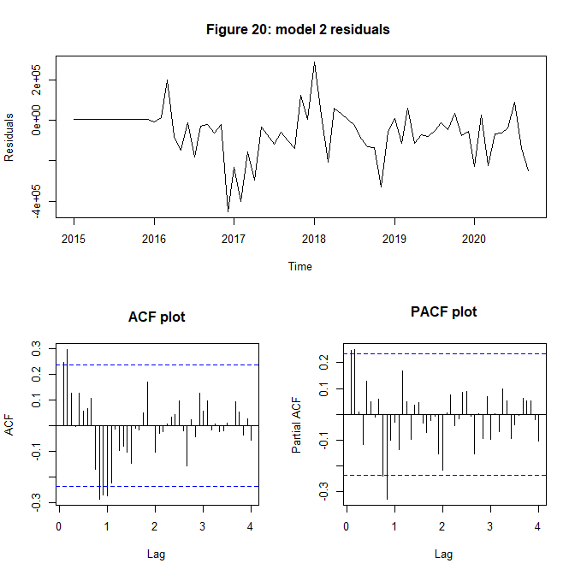

The residual plot of model 2 can be seen in figure X above, similarly to model one it can be seen there is no obvious seasonal component in the residuals.There is however still a significant lag on the first lag in the ACF shown in figure X above therefore for Model 3, Q will be updated to 2 and checked if there is still a significant lag.

# Model 3 SAMRA(0,2) with first seasonal differencing  
m3.ts<-Plot_Model(Data_ts_agg,3,"21",0,0,0,0,1,2)

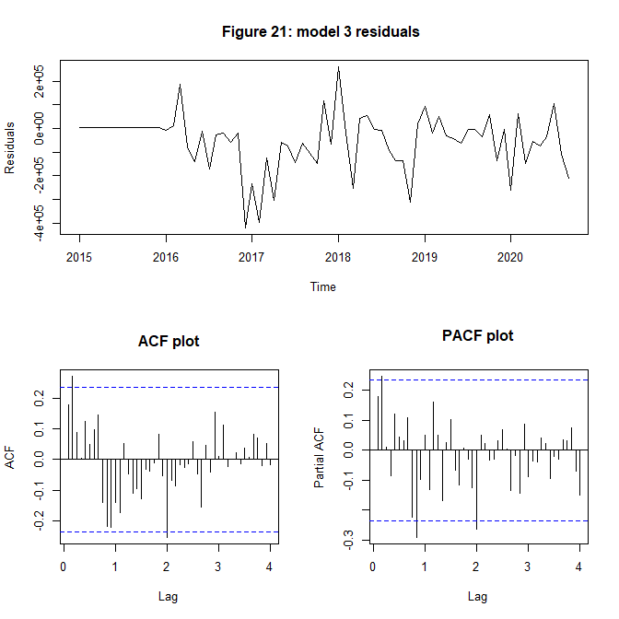

The residual plot of model 2 can be seen in figure X above, similarly to model two it can be seen there is no obvious seasonal component in the residuals.There is however still a significant lag on the second lag in the ACF shown in figure X above as well as the PACF shown in figure X above. Therefore for Model 3, Q will be updated to 3 for model 4 and checked if there is still a significant lag.

# Model 4 SAMRA(0,3) with first seasonal differencing  
m4.ts<-Plot_Model(Data_ts_agg,4,"22",0,0,0,0,1,3)

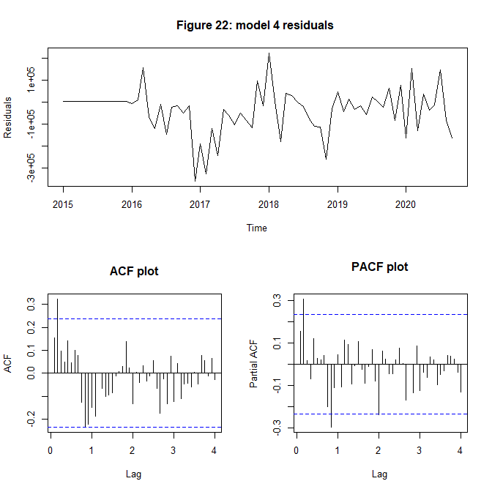

The residual plot of model 4 can be seen in figure X above, similarly to model 3 it can be seen there is no obvious seasonal component in the residuals.There is also no significant lags in the PACF or ACF plots shown above and therefore P = 0 and Q = 3 can be considered to model the seasonal component of the monthly aggregated time series.

Stationary_tests(residuals(m4.ts))

##   
## Augmented Dickey-Fuller Test  
##   
## data: data  
## Dickey-Fuller = -2.6091, Lag order = 4, p-value = 0.3276  
## alternative hypothesis: stationary  
##   
##   
## Phillips-Perron Unit Root Test  
##   
## data: data  
## Dickey-Fuller Z(alpha) = -65.459, Truncation lag parameter = 3, p-value  
## = 0.01  
## alternative hypothesis: stationary  
##   
##   
## KPSS Test for Level Stationarity  
##   
## data: data  
## KPSS Level = 0.13522, Truncation lag parameter = 3, p-value = 0.1

For the Dickey-Fuller Test above, a p-value of 0.32 is greater than 0.05 indicates that under the 95% confidence interval the null hypothesis of non-stationarity can be rejected and there is statistically significant stationarity in the data. This also also shown for the pp test value of 0.01 which is less than 0.05 abd therefore also shows the time series is stationary.

The KPSS test however does not show stationarity as the p-value of 0.1 is greater than 0.05.

# Base model for BIC and eacf  
base.ts<-Plot_Model(Data_ts_agg,1,"23",0,1,0,0,1,3)

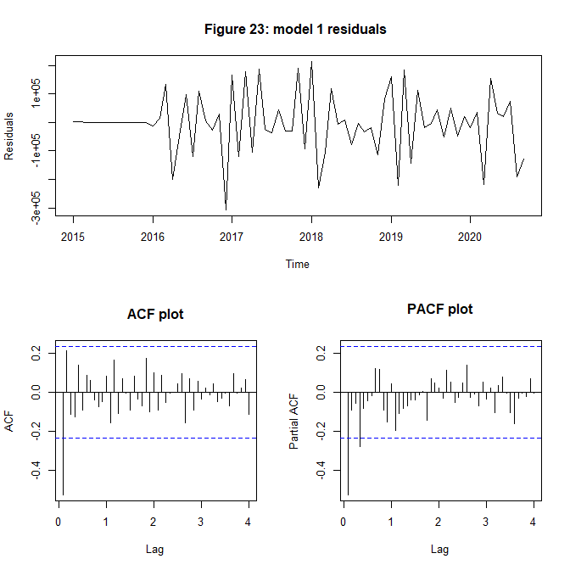

adf.test(residuals(base.ts))

##   
## Augmented Dickey-Fuller Test  
##   
## data: residuals(base.ts)  
## Dickey-Fuller = -5.2585, Lag order = 4, p-value = 0.01  
## alternative hypothesis: stationary

To find initial p and q values, the ACF and PACF plots will be analysed. A first differencing will be used as per the ADF test above with a p-value of 0.01, the differenced series can be considered stationary.Looking at the lags in the ACF and PACF plots in figure x and x above, there is 1 significant lag in ACF and 2 significant lags in PACF. There could be a decreasing pattern.

Therefore, possible p and q values for the ARIMA section can be 2 and 1 respectively.

so we will ty to use a ARIMA(2,1) model.

# Model 5 ARIMA(2,1)+ SAMRA(0,3) with first seasonal differencing  
m5.ts<-Plot_Model(Data_ts_agg,5,"24",2,1,1,0,1,3)

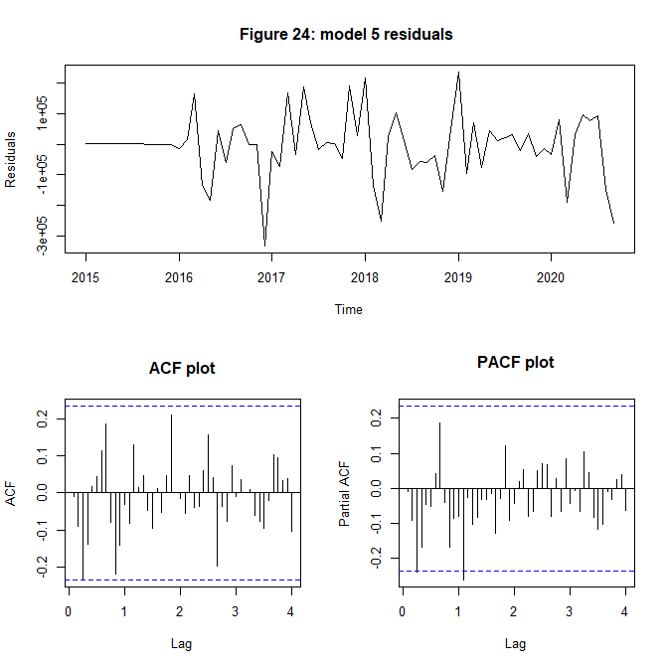

As can be seen in the ACF and PACF in figure X and figure X above, p = 2 and q = 1 reduced significant lags in both the ACF and PACF plot. There is also no obvious trends or seasonality in the plot of residuals.

# GET EACF  
res.base = residuals(base.ts)  
eacf(res.base)

## AR/MA  
## 0 1 2 3 4 5 6 7 8 9 10 11 12 13  
## 0 x o o o o o o o o o o o o o   
## 1 o o o o o o o o o o o o o o   
## 2 x o x o o o o o o o o o o o   
## 3 x x x x o o o o o o o o o o   
## 4 x o o o o o o o o o o o o o   
## 5 x o o x o o o o o o o o o o   
## 6 x o o o o o o o o o o o o o   
## 7 o x o o o o o o o o o o x o

The tentative models found using EACF table above , with e point (0,1) being the top leftmost ‘o’ are specified as: - SARIMA(0,1,2)x(0,1,3)_12  
- SARIMA(0,1,1)x(0,1,3)_12  
- SARIMA(1,1,1)x(0,1,3)_12 - SARIMA(1,1,2)x(0,1,3)_12  
- SARIMA(2,1,1)x(0,1,3)_12

# BIC  
par(mfrow=c(1,1))  
bic_table = armasubsets(y=res.base,nar=5,nma=5,y.name='p',ar.method='ols')

## Reordering variables and trying again:

plot(bic_table)

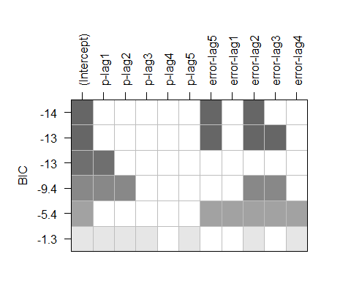 The tentative models found using the BIC table are specified as:

* SARIMA(0,1,5)x(0,1,3)_12
* SARIMA(0,1,2)x(0,1,3)_12
* SARIMA(0,1,3)x(0,1,3)_12

overall the TOTAL SET of possible models:  
- SARIMA(0,1,1)x(0,1,3)_12  
- SARIMA(1,1,1)x(0,1,3)_12  
- SARIMA(1,1,2)x(0,1,3)_12  
- SARIMA(2,1,1)x(0,1,3)_12  
- SARIMA(0,1,5)x(0,1,3)_12  
- SARIMA(0,1,2)x(0,1,3)_12  
- SARIMA(0,1,3)x(0,1,3)_12

## 6.2 Model Fitting and Diagnostic Checking

### 6.2.1 Parameter significance

#### SARIMA(0, 1, 1)(0, 1, 3)_12

# SARIMA(0,1,1)x(0,1,3)_12  
# ML METHOD   
m4_011_ML <- Parameter.estimation(Data_ts_agg,c(0,1,1),c(0,1,3),method="ML",'25')

##   
## Shapiro-Wilk normality test  
##   
## data: res.model  
## W = 0.95234, p-value = 0.01036

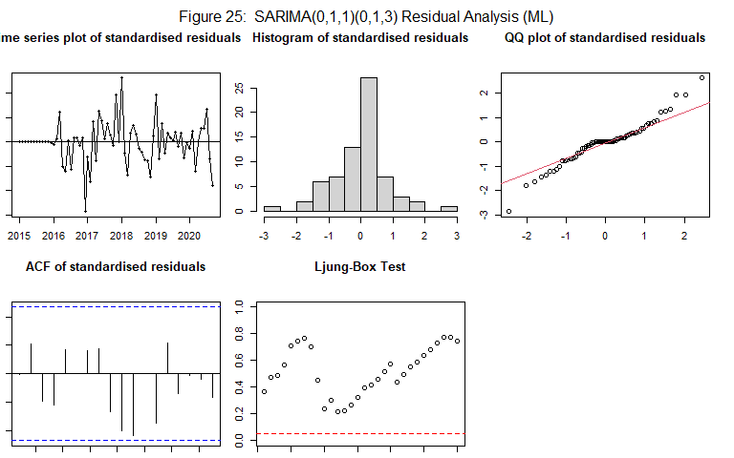

##   
## z test of coefficients:  
##   
## Estimate Std. Error z value Pr(>|z|)   
## ma1 -0.792971 0.164764 -4.8128 1.489e-06 ***  
## sma1 -1.000633 0.847262 -1.1810 0.2376   
## sma2 -0.016741 0.272201 -0.0615 0.9510   
## sma3 0.018542 0.249494 0.0743 0.9408   
## ---  
## Signif. codes: 0 '***' 0.001 '**' 0.01 '*' 0.05 '.' 0.1 ' ' 1

It can be seen for the above model the MA(1) value is significant, however not the seasonal P and Q values. It can be seen in the residual analysis, there is no obvious trend in the residuals plot. However using the histogram of residuals and the QQ plot, it does not seem the residuals are normally distributed. This can be further seen by the Shapiro Wilks t-test which returned a p-value of 0.01 which is less than 0.05. However there is no significant lags in the ACF plot and all p values are above the confidence interval in the Ljung-Box test. Because the residuals are not normal, CSS is likely a better method over ML.

# CSS METHOD   
m4_011_CSS <- Parameter.estimation(Data_ts_agg,c(0,1,1),c(0,1,3),method="CSS",'26')

##   
## Shapiro-Wilk normality test  
##   
## data: res.model  
## W = 0.94238, p-value = 0.00321

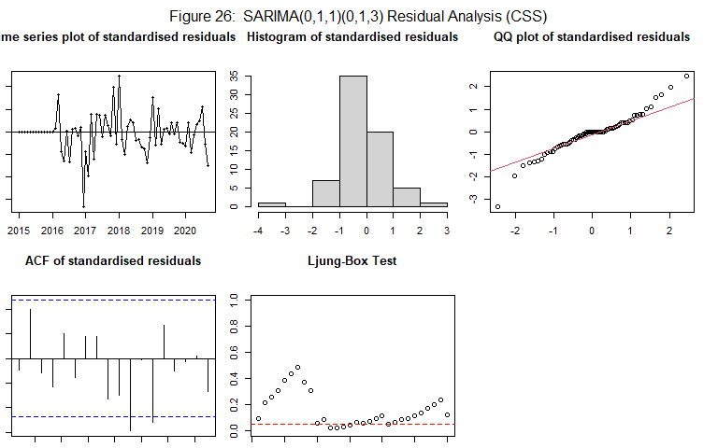

##   
## z test of coefficients:  
##   
## Estimate Std. Error z value Pr(>|z|)   
## ma1 -0.830103 0.119658 -6.9373 3.996e-12 ***  
## sma1 -0.676582 0.155618 -4.3477 1.376e-05 ***  
## sma2 -0.013952 0.220682 -0.0632 0.9496   
## sma3 -0.041265 0.209363 -0.1971 0.8438   
## ---  
## Signif. codes: 0 '***' 0.001 '**' 0.01 '*' 0.05 '.' 0.1 ' ' 1

It can be seen for the above model the MA(1) value is significant as well as the seasonal MA value. It can be seen in the residual analysis, there is no obvious trend in the residuals plot. However using the histogram of residuals and the QQ plot, it does not seem the residuals are normally distributed. This can be further seen by the Shapiro Wilks t-test which returned a p-value of 0.01 which is less than 0.003. There is also significant lags in the ACF plot and all p values are not above the confidence interval in the Ljung-Box test of 0.05 sugesting there is still a trend not covered by the model.

IT is evident that the seasonal component is not being captured as none of the SIMRA parameters are significant. Therefore the P and Q values will be altered using over fitting to see which values are optimal.

##### 1 - reducing Q value by 1

# ML METHOD   
m4_011_ML <- Parameter.estimation(Data_ts_agg,c(0,1,1),c(0,1,2),method="ML",'27')

##   
## Shapiro-Wilk normality test  
##   
## data: res.model  
## W = 0.9521, p-value = 0.01007

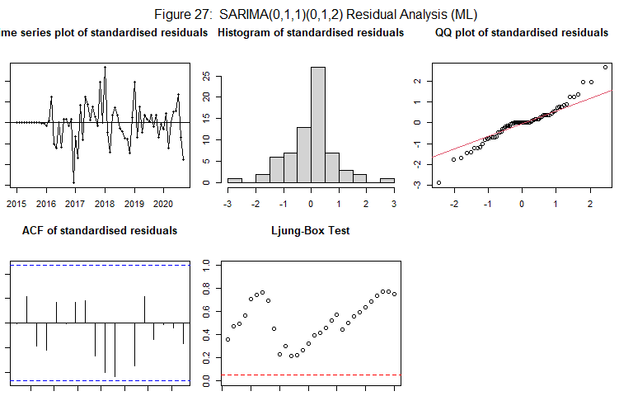

##   
## z test of coefficients:  
##   
## Estimate Std. Error z value Pr(>|z|)   
## ma1 -0.7974117 0.1535891 -5.1919 2.082e-07 ***  
## sma1 -0.9976695 0.7282187 -1.3700 0.1707   
## sma2 -0.0022906 0.1900177 -0.0121 0.9904   
## ---  
## Signif. codes: 0 '***' 0.001 '**' 0.01 '*' 0.05 '.' 0.1 ' ' 1

It can be seen for the above model the MA(1) value is significant, however not the seasonal P and Q values. It can be seen in the residual analysis, there is no obvious trend in the residuals plot. However using the histogram of residuals and the QQ plot, it does not seem the residuals are normally distributed. This can be further seen by the Shapiro Wilks t-test which returned a p-value of 0.01 which is less than 0.05. However there is no significant lags in the ACF plot and all p values are above the confidence interval in the Ljung-Box test.

#### 1 - reducing Q value by 2

# ML METHOD   
m4_011_ML <- Parameter.estimation(Data_ts_agg,c(0,1,1),c(0,1,1),method="ML",'28')

##   
## Shapiro-Wilk normality test  
##   
## data: res.model  
## W = 0.95199, p-value = 0.009934

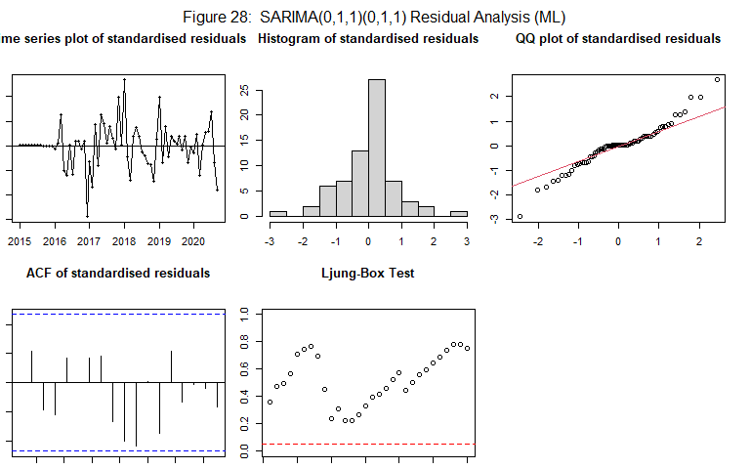

##   
## z test of coefficients:  
##   
## Estimate Std. Error z value Pr(>|z|)   
## ma1 -0.79829 0.13531 -5.8997 3.643e-09 ***  
## sma1 -0.99918 0.72796 -1.3726 0.1699   
## ---  
## Signif. codes: 0 '***' 0.001 '**' 0.01 '*' 0.05 '.' 0.1 ' ' 1

It can be seen for the above model the MA(1) value is significant, however not the seasonal Q value. It can be seen in the residual analysis, there is no obvious trend in the residuals plot. However using the histogram of residuals and the QQ plot, it does not seem the residuals are normally distributed. This can be further seen by the Shapiro Wilks t-test which returned a p-value of 0.01 which is less than 0.05. However there is no significant lags in the ACF plot and all p values are above the confidence interval in the Ljung-Box test.

#### 1 - reducing Q value by 3 and increasing P

# SARIMA(0,1,1)x(0,1,3)_12  
# ML METHOD   
m4_011_ML <- Parameter.estimation(Data_ts_agg,c(0,1,1),c(1,1,0),method="ML",'29')

##   
## Shapiro-Wilk normality test  
##   
## data: res.model  
## W = 0.94454, p-value = 0.004114

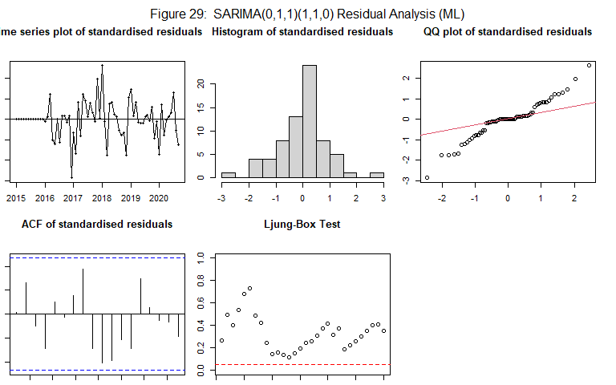

##   
## z test of coefficients:  
##   
## Estimate Std. Error z value Pr(>|z|)   
## ma1 -0.81526 0.14323 -5.6920 1.255e-08 ***  
## sar1 -0.50536 0.12883 -3.9227 8.757e-05 ***  
## ---  
## Signif. codes: 0 '***' 0.001 '**' 0.01 '*' 0.05 '.' 0.1 ' ' 1

It can be seen for the above model the MA(1) value is significant and so is the seasonal AR(1) value. It can be seen in the residual analysis, there is no obvious trend in the residuals plot. However using the histogram of residuals and the QQ plot, it does not seem the residuals are normally distributed. This can be further seen by the Shapiro Wilks t-test which returned a p-value of 0.004 which is less than 0.05. However there is no significant lags in the ACF plot and all p values are above the confidence interval in the Ljung-Box test.

# SARIMA(0,1,1)x(0,1,3)_12  
# ML METHOD   
m4_011_ML <- Parameter.estimation(Data_ts_agg,c(0,1,1),c(2,1,0),method="ML",'30')

##   
## Shapiro-Wilk normality test  
##   
## data: res.model  
## W = 0.95544, p-value = 0.01511

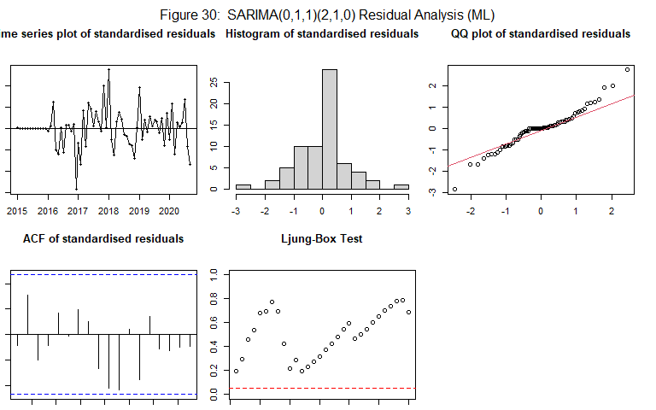

##   
## z test of coefficients:  
##   
## Estimate Std. Error z value Pr(>|z|)   
## ma1 -0.81680 0.15595 -5.2374 1.628e-07 ***  
## sar1 -0.71999 0.15954 -4.5128 6.397e-06 ***  
## sar2 -0.41048 0.14444 -2.8419 0.004485 **   
## ---  
## Signif. codes: 0 '***' 0.001 '**' 0.01 '*' 0.05 '.' 0.1 ' ' 1

It can be seen for the above model the MA(1) value is significant and so is the seasonal AR(1) and AR(2) values. It can be seen in the residual analysis, there is no obvious trend in the residuals plot. However using the histogram of residuals and the QQ plot, it does not seem the residuals are normally distributed. This can be further seen by the Shapiro Wilks t-test which returned a p-value of 0.015 which is less than 0.05. However there is no significant lags in the ACF plot and all p values are above the confidence interval in the Ljung-Box test. Due to the higher number of significant seasonal perameters in this model compared to previous, it is more likely to capture the seasonal trend to a greater degree. This is thew most optimal model as increasing any further causes and reduction in the number of significant parameters. The updated seasonal parameters will be used now to check the ARIMA p and q values for previously identified possible models.

Final seasonal parameters:

* P = 2
* D = 1
* Q = 0

#### SARIMA(1, 1, 1)(2, 1, 0)_12

# SARIMA(1,1,1)x(2,1,0)_12  
# ML METHOD   
base_111_ML <- Parameter.estimation(Data_ts_agg,c(1,1,1),c(2,1,0),method="ML",'31')

##   
## Shapiro-Wilk normality test  
##   
## data: res.model  
## W = 0.95747, p-value = 0.01942

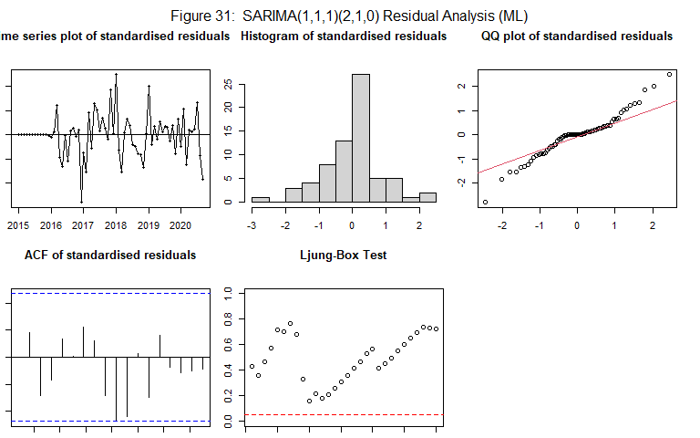

##   
## z test of coefficients:  
##   
## Estimate Std. Error z value Pr(>|z|)   
## ar1 -0.11184 0.30303 -0.3691 0.71209   
## ma1 -0.72021 0.29987 -2.4017 0.01632 *   
## sar1 -0.70556 0.17030 -4.1429 3.429e-05 ***  
## sar2 -0.42200 0.15851 -2.6624 0.00776 **   
## ---  
## Signif. codes: 0 '***' 0.001 '**' 0.01 '*' 0.05 '.' 0.1 ' ' 1

It can be seen for the above model none of the AR or MA values for the ARIMA component are significant. It can be seen in the residual analysis, there is no obvious trend in the residuals plot. However using the histogram of residuals and the QQ plot, it does not seem the residuals are normally distributed. This can be further seen by the Shapiro Wilks t-test which returned a p-value of 0.02 which is less than 0.05. However there is no significant lags in the ACF plot and all p values are above the confidence interval in the Ljung-Box test. The CSS method will be used because the residuals were not normally distributed.

# CSS METHOD   
base_111_CSS <- Parameter.estimation(Data_ts_agg,c(1,1,1),c(2,1,0),method="CSS",'32')

##   
## Shapiro-Wilk normality test  
##   
## data: res.model  
## W = 0.78084, p-value = 9.102e-09

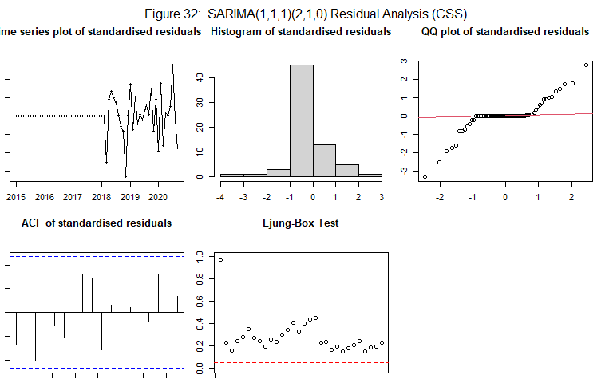

##   
## z test of coefficients:  
##   
## Estimate Std. Error z value Pr(>|z|)   
## ar1 0.0875129 0.0023623 37.046 < 2.2e-16 ***  
## ma1 -1.2745978 0.0117095 -108.852 < 2.2e-16 ***  
## sar1 -0.5545065 0.0025092 -220.991 < 2.2e-16 ***  
## sar2 -0.1613516 0.0087511 -18.438 < 2.2e-16 ***  
## ---  
## Signif. codes: 0 '***' 0.001 '**' 0.01 '*' 0.05 '.' 0.1 ' ' 1

It can be seen for the above model using the CSS method, All of the AR and MA values for the ARIMA component are significant. It can be seen in the residual analysis, there is no obvious trend in the residuals plot. However using the histogram of residuals and the QQ plot, it does not seem the residuals are normally distributed. This can be further seen by the Shapiro Wilks t-test which returned a p-value of 0.02 which is less than 0.05. However there is no significant lags in the ACF plot and all p values are above the confidence interval in the Ljung-Box test. Therefore this is likely to be a promising model.

#### SARIMA(1, 1, 2)(2, 1, 0)_12

# ML METHOD   
base_112_ML <- Parameter.estimation(Data_ts_agg,c(1,1,2),c(2,1,0),method="ML",'33')

##   
## Shapiro-Wilk normality test  
##   
## data: res.model  
## W = 0.95424, p-value = 0.01305

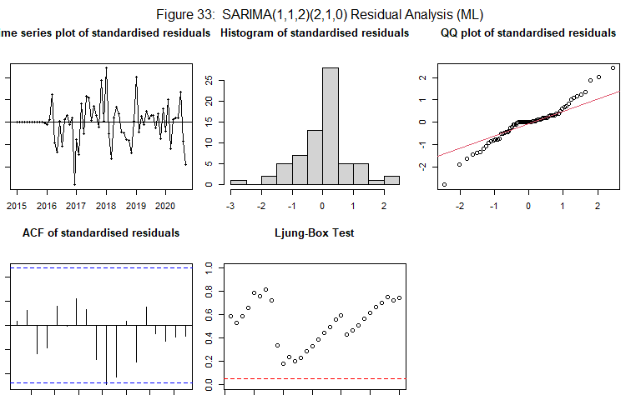

##   
## z test of coefficients:  
##   
## Estimate Std. Error z value Pr(>|z|)   
## ar1 -0.52569 0.50196 -1.0473 0.294977   
## ma1 -0.32004 0.51600 -0.6202 0.535107   
## ma2 -0.30295 0.44495 -0.6809 0.495960   
## sar1 -0.70596 0.16101 -4.3847 1.162e-05 ***  
## sar2 -0.42545 0.14098 -3.0179 0.002546 **   
## ---  
## Signif. codes: 0 '***' 0.001 '**' 0.01 '*' 0.05 '.' 0.1 ' ' 1

It can be seen for the above model none of the AR or MA values for the ARIMA component are significant. It can be seen in the residual analysis, there is no obvious trend in the residuals plot. However using the histogram of residuals and the QQ plot, it does not seem the residuals are normally distributed. This can be further seen by the Shapiro Wilks t-test which returned a p-value of 0.013 which is less than 0.05. However there is no significant lags in the ACF plot and all p values are above the confidence interval in the Ljung-Box test. The CSS method will be used because the residuals were not normally distributed.

# CSS METHOD   
base_112_CSS <- Parameter.estimation(Data_ts_agg,c(1,1,2),c(2,1,0),method="CSS",'34')

##   
## Shapiro-Wilk normality test  
##   
## data: res.model  
## W = 0.82263, p-value = 1.18e-07

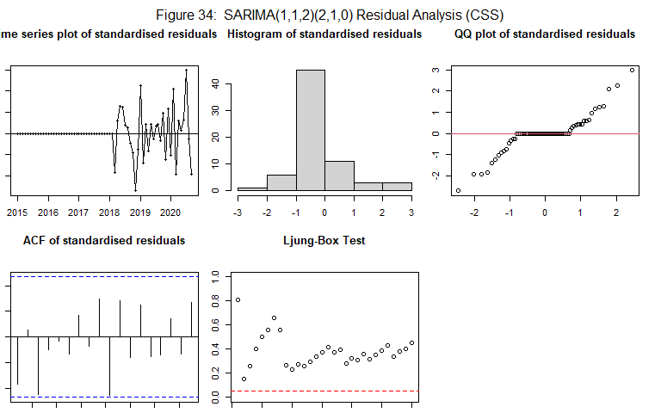

##   
## z test of coefficients:  
##   
## Estimate Std. Error z value Pr(>|z|)   
## ar1 0.0035225 0.0203324 0.1732 0.8625   
## ma1 -1.1662376 0.1202955 -9.6948 <2e-16 ***  
## ma2 -0.1153427 0.1619569 -0.7122 0.4764   
## sar1 -0.6806481 0.0209258 -32.5268 <2e-16 ***  
## sar2 -0.3865264 0.0212518 -18.1879 <2e-16 ***  
## ---  
## Signif. codes: 0 '***' 0.001 '**' 0.01 '*' 0.05 '.' 0.1 ' ' 1

It can be seen for the above model using the CSS method, All of the AR and MA values for the ARIMA component are significant. It can be seen in the residual analysis, there is no obvious trend in the residuals plot. However using the histogram of residuals and the QQ plot, it does not seem the residuals are normally distributed. This can be further seen by the Shapiro Wilks t-test which returned a p-value of 0.02 which is less than 0.05. However there is no significant lags in the ACF plot and all p values are above the confidence interval in the Ljung-Box test.

#### SARIMA(2, 1, 1)(2, 1, 0)_12

# ML METHOD   
base_211_ML <- Parameter.estimation(Data_ts_agg,c(2,1,1),c(2,1,0),method="ML",'35')

##   
## Shapiro-Wilk normality test  
##   
## data: res.model  
## W = 0.95635, p-value = 0.01692

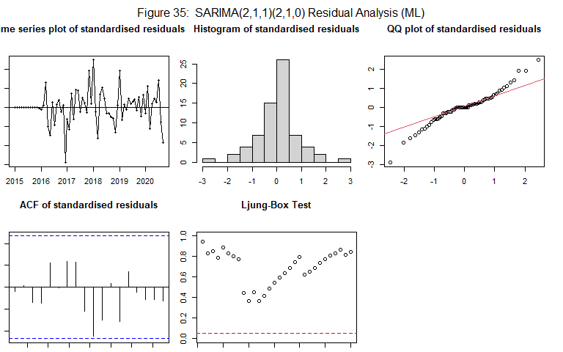

##   
## z test of coefficients:  
##   
## Estimate Std. Error z value Pr(>|z|)   
## ar1 0.116663 0.139368 0.8371 0.402544   
## ar2 0.276976 0.137889 2.0087 0.044570 *   
## ma1 -0.999867 0.083334 -11.9984 < 2.2e-16 ***  
## sar1 -0.641745 0.150041 -4.2771 1.893e-05 ***  
## sar2 -0.405200 0.139817 -2.8981 0.003755 **   
## ---  
## Signif. codes: 0 '***' 0.001 '**' 0.01 '*' 0.05 '.' 0.1 ' ' 1

It can be seen for the above model none of the AR values and the MA(1) value for the ARIMA component are significant. It can be seen in the residual analysis, there is no obvious trend in the residuals plot. However using the histogram of residuals and the QQ plot, it does not seem the residuals are normally distributed. This can be further seen by the Shapiro Wilks t-test which returned a p-value of 0.012 which is less than 0.05. However there is no significant lags in the ACF plot and all p values are above the confidence interval in the Ljung-Box test. The CSS method will be used because the residuals were not normally distributed.

# CSS METHOD   
base_211_CSS <- Parameter.estimation(Data_ts_agg,c(2,1,1),c(2,1,0),method="CSS",'36')

##   
## Shapiro-Wilk normality test  
##   
## data: res.model  
## W = 0.82392, p-value = 1.284e-07

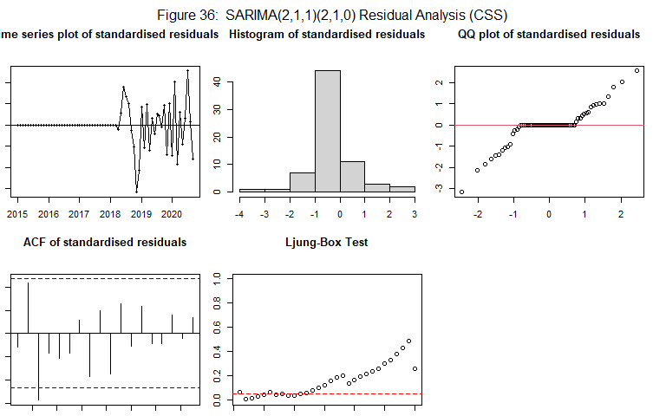

##   
## z test of coefficients:  
##   
## Estimate Std. Error z value Pr(>|z|)   
## ar1 -0.223200 0.077451 -2.8818 0.003954 **   
## ar2 -0.466185 0.037515 -12.4266 < 2.2e-16 ***  
## ma1 -1.250171 0.021429 -58.3394 < 2.2e-16 ***  
## sar1 -0.728645 0.021386 -34.0707 < 2.2e-16 ***  
## sar2 -0.405981 0.018689 -21.7233 < 2.2e-16 ***  
## ---  
## Signif. codes: 0 '***' 0.001 '**' 0.01 '*' 0.05 '.' 0.1 ' ' 1

It can be seen for the above model using the CSS method, All of the AR and MA values for the ARIMA component are significant. It can be seen in the residual analysis, there is no obvious trend in the residuals plot. However using the histogram of residuals and the QQ plot, it does not seem the residuals are normally distributed. This can be further seen by the Shapiro Wilks t-test which returned a p-value of 0.004 which is less than 0.05. There is also a significant lag in the ACF plot and not all p values are above the confidence interval in the Ljung-Box test suggesting this model is not acceptably capturing all trends in the time series.

#### SARIMA(0, 1, 5)(2, 1, 0)_12

base_015_ML <- Parameter.estimation(Data_ts_agg,c(0,1,5),c(2,1,0),method="ML",'37')

##   
## Shapiro-Wilk normality test  
##   
## data: res.model  
## W = 0.95543, p-value = 0.0151

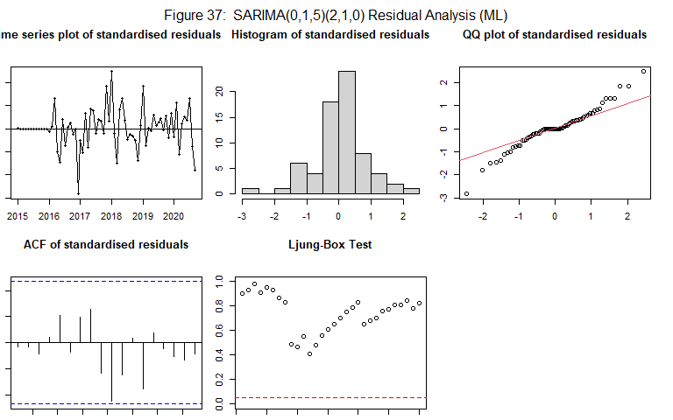

##   
## z test of coefficients:  
##   
## Estimate Std. Error z value Pr(>|z|)   
## ma1 -0.8730969 0.1743786 -5.0069 5.531e-07 ***  
## ma2 0.1954657 0.1936328 1.0095 0.312751   
## ma3 -0.2699945 0.2430327 -1.1109 0.266595   
## ma4 -0.0582800 0.2360817 -0.2469 0.805014   
## ma5 0.0060052 0.1250764 0.0480 0.961707   
## sar1 -0.6187762 0.1588614 -3.8951 9.817e-05 ***  
## sar2 -0.3873829 0.1445589 -2.6798 0.007368 **   
## ---  
## Signif. codes: 0 '***' 0.001 '**' 0.01 '*' 0.05 '.' 0.1 ' ' 1

It can be seen for the above model the MA(1) value for the ARIMA component are significant and none of the others. It can be seen in the residual analysis, there is no obvious trend in the residuals plot. However using the histogram of residuals and the QQ plot, it does not seem the residuals are normally distributed. This can be further seen by the Shapiro Wilks t-test which returned a p-value of 0.015 which is less than 0.05. However there is no significant lags in the ACF plot and all p values are above the confidence interval in the Ljung-Box test. The CSS method will be used because the residuals were not normally distributed.

base_015_CSS <- Parameter.estimation(Data_ts_agg,c(0,1,5),c(2,1,0),method="CSS",'38')

##   
## Shapiro-Wilk normality test  
##   
## data: res.model  
## W = 0.7918, p-value = 1.726e-08

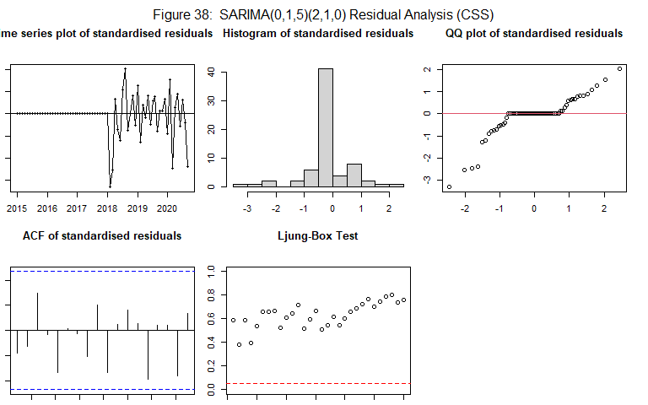

##   
## z test of coefficients:  
##   
## Estimate Std. Error z value Pr(>|z|)   
## ma1 -0.50653 0.15146 -3.3443 0.0008249 ***  
## ma2 0.25607 0.17834 1.4358 0.1510465   
## ma3 -0.57897 0.15413 -3.7563 0.0001725 ***  
## ma4 0.17350 0.16677 1.0403 0.2981929   
## ma5 0.59534 0.14348 4.1493 3.335e-05 ***  
## sar1 -0.63321 0.10866 -5.8275 5.628e-09 ***  
## sar2 -0.61838 0.13624 -4.5391 5.651e-06 ***  
## ---  
## Signif. codes: 0 '***' 0.001 '**' 0.01 '*' 0.05 '.' 0.1 ' ' 1

It can be seen for the above model using the CSS method, only the MA(1) and MA(3) parameters for the ARIMA component are significant. It can be seen in the residual analysis, there is no obvious trend in the residuals plot. However using the histogram of residuals and the QQ plot, it does not seem the residuals are normally distributed. This can be further seen by the Shapiro Wilks t-test which returned a p-value of ~0 which is less than 0.05. However there is no significant lags in the ACF plot and all p values are above the confidence interval in the Ljung-Box test.

#### SARIMA(0, 1, 2)(2, 1, 0)_12

base_012_ML <- Parameter.estimation(Data_ts_agg,c(0,1,2),c(2,1,0),method="ML",'39')

##   
## Shapiro-Wilk normality test  
##   
## data: res.model  
## W = 0.95775, p-value = 0.02012

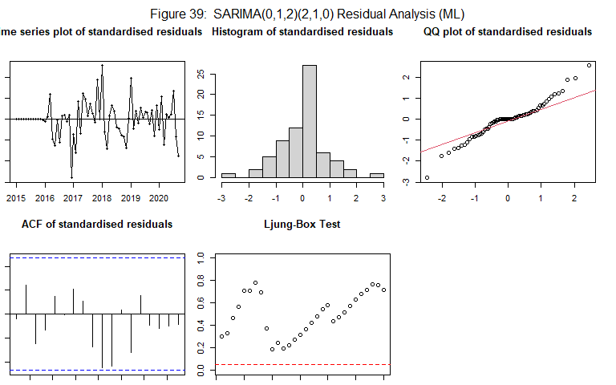

##   
## z test of coefficients:  
##   
## Estimate Std. Error z value Pr(>|z|)   
## ma1 -0.821572 0.149305 -5.5026 3.741e-08 ***  
## ma2 0.048129 0.150831 0.3191 0.749658   
## sar1 -0.712262 0.162707 -4.3776 1.200e-05 ***  
## sar2 -0.416974 0.144295 -2.8897 0.003856 **   
## ---  
## Signif. codes: 0 '***' 0.001 '**' 0.01 '*' 0.05 '.' 0.1 ' ' 1

It can be seen for the above model the MA(1) value for the ARIMA component are significant and none of the others. It can be seen in the residual analysis, there is no obvious trend in the residuals plot. However using the histogram of residuals and the QQ plot, it does not seem the residuals are normally distributed. This can be further seen by the Shapiro Wilks t-test which returned a p-value of 0.02 which is less than 0.05. However there is no significant lags in the ACF plot and all p values are above the confidence interval in the Ljung-Box test. The CSS method will be used because the residuals were not normally distributed.

base_012_CSS <- Parameter.estimation(Data_ts_agg,c(0,1,2),c(2,1,0),method="CSS",'40')

##   
## Shapiro-Wilk normality test  
##   
## data: res.model  
## W = 0.80252, p-value = 3.298e-08

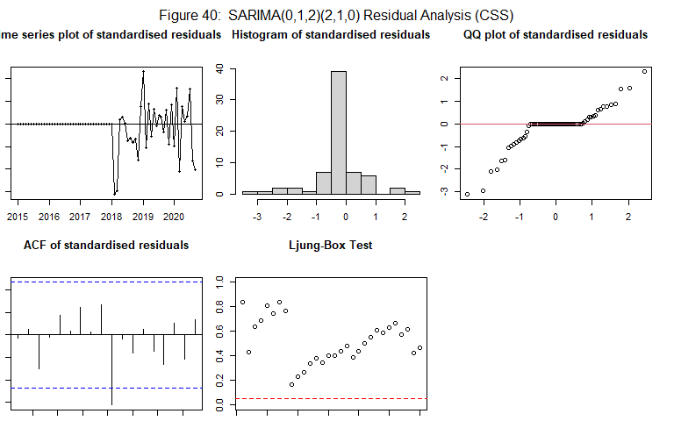

##   
## z test of coefficients:  
##   
## Estimate Std. Error z value Pr(>|z|)   
## ma1 -0.516560 0.136887 -3.7736 0.0001609 ***  
## ma2 -0.024451 0.139904 -0.1748 0.8612620   
## sar1 -0.597292 0.136534 -4.3747 1.216e-05 ***  
## sar2 -0.379309 0.118047 -3.2132 0.0013126 **   
## ---  
## Signif. codes: 0 '***' 0.001 '**' 0.01 '*' 0.05 '.' 0.1 ' ' 1

It can be seen for the above model using the CSS method, only the MA(1) parameter for the ARIMA component are significant. It can be seen in the residual analysis, there is no obvious trend in the residuals plot. However using the histogram of residuals and the QQ plot, it does not seem the residuals are normally distributed. This can be further seen by the Shapiro Wilks t-test which returned a p-value of ~0 which is less than 0.05. There is also a significant lag in the ACF plot and all p values are above the confidence interval in the Ljung-Box test. This is likely a less promising model.

#### SARIMA(0, 1, 3)(2, 1, 0)_12

base_013_ML <- Parameter.estimation(Data_ts_agg,c(0,1,3),c(2,1,0),method="ML",'41')

##   
## Shapiro-Wilk normality test  
##   
## data: res.model  
## W = 0.9533, p-value = 0.01164

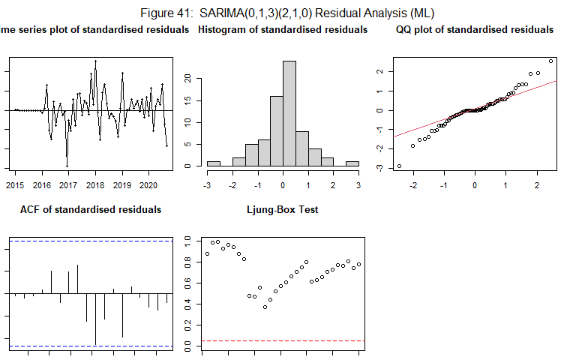

##   
## z test of coefficients:  
##   
## Estimate Std. Error z value Pr(>|z|)   
## ma1 -0.88581 0.17577 -5.0397 4.663e-07 ***  
## ma2 0.20971 0.17038 1.2308 0.218392   
## ma3 -0.32389 0.13919 -2.3270 0.019965 *   
## sar1 -0.63225 0.15045 -4.2023 2.642e-05 ***  
## sar2 -0.39644 0.13844 -2.8637 0.004188 **   
## ---  
## Signif. codes: 0 '***' 0.001 '**' 0.01 '*' 0.05 '.' 0.1 ' ' 1

It can be seen for the above model the MA(1) value for the ARIMA component are significant and none of the others. It can be seen in the residual analysis, there is no obvious trend in the residuals plot. However using the histogram of residuals and the QQ plot, it does not seem the residuals are normally distributed. This can be further seen by the Shapiro Wilks t-test which returned a p-value of 0.01 which is less than 0.05. However there is no significant lags in the ACF plot and all p values are above the confidence interval in the Ljung-Box test. The CSS method will be used because the residuals were not normally distributed.

base_013_CSS <- Parameter.estimation(Data_ts_agg,c(0,1,3),c(0,1,3),method="CSS",'42')

##   
## Shapiro-Wilk normality test  
##   
## data: res.model  
## W = 0.93896, p-value = 0.002181

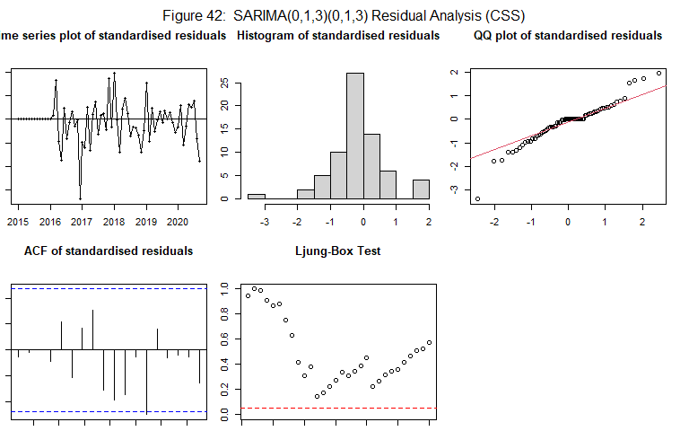

##   
## z test of coefficients:  
##   
## Estimate Std. Error z value Pr(>|z|)   
## ma1 -0.83184 0.14559 -5.7136 1.106e-08 ***  
## ma2 0.26912 0.16276 1.6534 0.0982429 .   
## ma3 -0.32952 0.13260 -2.4851 0.0129501 *   
## sma1 -0.61233 0.16467 -3.7186 0.0002004 ***  
## sma2 -0.16972 0.23594 -0.7193 0.4719408   
## sma3 0.04330 0.20938 0.2068 0.8361630   
## ---  
## Signif. codes: 0 '***' 0.001 '**' 0.01 '*' 0.05 '.' 0.1 ' ' 1

It can be seen for the above model using the CSS method, only the MA(1) parameter for the ARIMA component are significant. It can be seen in the residual analysis, there is no obvious trend in the residuals plot. However using the histogram of residuals and the QQ plot, it does not seem the residuals are normally distributed. This can be further seen by the Shapiro Wilks t-test which returned a p-value of 0.02 which is less than 0.05. There is also a significant lag in the ACF plot and all p values are above the confidence interval in the Ljung-Box test.

### 6.2.2 BIC/AIC values

An alternative method to evaluate and compare the suitability of various SIMRA models is by utilizing AIC (Akaike Information Criterion) and BIC (Bayesian Information Criterion) scores. In both instances, lower values of AIC and BIC indicate better-fitting models.

AIC and BIC evaluate models based on their goodness of fit and complexity. Both criteria consider the likelihood of the data fitting the model and penalize models for their complexity, effectively avoiding overfitting. By striking a balance between fit and complexity, AIC and BIC provide a comprehensive assessment of model quality.

sc.AIC = AIC(m4_011_ML,base_111_ML,base_112_ML,base_211_ML,base_015_ML,base_012_ML,base_013_ML)  
  
sc.BIC = BIC(m4_011_ML,base_111_ML,base_112_ML,base_211_ML,base_015_ML,base_012_ML ,base_013_ML)  
  
# sc.BIC = AIC(m5_014.landing, m5_015.landing, m5_614.landing, m5_114.landing,   
# m5_115.landing, m5_1012.landing, m5_412.landing, m5_112.landing,  
# k = log(length(NMFS_Landings.ts)))  
  
sort.score(sc.AIC, score = "aic")

## df AIC  
## m4_011_ML 4 1483.568  
## base_013_ML 6 1483.708  
## base_211_ML 6 1484.183  
## base_111_ML 5 1485.380  
## base_012_ML 5 1485.475  
## base_112_ML 6 1486.979  
## base_015_ML 8 1487.630

sort.score(sc.BIC, score = "bic")

## df BIC  
## m4_011_ML 4 1491.669  
## base_111_ML 5 1495.507  
## base_012_ML 5 1495.602  
## base_013_ML 6 1495.860  
## base_211_ML 6 1496.335  
## base_112_ML 6 1499.131  
## base_015_ML 8 1503.833

Based on the AIC and BIC tables mentioned, the ‘m4_011_ML’ model attained the lowest AIC and BIC values, indicating that the SARIMA(0,1,1)x(0,1,3)_12 model is the best fitting model according to these scores. On the other hand, the SARIMA(0,1,5)x(0,1,3)_12 model exhibited the highest values, suggesting a poorer fit.

### 6.2.3 Accuracy Scores

In addition to AIC and BIC, another approach to comparing the fit or accuracy of models is by utilizing various accuracy scores. These scores include metrics such as ME (Mean Error), RMSE (Root Mean Squared Error), MAE (Mean Absolute Error), MPE (Mean Percentage Error), MAPE (Mean Absolute Percentage Error), MASE (Mean Absolute Scaled Error), and ACF1 (Autocorrelation Function at lag 1).

Lower values for these accuracy metrics indicate a better fit in terms of the accuracy of the model. By assessing these metrics, one can gauge how well the model predicts or approximates the observed data. The selection of the model with the lowest values for these accuracy scores suggests its superior performance in accurately capturing the underlying patterns and trends in the data.

Sm4_011_ML <- accuracy(m4_011_ML)[1:7]  
Sbase_111_ML <- accuracy(base_111_ML)[1:7]  
Sbase_112_ML <- accuracy(base_112_ML)[1:7]  
Sbase_211_ML <- accuracy(base_211_ML)[1:7]  
Sbase_015_ML <- accuracy(base_015_ML)[1:7]  
Sbase_012_ML <- accuracy(base_012_ML)[1:7]  
Sbase_013_ML <- accuracy(base_013_ML)[1:7]  
  
df.Smodels <- data.frame(  
 rbind(Sm4_011_ML, Sbase_111_ML, Sbase_112_ML, Sbase_211_ML,   
 Sbase_015_ML, Sbase_012_ML, Sbase_013_ML)  
)  
colnames(df.Smodels) <- c("ME", "RMSE", "MAE", "MPE", "MAPE",   
 "MASE", "ACF1")  
rownames(df.Smodels) <- c("SARIMA(0,1,1)x(2,1,0)_12","SARIMA(1,1,1)x(2,1,0)_12", "SARIMA(1,1,2)x(2,1,0)_12", "SARIMA(2,1,1)x(2,1,0)_12",   
 "SARIMA(0,1,5)x(2,1,0)_12", "SARIMA(0,1,2)x(2,1,0)_12", "SARIMA(0,1,3)x(2,1,0)_12")  
round(df.Smodels, digits = 3)

## ME RMSE MAE MPE MAPE MASE ACF1  
## SARIMA(0,1,1)x(2,1,0)_12 -1558.413 105731.8 72165.75 -0.129 2.019 0.614 -0.042  
## SARIMA(1,1,1)x(2,1,0)_12 -2938.686 105795.6 72354.91 -0.166 2.020 0.616 0.001  
## SARIMA(1,1,2)x(2,1,0)_12 -2804.154 105329.9 71654.10 -0.162 1.999 0.610 0.016  
## SARIMA(2,1,1)x(2,1,0)_12 2249.273 100606.6 69026.11 -0.014 1.924 0.587 -0.021  
## SARIMA(0,1,5)x(2,1,0)_12 3228.639 100428.4 68468.06 0.015 1.911 0.583 -0.016  
## SARIMA(0,1,2)x(2,1,0)_12 -2543.015 105825.4 72425.96 -0.156 2.024 0.616 -0.020  
## SARIMA(0,1,3)x(2,1,0)_12 3870.899 100153.2 67915.61 0.033 1.895 0.578 -0.009

Based on the table provided, it is observed that the SARIMA(1,1,1)x(2,1,0)_12 model achieved the best ME (Mean Error) and MPE (Mean Percentage Error) scores, indicating a better accuracy in terms of these metrics. On the other hand, the SARIMA(0,1,3)x(2,1,0)_12 model attained the best scores in terms of RMSE (Root Mean Squared Error), MAE (Mean Absolute Error), MAPE (Mean Absolute Percentage Error), and MASE (Mean Absolute Scaled Error).

In contrast, the SARIMA(0,1,1)x(2,1,0)_12 model did not achieve the best accuracy values and was ranked fourth or fifth in most categories.

## 6.3 Summary

After conducting parameter significance and residuals analysis, it was observed that the SARIMA(0,1,1)x(2,1,0)_12 model had the most significant parameters, indicating its suitability as an optimal fit. Additionally, the model achieved the lowest AIC and BIC scores, further supporting its strong performance.

Although the SARIMA(0,1,1)x(2,1,0)_12 model did not achieve the best accuracy scores, it is crucial to consider multiple model diagnostic tools for a comprehensive evaluation. By taking into account the consensus among these diagnostic tools, the SARIMA(0,1,1)x(2,1,0)_12 model emerges as the best choice for forecasting.

## 6.4 Model Diagnostics

To assess whether the SARIMA(0,1,1)x(2,1,0)_12 model is not underfit, we can employ model overfitting as an additional diagnostic tool. this approach involves increasing the values of both p (autoregressive order) and q (moving average order) in the SARIMA model. By doing so, we can examine if the number of significant parameters and the quality of fit improve, indicating potential underfitting in the initial SARIMA(0,1,1)x(2,1,0)_12 model.

# Increasing the value of P  
m4_111 <- Parameter.estimation(Data_ts_agg,c(1,1,1),c(2,1,0),method="ML",'43')

##   
## Shapiro-Wilk normality test  
##   
## data: res.model  
## W = 0.95747, p-value = 0.01942

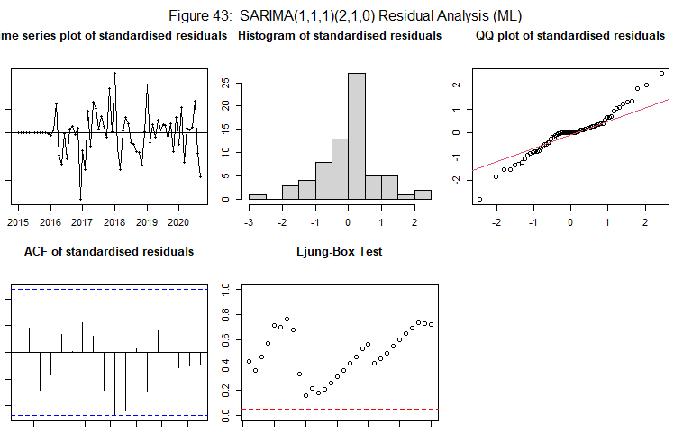

##   
## z test of coefficients:  
##   
## Estimate Std. Error z value Pr(>|z|)   
## ar1 -0.11184 0.30303 -0.3691 0.71209   
## ma1 -0.72021 0.29987 -2.4017 0.01632 *   
## sar1 -0.70556 0.17030 -4.1429 3.429e-05 ***  
## sar2 -0.42200 0.15851 -2.6624 0.00776 **   
## ---  
## Signif. codes: 0 '***' 0.001 '**' 0.01 '*' 0.05 '.' 0.1 ' ' 1

By increasing the value of p the AR(1) is not significant , meaning no imporvement of fit has occured by overfitting the model in this direction.

m4_012 <- Parameter.estimation(Data_ts_agg,c(0,1,2),c(2,1,0),method="ML",'44')

##   
## Shapiro-Wilk normality test  
##   
## data: res.model  
## W = 0.95775, p-value = 0.02012

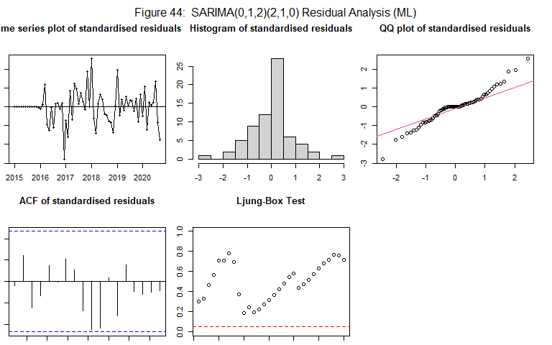

##   
## z test of coefficients:  
##   
## Estimate Std. Error z value Pr(>|z|)   
## ma1 -0.821572 0.149305 -5.5026 3.741e-08 ***  
## ma2 0.048129 0.150831 0.3191 0.749658   
## sar1 -0.712262 0.162707 -4.3776 1.200e-05 ***  
## sar2 -0.416974 0.144295 -2.8897 0.003856 **   
## ---  
## Signif. codes: 0 '***' 0.001 '**' 0.01 '*' 0.05 '.' 0.1 ' ' 1

By increasing the value of p the MA(1) is not significant , meaning no improvement of fit has occurred by overfitting the model in this direction.

Upon increasing both the p and q values and evaluating the resulting models, no significant improvement was observed in the overall model fit. This suggests that the initial SARIMA(0,1,1)x(2,1,0)_12 model is not underfit. Consequently, there is no indication of an insufficient capturing of the underlying patterns and dynamics in the data.

Since increasing the p and q values did not lead to an improved fit, it can be concluded that the SARIMA(0,1,1)x(2,1,0)_12 model is already well-suited for the dataset at hand. This confirmation allows for greater confidence in proceeding with forecasting tasks using the established model.

## 6.5 Forecasting

m5_1012.landingA = Arima(Data_ts_agg,order=c(0,1,1),seasonal=list(order=c(2,1,0), period=12),   
 method = "ML")  
# Notice that I use lambda = 0 and send NMFS_Landings.ts instead of log(NMFS_Landings.ts) to get Arima() function to do the transformation.  
# This way, I will get the forecasts in the original scale.  
preds1 = forecast(m5_1012.landingA, h = 48)  
  
  
plot(preds1)

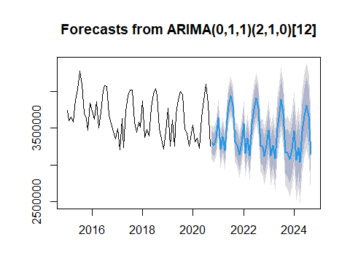

From the forecast provided, it is evident that the SARIMA model SARIMA(0,1,1)x(2,1,0)_12 successfully captures the seasonal trends present in the data as well as the slowly decreasing trend. This indicates that the model is effectively accounting for the patterns and dynamics in the dataset.

However, it is important to note that as the forecasting horizon extends further into the future, the confidence interval for the predictions widens significantly. This widening of the confidence interval is expected, primarily due to insufficient data caused by data loss during monthly aggregation. With less historical data available for modeling and forecasting, there is increased uncertainty and variability in the predictions.

# 7. Conclusion

After conducting various model specification and parameter estimation techniques to analyze the Victoria energy demand time series, the SARIMA(0,1,1)x(2,1,0) model emerged as the most fitting model based on several supporting factors. The significance of its parameters and the favorable AIC/BIC scores obtained provide evidence for its goodness of fit.

On the other hand, a simpler deterministic model that combined linear and seasonal components also produced satisfactory forecasting results. However, this model may suffer from overfitting, as indicated by the large R-squared value recorded. Additionally, it lacks the capability to capture changing variances across different years. Consequently, the SARIMA model is slightly more preferable.

With the inclusion of more historical data, the SARIMA model can be utilized effectively in future renewable energy applications. It can accurately predict energy requirements on a monthly basis, enabling the estimation of necessary battery and grid capacities to support the transition towards renewables.

# 8. References