Member and Casual Cyclist Analysis with R
by John
2025-02-05
In this report, we will go through the process of data collection, cleaning, transforming and visualising the data of Cyclist bike share company in Chicago using R package Tidyverse.
Structure:
1. Understand case study and scenario
2. Business questions
3. Data Analysis process
3.1 Data import and R package installation
3.2 Wrangle data and combine into a single file
3.3 Clean up data and organize data for analysis
3.4 Conduct data analysis process
3.5 Data visualization
4. Recommendations

1. Understand Case Study and Scenario

Introduction
In this case study, you work for a fictional company, Cyclistic, along with some key team members. In order to answer the business questions, follow the steps of the data analysis process: Ask, Prepare, Process, Analyze, Share, and Act. Along the way, the Case Study Roadmap tables—including guiding questions and key tasks—will help you stay on the right path.

Scenario
You are a junior data analyst working on the marketing analyst team at Cyclistic, a bike-share company in Chicago. The director of marketing believes the company’s future success depends on maximizing the number of annual memberships. Therefore, your team wants to understand how casual riders and annual members use Cyclistic bikes differently. From these insights, your team will design a new marketing strategy to convert casual riders into annual members. But first, Cyclistic executives must approve your recommendations, so they must be backed up with compelling data insights and professional data visualizations.

Characters and Teams
Cyclistic: A bike-share program that features more than 5,800 bicycles and 600 docking stations. Cyclistic sets itself apart by also offering reclining bikes, hand tricycles, and cargo bikes, making bike-share more inclusive to people with disabilities and riders who can’t use a standard two-wheeled bike. The majority of riders opt for traditional bikes; about 8% of riders use the assistive options. Cyclistic users are more likely to ride for leisure, but about 30% use the bikes to commute to work each day.
Lily Moreno: The director of marketing and your manager. Moreno is responsible for the development of campaigns and initiatives to promote the bike-share program. These may include email, social media, and other channels.
Cyclistic Marketing Analytics Team: A team of data analysts who are responsible for collecting, analyzing, and reporting data that helps guide Cyclistic marketing strategy. You joined this team six months ago and have been busy learning about Cyclistic’s mission and business goals—as well as how you, as a junior data analyst, can help Cyclistic achieve them.
Cyclistic Executive Team: The notoriously detail-oriented executive team will decide whether to approve the recommended marketing program.
About the Company
In 2016, Cyclistic launched a successful bike-share offering. Since then, the program has grown to a fleet of 5,824 bicycles that are geotracked and locked into a network of 692 stations across Chicago. The bikes can be unlocked from one station and returned to any other station in the system anytime.
Until now, Cyclistic’s marketing strategy relied on building general awareness and appealing to broad consumer segments. One approach that helped make these things possible was the flexibility of its pricing plans: single-ride passes, full-day passes, and annual memberships. Customers who purchase single-ride or full-day passes are referred to as casual riders. Customers who purchase annual memberships are Cyclistic members.
Cyclistic’s finance analysts have concluded that annual members are much more profitable than casual riders. Although the pricing flexibility helps Cyclistic attract more customers, Moreno believes that maximizing the number of annual members will be key to future growth. Rather than creating a marketing campaign that targets all-new customers, Moreno believes there is a solid opportunity to convert casual riders into members. She notes that casual riders are already aware of the Cyclistic program and have chosen Cyclistic for their mobility needs. Moreno has set a clear goal: Design marketing strategies aimed at converting casual riders into annual members. In order to do that, however, the team needs to better understand how annual members and casual riders differ, why casual riders would buy a membership, and how digital media could affect their marketing tactics. Moreno and her team are interested in analyzing the Cyclistic historical bike trip data to identify trends.

2. Business questions:
- How do annual members and casual riders use Cyclistic bikes differently?
- Why would casual riders buy Cyclistic annual memberships?

3. Data Analysis process

3.1. Data import and R package installation:
The data analysis process began with installing and loading the tidyverse package in R, which provides a collection of tools for data manipulation, transformation, and analysis.
Two datasets were downloaded from the Divvy public dataset repository: Divvy_Trips_2019_Q1 and Divvy_Trips_2020_Q1. These files were uploaded into the R environment and imported into the workspace for further processing.
The purpose of importing both datasets was to compare user behaviour across two different years and prepare them for consolidation into a unified dataset.

3.2. Wrangle data and combine into a single file:
Before merging the datasets, the column names of both files were compared to ensure structural consistency. Since column names must match exactly before stacking data, the 2019 dataset was renamed to align with the 2020 schema, which represents the updated system structure moving forward.
Next, inconsistencies in data types were resolved. Specifically, the ride_id and rideable_type fields were converted to character format to ensure compatibility between datasets.
After standardising column names and data types, both datasets were combined into a single dataframe.
Irrelevant variables such as latitude, longitude, birth year, gender, and trip duration (which was removed from the 2020 dataset) were excluded to maintain consistency and focus the analysis on relevant ride-level information.

3.3 Clean up data and organize data for analysis:
Once merged, the dataset was inspected to verify structure, dimensions, and data types. Summary statistics were generated to identify potential inconsistencies.
Several data cleaning steps were performed:
1. Standardising Customer Labels Different labels were used historically to classify riders (e.g., “Subscriber” vs. “member”, “Customer” vs. “casual”). These were consolidated into two consistent categories:
•member
•casual
This ensured uniform segmentation for analysis.
2. Creating Date-Based Variables Since the data was originally at the ride level, additional time-based variables were created, including:
•date
•month
•day
•year
•day of week
These new attributes allow aggregation of ride data across different time dimensions.
3. Calculating Ride Length Because the 2020 dataset no longer included trip duration, a new variable called ride_length was calculated using the difference between ride start and end times. The variable was converted to numeric format to enable statistical analysis.
4. Removing Invalid Records Rides with negative durations and internal quality-control rides were removed, as these records represent erroneous or non-customer activity. A cleaned dataset version was created for analysis.

3.4 Conduct data analysis process:
Descriptive statistics were conducted on ride length to understand overall usage patterns. Key measures included:
•Mean ride duration
•Median ride duration
•Minimum and maximum ride times
•Summary distribution statistics
Comparative analysis was then performed between members and casual riders, examining:Average ride duration Median ride duration, Shortest and longest rides.This comparison provided insight into behavioural differences between customer segments.
Additionally, ride distribution by day of the week was analysed to ensure completeness and identify usage trends. The days were ordered chronologically (Sunday to Saturday) to support accurate weekly pattern analysis.
To gain deeper behavioural insights, rides were grouped by both customer type and day of the week.
Two key metrics were calculated: Total number of rides, Average ride duration
This aggregation enabled comparison of weekday and weekend riding patterns between members and casual users.

3.5. Data visualization:
Figure 1. Number of Rides per Day (Members vs Casual)
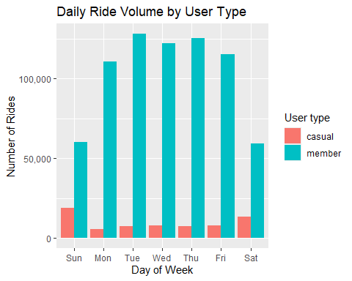
Key Trends
The chart above (Figure 1) show that members generate significantly more rides than casual users across all days of the week, clearly dominating total ride volume. This suggests that members rely on the service on a regular basis, most likely for commuting or routine travel. Member usage peaks during weekdays, particularly from Tuesday to Thursday, with a slight decline on Friday and the lowest ride volumes occurring on Saturday and Sunday. This pattern indicates that members primarily use the bikes for weekday commuting rather than leisure activities.
In contrast, casual user activity follows a different trend. Casual rides increase noticeably on weekends, especially on Saturday and Sunday, while remaining relatively low during weekdays. This suggests that casual riders are more likely to use the service for leisure, recreational activities, or occasional trips. Overall, the data reveals a clear behavioural difference between the two customer segments: members exhibit a weekday-heavy usage pattern, whereas casual users demonstrate a weekend-heavy pattern. These contrasting trends indicate two distinct customer groups with different motivations and usage behaviours.
Figure 2. Average Ride Length per Day
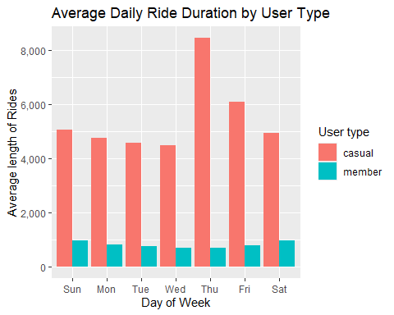
Based on the insight from Figure 2, the average ride length analysis reveals a clear behavioural difference between members and casual users. Across all days, casual riders have significantly longer ride durations—approximately four to eight times longer than members—indicating that they primarily use the service for leisure, recreation, or exploratory trips. In contrast, members tend to take shorter rides, suggesting functional and commute-based usage.
Casual ride duration also peaks around Thursday and Friday, which may reflect early weekend leisure activities or tourism patterns. Meanwhile, member ride length remains relatively stable throughout the week, demonstrating consistent and structured usage behaviour.

4.Recommendations:
Insights from analysis:
- Members ride more frequently but their ride duration is shorter. Members may represent a stable, predictable revenue stream because they subscribe and use the service frequently. Their shorter ride duration could be more cost-effective for the company in terms of maintenance
- Casual riders ride longer, but less frequently. Casual riders might be using the service for special events or occasional leisure trips, so while their ride duration is longer and can generate more revenue per ride, they don’t generate income consistently.
Recommendations:
- Continue offering competitive membership programs (e.g., discounts, one-month rewards for renewing members) to encourage frequent cyclists to become members. Since members tend to take shorter rides, this can help reduce maintenance costs while ensuring stable and predictable revenue.
- Schedule maintenance activities on weekends when demand is lower, ensuring more bikes are available on weekdays to accommodate higher ride counts.
- Implement discount or reward programs for casual riders who take longer trips, as they generate more revenue per ride, incentivizing continued usage.
What’s next?
To know if the members or casual members are more profitable we should have some extra data such as:
- Subscription price to be a member.
- Total members are available.
- The cost casual need to pay per hour.
After that, we can analyze how much total revenue is generated by members per month compared to casual riders. Then, we can assess how much each customer type typically pays per hour. Since members take shorter rides than casual riders, even though they ride more frequently, it is possible that members, on average, pay more per hour than casual riders. If this is the case, it suggests that members are indeed more profitable on a per-hour basis. Based on this insight, we can recommend targeted advertising campaigns to convert casual riders into members.
This concludes the report.

