Create cubeRT class:
Initial several function :
Create Rtv and dsv descriptor heaps;1
updateCubemap face passCBs;1
Build descriptor heaps;1
buildcubeDepthStencil;1
buildFrameResource;1
DrawSceneToCubemap;1
BuildCubeFaceCamera;1
Initialize include:
Contruct cubemap object1
buildcubefaceCamera;1
buildcubemapDS:ds resource and dsv1

Draw function struct :
Reset cmdlistAlloc
Resetcmdlist

Rt stage:
Set viewport
resourceBarrier
Clear rt view(clear buffer)
Set RT
Set root signature
Draw item
resourceBarrier
Irradiance envmap efficient representation:
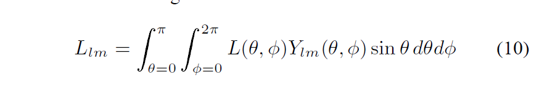
Meaning
radiance coefficient = sum of the pixel in the env map L.weighted by the function Ylm(spherical harmonic basis function ).

Rendering :
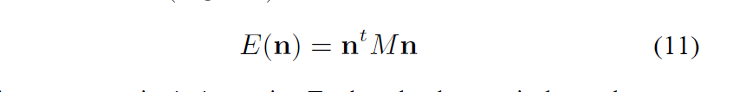
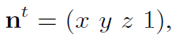
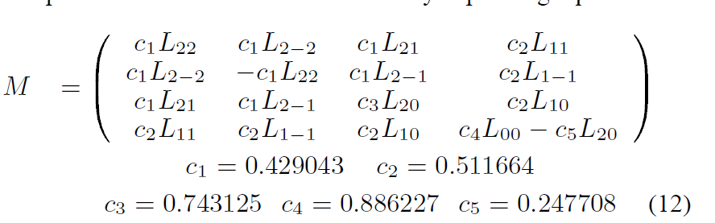
Expand equation like this
