* Data for this assignment found at this link: [**Human Resources analysis - Data**](https://www.kaggle.com/pavansubhasht/ibm-hr-analytics-attrition-dataset/data)
  + Need to create a Kaggle account,
  + Then press download button shown below
  + 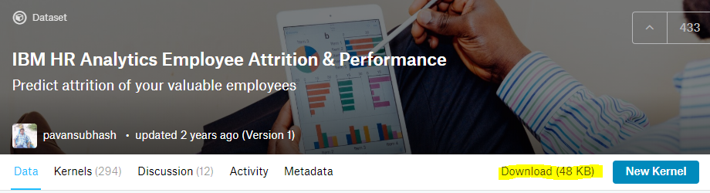
  + File will be downloaded to the folder you choose as a .csv file