**Project Data:**

**Final “clean” Git hub repository**

<https://github.com/JohnONeillGMIT/DRProjectPA.git>

**Contains Files:**

**Main file:** Server2.py

**Flask**: DAO.py

**Configuration File:** dbconfig.py

**HTML File**: Emplviewer.html

(also includes application.py… work on Pythonanywhere)

I did most of the work offline … some work was committed here as a “roughwork”

<https://github.com/JohnONeillGMIT/DRProject.git>

<https://github.com/JohnONeillGMIT/dataRepresentation.git>

PythonAnywhwere: Not fully up and running… <http://johnoneillgmit.pythonanywhere.com/>

**SQL Database:** datarepresentation2 **Table:** empldirectory

Code to create SQL Table:

In My SQL:

**mysql>** CREATE DATABASE datarepresentation2;

**mysql>** **mysql> CREATE TABLE empldirectory (**

**-> id int(11)NOT NULL AUTO_INCREMENT,**

**-> first_name varchar(20),**

**-> surname varchar(25),**

**-> Ext int(11),**

**-> PRIMARY KEY (id)**

**-> );**

Schema here

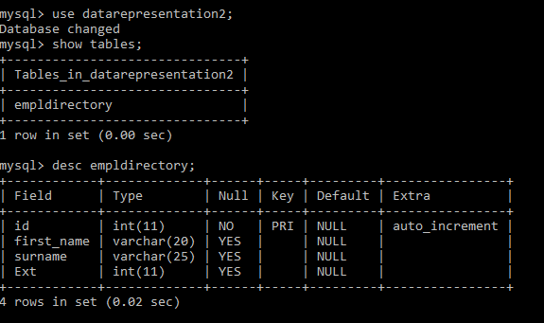

Just in case it fails for some reason!!... I had it all working locally… updating HTML and in SQL concurrently with no issues in any of the CRUD.

**HTML Snapshot**

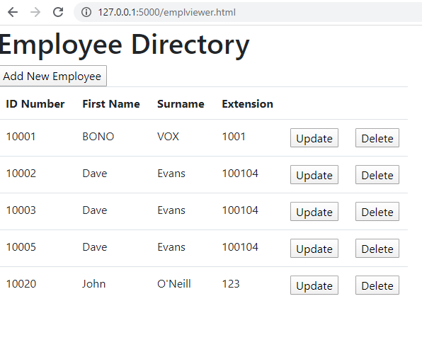

Curl Operations… to demonstrate CRUD operations from Server2.py

**Get All :** curl <http://127.0.0.1:5000/empldirectory>

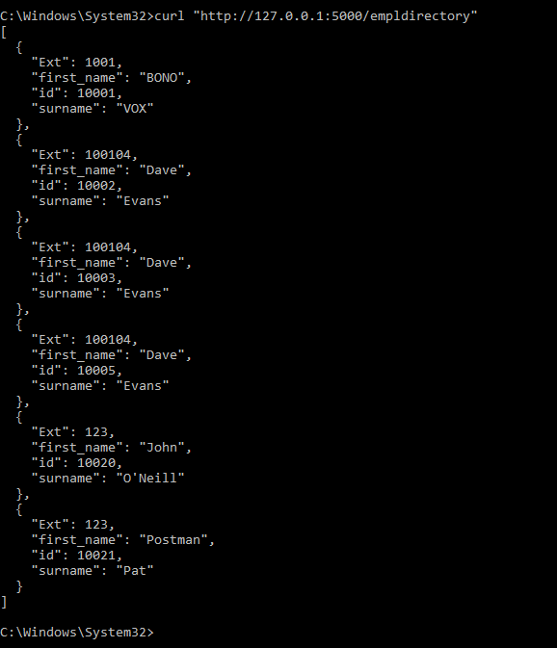

**FindByID:** curl <http://127.0.0.1:5000/empldirectory/10001>

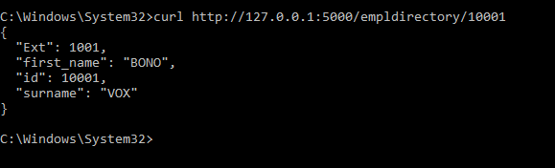

**Create:** curl -i -H "Content-Type:application/json" -X POST -d "{\"first_name\":\"Dave\",\"surname\":\"Evans\",\"Ext\":\"100104\"}" <http://127.0.0.1:5000/empldirectory>

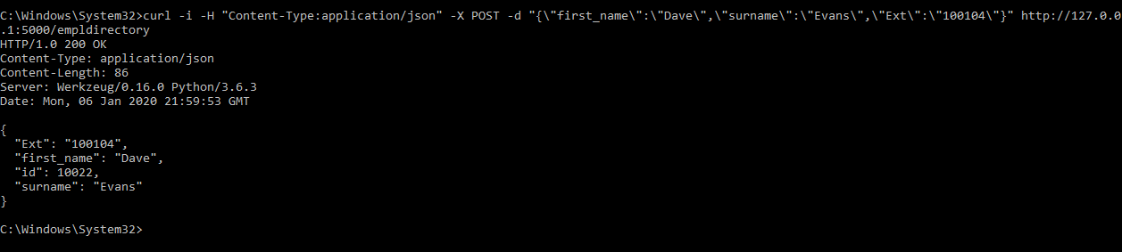

Update: #curl -i -H "Content-Type:application/json" -X PUT -d "{\"first_name\":\"a\"}" <http://localhost:5000/empldirectory/10005>

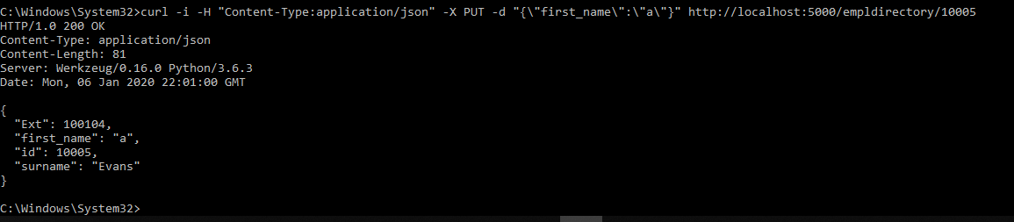

#curl -X DELETE <http://localhost:5000/empldirectory/10008>

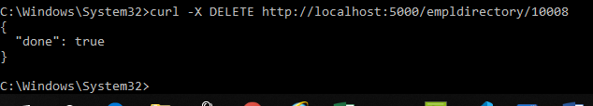

**CRUD in HTML….**

Create:

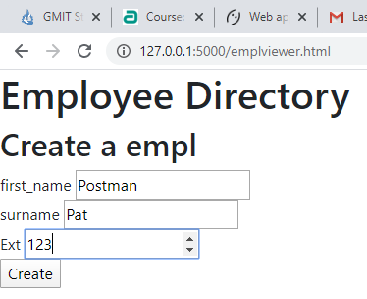

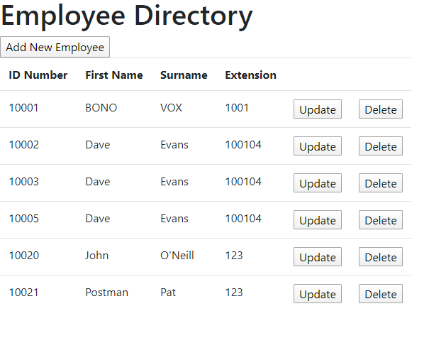

Update

