## WIRE FRAMES

### **1 Home page**

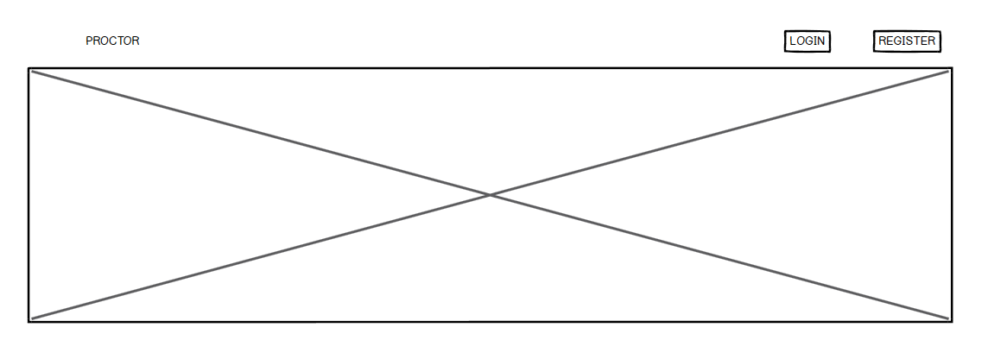

### **Registration page**

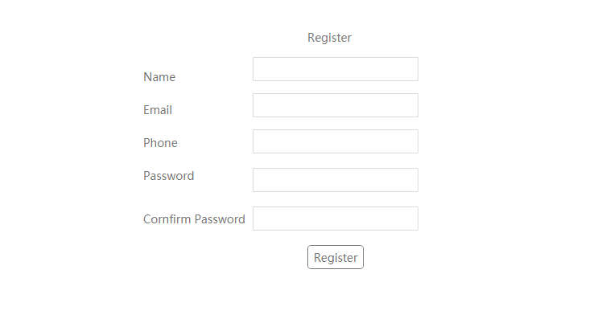

### **Login page**

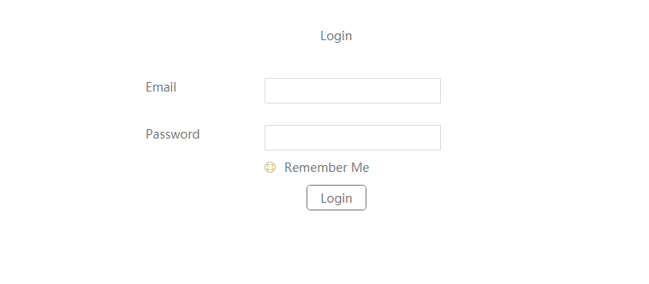

### **Update profile page**

This is where the user defines his/her role, which is the Driver or client.

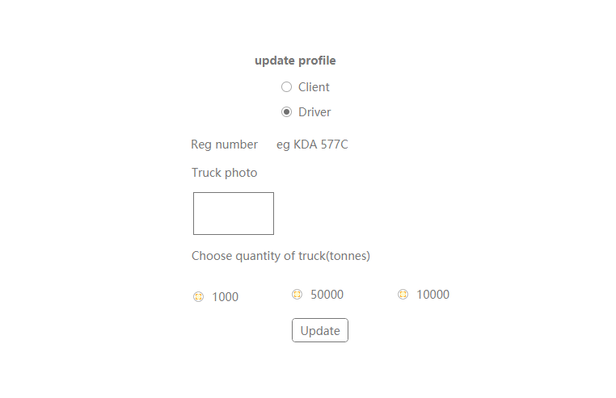

### **Clients’ page**

­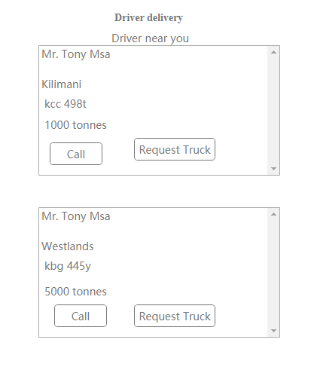

**Driver delivery screen**

**delivery input**

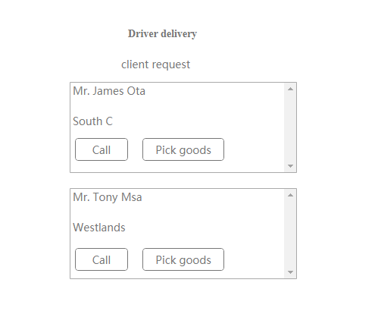

**Rating screen**

**rating input**

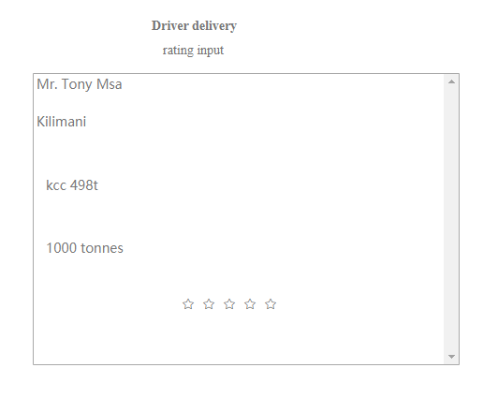

put