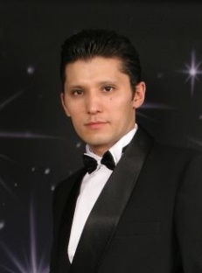**Zhanbauyr Tuleuov** *( Jan )*

Address: Almaty, Ili area, Baiserke, Dauletkerei str, 186

Phone number: +77072333707

E-mail: zhanbaur@gmail.com

**Education**

|  |  |
| --- | --- |
| 2017 – 2018 | **Tallinna Tööstushariduskeskus,** Infotehnoloogia, Junior Software Developer (Java, Python, C#, C++, Android Studio, SQL, JavaScript) |
| 1990 - 1998 | Moscow State University named after M.V. Lomonosov, Department of Genetics (Biology Faculty), Geneticist |

**Working Experience**

|  |  |
| --- | --- |
| 2020 - 2021 | ABB M&G (Motors and Generators), Tallinn, Forming machine operator |
| 2018-2019 | IT-Buss, Tallinn, Computer repair shop, Computer troubleshooting, repair, assembly and maintenance. Household appliance repair. |
| 2011 - 2016 | KAZREKLAMA GROUP LLP, Republic of Kazakhstan, Almaty, Raimbek avenue, 190A, Eng/Rus Translator, Network Administrator |
| 2006 - 2011 | INSEL (language translation company), Almaty, Eng/Rus Translator (translations of engineering/medical/biological documents) |
| 2009 | Biotechnical Center, Astana, Junior Research Scientist (breast cancer genetics) |
| 2003 - 2006 | Self-Employed Entrepreneur, Almaty, Computer equipment assembly and sales |
| 1999 - 2002 | AYAT Company, (water and heat supply systems)  Marketing Specialist, Network Administrator |
| 1992 - 1994 | “Parasat-Soft” Small Enterprise, Computer Equipment Sales, Almaty, Sales Manager, Forwarding Agent. |
| 1989 | Atasu Mining and Processing Works, Karazhal, Lathe Operator. |

**Skills**

Languages: English (excellent), Estonian (А2 level), Russian (fluent), Kazak (native), French (basic).

Programming languages: Java, JavaScript, CSS, HTML5, Python

Computer assembly, repair and maintenance. Troubleshooting and software maintenance.

**Driving Licenses**

A, B, C categories of transport vehicles