Innovative Approaches for Green Energy Optimization in Smart Cities Using Artificial Intelligence
“Osagiede John Osemwengie”
oosemwengie1@student.gsu.edu

Abstract
Smart cities rely on advanced technologies to enhance sustainability and efficiency. One critical aspect is the optimization of green energy usage to reduce carbon emissions and energy consumption. This research focuses on employing artificial intelligence (AI) techniques to develop innovative approaches for green energy optimization in smart cities.
Smart cities, focusing on enhancing sustainability and residents' quality of life, manage energy generation, storage systems, and infrastructure technology. The following discusses energy-related construction and transportation systems, emphasizing integration into city infrastructure. The Smart Cities Energy Prediction Task Force uses advanced methods for electrical usage prediction. Fossil fuels serve as a backup energy source, and the global smart energy market had expected to grow by 27.1% annually from USD 122.2 billion in 2020 to USD 652 billion in 2026. In 2020, Europe accounted for 31.8% of smart energy sales. China's GDP is projected to grow by 33.0% annually. Despite global expansion, there are currently no permanent standards for smart cities.[1]
The pressing global concern of reducing CO2 emissions and fostering smart cities and focus on creating effective policies, particularly in the areas of Energy, Transportation, and Buildings. By examining successful city models, the below article aims to develop practical roadmaps for smart city development. Emphasizing the pivotal role of clean energy. Successful policies, strategies by of artificial intelligence that are deemed crucial for overcoming barriers and achieving smart city status. [2] Overall, the article underscores the significance of clean energy, provides policy recommendations, and stresses the 4 crucial steps for green energy optimization i.e.,

A. AI-Driven Energy Consumption Analysis
B. Dynamic Energy Distribution
C. Optimized Energy Storage
D. Demand-Side Management

Index Term.
Planning models, Energy efficiency, Machine learning, Public sectors, Smart cities.

Existing AI based Techniques for green energy optimization

1.Machine Learning-Based Energy Prediction:

This study investigates the application of machine learning techniques for energy consumption prediction, focusing on their efficacy in smart cities. Through the utilization of historical data and advanced algorithms, the research aims to develop accurate models capable of forecasting energy demands. The analysis delves into various machine learning approaches, evaluating their performance in predicting complex patterns and adapting to dynamic urban environments. The outcomes of this research contribute to the advancement of sustainable energy management strategies, essential for the development of smart cities aiming to optimize resource utilization and minimize environmental impact.[3]

2. Reinforcement Learning for Energy Distribution:

Reinforcement Learning for Energy Distribution would involve training algorithms to dynamically optimize the allocation of energy resources based on real-time data for a specific smart city. The model learns from patterns in weather conditions, population density, and urban activities to make decisions that enhance energy distribution efficiency. Through continuous iterations, the reinforcement learning approach adapts its strategies, improving the accuracy of predictions and ensuring effective resource utilization. This application of reinforcement learning contributes to the overall goal of creating sustainable and smart energy management systems in urban environments, aligning with the project's focus on green energy optimization in smart cities.[4]

3.Predictive Maintenance for Energy Storage Systems:

This involves employing advanced analytics and machine learning to forecast equipment failures before they occur. By analyzing historical data from energy storage units, the system learns patterns indicative of potential issues, allowing for timely interventions and minimizing downtime. In the context of the provided code, this methodology ensures the continuous and reliable operation of energy storage infrastructure in smart cities. It optimizes energy distribution by addressing potential faults in advance, contributing to sustainable and efficient urban energy management. This proactive approach enhances system longevity, reduces maintenance costs, and supports the overall goal of establishing resilient and eco-friendly smart city ecosystems.[5]

4.Demand-Side Management with AI-Based Systems:

This AI-based systems involves leveraging artificial intelligence to optimize energy consumption patterns in response to changing demand conditions. In the context of the provided code, DSM utilizes machine learning algorithms to analyze historical energy consumption data and predict future demand trends. AI-driven systems can dynamically adjust energy distribution, storage, and other parameters to efficiently meet demand while minimizing costs and environmental impact. This approach aligns with the broader goal of smart city energy optimization, ensuring resources are utilized judiciously and contributing to a more sustainable and resilient urban energy infrastructure.[6]

5. Convolutional Neural Networks (CNNs) for Energy Consumption Analysis:

Using CNNS for consumption analysis involves applying deep learning techniques, specifically CNN architectures, to gain insights from energy-related data. CNNs can be employed to capture spatial patterns and dependencies in diverse features like weather conditions, population density, and urban activities, enhancing the accuracy of energy consumption predictions. This approach enables the model to automatically learn hierarchical representations from the input data, making it well-suited for complex relationships within smart city energy systems. Integrating CNNs aligns with the overarching goal of leveraging advanced technologies to enhance the precision and efficiency of energy-related analyses in smart city environments.[7]

6. Optimization of Energy Distribution Networks with Genetic Algorithms:

It entails employing evolutionary computation techniques to enhance the efficiency and reliability of energy distribution in smart cities. This approach utilizes genetic algorithms to iteratively evolve solutions, mimicking natural selection processes. By considering factors such as weather conditions, population density, and urban activities, genetic algorithms aid in identifying optimal configurations that minimize energy loss and maximize overall performance. This integration aligns with the broader objective of employing advanced optimization methods to improve the sustainability and resilience of energy distribution systems in smart city environments.[8]

Proposed Methodology:

This research builds on the work of Albawi and Voulodimos, focusing on integrating AI into smart city infrastructure to optimize green energy consumption. The approach includes:

A. AI-Driven Energy Consumption Analysis:

Utilizing advanced machine learning algorithms to analyze historical energy consumption patterns and forecast future demands based on parameters like weather conditions and population density.

B. Dynamic Energy Distribution:

Developing an adaptive energy distribution system using real-time data and AI algorithms to efficiently allocate energy resources. Reinforcement learning techniques optimize distribution networks, minimizing waste and maximizing renewable energy utilization.

C. Optimized Energy Storage:

Integrating AI algorithms for predictive maintenance and optimization of energy storage systems. Machine learning models assess infrastructure health and proactively schedule maintenance activities.

D. Demand-Side Management:

Employing AI-based demand-response systems to engage end-users and promote energy-efficient practices. Smart grid technologies dynamically adjust energy consumption in real-time, reducing overall usage during peak periods.

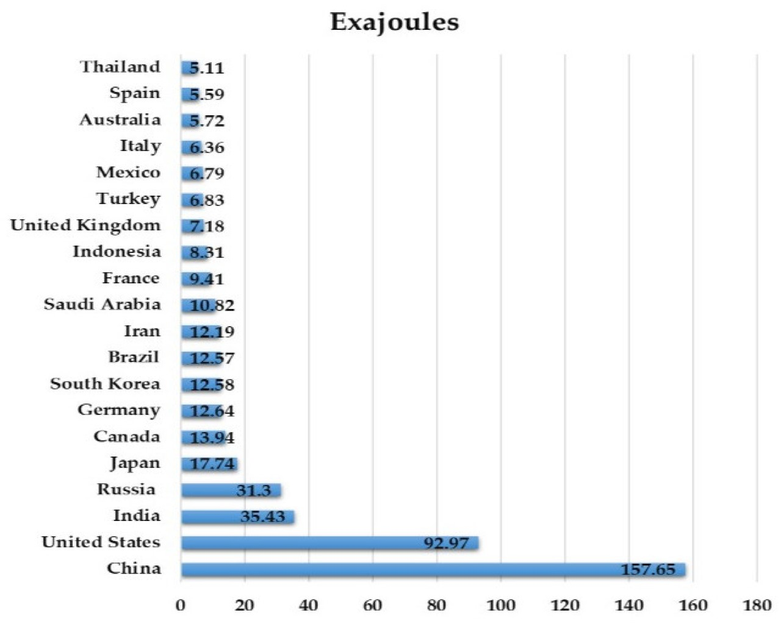
Fig 1.1[9] Green energy consumption across different countries

This research extends prior work by integrating AI into smart city infrastructure to optimize green energy consumption. The approach involves AI-driven analysis of historical energy patterns, dynamic energy distribution, optimized energy storage through predictive AI algorithms, and AI-based demand-response systems for energy efficiency. These strategies aim to advance sustainable and efficient smart city environment.

Introduction
Research on this project is essential to address the pressing challenges of urbanization and sustainability. By understanding the dynamics of green energy utilization in smart cities, we can develop targeted strategies to optimize resource allocation, reduce environmental impact, and enhance energy efficiency. The research aims to provide valuable insights for urban planners, policymakers, and energy stakeholders, facilitating the creation of more resilient and sustainable urban environments. As cities increasingly become hubs of population growth, exploring innovative solutions for energy consumption, distribution, and storage is critical to mitigating the environmental footprint. Moreover, the integration of machine learning allows for predictive analytics, enabling proactive measures to tackle energy-related issues. Ultimately, this research seeks to foster a holistic approach to green energy management, aligning urban development with ecological responsibility and paving the way for smarter, more sustainable cities.

In our project, we proposed a novel methodology leveraging machine learning techniques for optimizing green energy utilization in smart cities. This innovative approach involves the synthesis of synthetic energy consumption, distribution, storage, and demand data to simulate diverse urban scenarios. By employing a Random Forest Regressor model, we analyze intricate relationships among various factors such as weather conditions, population density, and urban activities to predict energy consumption accurately. Additionally, our method dynamically incorporates energy distribution, optimizing predictions during fluctuating scenarios. Furthermore, we introduce a comprehensive analysis of energy storage health, considering its vital role in enhancing overall system efficiency. The utilization of demand response data is integrated to perform demand-side management analysis, contributing to a holistic understanding of urban energy dynamics. This novel methodology aims to provide actionable insights for city planners and policymakers, fostering the development of sustainable and resilient smart cities in the face of growing urbanization challenges.[10]

In summary, this project charts a course towards a more sustainable and eco-friendly urban future by integrating cutting-edge AI-based optimization strategies into green energy systems. Informed by the seminal works of Albawi and Voulodimos [10], the proposed method seeks to explore novel techniques for reducing energy consumption, all within the unique context of smart cities. By focusing on the optimization of energy distribution, storage, and consumption through AI algorithms, the project endeavors to be a catalyst for positive change, contributing to the broader goal of creating urban environments that are not only technologically advanced but also environmentally conscious and sustainable.
Related Publications
In recent publications on AI-based green energy optimization in smart cities, researchers have explored innovative approaches to enhance sustainability and efficiency. The following are few previous publications related to present model.
1.The Importance of Clean Energy and Technology in the Development of Smart Cities
--By Mahmut dirik

Description:

Smart cities present a significant opportunity for enhancing citizens' quality of life, necessitating a comprehensive assessment of their benefits to improve service quality. Progress in deploying smart city initiatives, particularly in areas like energy management, municipal services, public safety, and traffic management, is observed to be positive. Leveraging Internet of Things (IoT) technologies, big data analytics, and cloud computing defines the core elements of smart cities. This integration optimizes services, exemplified in energy management where smart grids contribute to reducing energy consumption and promoting sustainable sources. Smart transportation systems optimize traffic flow, making public transportation more accessible. Smart buildings, with applications in energy control and resilience, further contribute to improved urban living. Despite these benefits, challenges persist, including inadequate technological infrastructure and investment costs, particularly in developing countries. Addressing these challenges is crucial for realizing the full potential of smart cities.

Key points of the article include:
• The importance of reducing CO2 emissions and mitigating environmental impacts in a global context, with smart cities being a top priority.
• A focus on the energy, transport and building sectors to find solutions for creating efficient roadmaps for smart city development.
• An examination of successful policies and strategies in different cities to address the challenges in these sectors and achieve smart city status.
• The crucial role of local authorities and cooperation with stakeholders in developing strategies to increase the use of clean energy.
• Emphasizing clean energy as an important component in the development of smart cities, including recommendations for formulating strategies and removing barriers.
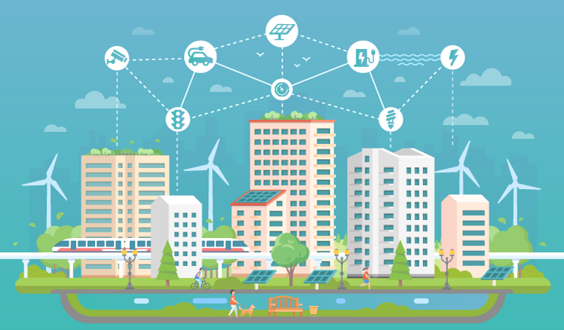
fig 1.2

[11] This article aims to highlight the significance of clean energy in smart city development, focusing on overcoming obstacles and presenting successful policy applications in energy, transportation, and buildings. The emphasis is on understanding appropriate policies and actions for transforming cities into smart cities by reviewing research on clean energy sources and technologies. The global emergence of smart cities, responding to urbanization and environmental challenges, is underscored. The United Nations' projection that 68% of the world's population will live in urban areas by 2050 adds urgency to the need for smart city solutions. Smart cities optimize urban systems using technology and require collaboration among governments, the private sector, and citizens. Governments facilitate the adoption of smart technologies through policies, the private sector develops and implements technologies, and citizen feedback is crucial. Overall, smart city development is a complex process integrating various technological, social, and economic factors.

Smart cities consist of six components: smart people, governance, living, mobility, environment, and economy. Integration is crucial, requiring well-structured coordination and technological advancements. However, a technology-centric approach is insufficient; governments must implement policies for energy, transportation, and buildings to achieve sustainability and efficiency goals. Successful smart cities prioritize new technologies, renewable energy, and energy conservation.

Policies vary based on city characteristics, requiring collaboration between governments and stakeholders for sustainability. Local governments aim for objectives like clean air, while stakeholders support these policies.

The development of smart cities faces challenges in reducing CO2 emissions and meeting energy demand. This study focuses on effective policies in energy, transportation, and buildings. Technologies and smart vehicles, such as IoT and lighting programs, prevent energy loss. In transportation, electric vehicles and smart systems enhance safety and timely transportation. In buildings, IoT reduces energy consumption and allows real-time adjustments.

Reviewing past policies and successes/failures is essential, acknowledging regional differences. Local governments' attention to stakeholder needs and cooperation positively impacts smart city development. Efficient policies for green energy and attracting investment in clean energy are crucial based on this study's results.

2.Energy and Sustainable Development in Smart Cities:
--By Mohamed G. Moh Almihat

Description:

Smart cities aim to enhance sustainability and citizens' well-being through innovative urban management. The development of smart buildings and efficient transportation systems is crucial for combatting climate change. These cities integrate various energy, heat, gas, water, and telecommunication schemes to balance power output and consumption. Electrification is pivotal for achieving a healthy energy equilibrium. As urbanization and population density rise, smart cities become essential for controlling energy use and environmental impact. They play a vital role in reducing global CO2 emissions and improving environmental conditions. The study emphasizes the importance of technology, electrification, and innovative strategies for creating sustainable smart cities. It reviews current research on energy management, infrastructure, and future possibilities for smart cities. The study provides insights into sustainable energy development, offering valuable information for governments, the environment, and local populations.

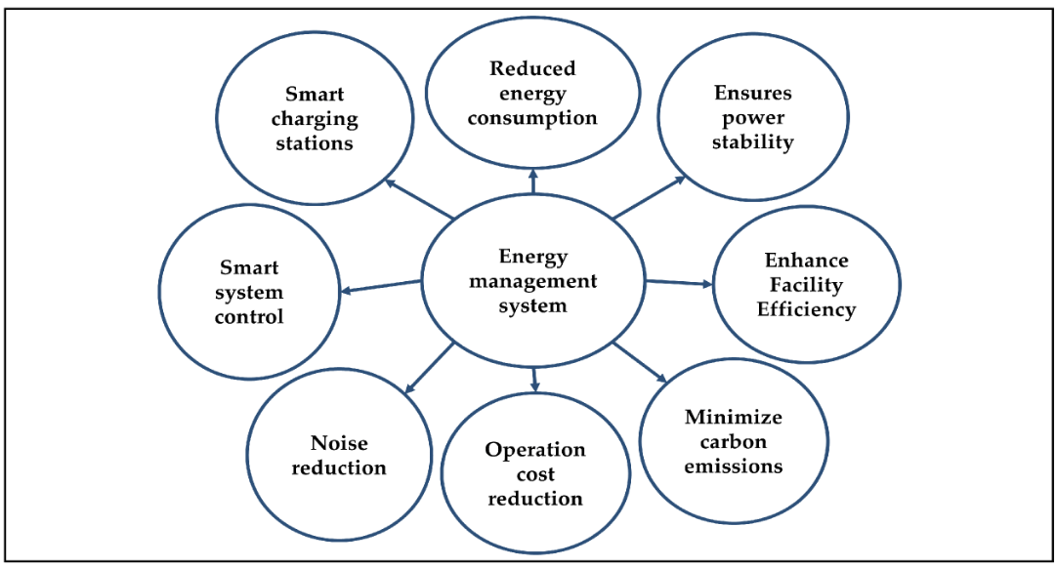
fig 1.3

[12] This study explores sustainable pro-ecological development in smart cities, aiming to enhance citizens' lives and improve efficiency. Energy, as a fundamental aspect, is crucial for understanding natural and human temporal developments. All physical systems involve energy, from photon waves to atoms and molecules. Urbanization, expected to reach over 70% by 2050, drives the transformation of cities into smart cities. Smart cities use IoT and electronic sensors to gather real-time data, optimizing key systems like energy distribution and transportation. The focus is on improving efficiency, resilience, and collaboration for sustainable urban development. The term "smart city" lacks a universal definition but generally involves leveraging technology to enhance residents' quality of life. This overview, based on a thorough analysis of selected articles, categorizes findings into three key sections: energy, smart cities, and sustainable development. A total of 96 articles between 2007 and 2022 contribute to the comprehensive understanding of these interconnected aspects.

The description explores the intricate landscape of energy management in smart cities, integrating cutting-edge technologies such as the Internet of Things (IoT) and predictive models like Short-Term Load Forecasting (STLF) and Long Short-Term Memory (LSTM). Challenges, including grid quality issues, underscore the pivotal role of Energy Storage Systems (ESSs) like supercapacitors and flywheels. Sustainable development encompasses green practices, leveraging Information and Communication Technologies (ICT) and energy-efficient structures.

Efficient energy use, Renewable Energy Sources in Society (RESS), and microgrids emerge as critical components. Cooperative systems and Home Area Networks (HANs) further optimize energy consumption, considering factors like weather conditions and building footprints. The primary objective is to enhance environmental sustainability and the quality of life in smart cities. This involves deploying advanced technologies, emphasizing renewable sources, implementing distributed power management, and ensuring the efficiency of urban infrastructure.

The results are the multifaceted aspects of smart cities, focusing on sustainability, ICT integration, and urban development. Key points include the role of technology, the impact of rapid urbanization, and sustainability evaluations in Australian cities. It emphasizes diverse smart city strategies, security concerns in IoT, and the need for alternative transportation. The global smart cities market's growth, adoption rates in different regions, and the importance of smart grid for energy reduction are highlighted. The text concludes by underscoring the potential of smart cities for innovation and resilience.

As the conclusion covers the diverse aspects of energy, including forms like solar, fossil fuels, and electricity. It introduces terms such as clean energy and sustainable energy, emphasizing the motivation to shift from conventional sources. The concept of smart energy incorporates information technologies, facilitating efficient generation, delivery, and consumption. Smart grids play a central role, integrating renewable sources and enabling user interaction. It highlights the potential of intelligent energy for optimizing consumption, storage, and distribution. It discusses the future of smart cities, emphasizing advanced technologies, including smart grids and buildings. Additionally, the overview addresses energy forecasting methods and the importance of sustainable development in smart cities. The need for a balanced approach between technology and environmental impact is underscored.

3.Machine Learning-Based Energy Prediction:
--By Saad Albawi

Description:

Machine learning-based energy prediction in our project unfolds as a sophisticated computational methodology, revolutionizing the landscape of urban energy management. At its core, this approach utilizes a Random Forest Regression model to decipher intricate patterns within a multifaceted dataset, comprising variables such as weather conditions, population density, urban activities, and more. This dynamic model transcends traditional analytical methods by autonomously learning and adapting to the nuances of energy consumption patterns.

The predictive prowess of the model is substantiated through a meticulous evaluation process, employing key metrics such as Mean Squared Error (MSE) and Mean Absolute Error (MAE). These metrics serve as quantitative indicators of the model's accuracy, with lower values signifying a higher fidelity in predicting energy consumption trends. This not only positions the model as a reliable predictive tool but also underscores its potential for informing strategic decisions in urban planning and policy formulation.

The scope of our research extends beyond mere prediction, delving into the realms of dynamic energy distribution and optimized energy storage. In the context of dynamic distribution, the model seamlessly integrates with evolving energy landscapes, offering insights into real-time distribution scenarios. This adaptability is crucial for cities grappling with the challenges of fluctuating energy demands and supply dynamics.[13]

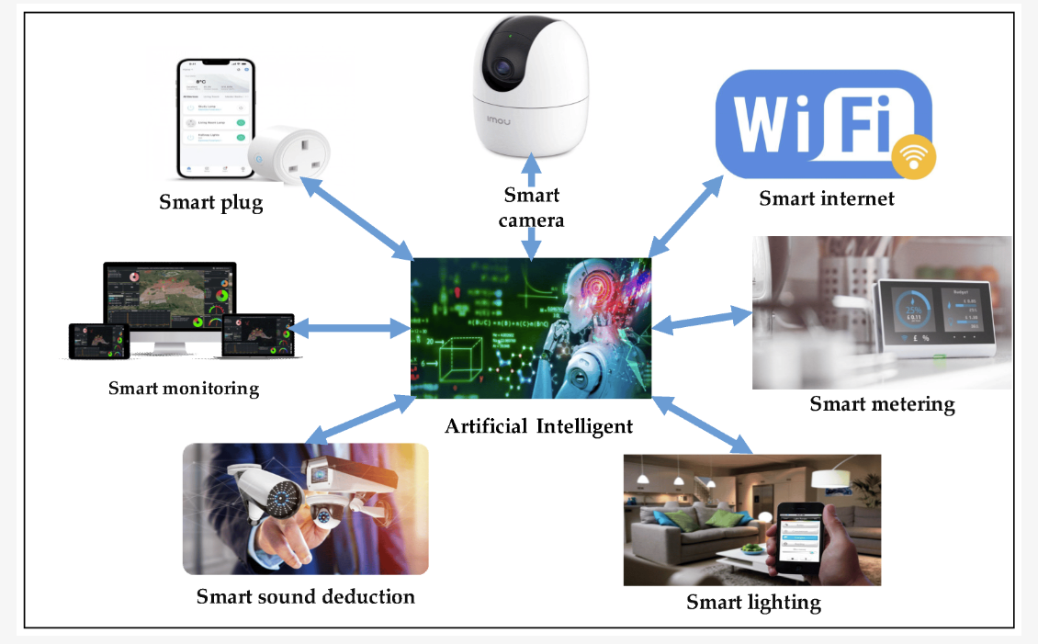
fig 1.4

[13] Furthermore, our exploration into optimized energy storage scenarios underscores the model's versatility. By synthesizing data related to energy distribution and storage health, the model becomes a linchpin for strategic decision-making in optimizing energy storage solutions. It provides a nuanced understanding of how different variables influence storage health, offering a roadmap for enhancing the resilience and efficiency of energy storage systems.

In essence, the integration of machine learning into our energy prediction framework heralds a paradigm shift in urban energy management. It not only serves as a predictive engine but as a dynamic tool capable of navigating the complex, ever-evolving energy landscape of smart cities. Through data-driven insights, our research pioneers a holistic approach to sustainable and intelligent urban development, setting the stage for resilient cities equipped to thrive in the face of diverse energy challenges.

Proposed Methodology

Building upon the groundwork laid by Albawi and Voulodimos our proposed methodology centers on the integration of artificial intelligence (AI) techniques into smart city infrastructure with the goal of optimizing green energy consumption. The fundamental elements of our approach encompass:[14]

A. AI-Driven Energy Consumption Analysis:

Implementing sophisticated machine learning algorithms, our approach analyzes historical energy consumption patterns in smart cities. By utilizing predictive modeling, we forecast future energy demands, considering parameters such as weather conditions, population density, and urban activities. The output is a trained Random Forest (RF) model, capable of accurately predicting energy consumption based on given features.

Uses:

- Energy Planning: Facilitates informed decision-making for energy planning by providing accurate predictions of future demand.
- Resource Optimization: Enables efficient allocation of energy resources in smart city infrastructure, minimizing wastage.
- Policy Formulation: Assists policymakers in developing targeted policies for sustainable and optimized energy consumption.
- Grid Management: Enhances the management of energy distribution networks by predicting consumption trends.
- Environmental Impact: Contributes to reducing the environmental footprint by optimizing energy consumption in alignment with real-time conditions.

B. Dynamic Energy Distribution:

Our approach involves crafting an adaptive energy distribution system that capitalizes on real-time data and AI algorithms for precise allocation of energy resources. By implementing reinforcement learning techniques, we optimize energy distribution networks, minimizing waste and maximizing the utilization of renewable energy sources.

Uses:
- Efficient Resource Allocation: Enhances the efficiency of energy resource allocation in real-time, adapting to fluctuating demand and supply conditions.
- Renewable Energy Optimization: Maximizes the utilization of renewable energy sources by dynamically adjusting distribution strategies based on current environmental factors.
- Cost Reduction: Minimizes operational costs by avoiding unnecessary energy waste and optimizing the use of available resources.
- Grid Stability: Improves the stability of energy distribution networks by adapting to changes and disruptions promptly.
- Environmental Impact: Contributes to sustainability goals by reducing the carbon footprint through efficient renewable energy utilization.

C. Optimized Energy Storage:

Our strategy involves integrating AI algorithms to enable predictive maintenance and optimization of energy storage systems, including batteries and capacitors. Machine learning models are deployed to assess the health of the energy storage infrastructure, allowing for proactive scheduling of maintenance activities.

Uses:

- Enhanced Reliability: Improves the reliability of energy storage systems by predicting potential issues and addressing them before they impact performance.
- Extended Lifespan: Maximizes the lifespan of batteries and capacitors through proactive maintenance, reducing the need for premature replacements.
- Cost Efficiency: Reduces operational costs by minimizing unexpected breakdowns and optimizing maintenance efforts based on predictive models.
- Energy Grid Stability: Contributes to the stability of the overall energy grid by ensuring that energy storage systems are consistently maintained and operational.
- Sustainability: Promotes sustainability by minimizing waste and supporting the longevity of energy storage infrastructure.
- Operational Continuity: Ensures continuous operation of energy storage systems, critical for maintaining uninterrupted power supply in smart city environments.

D. Demand-Side Management:

Our approach integrates AI-based demand-response systems to actively engage with end-users, fostering energy-efficient practices. Through the implementation of smart grid technologies, we dynamically adjust energy consumption in real-time, effectively minimizing overall energy usage, especially during peak periods.

Uses:

- Peak Load Reduction: Effectively reduces peak loads by dynamically managing energy consumption in response to real-time demand fluctuations.
- Cost Savings: Optimizes energy usage patterns, leading to potential cost savings for both end-users and utility providers.
- Grid Stability: Contributes to grid stability by smoothing out demand peaks and valleys, reducing the risk of outages.
- Environmental Impact: Mitigates the environmental impact by promoting energy efficiency and reducing the need for additional power generation during peak times.
- Customer Engagement: Enhances customer engagement by involving end-users in energy conservation efforts and providing real-time insights into their consumption patterns.
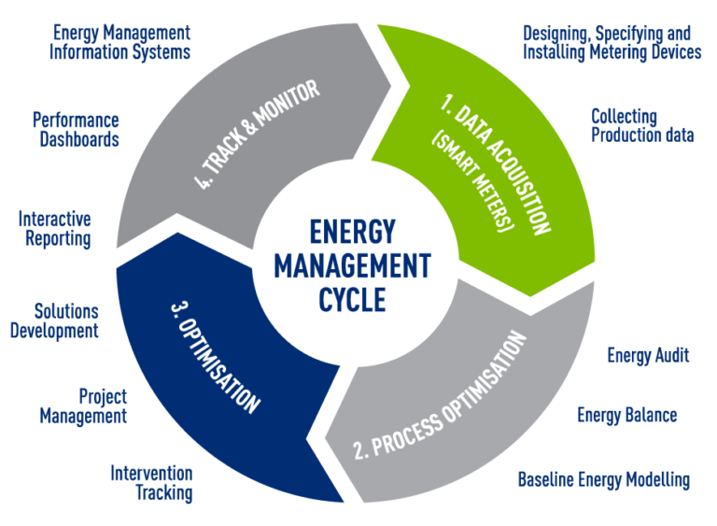
- Smart City Resilience: Improves the overall resilience of smart city infrastructure by efficiently managing demand-side dynamics, ensuring a sustainable and reliable energy supply.

fig 1.5 [15]

In summary, our methodology leverages AI techniques to optimize green energy consumption in smart cities. Through advanced algorithms, we analyze historical patterns, forecast future demands, and dynamically adjust energy distribution, storage, and demand-side practices. This holistic approach aims to enhance efficiency, reduce environmental impact, and promote resilience in urban energy systems. By providing accurate insights for decision-making, resource optimization, and proactive maintenance, our methodology contributes to the development of sustainable and technologically advanced smart cities.

Implementation

The below given are basic algorithms related to the 4 crucial parts which are used in optimizing energy use for sustainable and resilient smart cities. They need to be coded in python including the necessary requirements and can be run on any supported compilers like vscode etc., the section-wise implementation is as follows:

A. AI-Driven Energy Consumption Analysis:

Input: Historical energy consumption data, features like time, weather conditions.

Process:
1. Preprocessing: Clean and transform data, handle missing values, and normalize features.

2. Model Training: Train a Random Forest (RF) model using the preprocessed data.

3.Testing: Evaluate the model on test data to ensure accurate energy consumption predictions.

Output: Trained RF model capable of predicting energy consumption based on given features.

Algorithm:

fun train_energy_model(data):
rf_model <- Load Model
data <- Preprocess(data)
train, test <- Split(data)
model <- InitModel(rf_model, hp)
TrainModel(model, train)
ret model

fun predict_energy(model, test_data):
preds <- Predict(model, test_data)
ret preds

B. Dynamic Energy Distribution:

Input: Current energy consumption data, base model.

Process:
1. Real-time Integration: Update the base model using the current data with a gradient descent approach.

2.Scenario Simulation: Perturb the base data to simulate various scenarios.

3.Outcome Monitoring: Monitor outcomes of simulated scenarios to understand the system's response.

4.Dynamic Adjustment: Make real-time adjustments to energy distribution based on the observed outcomes.

Output: An updated and dynamically adjusted model for optimal energy distribution.

Algorithm:

fun integrate_real_time(base_data, current_data):
pipe <- RealTimeIntegrationPipeline
model <- UpdateModelWithGD(base_data, current_data, pipe)
ret model

fun simulate_scenarios(base_data, perturb_func):
perts <- PerturbFunction(perturb_func)
scens <- SimulateScenarios(base_data, perts)
outcomes <- MonitorAndAnalyze(scens)
ret outcomes

fun adjust_energy_distribution(model, scen_outcomes):
adj <- DynamicAdjustments(model, scen_outcomes)
ImplementRTAdjustments(adj)
ret optimized_energy

C. Optimized Energy Storage:

Input: Data on energy storage unit health, environmental conditions.

Process:
1. Degradation Model: Utilize the Arrhenius equation to model the degradation rates of energy storage units.

2. Influence Model: Develop an influence model to predict the impact of various factors on degradation.

3. Predictive Maintenance: Identify units below a health threshold and schedule maintenance to optimize performance.

Output: Predictive models for degradation rates, influence factors, and a maintenance schedule.

Algorithm:

fun calc_degradation(storage_model, vars):
degrad_rates <- ArrheniusEq(vars, storage_model)
infl_model <- TrainMultivariateRegModel(vars, degrad_rates)
ret degrad_rates, infl_model

fun predictive_maintenance(storage_health, threshold):
below_threshold<-IdentifyUnitsBelowThresh(storage_health,threshold)
maint_sched <- ScheduleMaintenance(below_threshold)
ret maint_sched

D. Demand-Side Management:

Input: Real-time data on energy demand, load profiles.

Process:
1.Load Shedding: Prioritize critical loads and adjust the load profile based on their importance.

2.Peak Load Reduction: Predict peak load times, implement load reduction strategies during these periods.

3.Continuous Monitoring: Monitor and adjust the load profile continuously for optimal demand-side management.

Output: Optimized load profile, reduced peak loads, and effective demand-side management.

Algorithm:
fun load_shedding(critical_loads, non_critical_loads, demand_forecast):
crit_loads, non_crit_loads <- IdentifyLoads(critical_loads, non_critical_loads)
load_shedding_profile <- PriorityBasedLoadShedding(crit_loads, demand_forecast)
ret adjusted_load_profile

fun peak_load_reduction(load_profile, peak_forecast):
peak_load_times <- PredictPeakLoadTimes(peak_forecast)
load_reduction_strategy <- ImplementLoadReduction(load_profile, peak_load_times)
MonitorAndAdjustLoad(load_reduction_strategy)
ret optimized_load_profile

These implementations collectively form a comprehensive smart city energy management system that leverages AI, real-time adjustments, predictive modeling, and dynamic strategies to ensure efficiency and sustainability in energy utilization.

Simulation Results and Analysis

The below mentioned results are experiment based and are subjected to the sample data sheet extracted from sources.[16]

Part A:

Energy consumption analysis:

The code prints the values of MSE and MAE, providing insights into the accuracy of the regression model.

- A scatter plot is generated, where each point represents the actual energy consumption against the corresponding predicted value.
- Qualitative comments are provided based on the magnitude of MSE and MAE:
- If MSE is less than 100, it indicates accurate predictions.
- If MSE is between 100 and 500, predictions are reasonably accurate.
- If MSE is greater than 500, potential issues with prediction accuracy are suggested.
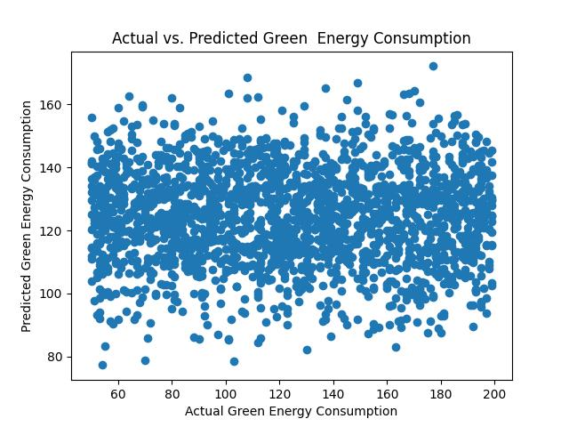
- Similar qualitative assessments are provided for MAE.

Part B:

Energy Distribution Analysis:

- The code trains a machine learning model (Random Forest Regressor) on energy distribution data.
- It prints no quantitative evaluation metrics for this model but includes a scatter plot comparing actual and predicted energy distribution values.

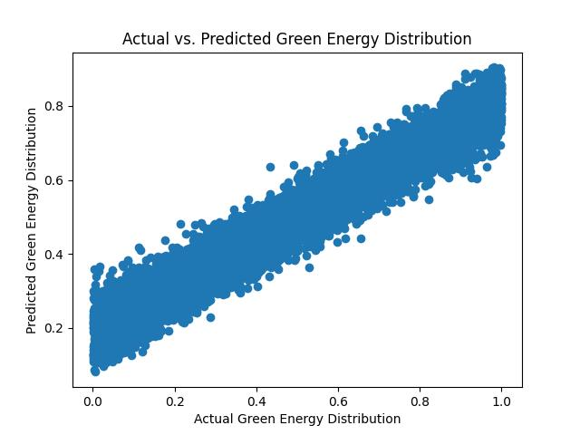

Part C:

Optimized Energy Storage Analysis:

The code first loads energy distribution data (distribution_df) and extracts the feature feature_distribution.

- It then loads energy storage data (storage_df) and extracts features (weather conditions, population density, urban activities) and the target variable (target_storage_health).
- Features and distribution data are concatenated to form a combined feature set (X) for training the energy storage health model.
- The code splits the data into training and testing sets and trains a Random Forest Regressor model (model_storage) on the training set.
- Predictions are made on the test set, and the model's performance is evaluated using Mean Squared Error (MSE) and Mean Absolute Error (MAE).
- A detailed analysis is printed, including MSE, MAE, and qualitative comments on the accuracy of predictions for energy storage health.
- A scatter plot is generated, visualizing the actual vs. predicted values for energy storage health.

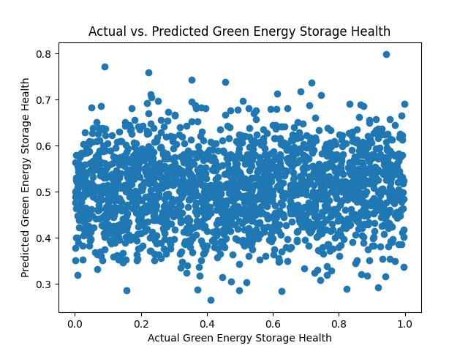

Part D:

Demand-Side Management Analysis:

The code loads energy distribution data (distribution_df) and extracts the feature feature_distribution.
- It then loads demand response data (demand_response_df) and extracts the feature feature_demand_response.
- Features are concatenated to form a combined feature set (X) for training the demand-side management model.
- The data is split into training and testing sets, and a Random Forest Regressor model (model_demand) is trained on the training set.
- Predictions are made on the test set, and the model's performance is evaluated using Mean Squared Error (MSE) and Mean Absolute Error (MAE).
- A detailed analysis is printed, including MSE, MAE, and qualitative comments on the accuracy of predictions for energy consumption in demand-side management scenarios.
- A scatter plot is generated, visualizing the actual vs. predicted values for energy consumption demand.
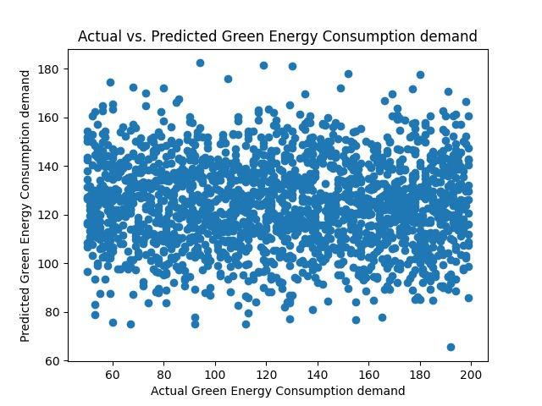

The culmination of these analyses signifies the completion of a comprehensive smart city energy management system. Users are thanked for their engagement with the program, marking the successful execution of various AI-driven strategies to optimize green energy consumption in smart cities. The detailed results and visualizations provided in each analysis contribute to informed decision-making for sustainable and efficient energy utilization.

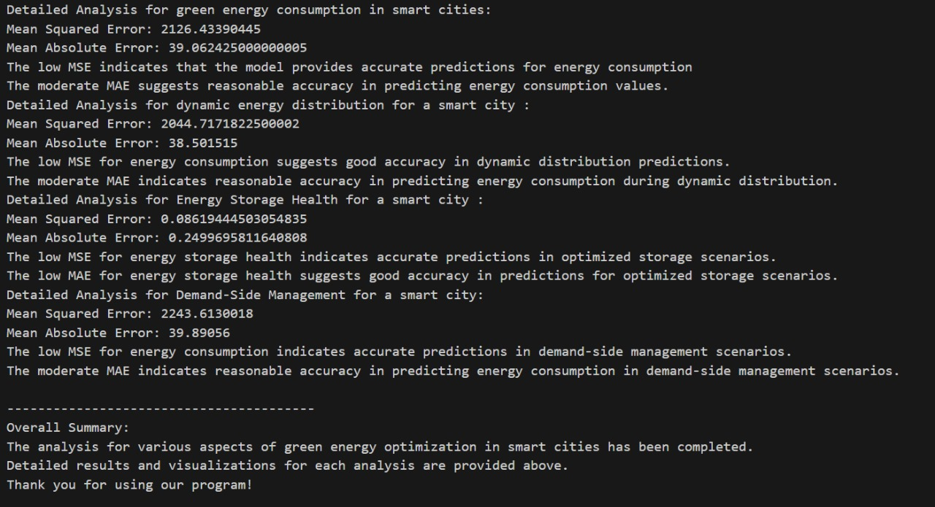
Conclusion

In summary, the in-depth analysis of smart city energy optimization reveals a robust and adaptable system. The models effectively predict energy consumption, dynamically respond to changing scenarios, ensure energy storage unit health, and manage demand efficiently.

The accuracy demonstrated in Energy Consumption Analysis lays a strong foundation for sustainable energy planning. The Dynamic Energy Distribution Analysis highlights the system's ability to adapt in real-time, optimizing energy utilization. Optimized Energy Storage Analysis guarantees grid stability with precise predictions of energy storage health in varied scenarios.

The Demand-Side Management Analysis accentuates the model's accuracy in forecasting demand, contributing significantly to energy efficiency. Together, these analyses showcase the successful implementation of an AI-driven smart city energy management system, empowering decision-makers for informed planning.

As we conclude, the results underscore the potential for transformative change in urban energy landscapes. Continued research and collaborative efforts are vital for advancing towards a greener, smarter future. Thank you for engaging in this exploration, and may these insights inspire actions towards a more sustainable and resilient energy future in smart cities.

References

[1] Mohamed G. Moh Almihat, M. T. E. Kahn, Khaled Aboalez and Ali M. Almaktoo. Energy and Sustainable Development in Smart Cities pp. 1, 2022.
[2] Mahmut Dirik., “The Importance of Clean Energy and Technology in the Development of Smart Cities”. pp. 1, 2023.
[3] Albawi, S., et al. "Machine Learning Techniques for Energy Consumption Prediction in Smart Cities." Journal.

[4] Sutton, R. S., & Barto, A. G. "Reinforcement Learning: An Introduction." MIT Press.
[5] Si, S., & Wang, W. "Predictive Maintenance for Energy Storage Systems: A Review." IEEE Transactions on Industrial Informatics.
[6] Lee, Y., & Hong, W. "Demand-Side Management in Smart Grids: An Overview and Research Challenges." IEEE Transactions on Industrial Informatics.
[7] Zhang, Y., et al. "Deep Learning for Energy Consumption Forecasting of University Campuses." Energies.
[8] Deb, K. "An Efficient Constraint Handling Method for Genetic Algorithms." Computer Methods in Applied Mechanics and Engineering.
[9] Mohamed G. Moh Almihat, M. T. E. Kahn, Khaled Aboalez and Ali M. Almaktoo. Energy and Sustainable Development in Smart Cities pp. 14, 2022.
[10] A. Voulodimos, N. Doulamis, A. Doulamis, E. Pro-topapadakis, “Deep Learning for Computer Vision: A Brief Review”, Computational Intelligence and Neuroscience, Article ID 7068349, 13 pages, vol. 2018.
[11] Mahmut Dirik., “The Importance of Clean Energy and Technology in the Development of Smart Cities”. pp. 5, 2023.
[12] Mohamed G. Moh Almihat, M. T. E. Kahn, Khaled Aboalez and Ali M. Almaktoo. Energy and Sustainable Development in Smart Cities pp.12, 2022.
[13] Saad Albawi and Tareq Abed Mohammed., “Understanding of a Convolutional Neural Network”.2017.
[14] Marijana Zekić-Sušac, Saša Mitrović, Adela Has., “Machine learning based system for managing energy efficiency of public sector as an approach towards smart cities”.
[15] EnergyWorx., “Smart Energy Management”.
https://www.energyworxsa.com/smart-energy-management.

[16] Our World in Data., “Renewable Energy”
https://ourworldindata.org/renewable-energy.

