**SOUTH EAST ASIA INSTITUTE OF TRADE AND INDUSTRY**

**Crownlink 2, Regalado Avenue. Greater Lagro, QuezonCity**

**"BIKOLICOUS"**

**A BUSINESS PLAN**

**IN PARTICULAR FULFILLMENT**

**OF THE REQUIRMENTS FOR THE SUBJECT**

**ENTREPRENEURSHIP**

**By:**

**Melvin Jones Gallano Repol**

**CSS4DA-2**

**BUSINESS PLAN**

**I. COMPANY NAME**

**A. BUSINESS NAME**

CELER FOOD LLC is a new fast food restaurant established in Year 2020. The name celer originated from the latin word which mean fast. Celer Food LLC offers a fast and convenient way to order food. One of our most famous food is a Bikolicous with a twist to make it delicious and different from others.

**B. TAGLINE**

"You deserve delicious food"

The tagline means all customer deserve nice and delicious food.

**C. LOGO**

The three boxes as represented on the logo demonstrates Shiva's Power which is Action, Knowledge and Power of Will. Inside the three boxes the black colored box represents my business, the three boxes will prevent the wealth, fame and assets of my business to go outside. The main reason of choosing the color black and white is to make it sharp and recognizable by any body that comes across the restaurant logo.

**D.STALLL**

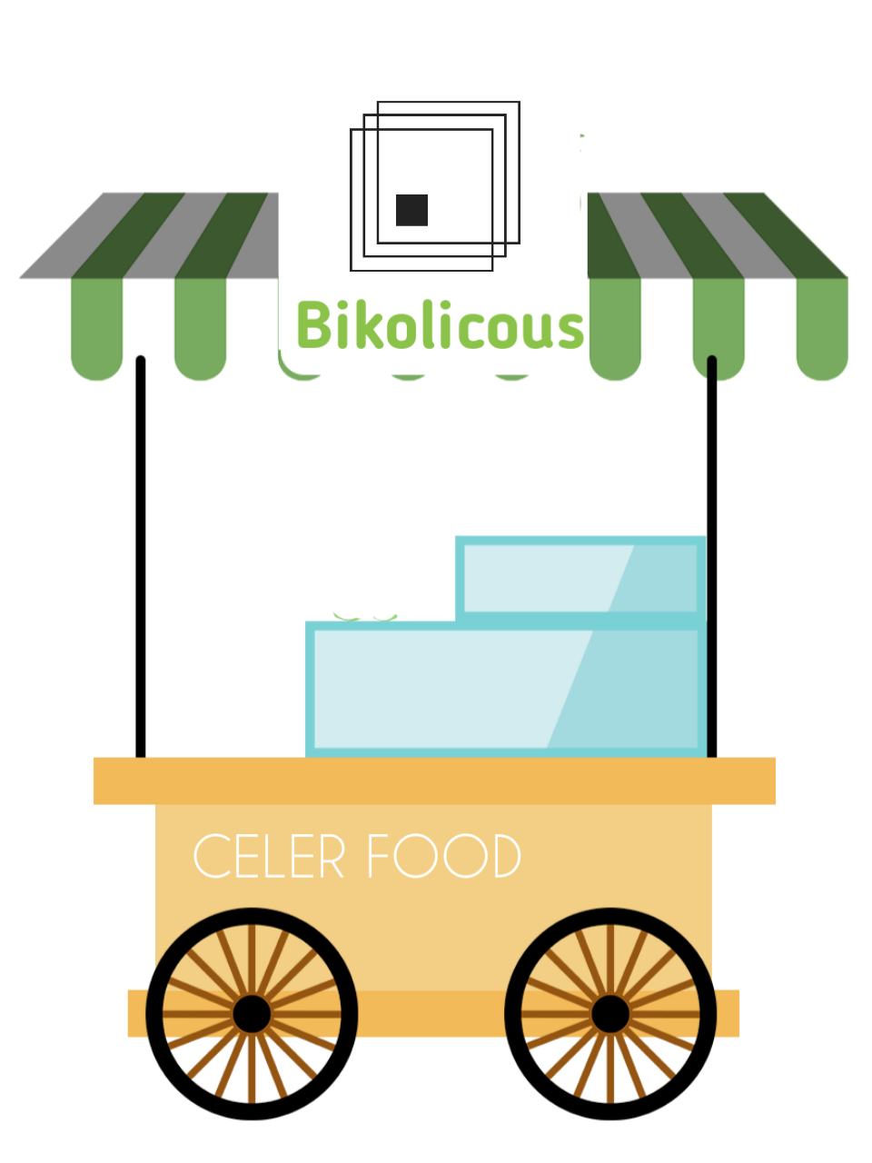

**E. LOCATION (MAP)**

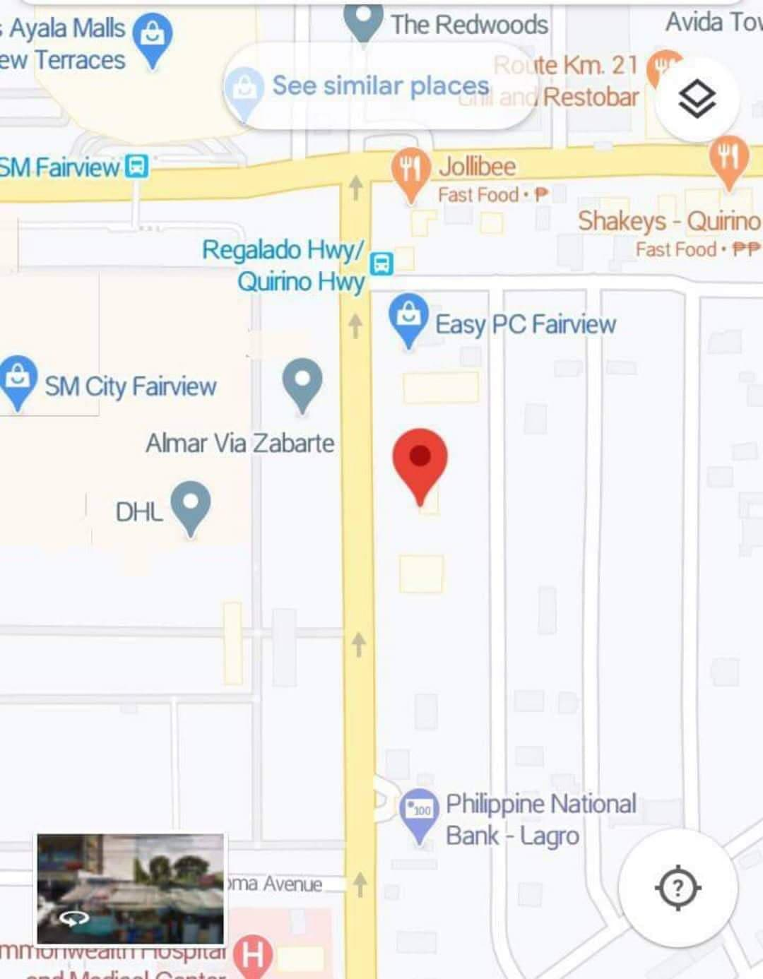

"Celer Food" is located at CrownLink 2 (SEA-ITT), Regalado Avenue, Quezon City.

**II. MISSION STATEMENT**

* To inspire and implement solution for new Entrepreneurs
* To extend the business to new locations and reach new customers
* To create the best food products
* To give customers the most compelling products experience possible

**III. VISION STATEMENT**

**A. SHORT TERM**

* To become a world leader at creating deliciou products
* A enjoys where everyone loved our products

**B. LONG TERM**

* To become popular all around the globe
* A world in which every person enjoys our products

**B. JOB DESCRIPTION**

|  |  |  |
| --- | --- | --- |
| **POSITION** | **NUMBER OF EMPLOYEE** | **JOB DESCRIPTION** |
| **Chief Executive Officer (CEO)** | 1 | Making major corporate decisions, managing the overall operations and resources of a company. |
| **Chief Operating Officer (COO)** | 1 | Designing and implementing business operation |
| **Manager** | 1 | Responsible for planning, directing and overseeing the operations. |
| **Chef** | 2 | Supervise the preparation of food for it's garnishing and presentation, as well as, the seasonings for a perfect taste. |
| **Staff** | 4 | Providing assistance to his/her superior officers on assigned duties |

Table above shows the different position, number of employee and their job description.

**V. PRODUCT**

**A. PRODUCT NAME/DESCRIPTION**

Bikolicous is a sweet rice cake. Bikolicous far and away some of our most popular product. It is made of coconut milk, brown sugar, and glutinous rice is the ultimate snack or dessert. It is usually topped with latik.

**B. INGREDIENTS/MATERIALS**

|  |  |  |
| --- | --- | --- |
| **MATERIALS** | **INGREDIENTS** | **PROCEDURE** |
| Pan | Glutinous Rice | 1. In a pan over medium heat, add the coconut cream and bring to a boil. Continue to cook, stirring occasionally, until liquid starts to thicken. |
| 2. Lower heat and simmer. As oil starts to separate and solids begin to form, regularly stir and scrape sides and bottom of the pan to prevent from burning. |
| Colander | Brown Sugar | 3. Continue to cook and stir until curds turn golden brown. Using a fine-mesh sieve or colander, drain latik. Reserve oil. |
| 4. Grease bottom and sides of a 5 x 8-inch baking dish with coconut oil. Set aside. |
| Spoon and Fork | Coconut Milk | 5. Wash glutinous rice a few times or until water runs almost clear. Drain well. |
| 6. In a thick bottom pot, combine rice and water. Over medium heat, bring to a boil. Lower heat, cover, and cook until liquid is absorbed. Allow to cool to touch and fluff with a fork to separate grains. |
|  | Coconut Cream | 7. In a wide non-stick skillet over medium heat, combine coconut milk, brown sugar, and salt. Stir until blended and bring to a boil. |
| 8. Lower heat and continue to cook until slightly reduced and thickened. |
|  | 6Water | 9. Add rice, gently stirring to evenly distribute. Cook, stirring occasionally, for about 1 hour or until mixture is very thick, sticky, and pulls away from the sides of the pan. |
| 10. Spoon biko into the prepared baking dish and pat down with a lightly greased spatula to even out. |
|  | Salt | 11. Lightly brush top with coconut oil, cut into portions, and top with latik. |

The table shows the different material and ingredients also the procedure on how to make Bikolicous.

**VI. PRICE**

**A. LIQUIDATION**

|  |  |  |  |
| --- | --- | --- | --- |
| **MATERIALS/INGREDIENTS** | **FUNCTION** | **QUANTITY** | **COST** |
| Glutinous Rice | For Cooking | 2 Cups | **₱**50 |
| Brown Sugar | 1 Cup | **₱**60 |
| Coconut Milk | 3 Cups | ₱80 |
| Coconut Cream | 1 Cup | ₱27 |
| Water | 1 1/2 Cups | ₱1 |
| Salt | 1/2 Teaspoon | ₱1 |
|  |  |  | Total Cost: ₱219 |

**B. ESTIMATED PRICE/COMPUTATION**

* CASH RECEIVED ₱219
* ESTIMATED PCS 12
* CAPITAL PER PRICE ₱6
* ESTIMATED PRICE ₱299
* NET INCOMPROFIT ₱219
* PROFIT ₱8**0**

**VII. PROMOTION**

**A. ADVERTISEMENT**

|  |  |  |
| --- | --- | --- |
| **PROMOTIONAL ACTIVITIES** | **Bikolicous** | **Naletchehan** |
| **Flyers** | ✔ | ✔ |
| **Facebook Page** | ✔ | ✔ |
| **Commercial** | ✔ | ✔ |
| **Tarpaulin** | **✖** | **✖** |

The table above show's promotional activities of Bikolicous and Naletchehan.

**Flyer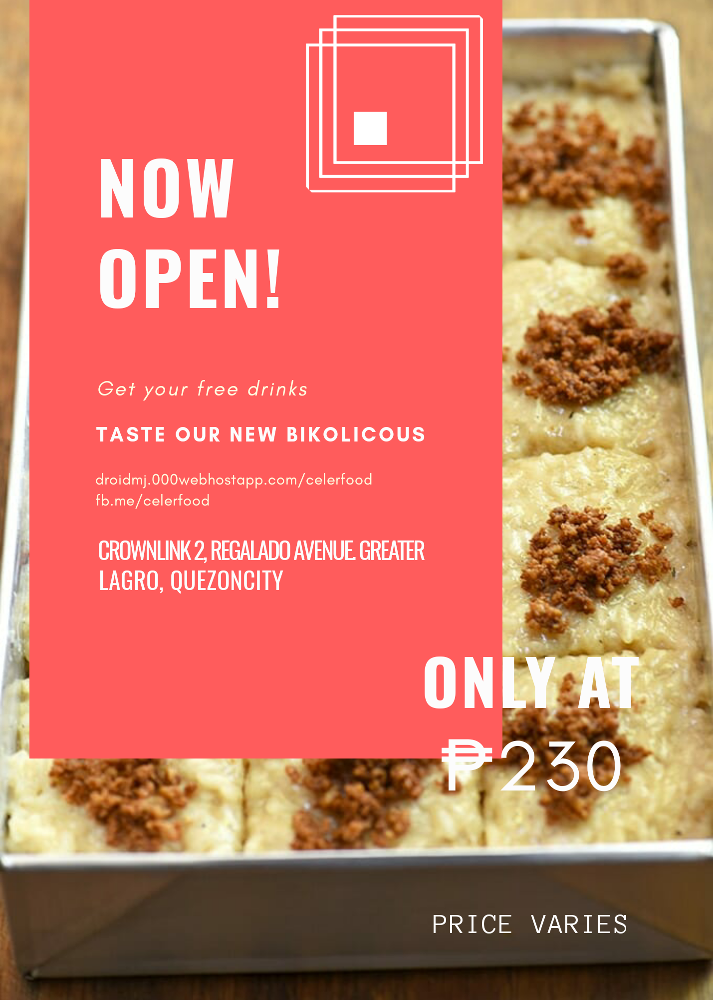s**

The figure shows the flyers of Bicolicous that includes the location, price and fb pPage

**FB Page**

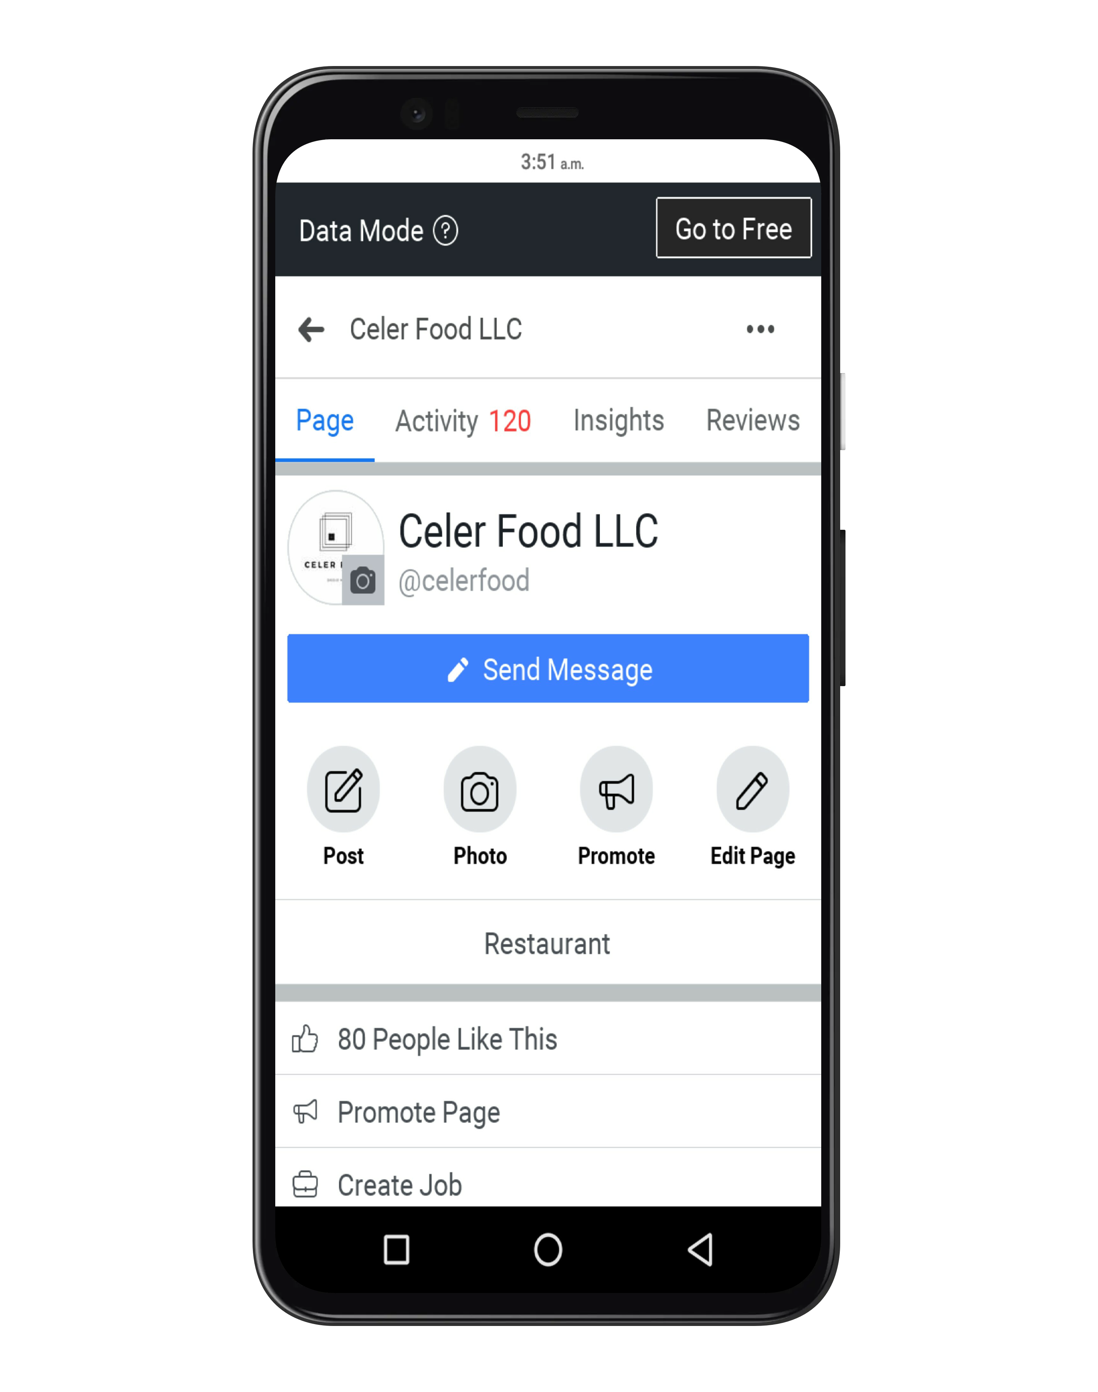

**The figure show's the fb page of celer food and the link is fb.me/celerfood**

**B. COMMERCIAL**

Commercial shows a brief video about the Bikolicous.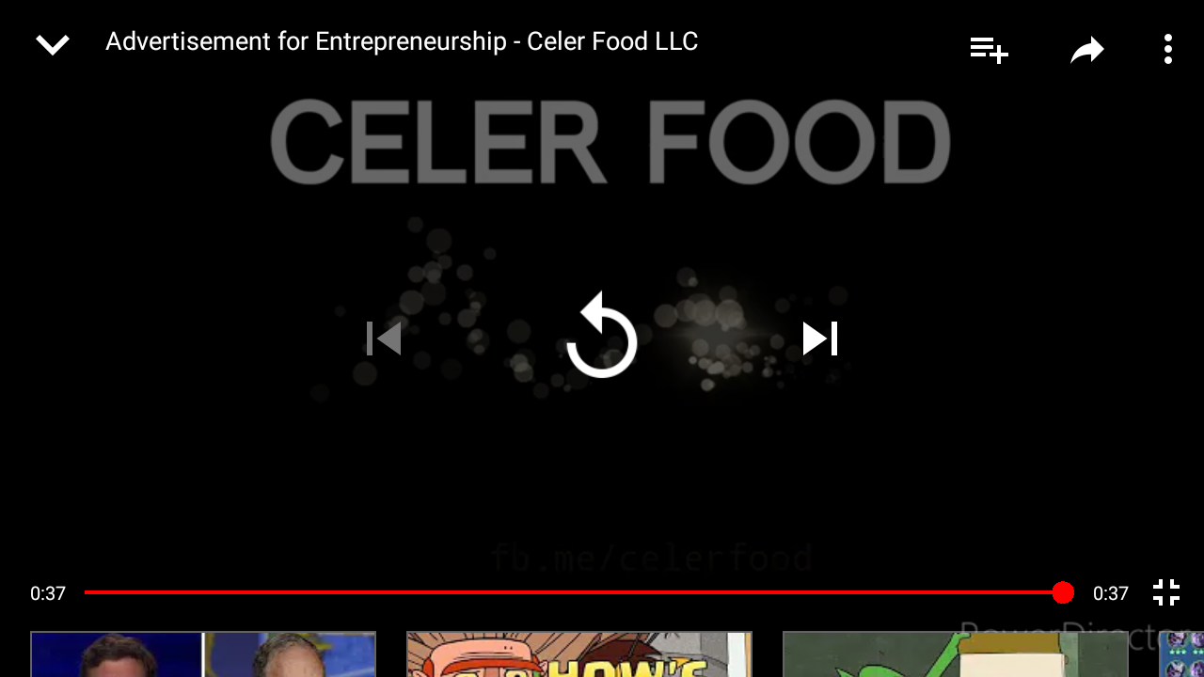

**C. PACKAGING**



**The figure shows the packaging of Bicolicous.**

**VIII. TARGET MARKET**

**A. PEOPLE (GENERAL)**

**B. DESCRIPTON OF THE TARGET MARKET**

1.GEOGRAPHIC

A. LOCATION: Crownlink2 (SEA-ITT), Regalado Avenue, Greater Lagro, Quezon City

B. CLIMATE: Wet and Dry

C. REGION: NCR

D. CITY: Quezon City

E. DENSITY AREA: Urban

2. DEMOGRAPHIC

A. AGE: 16 to 22 year's old

B. GENDER: Male and Female

**IX. SWOT ANALYSIS**

**A. STRENGTH**

* Prices are cheaper than competitors
* High brand recognition

**B. WEAKNESSES**

* Limited funds available
* Costs rising due to increases in food costs

**C. OPPORTUNITIES**

* Expansion into new location and reach new customers
* Create new jobs

**D. THREATS**

* Inflation rate goes higher
* A main competitor has lowered its prices