**How to Play the Skunk Game**

**I- Running a Jar file**

1. **Create a new directory**
2. [**Check for Java Application**](https://windowsreport.com/jar-file-windows/#1)
3. [**Open the Jar File**](https://windowsreport.com/jar-file-windows/#2)
4. [**Run a Jar File from the Command Prompt**](https://windowsreport.com/jar-file-windows/#2)
5. ***Create a new directory***

Create a new directory/folder in your computer, for example **Skunk**, then Copy the **SkunkTournament.jar** File from Documents folder (SkunkProject sub-folder) into your “**Skunk”** folder. (You can also create your own jar from **SkunkProject.** See documentation from <https://www.vogella.com/tutorials/Eclipse/article.html> )

***2. Check for Java Application***

You need to have [**Java**](https://windowsreport.com/outdated-java-windows-10/)installed. Without it, Java apps is not going to run in Windows. This is how you can check:

* First, pressing the **Win key + R** keyboard combination and entering ‘cmd‘ in the open box to open Command Prompt.
* Next, input “java -version” in the **Command Prompt** and press Enter. It will then provide further details on your Java version as below.

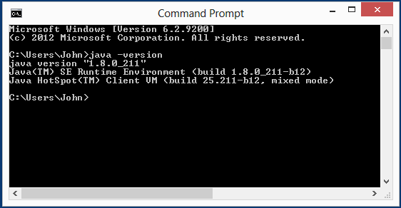

***3.*** [***Open the Jar File***](https://windowsreport.com/jar-file-windows/#2)

Change directory to **Skunk** directory to verify if the file exists

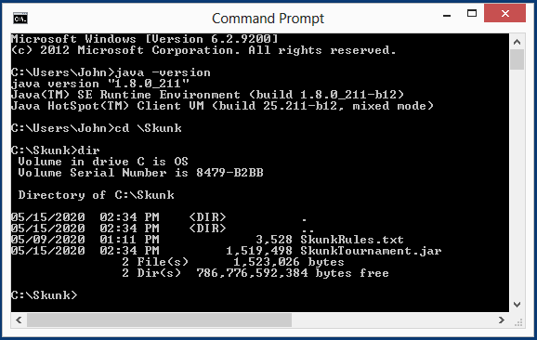

***4.*** [***Run a Jar File From the Command Prompt***](https://windowsreport.com/jar-file-windows/#2)

* Under command prompt, Type “**java -jar SkunkTournament.jar”** then press **Enter** key.

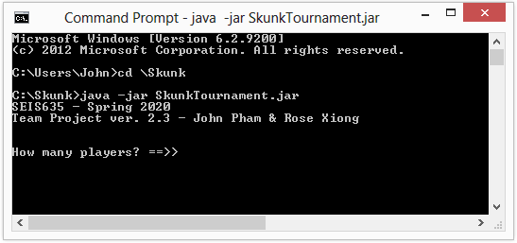

Enter number of player then press **Enter** key to continue the game.

**II- Running program from Java Workspace in Eclipse**

If you have all the source code and create a project for this skunk game, for example, **SkunkTournament** project, you can run the program from the workspace.

To run a program,Open **SkunkProject**workspace, ***right-click*** (Windows) on the **SkunkApp.java** file, and from the context menu, select the *Run As 🡪 1 Java Application* menu option. The program runs. The console output is at the bottom of the screen.

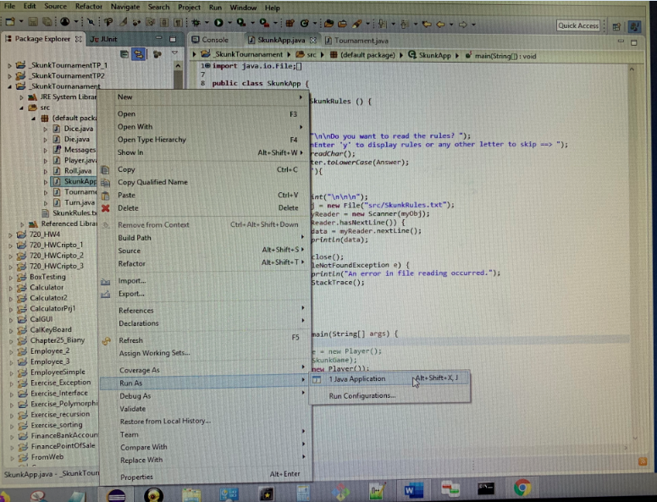

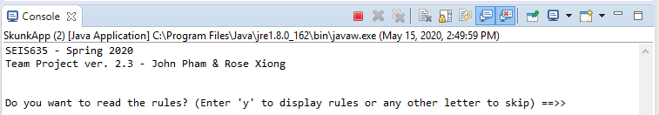

Please refer to Java Eclipse Document at <https://www.vogella.com/tutorials/Eclipse/article.html>